High-Resolution Landscape Data Products

This document lists and describes the high-resolution data sets available from the Chesapeake Bay Program Office as of April 2023. Questions about the data should be directed to Peter Claggett, (pclagget@chesapeakebay.net)

Landforms
Matt Baker’s team at UMBC is cataloging the land based on geomorphon techniques. Geomorphons are calculated based on a moving window. Ten-meter geomorphon analysis describes landscape features at a broad scale and divides the landscape into 10 categories: flat, summit, ridge, shoulder, spur, slope, hollow, footslope, valley, and depression. One-meter geomorphon analysis describes the same landscape features at a finer level of granularity. The 1-meter resolution valleys that fall within the 10-meter resolution valleys represent hydrographic features of interest.
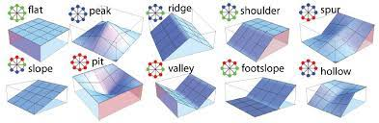

Outputs
Landform classification (10-meter and 1-meterresolutions). Available now.
Currently available for the Patuxent https://gis-data.chesapeakebay.net/RFP/Geomorphons_Patuxent.zip

Hyper-res hydrographic features
One-meter resolution hydrographic features of interest for the Patuxent River Watershed are available for viewing. Essentially, these data represent streams, gullies​, ditches, swales that are either natural or engineered. The Patuxent_12072022.zip file contains a series of folders representing all of the 12-digit HUC’s in the Patuxent Watershed. Within each HUC folder are the vector and raster files developed as part of the hydrography mapping effort. There is one merged file of the linework attributed with stream order for the entire Patuxent watershed provided as a geopackage. I could not open this file in ArcGIS Pro due to projection issues and you may not be able to either. Therefore, I created a shapefile version of the geopackage data (via QGIS) which is the second download link above. Matt Baker has noted that for the merged file, “there are a few non-tidal subcatchments in the downstream, tidal portion of the basin that are missing. This occurs because of how the merging process (written in somewhat ideal terms) interacts with some imprecisely drawn HUC boundaries and the fact that our DEMs did not include some of the lower Patuxent that is generally considered to be part of the Chesapeake Bay estuary. Rest assured, our algorithm does delineate channels and streamlines in these subcatchments, and they are included here in an unmerged form (HUC folders). Our original project concept did not anticipate how ugly delineating channels in the tidal portion of the bay would be, and it is fair to say that we have some challenges there.”

There is a subdirectory for each HUC12 that contains:
1. a vector polygon file of channel-like features selected by our algorithm for delineation (shp_chn_sel)
2. a vector polygon file of water features used to complete the delineation (waterPolygon)
3. a vector shp file of streamlines which may include reaches too short to be retained (strm_vec_clean)
4. a vector file of streamlines with attributes summarized over each reach (longStrAttr)
5. a vector file of streamlines with attributes summarized over each channel feature (shtStrAttr)
6. a vector file of streamlines with attributes summaries over each channel connector (shtConAttr)

All attribute tables need to be cleaned up, many have extra columns. Attributes for "long stream" or reach scale summary include strahler stream order (within each HUC12), length (m), downstream length to HUC12 outlet (km), reach level zonal statistics for elevation, channel depth (larger negative numbers indicate deeper channels in m), channel width (m) , and the proportion of each reach length that is a connection (versus over a channel feature).

Shp_chan_sel represents all channel-like features selected for their predicted Random Forest class probabilities. These probabilities are listed in the attribute table of each feature. The highest probability and its associated class are listed in a separate column, as is the second highest probability and its class.

"Short stream" attributes include all of the above plus the mean class probabilities of their underlying channel features from RF, including the probabilities of the highest and second highest classes. Connector attributes include length, zonal statistics for elevation, and eventually will include an indicator describing what kind of connector each feature crosses (land, roads/ridges, open water).
Most of these data will not be provided as part of the initial data release, but we are including the summaries for the Advisory panel and USGS colleagues who may want extra information.

Outputs
Hyper-res stream raster skeleton and vector polyline network. Draft in fall 2022, final in summer 2024
Currently available for the Patuxent https://gis-data.chesapeakebay.net/RFP/Patuxent_12072022.zip

Stream Network
The CBPO will need to decide what features to include in their official hyper-res stream network. The default will be those intermittent and perennial features which are most likely supporting aquatic life which will be based on stream order, drainage area, or independent estimates of stream flow performance. We can have multiple versions of hydrography for different purposes. For example, the streams used for riparian buffer assessments may be more or less extensive than the streams used for Phase 7. A vector layer will be produced with the following attributes:
Channel type (see above list.)
Flow permanence probability
Drainage area
Stream order
Channel width
Channel height
Valley width

The CBPO will run FACET on the network to generate the following additional attributes:
Upstream/downstream node
Flow accumulation raster
flow direction raster
Bank height
Channel width
Floodplain width
Entrenchment ratio (ratio between floodplain width at 2X bank height and channel width)

Outputs
Stream network vector with attributes. Draft in fall 2022, final in summer 2024.
Geomorphometry for Streams and Floodplains in the Chesapeake and Delaware Watersheds - ScienceBase-Catalog
https://www.sciencebase.gov/catalog/item/5cae39c3e4b0c3b00654cf57

Land use/land cover (LULC)
The 1-meter resolution land use/land cover (LULC) data for the Bay watershed will be available for the years 2013/14, 2017/18, and 2021/22 by the summer of 2024. Currently, data for only the first two sets of years are available. These data will have 64 classes representing combinations of land use and land cover (e.g., “solar field herbaceous”). The terrene and riverine pond classes include all non-tidal, non-fluvial areas where open water is visible in the aerial imagery and include both in-ground and above-ground areas of water detention.

The 64 classes are as follows:
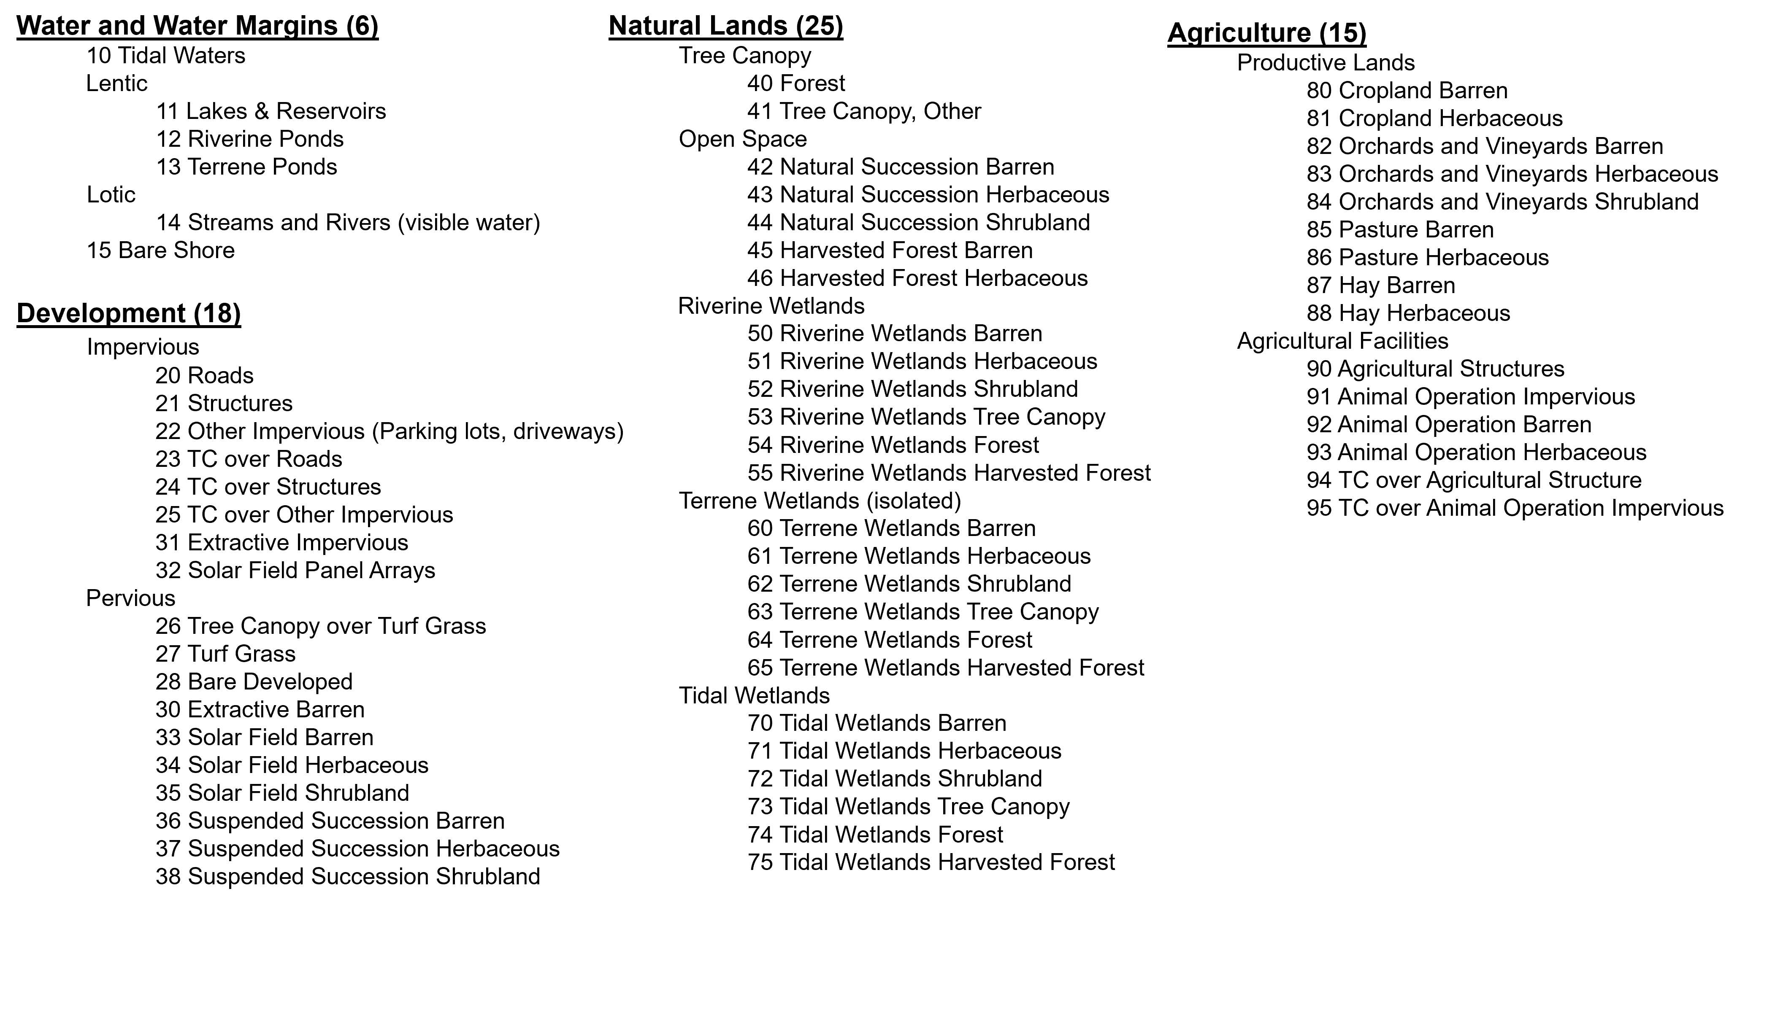

These 64 classes can be rolled up to the original 12 Phase 6 watershed model classes as follows:
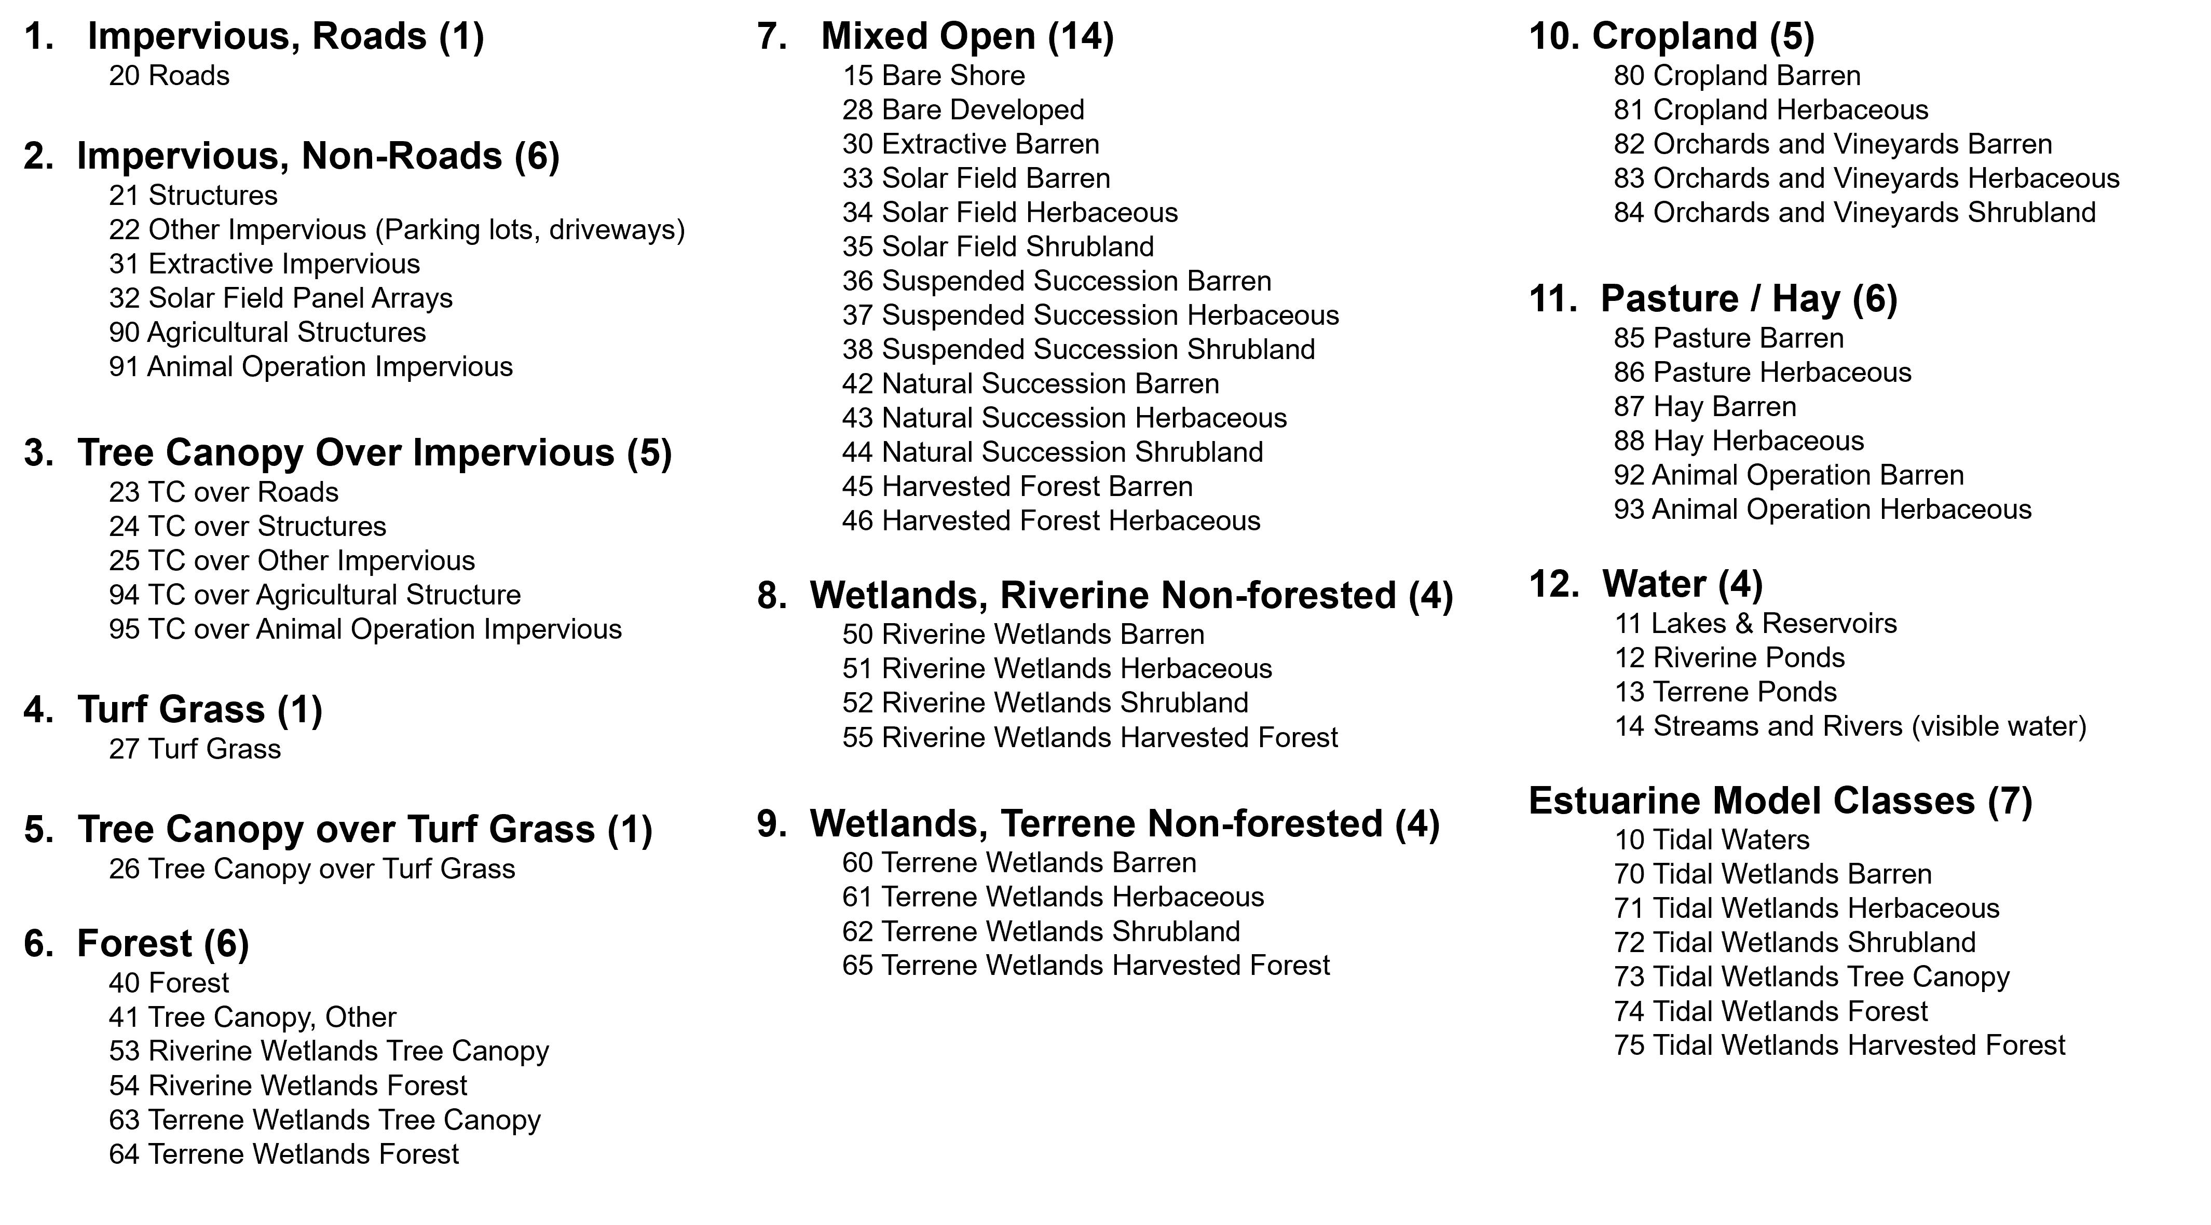

Outputs
Land use/land cover raster data at 1-meter resolution with 64 classes for 2013/14, 2017/18, and 2021/22. Available summer 2024.
Initial LULC data (extent and change products) are available here: https://doi.org/10.5066/P981GV1L
Vegetation phenology data are viewable here: https://phenology.cr.usgs.gov/viewer/

