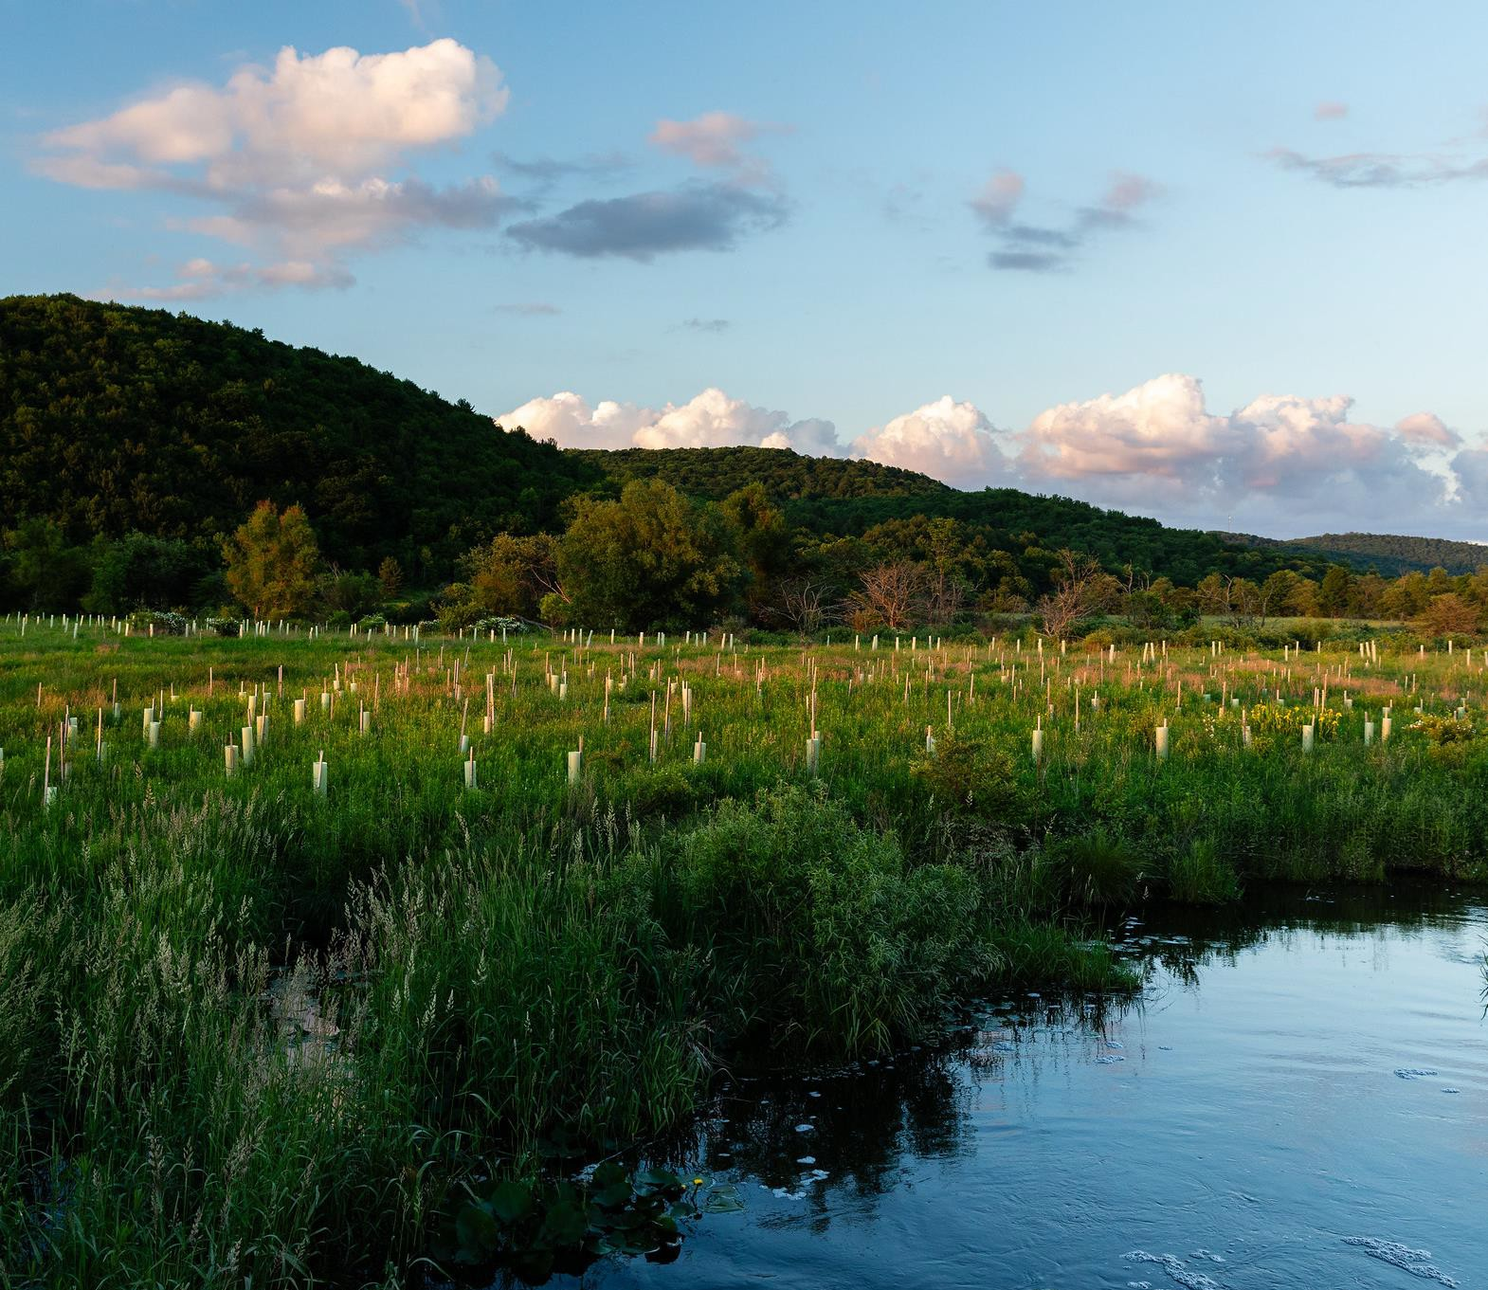
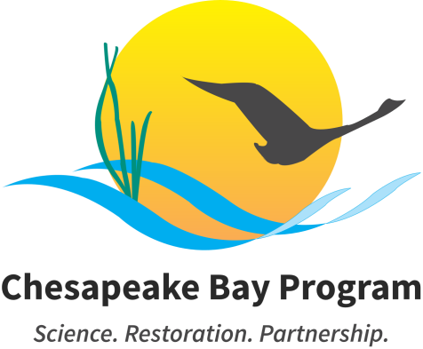

Chesapeake Bay Watershed Agreement
Beyond 2025 Revision DRAFT
Released for PUBLIC FEEDBACK July 1 – September 1, 2025


Table of Contents
ABOUT REVISIONS TO THE AGREEMENT 3
ABOUT THE PUBLIC FEEDBACK PERIOD 3
VISION 4
PREAMBLE 5
PRINCIPLES 7
GOALS & OUTCOMES 8
THRIVING HABITAT AND WILDLIFE 9
Blue Crab Sustainability 9
Oysters 9
Fish Habitat 9
Wetlands 10
Stream Health 10
Brook Trout 10
Fish Passage 10
Submerged Aquatic Vegetation (SAV) 10
CLEAN WATER 11
Water Quality Standards Attainment and Monitoring 11
Reducing Excess Nitrogen, Phosphorous and Sediment 11
Toxic Contaminants Mitigation 12
HEALTHY LANDSCAPES 13
Protected Lands 13
Land Use Decision Support 13
Healthy Forests and Trees 14
Adapting to Changing Environmental Conditions 14
ENGAGED COMMUNITIES 15
Stewardship 15
Local Leadership 15
Workforce 15
Public Access 15
Student Experiences 16
School District Planning 16
MANAGEMENT STRATEGIES DEVELOPMENT AND IMPLEMENTATION 17

ABOUT REVISIONS TO THE AGREEMENT


Since the Chesapeake Bay Program’s foundation in 1983, its partners have used written agreements to guide the restoration of the nation’s largest estuary and its watershed. Setting goals and tracking progress holds partners accountable for their work, while updating agreements over time ensures that goals are aligned with the best available science to attain restoration success. In December 2024, the Chesapeake Executive Council directed the Principals’ Staff Committee to revise the 2014 Chesapeake Bay Watershed Agreement and propose a simplified and streamlined structure and process for the Chesapeake Bay Program. While structure and process revisions are ongoing, the partnership has evaluated the

Watershed Agreement’s current goals and outcomes based on the latest policy, community needs, best available science, emerging threats and new opportunities. Working with the Principals’ Staff Committee, Management Board and subject matter experts, the 10 goals and 31 outcomes of the 2014 Chesapeake Bay Watershed Agreement were consolidated, reduced, updated, removed, replaced or revised to create the proposed four goals and 21 outcomes presented in this document, the draft Revised 2025 Chesapeake Bay Watershed Agreement.

ABOUT THE PUBLIC FEEDBACK PERIOD

From July 1–September 1, 2025, the public is invited to provide written feedback on the proposed updates to the Revised 2025 Chesapeake Bay Watershed Agreement. You are encouraged to read the Frequently Asked Questions on the Planning for 2025 and Beyond website before submitting your feedback to comments@chesapeakebay.net.

When submitting feedback, you are encouraged to do the following:

Feedback should be as specific as possible, detailing how you would like to see these sections, goals or outcomes revised.

Please include the sections and page numbers of the Watershed Agreement that you are commenting on. For example, your feedback could be categorized as pertaining to the Vision, Preamble, Principles or a specific Outcome.

You are encouraged to indicate the state (or D.C.) that you reside in when you submit your feedback so we may share it with your state’s representatives to the partnership. If your comments are in reference to a particular state or D.C. and not the entire watershed or agreement, we ask that you indicate that in your feedback as well.

You are highly encouraged to submit your feedback as early as possible and not wait until September 1.

All feedback received will be posted on the Planning for 2025 and Beyond website, with comments from individuals shared anonymously, unless you specify otherwise. Feedback from organizations, agencies or businesses will be shared as it is received, with identifying information and affiliations.

All feedback will be read, categorized and reviewed by a 12-person team representing the federal and state agencies and advisory committees that make up the Chesapeake Bay Program. A revised draft of the updated Watershed Agreement will be presented to the Management Board in October 2025.

VISION

The Chesapeake Bay Program partners envision an environmentally and economically sustainable and resilient Chesapeake Bay watershed with clean water, abundant life, conserved and healthy working lands producing abundant and healthy food for the regional population, a vibrant cultural heritage and a wide range of engaged individuals whose communities enjoy access to the waters and natural landscapes of the region.

PREAMBLE

The Chesapeake Bay watershed is one of the most extraordinary places in America, spanning six states and the District of Columbia. As the nation’s largest and one of the most productive estuaries in the world, the Chesapeake Bay and its vast network of more than 180,000 miles of streams, creeks and rivers holds tremendous ecological, cultural, economic, historic and recreational value for the more than 18 million people who live, work and play in the region.
To restore, conserve and protect this national treasure, the Chesapeake Bay Program partnership was formed in 1983 when the governors of Maryland, Virginia, Pennsylvania, the mayor of the District of Columbia, the chair of the Chesapeake Bay Commission and the administrator of the Environmental Protection Agency signed the first Chesapeake Bay Agreement. That initial Bay Agreement recognized the “historical decline of living resources” in the Chesapeake Bay and committed to a cooperative approach to “fully address the extent, complexity and sources of pollutants entering the Bay.” For more than 40 years, this regional partnership has been recognized as one of the nation’s premier estuarine restoration, conservation and protection efforts, implementing policies, engaging in scientific investigation and coordinating actions among the states, the District of Columbia and the federal government.

The Chesapeake Bay Program partners have made much progress in that time, and there is still more to do—especially in the face of continued challenges such as changes in population, loss of farm and forest lands, declining fish and wildlife resources, threats to biodiversity, emerging contaminants and changing environmental conditions. Through the Chesapeake Bay Watershed Agreement, the partnership remains committed to restoring, protecting and conserving the Bay and its watershed through effort based in and guided by science and responsive to the lessons learned from our past and shared experiences.

One of the most important lessons the partners have learned from the past four decades is that although watershed-wide partnerships can help to coordinate and catalyze progress, implementation is locally inspired and driven. Local governments, tribes, communities, farmers, businesses, watershed groups and other nongovernmental organizations are key partners in our work. Working together to engage, empower and facilitate these partner networks will leverage resources and ensure better outcomes for all watershed communities.

The partnership’s experience with watershed restoration, conservation and protection efforts has shown that measurable progress, coupled with clear accountability, yield the most effective results. The partnership continues to embrace new ideas, technologies and policies that will help meet our goals. We are committed to improving accountability, transparency and outreach to strengthen and increase public confidence in our work.

The 1983 Chesapeake Bay Agreement laid the foundation for a cooperative program that included four jurisdictions along with the Chesapeake Bay Commission and the federal government. Since 2014, the Chesapeake Bay Watershed Agreement has included all seven jurisdictions in the watershed, with New York, West Virginia and Delaware joining the original signatories as full partners in the Chesapeake Bay Program and the Chesapeake Executive Council. Numerous federal agencies also continue their longstanding commitment to restoring, conserving and protecting the Chesapeake Bay.

This Chesapeake Bay Watershed Agreement acknowledges that the partnership cannot address every issue at once and that progress must be made in a strategic manner, focusing on efforts that will achieve

the most meaningful and cost-effective results. Watershed restoration, conservation and protection are integral drivers of the region’s economy, health and culture. To that end, the partnership is committed to achieving success while maximizing the community and economic benefits across the watershed. The signatories to this voluntary agreement commit to achieving the restoration, conservation and protection of the Chesapeake Bay watershed, its water, habitats and living resources for the benefit of all people living in and visiting this nationally treasured watershed.

PRINCIPLES

The Chesapeake Bay Program commits to operate under the following principles, which reflect the partners’ collective, core values. The principles guide the work of the partnership as we develop policy and take action to achieve the Chesapeake Bay Watershed Agreement’s Goals and Outcomes.
The partnership will:
- Collaborate to achieve the Goals and Outcomes of the Chesapeake Bay Watershed Agreement.
- Achieve Goals and Outcomes in a measurable and timely way and at the least possible cost to the public.
- Represent the interests of all communities throughout the watershed fairly and effectively.
- Use place-based approaches, where appropriate, to target specific geographic areas and produce recognizable benefits to local communities while contributing to larger ecosystem goals.
- Recognize that productive working lands are a preferred land use for the Chesapeake Bay.
- Recognize the link between agriculture and aquaculture and how the economic viability of both hinge on healthy, productive, profitable soil and livestock systems.
- Acknowledge, support and embrace local governments and other local entities in watershed restoration, conservation and protection activities.
- Operate with transparency in program decisions, policies, actions and reporting on progress to strengthen public trust and confidence in our efforts.
- Use science-based decision-making, consider Indigenous and local knowledge and seek out innovative technologies and approaches to support sound management decisions in a changing system.
- Maintain and enhance a coordinated watershed-wide monitoring and research program to support decision-making, track progress and assess the effectiveness of management actions.
- Anticipate and respond to changing conditions, including long-term trends in sea level, temperature, precipitation, land use and other variables.
- Adaptively manage at all levels of the partnership to foster continuous improvement informed by the best available science and strong working relationships.
- Seek consensus across the partnership when making decisions.
- Meaningfully engage the public to foster collaboration and grow the partnership to support and carry out the restoration, conservation and protection activities necessary to achieve the Goals and Outcomes of the Chesapeake Bay Watershed Agreement.
- Integrate tribal nations into the partnership in a manner that appropriately considers their unique status as independent sovereign nations.
- Integrate social science holistically throughout the partnership to better understand and measure how human behavior can drive natural resource use, management and decision- making.
- Facilitate outreach to and welcome participation by all communities regarding the partnership’s activities, decisions and implementation of this Watershed Agreement.

GOALS & OUTCOMES

The commitments contained in this section are the Goals and Outcomes that the signatories will work on collectively to advance restoration and protection of the Chesapeake Bay ecosystem and its watershed. The Goals articulate the desired high- level aspects of the partners’ Vision. The Outcomes related to each Goal are specific, time-bound, measurable targets that directly contribute to achieving that Goal.
The Management Strategies, further described in the next section of this Watershed Agreement, articulate the actions necessary to achieve the Goals and Outcomes. This work will require effort from many, including all levels of government, academic institutions, nongovernmental organizations, watershed groups, businesses, farmers and foresters, and individuals. Local governments will continue to play a unique and critical role in helping the partnership realize this shared Vision for the Chesapeake Bay. Signatories will participate in achieving the Outcomes of this Watershed Agreement in the manner described in the “Management Strategies Development and Implementation” section.

While the Goals and Outcomes are described by separate topic areas, the signatories recognize that they are interrelated. Improvements in habitat and water quality lead to healthier living resources.
Environmentally and agriculturally literate people are more engaged stewards of the Chesapeake Bay’s healthy watersheds. Better water quality means swimmable, fishable waters for Bay residents and visitors. Increased public access to the Bay inspires people to care for critical landscapes and honor the region’s heritage and culture. Healthy fish and shellfish populations support a vibrant economy for a spectrum of fishing-related industries. The signatories recognize that all aspects of the ecosystem are connected and that these Goals and Outcomes support the health and the protection of the entire Bay watershed.

As the signatories identify new opportunities and concerns, Goals or Outcomes may be adopted or modified. Any changes or additions to Goals will be approved by the Executive Council. The Principals’ Staff Committee will approve changes or additions to Outcomes, although significant changes or additions will be raised to the Executive Council for approval. Proposed changes to Goals and Outcomes or the addition of new ones will be open for public input before being finalized. Final changes or additions will be available on the Chesapeake Bay Program’s website.

THRIVING HABITAT AND WILDLIFE


The fisheries of the Chesapeake Bay watershed are the backbone of the region's ecology, economy and heritage. However, impaired water quality, invasive species and habitat loss place pressure on fish and wildlife populations across the region. Meanwhile, our increasing use of land and resources can fragment and degrade the habitats they depend on. Maintaining sustainable fisheries and restoring habitat for native and migratory species will support a strong economy and a balanced ecosystem.

GOAL: Protect, restore and sustain fisheries and wildlife, as well as the network of land and water habitats they depend on, to promote a balanced and resilient ecosystem and support local economies and recreational opportunities.

Blue Crab Sustainability
Achieve a sustainable Bay-wide blue crab fishery through cross jurisdictional coordination that supports healthy blue crab populations and thriving fishing communities.

- Continually maintain abundance and harvest rate targets as determined by the 2026 benchmark stock assessment.
- Achieve cross-jurisdictional coordination by jointly evaluating and communicating stock status annually through the Blue Crab Advisory Report and refining targets, as needed, through the next stock assessment.

Oysters
Increase ecosystem benefits from oysters through reef habitat restoration, sustainable harvest and aquaculture.

- Restore or conserve at least 1,800 additional acres of oyster reef habitat concentrated primarily in

Maintain sustainable oyster abundance through oyster fisheries and aquaculture practices.
restoration focus areas to provide ecosystem service benefits.

- Maintain reefs established under the 2014 Chesapeake Bay Watershed Agreement to achieve
restoration success metrics.

Fish Habitat
Achieve and maintain suitable shallow water fish habitat in tidal and non-tidal areas for key species through focused water quality, conservation and restoration improvements informed by a synthesis of fisheries science and habitat assessments.

Continually improve the quantity and quality of shallow water fish habitat in tidal areas above
baseline conditions as determined by a Bay-wide assessment of fish habitat conditions completed in 2026.
- Increase the consideration of forage species in fishery management decision-making for key predators by annually developing reports of prey status as good, uncertain or poor.
- Establish a baseline and assess the overall condition and suitability of fish habitat in the watershed to support healthy communities and inform effective restoration, conservation and management actions.
- Develop an acid mine drainage target, in collaboration with the Brook Trout Outcome, that strives to better understand the impacts and mitigation opportunities for acid mine drainage throughout the watershed.

- Develop freshwater mussel conservation plans for five tributaries and begin implementation by 2035.

Wetlands
Restore, create, enhance and protect wetlands to support people and living resources, including waterbirds and fish, provide water quality, flood and erosion protection, recreation and other valuable benefits to people, without removing productive agricultural lands.
- Tidal Wetlands Target: Restore or create 1,000 acres and enhance 15,000 acres by 2035.

- Non-Tidal Wetlands Target: Restore or create 2,000 acres and enhance 15,000 acres by 2035.
- Buffer Protection Target: Same as the Protected Lands Outcome and will be tracked under that Outcome.
- Waterbirds represent wetlands functioning at its highest level; priorities for specific species will be developed over the next 12 to 18 months.

Stream Health
Continually improve and protect local stream health and function, including their living resources and ecosystem services throughout the watershed using the best available science to inform land management, planning and conservation.

- Improve health and ecological integrity of at least 3% of non-tidal stream miles every six years.

Brook Trout
Protect and enhance brook trout within the Chesapeake Bay watershed by increasing occupancy, abundance and resilience to changing environmental conditions.

- By 2035, increase brook trout occupancy by 1% in watersheds supporting healthy populations while achieving no net loss in other watersheds.
- By 2035, increase abundance at 10 long-term monitoring sites.
- By 2035, reduce identified threats by _XX_% to increase brook trout resilience in watersheds supporting healthy populations.

Fish Passage
Improve habitat and water quality, while creating more resilient and sustainable populations of fish and other aquatic organisms by removing barriers throughout the Chesapeake Bay watershed’s coastal and freshwater rivers and streams.

- Restore passage and connectivity to at least 150 miles of aquatic habitat every two years.

Submerged Aquatic Vegetation (SAV)
Sustain and increase the habitat and ecosystem benefits of SAV in the Chesapeake Bay. Achieve and sustain the outcome of 196,000 acres of SAV Bay-wide, which is necessary for a restored Bay.
- Progress toward this Outcome will be measured against interim targets of 90,000 acres by 2030 and 95,000 acres by 2035.
- Progress will also be measured against the following targets for each salinity zone:
  - Tidal Fresh: 21,330 acres
  - Low Salinity: 13,094 acres
  - Medium Salinity: 126,032 acres
  - High Salinity: 35,790 acres

CLEAN WATER

Clean water is the foundation of healthy fisheries, habitats and communities across the watershed. However, excess nitrogen, phosphorus, sediment and toxic contaminants can degrade our waterways, harm wildlife and pose risks to human health. The Chesapeake Bay Program partners use a variety of tools to reduce excess nitrogen, phosphorus and sediment, address toxic contaminants and monitor progress toward achieving water quality standards.


GOAL: Reduce pollutants entering the Bay and its rivers to achieve the water quality necessary to support aquatic wildlife and protect human health and support economically viable, productive agriculture.

Water Quality Standards Attainment and Monitoring
Measure changing water quality conditions by maintaining core monitoring networks, evaluating attainment of established water quality standards (i.e., dissolved oxygen, clarity and chlorophyll-a) in the Bay and strengthening scientific understanding and communication of patterns in nitrogen, phosphorus, sediment and other parameters throughout the Bay and watershed.

- Maintain Monitoring Networks: Annually, maintain full core monitoring network operations to support analysis and communication of water quality loads, water quality trends and water quality standards attainment
- Develop Methods for Water Quality Standards Attainment: Develop and expand partnership- approved approaches to support assessment of all dissolved oxygen, clarity and chlorophyll a criteria in all designated uses using all available data. For dissolved oxygen criteria assessment, have methods established and approved by 2028 and applied in reporting by the end of 2030.
- Evaluate Water Quality Standards Attainment: Through management actions in support of the Reducing Excess Nitrogen, Phosphorus and Sediment Outcome, maintain a long-term trend of improvement in the water quality standards attainment indicator at a rate of at least 0.2% per year, aligned with the historical baseline trend of the multi-metric water quality standards indicator between 1985 and 2022. Update the water quality standards attainment indicator annually.

Calculate Water Quality Loads and Trends:
- Watershed: In coordination with the Reducing Excess Nitrogen, Phosphorus and Sediment Outcome, compute and communicate loads and trends in nitrogen, phosphorous and sediment for the watershed. On an annual basis produce the load and trend analyses and communication results for the nine major river system river input monitoring sites. Conduct the same analysis for the complete non-tidal network on a biennial basis.
- Tidal Bay and tidal tributaries: On an annual basis for the tidal Bay and tributary stations, compute and communicate trends for physical, chemical and biological measures.

Reducing Excess Nitrogen, Phosphorous and Sediment
Implement and maintain practices and controls that will reduce excess nitrogen, phosphorus and sediment to support living resources and protect human health and viable, productive agriculture by achieving water quality standards.

- Through 2030, continue to implement and maintain practices and controls to reduce excess nitrogen, phosphorus and sediment to achieve the interim water quality targets as determined by the Principals’ Staff Committee. Partners may meet this target by implementing their Phase III Watershed Implementation Plans, two-year milestone commitments or other innovative strategies.
- By December 2030, update this outcome with revised targets that include a timeline to meet the updated water quality targets for nitrogen, phosphorus and sediment.
- Demonstrate net reductions in nitrogen, phosphorus and sediment toward meeting the interim water quality targets as determined by the Principals’ Staff Committee, through multiple lines of evidence, including annual progress reporting and monitoring data (in coordination with the Water Quality Standards Attainment and Monitoring Outcome).

Toxic Contaminants Mitigation
Reduce the amount and effect of toxic contaminants, such as PCBs, plastics, mercury and PFAS, on the waters, lands, living resources and communities of the Chesapeake Bay watershed by facilitating an increased understanding of their impacts and mitigation options.

- Promote continuous information sharing between researchers, program managers and policymakers on the lessons learned, best practices and most up-to-date science, policy and communications around the toxic contaminants impacting the Chesapeake Bay watershed.

HEALTHY LANDSCAPES


The well-being of the Chesapeake Bay depends on the health of the lands that make up its watershed. As communities within the region continue to grow, the demand for land and resources can put our waters and habitats at risk. Sound land use management and conservation of areas with ecological, historic and cultural value can reduce pollution, maintain healthy ecosystems and ensure the health of forests, farms and open spaces, all while supporting growing economies. These cost-effective strategies will help communities adapt to changing environmental conditions and ensure clean water for future generations.

GOAL: Conserve, restore and enhance landscapes of ecological, economic and cultural value to maintain water quality, provide habitat for wildlife, support viable food production and increase resilience.

Protected Lands
Protect critical landscapes within the Chesapeake Bay watershed to protect water quality, enhance biodiversity, support sustainable livelihoods, ensure military readiness and national defense, and honor cultural heritage.

- Protected Lands: By 2040, permanently protect an additional 1.5-2 million acres of land throughout the watershed at the federal, state or local level.
- Forests: By 2040, permanently protect a total of _XX_ acres of forest, of which XX% are in riparian areas.
- Wetlands: By 2040, permanently protect a total of _XX_ acres of wetlands, focusing on the protection of buffer zones.
- Watershed Health: By 2040, protect a total of _XX_ acres of natural lands in watersheds that support good stream health.
- Tribal Lands: Support the sovereignty and duty of care of tribal nations and communities by securing protection status and/or co-management agreements for a total of _XX_ acres of tribal homelands.
- Agricultural Lands: By 2040, permanently preserve a total of _XX_ acres of agricultural lands within the Chesapeake Bay watershed, with a focus on maintaining the continued agricultural function and profitability.
- Community Greenspace: By 2040, permanently protect a total of _XX_ acres of community greenspace.

Land Use Decision Support
Develop and disseminate relevant and actionable land use information to organizations and communities involved in local and regional land use planning on past, present and future conditions, and the potential environmental and socioeconomic consequences of changing conditions.

- Continually increase the number, variety and/or geographic scope of use cases (e.g., watershed protection, aquatic connectivity, stormwater, tree canopy, stream health or redevelopment) for landscape information.
- Highlight two use cases annually to showcase best practices and share this information with local planning officials and partners through Story Maps and/or other communication products.
- Promote land use data and tool applications that maintain the economic viability of agricultural lands and ecological integrity of watersheds supporting good stream health and address the needs of local communities.

Healthy Forests and Trees
Conserve, manage and restore forests and tree cover to maximize benefits for water quality, habitat and people throughout the watershed, with a particular focus on riparian areas and communities.

- Tree Canopy: Reduce the loss of existing canopy, and plant and maintain 35,000 acres of community trees by 2035 to achieve a net gain in canopy over the long-term.
- Forest Buffers: Reduce the loss of existing buffers, and plant and maintain 7,500 acres of forest buffers annually to achieve no less than 71% riparian forest cover by 2035 and 75% riparian forest cover over the long-term.

- Forest Conservation: Reduce the loss of existing forests to development through planning and conservation, and plant and maintain _XX_ acres of new forests by 2035 to achieve a net gain in forests over the long-term.
- Forest Management: Develop and implement Forest Harvest Management Plans for XX acres of existing forests to support their long term health and sustainability.

Adapting to Changing Environmental Conditions
Increase the capacity for pursuing nature-based solutions to improve planning and response to changing conditions while balancing long-term resiliency of watershed communities, economies and ecosystems.

- By 2040, at least seven subwatershed areas have benefited from knowledge-sharing and technical assistance to identify adaptation options with nature-based solutions. These solutions include restoration and protection projects that will help address risks to people, infrastructure and habitats from changes in temperature, precipitation and landscapes.
- By 2040, workgroup activities will inform and lead to an increase in the implementation of adaptation strategies that integrate nature-based solutions in the above subwatershed areas.

ENGAGED COMMUNITIES

The long-term success of the Chesapeake Bay restoration effort depends on individuals, farms, businesses and communities throughout the watershed understanding their connection to the local environment and making choices that support its health. Stewardship begins with increasing access to outdoor recreation, providing learning opportunities to students, adults and job seekers, and empowering local decision-makers to support conservation actions.

GOAL: Engage and grow a community of local stewards and leaders through education, recreation and professional opportunities.

Stewardship
Increase public participation in stewardship actions that contribute positively to the lands, waters, living resources and communities throughout the Chesapeake Bay watershed.

- Through 2040, better equip practitioners with the social science data, technical assistance and support needed to develop, improve and carry out individual and community-level stewardship programs, including those that will help advance Chesapeake Bay Watershed Agreement Goals and Outcomes.

Local Leadership
Continually increase the knowledge and capacity of local government leaders and producer-led groups to empower them to make decisions and implement local actions that support the Chesapeake Bay Watershed Agreement.

- Increase the percentage of local government leaders reporting water resource management actions biennially.
- Producers are a vital and under-recognized group to provide local leadership within agricultural communities. Peer-to-peer knowledge is effective to support increased adoption of best management practices at the local level.

Workforce
Increase the ability of all job seekers in the watershed to understand, participate in and succeed in environmental and agricultural conservation career pathways.

- Understanding: By 2035, inform and grow implementation of strategies that help students, educators and job seekers to become aware of and understand environmental and agricultural careers and the pathways to them.
- Participating: By 2035, increase the number of post-secondary institutions and training providers offering industry-recognized credentials that support Chesapeake Bay Watershed Agreement Goals and Outcomes.
- Succeeding: By 2035, inform and support greater hiring and retention of workers trained in fields necessary to support Chesapeake Bay Watershed Agreement Goals and Outcomes.

Public Access
Enhance new and existing public access sites to the Bay and its tributaries through a combination of actions aimed at improving recreational opportunities and accessibility while addressing barriers to access by increasing the number, quality and geographic distribution of sites.

- New Access Sites: By 2040, add 100 new public access sites with a strong emphasis on providing opportunities for recreation where feasible.
- Improving ADA/ABA Accessibility: By 2040, improve 3% of existing public water access sites by adding ADA/ABA accessible features, where feasible, to meet the needs of communities.

- Access Upgrades, Maintenance and Expansion: By 2040, improve at least 100 existing public water access sites by upgrading or maintaining site grounds and structures—including signage, parking, seating and public facilities—and expanding the range of active and passive recreation opportunities, such as kayaking, boating, trails, courts, piers, wildlife viewing and picnic areas.
- Expanding Access to Urban Lands: By 2040, expand access to _XX_% of urban lands and community green spaces identified in the Protected Lands data set. An initial baseline study is to be conducted by 2025-2026 to determine appropriate numeric targets for this metric.

Student Experiences
Continually increase the number of students who participate in inquiry-based environmental and agricultural literacy instruction working towards at least one Meaningful Watershed Educational Experience (MWEE) in each elementary, middle and high school.

- By 2040, state targets are reached that result in 75% of public-school students being enrolled in a school district that offers a MWEE for all students.

School District Planning
Continually increase the number of school districts that have policies and practices in place that support environmental education and sustainable schools.

- By 2040, all jurisdictions reach their target for the number of school districts that are well prepared to deliver a comprehensive and systemic approach to environmental and agricultural literacy.

MANAGEMENT STRATEGIES DEVELOPMENT AND IMPLEMENTATION


Within X timeframe (previously “one year”) of the revision of the Chesapeake Bay Watershed Agreement, the Chesapeake Bay Program’s Goal Implementation Teams will update or develop Management Strategies for the Outcomes that support the Goals of this Watershed Agreement. These strategies outline the means for accomplishing each Outcome as well as monitoring, assessing and reporting progress and coordinating actions among partners and stakeholders as necessary. Management Strategies describe how local governments, Indigenous representatives, nonprofit and private partners are engaged; where actions, tools or technical support are needed to empower local governments and others to do their part; and what steps are necessary to facilitate greater local participation in achieving the Outcome.

Participation in Management Strategies or participating in the achievement of Outcomes varies by signatory based on differing priorities across the watershed. This participation may include commitments, such as: sharing knowledge, data or information, educating the public, working on future legislation, and developing or implementing programs or practices. Management Strategies, which are aimed at implementing Outcomes, identify participating signatories and other stakeholders, including local governments and nonprofit organizations, and will be implemented in X-year (previously “2-year”) periods.

The signatories and other partners shall thereafter update and/or modify such commitments every X (previously “2”) years. Specific Management Strategies will be updated in consultation with stakeholders, organizations and other agencies, and will include a period for public input and review prior to final adoption.

Management Strategies may address multiple Outcomes if deemed appropriate. Goal Implementation Teams will re-evaluate with X frequency (previously “biennially”) and update strategies as necessary, with attention to changing environmental and economic conditions. Partners may identify policy changes to address these conditions and minimize obstacles to achieve the Outcomes.

Stakeholder input will be incorporated into the development and reevaluation of each of the strategies. The Chesapeake Bay Program will continue to make these strategies and reports on progress available to the public in a transparent manner on its websites and through public meetings of the appropriate Goal Implementation Team and Management Board.

The Goal Implementation Teams will submit the Management Strategies to the partnership’s Management Board for review. If the Management Board determines that any strategy or plan developed prior to the revision of this Watershed Agreement meets the requirements of a Management Strategy as defined above, no new strategy needs to be developed. This includes,

but is not limited to, the strategies and plans for implementing the Chesapeake Bay Total Maximum Daily Load.

