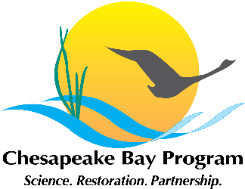

Local Leadership Management Strategy Discussion Meeting
National Park Service Chesapeake Bay Office
410 Severn Avenue
Suite 314
Annapolis, MD 21403

November 3, 2015
10:00am – 12:00pm

Conference Line: 866-299-3188
Conference Code: 410-267-5731
Web Access: https://epa.connectsolutions.com/git6/

Agenda

- Introductions, 10 minutes
- Discuss revised Work Plan approach, 15 minutes
- Highlights of the Chesapeake Watershed Local Leadership Development Programs Report, 15 minutes
- Discuss FY15 GIT Funding project: “Designing a Watershed Education Program for Local Elected Officials”, 10 minutes
- Discuss revised Work Plan, 30 minutes
- Next Steps, 10 minutes
  - Small teams to review and discuss management approaches and plan focus groups.
  - Workgroup members provide written comments by end of November.
  - Next meeting early December. Discuss future meeting/conference call schedule.
- Adjourn

