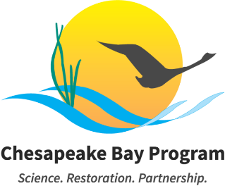

Stewardship Workgroup – December 2025

December 15, 2025
3:00-4:00pm EST

Example Meeting Link: Join the meeting via Zoom
Meeting ID: 829 9407 3797 Passcode: 543294
One tap mobile: +1 3017158592,,82994073797#,,,,*543294# US
Visit the meeting webpage for meeting materials and additional information.

This meeting may be recorded for internal use only to assure the accuracy of meeting notes.
To request meeting accommodations, please contact Meredith Lemke at lemkem@chesapeake.org.

Please read the following information carefully, as our meeting policies have changed:

- All meeting attendees' cameras and microphones will be muted at the start of the meeting until participants are verified.
- Compromised Meeting Plan: If the meeting is interrupted by spam users or technical difficulties, the meeting staffer and coordinator will send an email to all Members, alternates, staffers, coordinators, and interested parties. Within the email, you will find a new meeting link, instructions on sharing this information with external partners, and any necessary adjustments to the meeting schedule. Please do NOT share this information publicly or post it to the Chesapeakebay.net webpage.

Purpose: The purpose of this meeting is to review the workgroup progress throughout 2025, plan for actions in 2026, review the results of the signing of the revised Watershed Agreement, and to welcome new workgroup leadership.

Agenda
- Welcome & Introductions (3:00 – 3:15)
Introduction to new workgroup leadership, Marissa O’Neill, DOEE. New and returning workgroup members will also be invited to introduce themselves.

- Watershed Agreement & Beyond 2025 Update (3:15 – 3:30)
Review results of the signing of the revised Watershed Agreement. Review the Stewardship Outcome and Target language. Discuss Chesapeake Bay Program structure and governance developments as relevant to the workgroup.
Lead: Meredith Lemke, Staffer
Materials:
  - Watershed Agreement
  - Structure Recommendations One-Pager
  - Governance Recommendations One-Pager

- Action Team Updates & Planning for 2026 (3:30 – 3:50)
Action Team leads are invited to provide updates about progress throughout 2025. The workgroup will discuss next steps for each team.
Lead: Meredith Lemke & attending action team leads

- Wrap-Up (3:50 – 4:00)
Requested Action: Decisional
  - Schedule quarterly meetings for 2026.
  - Proposal: 2nd Wednesday quarterly starting in February, 10:00-11:30am
    - Feb 11
    - May 13
    - Aug 12
    - Nov 4 or Nov 10 (Tuesday because Nov 11 is veterans day)
Lead: Meredith Lemke

- Adjourn (4:00)

