Fisheries GIT
2014 Meeting Calendar

Important Calendars and Dates: (crossed out items are included in below calendar)
- Holidays
- CBP (Management Board)
- STAC (CBP’s Scientific and Technical Advisory Committee)
- ASMFC
- MAFMC
- MD DNR Online calendar (http://dnr.maryland.gov/fisheries/calendar/v2/; SFAC and TFAC meetings)
- PRFC
- DC DOE No online calendar.
- VMRC (check early Dec. meeting date)
- VDGIF
- Any others not on this list?

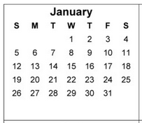
January
1 Holiday (New Year’s)
9CBP Management Board
13 1pm-3pm – Fisheries GIT Ex Comm
161pm-3pm CBP Principals’ Staff Committee
20 Holiday (Martin Luther King, JR.)
289:30am – VMRC; 2-5pm DNR SFAC

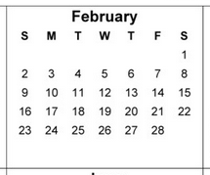
February
3-6 ASMFC Winter Meeting
11-13 MAFMC
13CBP Management Board
17 Holiday (Washington’s Birthday)
202-5pm DNR TFAC
24 1pm-3pm – Fisheries GIT Ex Comm
25 9:30am – VMRC

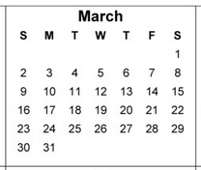
March
7 PRFC
13CBP Management Board
17-21ASMFC Technical Committee Week
18-19STAC
24 1pm-3pm – Fisheries GIT Ex Comm
259:30am – VMRC

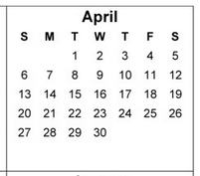
April
8-10 MAFMC
10CBP Management Board
21 1pm-3pm – Fisheries GIT ExComm
292-5pm DNR SFAC
229:30am – VMRC

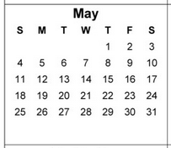
May
12-5 pm DNR TFAC
12-15 ASMFC Spring Meeting
19 1pm-3pm – Fisheries GIT ExComm
26 Holiday (Memorial Day)
279:30am – VMRC

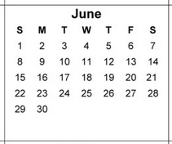
June
4-5 (first week) Full Fisheries GIT
10-12 MAFMC
12 PRFC
12CBP Management Board
16-20ASMFC Technical Committee Week
17-18STAC
17-19NEFMC
249:30am – VMRC

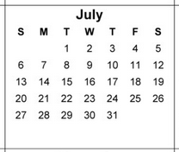
July
4 Holiday (Independence Day)
10CBP Management Board
?? 1pm-3pm – Fisheries GIT ExComm
229:30am – VMRC
223-6pm DNR SFAC
243-6pm DNR TFAC

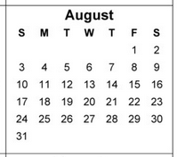
August
5-7 ASMFC Summer Meeting
12-14 MAFMC
14CBP Management Board
?? 1pm-3pm – Fisheries GIT ExComm
269:30am – VMRC

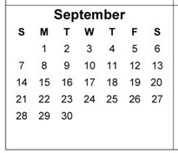
September
1 Holiday (Labor Day)
8-12ASMFC Technical Committee Week
9-10STAC
11CBP Management Board
11PRFC
?? 1pm-3pm – Fisheries GIT ExComm
239:30am – VMRC

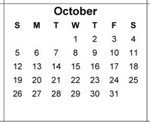
October
7-9 MAFMC
9CBP Management Board
13 Holiday (Columbus Day)
142-5pm DNR SFAC
162-5pm DNR TFAC
?? 1pm-3pm – Fisheries GIT ExComm
27-30ASMFC Annual Meeting
289:30am – VMRC

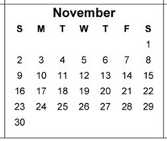
November
11 Holiday (Veteran’s Day)
12-14STAC Forage Workshop
13CBP Management Board
?? 1pm-3pm – Fisheries GIT ExComm
27-28 Holiday (Thanksgiving)

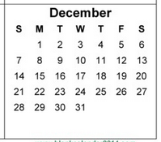
December
?? Full Fisheries GIT
5PRFC
9-10STAC
9-11 MAFMC
11CBP Management Board
25 Holiday (Christmas)

