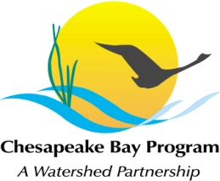
Stream Health Workgroup Meeting
Tuesday, August 4, 2015
9:00 - 11:00AM

Chesapeake Bay Program Office
Joe Macknis Memorial Conference Room (Fish Shack)
410 Severn Ave, Annapolis, MD 21403

Conference Line: 866-299-3188 Code: 4102675731
Adobe Connect: https://epa.connectsolutions.com/streamhealthwg/ (Note: Enter as Guest)

9:00 Welcome (Rich Starr, FWS)
- Review & Approval of June and July meeting minutes

9:10 Stream Health Outcome Management Strategy Biennial Work Plan (Neely Law, Rich Starr)
- The following topics will facilitate and guide our discussion as a Work Group.
  - Overview of permit documentation summary of existing actions and recommendations
  - How do the existing actions and recommendations align with the Management Strategy?
  - Identify and discuss additional existing actions identified by the Work Group
  - What’s missing?
  - Are there actions and recommendations that may be readily identified as priorities?

10:45 Member Updates

10:55 Next Steps for the Workgroup

11:00 Adjourn

