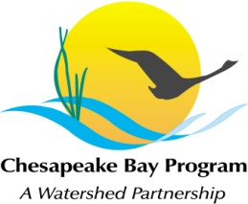
Stream Health Workgroup Meeting
Wednesday, Nov 4 2015
9:00 - 11:00AM

US Fish and Wildlife Service, Chesapeake Bay Field Office
177 Admiral Cochrane Drive in
Annapolis, Maryland 21401

Conference Line: 866-299-3188 Code: 267-985-6222
Adobe Connect: https://epa.connectsolutions.com/streamhealthworkgroup/
(Note: Enter as Guest with your name and affiliation)

9:00 Welcome (Rich Starr, FWS)
Review & Approval of October meeting minutes

9:10 Stream Sediment Source Modeling, (Reid Christianson, Sediment/Stream Coordinator-CWP)
Presentation on methods to characterize sediment sources as part of headwater streams in Phase 6 Chesapeake Bay Watershed Model update, with Q&A.

9:40 Pooled Monitoring research questions (Sadie Drescher, Chesapeake Bay Trust)
Provide update to SHWG on the research questions proposed for 2016 pooled monitoring RFP for consideration by CBT and Ad-Hoc Pooled Monitoring Committee

10:00 Stream Health Outcome Management Strategy Biennial Work Plan (Neely Law, Rich Starr)
Continued review of draft biennial workplan priorities for action 2016-2018
10:45 Member Updates (All)

10:55 Next Steps for the Workgroup

11:00 Adjourn

