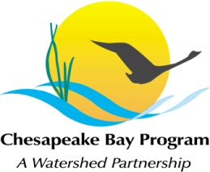
Stream Health Workgroup Meeting
Tuesday, October 6, 2015
1:00 - 3:00PM

Chesapeake Bay Program Office
Joe Macknis Memorial Conference Room (Fish Shack)
410 Severn Ave, Annapolis, MD 21403

Conference Line: 866-299-3188 Code: 267-5715
Adobe Connect: https://epa.connectsolutions.com/streamhealthwg/ (Note: Enter as Guest)

1:00 Welcome (Rich Starr, FWS)
Review & Approval of September meeting minutes

1:10 Stream Health Outcome Management Strategy Biennial Work Plan (Neely Law, Rich Starr)
Continued review of draft biennial workplan priorities for action 2016-2018 with a focus on identifying responsible parties, timeline and costs associated with actions. Decision to adopt draft biennial workplan requested.
2:40 Habitat GIT Fall meeting information (Kyle Runion)

2:45 Member Updates (All)

2:55 Next Steps for the Workgroup

3:00 Adjourn

