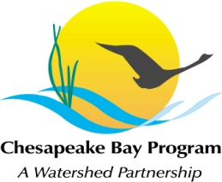
Stream Health Workgroup Meeting
Tuesday, September 8, 2015
9:00 - 11:00AM

Chesapeake Bay Program Office
Joe Macknis Memorial Conference Room (Fish Shack)
410 Severn Ave, Annapolis, MD 21403

Conference Line: 866-299-3188 Code: 4102675731
Adobe Connect: https://epa.connectsolutions.com/streamhealthworkgroup/ (Note: Enter as Guest)

9:00 Welcome (Rich Starr, FWS)
- Review & Approval of August meeting minutes

9:10 Update on Habitat GIT Funding Proposals

9:20 Stream Health Outcome Management Strategy Biennial Work Plan (Neely Law, Rich Starr)
- Review draft biennial workplan priorities for action 2016-2018

10:45 Member Updates

10:55 Next Steps for the Workgroup

11:00 Adjourn

