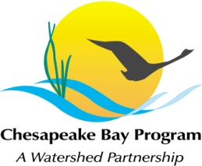
Stream Health Workgroup Meeting
Thursday, April 21st, 2016
1:00 - 3:00PM

Chesapeake Bay Program Office
Conference Room 305
410 Severn Ave, Annapolis, MD 21403

Conference Line: 866-299-3188 Code: 410-267-5731
Adobe Connect: https://epawebconferencing.acms.com/streamhealthworkgroup (Note: Enter as Guest)

1:00 Welcome (Rich Starr, FWS)
- Review & Approval of November meeting minutes

1:10 Chairmanship Poll Results & Discussion (Rich Starr)

1:30 ChesapeakeStat for Stream Health (Catherine Krikstan, UMCES)
- Introduction to ChesapeakeStat and review of Stream Health mapping issue

1:45 Stream Health Outcome Management Strategy Biennial Work Plan (Rich Starr)
- Review of public comments
- Finding potential leads for Key Actions

2:45 Member Updates

2:55 Next Steps for the Workgroup

3:00 Adjourn

