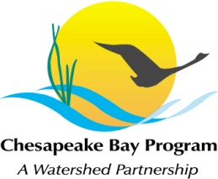
Stream Health Workgroup Meeting
Tuesday, October 25th, 2016
9:00 - 11:00AM

Chesapeake Bay Program Office
Joe Macknis Memorial Conference Room
(Fish Shack)
410 Severn Ave, Annapolis, MD 21403

Conference Line: 866-299-3188 Code: 267-5715
Adobe Connect: https://epawebconferencing.acms.com/streamhealthworkgroup (Note: Enter as Guest)

9:00 Welcome (Rich Starr, FWS & Mike Lovegreen, USC)
- Review & Approval of April meeting minutes

9:10 Chesapeake Bay Program’s Quantifying BMP Benefits project
- Finding a point of contact from the workgroup to coordinate responses for Tetra Tech

9:25 Stream Health Outcome Management Strategy Biennial Work Plan (Rich Starr)
- Review of action progress made thus far and planning forward
- Finding potential leads for Key Actions

10:15 Chesapeake Monitoring Cooperative project (Lea Rubin, IWLA)
- Lea will address how the Stream Health Workgroup can play a role in determining how the additional inflow of benthic macroinvertebrate monitoring data will impact assessing stream health.

10:45 Member Updates

10:55 Next Steps for the Workgroup

11:00 Adjourn

