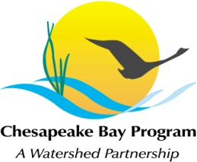
Stream Health Workgroup Meeting
Tuesday, December 11, 2018
1:00- 3:00PM

Chesapeake Bay Program Office
Conference Room 305
410 Severn Ave, Annapolis, MD 21403

Join Zoom Meeting: https://zoom.us/j/670238600 Meeting ID: 670 238 600 +1 929 205 6099 US

1:00 Welcome and Introductions (Matt Meyers, Neely Law)

1:05 SHWG Membership Survey (Matt Meyers, Neely Law)
- Review results and confirm membership, roles and responsibility (clarify voting v non voting and structure group as a core group actively engaged, participate in meetings, consensus-based decision making).
- Remaining gaps in State representation
- Recap topics interested by individuals

1:20 2019 Priority Actions
- CBP Management Board and SRS Process and Science needs consolidation
- Updates and Next Steps with Workplan (organized by Management Action)
  - Management Approach 1 (Claire Buchanan)
  - Management Approach 2
    - Action 2.1: (Sadie Drescher)
  - Management Approach 3
    - Action 3.1: Permitting Committee: (Josh Burch)
  - Management Approach 4
    - Action 4.1: Work underway via USWG (Matt Meyers)
    - Action 4.2: Stressor and Stream Health white paper (Neely Law)
  - Management Approach 5
    - Action 5.1: No definitive tasks, general updates provided through meetings

2:30 Next Steps
- Set up regular, quarterly meeting schedule

2:45 Adjourn

