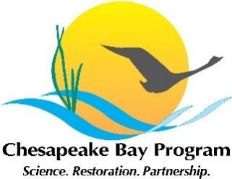 | Stewardship Workgroup Meeting  Monday, February 3, 2025  10:00 am - 12:00 pm  Virtual meeting via Zoom  Meeting ID: 814 5253 3968  Passcode: 300264  Or by phone: +1 301 715 8592 US

Meeting Purpose / Outcomes:
- Build a community of practice among stewardship practitioners throughout the Chesapeake Bay Watershed.
- Offer participants opportunities to share what they are working on, to gain support and potential partners; to gather input and solve challenges; and/or learn about similar efforts among peers.
- Update the Workgroup on news, actions and opportunities from the Bay Program that are relevant to stewardship.
  - Engage Workgroup members in providing input for the assessment of the Stewardship Outcome for the “Beyond 2025” planning effort.
- Engage the membership in implementation of the 2024-2025-Stewardship-Work-Plan.pdf and use the quarterly Workgroup meetings to center our coordination and organization, share information about progress, serve as a check-in and means to keep current on plans and accomplishments, and involve members in actions.

AGENDA

10:00 Welcome/ Intros – Britt Slattery, National Park Service, Stewardship Goal Team Coordinator

10:15 Beyond 2025 Outcome Assessment
- Brief review of the process and summary of input received so far
  - Gathering new feedback from meeting participants
  - Discussion

11:00 Implementing Stewardship Work in 2025

- Ongoing Efforts
  - Chesapeake Steward Map Update – Meredith Lemke, Chesapeake Research Consortium, Stewardship Workgroup Staffer
  - Training on Developing Stewardship Campaigns (using the online tool/portal ChesapeakeBehaviorChange.org) – Steve Raabe, OpinionWorks

- New Action Teams – opportunity for Workgroup members to join

11:30 Round Robin / Rapid Coordination – All participants invited to share quick announcements of what they’re working on or want to seek collaboration on with other Workgroup members.

11:50 Closing Announcements

12:00 Adjourn

