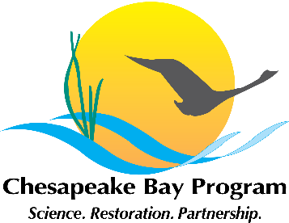
Developing a Citizen Stewardship Indicator
Chesapeake Bay Program, Fish Shack Conference Room
410 Severn Avenue, Annapolis, MD
March 16th, 2015 10:00am – 12:00pm
Call-in#: 866-740-1260 Passcode: 974 2941
https://epa.connectsolutions.com/git5/

10:00 Welcome / Introductions

10:10 Review purpose and scope

10:45 What do we need to know to measure progress, improve programs and quantify impact?

11:20 Existing and related efforts to measure progress of citizen stewardship programs (e.g that might help answer questions generated previously)

11:45 Next Steps

12:00 Adjourn

