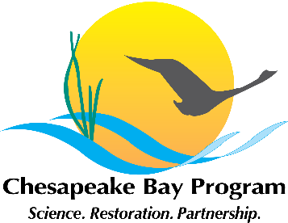
Developing a Citizen Stewardship Indicator
Chesapeake Bay Program, Fish Shack Conference Room
410 Severn Avenue, Annapolis, MD
March 16th, 2015 10:00am – 12:00pm
Minutes

10:00 Welcome / Introductions

Jamie Baxter- Chesapeake Bay Trust
Jen Dindinger – University of Maryland Sea Grant Extension
Al Todd – Alliance for the Chesapeake Bay
Steve Raabe - Opinion Works
Tom Schueler – Chesapeake Stormwater Network
Curtis Dalpra - Potomac River Commission
Suzanne Etgen – Anne Arundel Watershed Stewards Academy
Amy Handen- Stewardship Goal Team Coordinator; National Park Service
Jana Davis- Chesapeake Bay Trust
Julie Walker- Chesapeake Research Consortium, Stewardship Goal Team Staffer
Kasey Wetzel- Chesapeake Bay Trust
Mary Gattis- Alliance for the Chesapeake Bay; Local Government Advisory Committee
Alana Hartman - West Virginia Department of Environmental Protection
Kristin Flemming - Maryland Department of the Natural Resources
Diane Davis - District Department of the Environment
Greg Evans Virginia Department of Forestry, Citizens Advisory Committee
Sarah Felker- Elizabeth River Project – River Star Homes
Virginia Witmer- Virginia Department of Environmental Quality
Reggie Parish – Environmental Protection Agency
Erin Ling- Virginia Tech
Margret Enloe- Alliance for the Chesapeake Bay

10:10 Review purpose and scope
Jamie introduced the purpose of the meeting as a kick off of the indicator project for the Citizen Stewardship outcome. He explained that during this meeting we would like to identify what would be the most helpful method of measuring progress, and how can this tool be used to improve the way we engage citizens.

Amy then reviewed the background of the Citizen Stewardship effort, the Stewardship
Goal, and the Citizen Stewardship Outcome. Amy then spoke about the EPA funds awarded to develop an indicator to track progress towards the Citizen Stewardship outcome.

Stewardship Goal:
“Increase the number and diversity of local citizen stewards and local governments that actively support and carry out the conservation and restoration activities that achieve healthy local streams, rivers and a vibrant Chesapeake Bay.”

Citizen Stewardship Outcome:
“Increase the number and diversity of trained and mobilized citizen volunteers with the knowledge and skills needed to enhance the health of their local watersheds.”

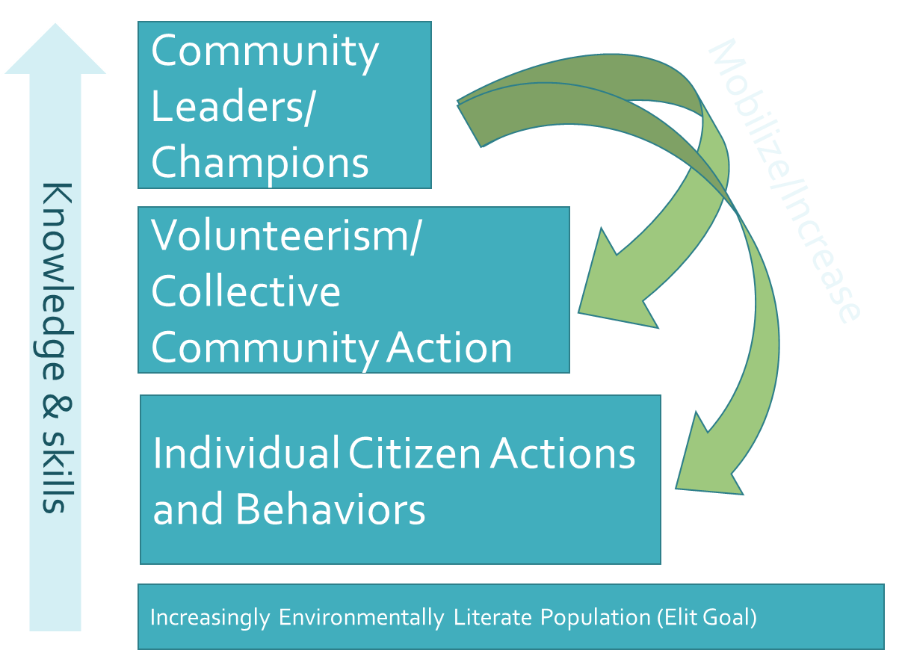
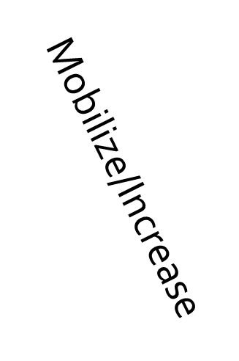

Jamie discussed the framework that has been developed and improved upon in previous meetings, reiterating that the three levels of stewardship represent the three types of actions and behaviors that are targeted by citizen outreach and engagement.

  - Community Leaders / Champions- highest level of action- most stewardship efforts rely on a local champion – building up local champions to lead community action and engage individuals in their community
  - Volunteerism / Collective Community Action- doesn’t involve leadership, but gets people active and engaged in their community
  - Individual Citizen Action- behavioral change on the individual level

- Greg Evans noted that the Citizens Advisory Committee is doing similar work, and is not as far along as the Citizen Stewardship group is so it would be beneficial to make sure we keep open communication with Citizens Advisory Committee in order to not duplicate efforts.

10:45 What do we need to know to measure progress, improve programs and quantify impact?
Jamie reviewed the importance of how the indicator is relevant and helpful, not just a bean counting exercise. In order to achieve a useful indicator we believe it should help us to achieve these four outcomes:
- Collect and share data that is useful to practitioners in informing program design and improvements
- Predict/quantify/prioritize the water quality and other engagement values of stewardship programs and citizen actions.
- Provide an accurate and easily (relatively) scalable baseline of stewardship actions
- Increase/maintain support for investments in citizen stewardship efforts.

This project is envisioned to have two products:
- Develop a method to measure and track progress at each framework level
- Design and pilot behavior index to track behavior change

Steve Raabe (Opinion Works) introduced the Behavior Index and led a discussion on what would be useful to gain from the index.
- Previous surveys show the public is ready to be engaged in individual stewardship, yet they are unsure of the impact of their individual actions. This indicator can give them a sense of cumulative impact. By sharing it publically, it can encourage people to engage in stewardship because they know their neighbor is and they can build a sense of progress.
- Behavior index is focused on social marketing model and measuring engagement
  - Telephone-based probability sample
  - Landline and cell phones
  - English and Spanish as needed
  - 2,000+ interviews
  - Behavior selection
  - Methodology and scale
  - Questionnaire development and testing
  - Field interviewing
  - Index calculation

- What could the Index tell us?
- Assess penetration of behaviors
- Assess likelihood of future adoption
- Identify trends by audience or behavior
- Segment this by jurisdiction, audience
- Inform behavior selection for NGOs, jurisdictions
- Identify “Show Me, Help Me, Make Me” audience segments to inform social marketing
- Demonstrate progress to stakeholders, public

- Stewardship Index Scope
  - Ultimately measure all 3 levels of stewardship
  - Pilot scope under this budget
  - Road map for Leadership and Volunteer levels
  - Design/pilot data collection for Behavior level
  - Geographic Scope is watershed wide, in order to go down to the community level we would need more funding from NGOs to get the community level, but we could make judgments on the urban, rural, community type

- Index Timeline
  - Phase 1: Develop Framework
    - (March – April)
  - Phase 2: Develop Behavior Survey Tool
    - (April – June)
  - Phase 3: Field Interviewing
    - (July – Aug)
  - Phase 4: Analysis & Presentation/
    - Recommendations for Follow-up
    - (Sept – Nov)

- Participant Comments:
  - Kristin Flemming - If we are asking jurisdiction we need to be able to communicate the benefit and quantify what they would get if they contribute.
  - Amy Handen Maybe we could measure aspirations of becoming a leader or volunteer
  - Steve Raabe- Aspirations could and should be measured in the index
  - Mary Gattis - Maybe we can ask if you feel your community is a leader in the environment
  - Kristin Flemming- We should make sure we know our audience, use different words to make sure we are getting the right responses – people of different communities interpret words differently
  - Steve Raabe - We will be conducting testing to make sure the words are what we want to convey, and we can administer test in Spanish if necessary

Steve then asked the group what are their needs were and what they are you hoping to get out of the index.
- Jen Dindinger Are we planning on including agricultural land owners or just regular public? And are they mutually exclusive?
- There is data on agriculture, but we may need to know what that data is, and what the jurisdiction need to know about citizen and citizen participating in agriculture.
- Steve Raabe - It is unlikely to get a large number of farmers in a random sampling of 2,000. Some behaviors are not applicable to all audiences, is this the right tool to measure ag practices?
- Amy Handen - We need to engage the jurisdictions to find out their needs.
- Jamie Baxter We need to explore the concept of how to incorporate agriculture practices this and if we want to incorporate agriculture, what gaps in data could the stewardship index could fill?
- Greg Evans- It would be useful to know what would incentivize people to change behavior.
- Steve Raabe- What are the important drivers that you want to know?
- Tom Schueler- Focus on repetitive practices
    - Fertilizers / pesticides use
    - Pet waste
    - Stormwater practices
    - Waste management, recycling, leaf biomass & compost
    - Winter deicing
    - Tree planting
    - Air quality / Driving patterns
    - Consumer behaviors
    - Public transportation
- Margret Enloe- Air quality practices, consumer behaviors Political will – advocacy, civic engagement.
- Kristin Flemming- Maybe have people tell you what they do, instead of pinning them into questions, so the questions are less exclusive.

11:20 Existing and related efforts to measure progress of citizen stewardship programs (e.g that might help answer questions generated previously)

Do you know any similar metrics? Especially at the volunteer and leadership level?
  - Virginia Tech – Overall leadership and citizen engagement metric
  - Environmental Justice metrics – Kristin Flemming will look into
  - Americorp – Volunteerism metrics

11:45 Next Steps

- Next Meeting – Late April/May
  - Presentation of existing measurement/tracking efforts relevant to this work
  - Present DRAFT indicator framework
  - Seek feedback on development of the behavior index

12:00 Adjourn

