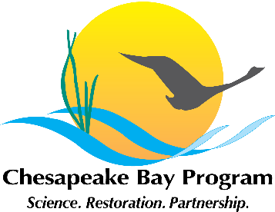
Developing a Citizen Stewardship Indicator
Chesapeake Bay Foundation, Merganser Room
6 Herndon Avenue, Annapolis, MD 21403
April 27th, 2015, 1:00am – 4:00pm
Conference Line: 410-295-1399
Access Code: 123456

1:00 Welcome / Introductions

1:10 Review previous meeting, purpose of meeting and scope

1:20 Presentation of literature review of related projects

2:20 Review and discuss strategic decisions regarding what our Stewardship Indicator will measure

3:30 Next Steps

4:00 Adjourn

