
Developing a Citizen Stewardship Indicator
Chesapeake Bay Foundation, Merganser Room
6 Herndon Avenue, Annapolis, MD 21403
April 27th, 2015, 1:00am – 4:00pm
Meeting Minutes

1:00 Welcome / Introductions

1:10 Review previous meeting, purpose of meeting and scope

The purpose of this meeting is to review what our task at hand is and present a literature review of related efforts. , We will use these models to facilitate a discussion about key strategic decisions to guide the development of the indicator, and identify working groups to determine what will actually be measured.

It is important to make sure that this exercise will produce feedback that will be useful to the Bay community to inform and improve future work, by showing whether or not we are being successful in engaging citizens and how we can be doing it better.

In order to do this the tool should be able to predict, prioritize, and quantify water quality and other engagement values of stewardship, develop an accurate and scalable baseline, and be able to be used to document the value of citizen stewardship to justify and potentially increase the support for engagement programs.

In previous meetings we have discussed the Citizen Stewardship Framework and how each level has an associated method to measure engagement. Each of these different methods will be a component of a larger citizen stewardship indicator.

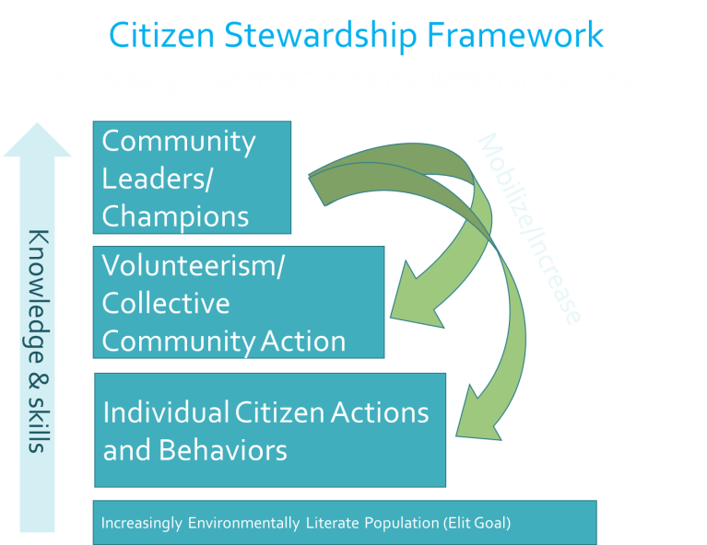

Mobilize/Increase

The first method we have been moving forward with and discussed at previous meetings is the development of a behavior index to measure engagement on the individual citizen action and behaviors level.

- Behavior index could tell us things like the impact of the behavior on water quality, the penetration (level of adoption) of a behavior in the community, or the likelihood the public will adopt a behavior, and which behaviors should be targeted

From previous meetings we were able to brainstorm what we want this measure to include
- Physical Practices (BMPs & Behaviors)
- Civic Engagement (Voting, Weighing in, Etc.)
- Attitudes (Concerns, Affinities, Etc.)

Steve Raabe from Opinion Works introduced the two products in greater detail.

Product #1 – Behavior index . Will be linked directly to the individual action level and may incorporate a little bit of the volunteerism level, but is not the most effective method of measuring volunteerism.

Behavior index will consist of…
- Telephone-based probability sample
- Landline and cell phones
- English and Spanish as needed
- 2,000+ interviews
- Behavior selection
- Methodology and scale
- Questionnaire development and testing
- Field interviewing
- Index calculation

Product #2- Roadmap. Will inform how we will measure the volunteerism and leadership levels of the stewardship framework.

Questions included:

- Would the index be conducted at the jurisdiction level?
- In the piolet phase it will be higher level, but in the future there may be the capability for a jurisdiction to contribute more funds to conduct the survey on a more localized scale
- Are there any actions that can be measured through this indicator that are a part of the model? Jamie responded yes to an extent. The verification of the data would be an issue but could definitely provide support for homeowner BMPs in the model and WIPs.

1:20 Presentation of literature review of related projects

Puget Sound behavior index

Overview
- Assesses 28 behaviors
- Telephone data collection
- Stratified for 12 jurisdictions (county level)
- Conducted biennially
- 3,131 interviews (2013)
- Drives decision-making
- Measures progress (2011, 2013, 2015)
- Great attention focused on SBI
- Measures both positive and negative behaviors.
- 18-minute instrument
- Scale: Never, Seldom, Sometimes, Usually, Always
- Measures impact more than behavior
Key concepts
- Model does not measure likelihood, it’s a frequency penetration measurement
- Very robust and a lot of focus on demography
- Actions that they ask about are repetitive actions
- There index is rolled into one single indicator number
- There index was subject to externalities such as the economy
- Chose to keep behaviors stagnant

King County Index
- Measured 2006, 2008, 2011
- Assesses 21 behaviors
- Also includes some self-assessment
- Blended telephone and addressed-based online data collection
- 1,816 interviews (2011; approx. 2/3 phone, 1/3 web)
- Used for planning
Key concepts
- Measures penetration, frequency and likelihood
- Behaviors on survey are not stagnant
- Does not boil down to a single indicator, may be more difficult to read

National Geographic Greendex
- Consumption awareness exercise
- Impact index
- Scoring system implies that you can be perfectly sustainable
- Interviews collected through online panels; 1,000/country
- Meta index – weigh different categories based on their environmental impact
Key Concepts
- Meta-index format helps protect against negative movement

National Conference on Citizenship
- Congressionally chartered
- Measuring civic health nationwide
- Expanded previous Census Bureau measures
- Now measuring:
  - Voting behavior
  - Participation in groups
  - Civic discussion
  - Public trust
  - Paying attention to current events
  - General volunteerism
  - Charitable giving
Key Concepts
- The idea of measuring how much the public is paying attention to issues such as the environment may be valuable to our survey

OECD Better Life Index
- Extremely Powerful
- Can be customized, localized
Key Concepts
- Much more sophisticated than what we could do, but a good place to get ideas

Attitudinal Measurements
- Choose a short list of relevant measures.
- Self-assessment of affinity for water protection
- Level of concern for specific priorities
Key Concepts
- A limited number of broad attitudinal questions may be appropriate on the pilot indicator
- We are not going to measure policy preferences or public opinion

2:20 Review and discuss strategic decisions regarding what our Stewardship Indicator will measure

Forks in the road- Strategic Decisions
- Do we want questions to be stagnant or changeable?
  - Group potentially would like to have a core survey, and then changeable modules or jurisdictional modules. This can be further discussed in future meetings
- Impact or Behavior measurement?
  - Group consensus is to measure behaviors instead of impact, as well as likelihood of behavior adoption, and attitudinal measurements
- Should all actions measured be able to be scientifically tied back to impact?
  - Julie- We should begin with the end in mind; if we can’t measure it we can’t manage it
  - Jamie / Al- We will be measuring progress on the leadership, volunteerism, and behavioral levels, not necessarily at the specific action level. We cannot specifically tract the impact of individual actions,
  - Jen- Do we have any scientific data indicating that the frame level of actions we are planning on measuring ties to improved water quality?
  - Al- The task at hand is to measure stewardship as defined in the agreement, not necessary to measure the impact stewardship has on water quality
- How will we package or present the data?
  - Group favors the sub-indices GreenDex model to present data.

3:30 Next Steps
- April – June - Develop Behavior Survey Tool & Road Map
- July – Sept- Field Interviewing
- Sept – Nov- Analysis & Presentation / Recommendations for Follow-up

4:00 Adjourn

