Chesapeake Bay Program | Indicator Analysis and Methods Document
Chesapeake Bay Total Maximum Daily Loads Indicator
Updated March 2023

Indicator Title: Chesapeake Bay Total Maximum Daily Loads Indicator

Relevant Outcome(s): 2017 and 2025 Watershed Implementation Plans (WIP) Outcome

Relevant Goal(s): Water Quality

Location within Framework (i.e., Influencing Factor, Output or Performance): Performance

A. Data Set and Source

- Describe the data set. What parameters are measured? What parameters are obtained by calculation? For what purpose(s) are the data used?

River discharge and nutrient concentrations are measured directly at the river input monitoring (RIM) sites according to approved field and laboratory methods and associated quality control protocols that are described by Chesapeake Bay Program (2017).

Nitrogen and phosphorus load and trend estimates at the RIM sites are made by the USGS using the Weighted Regressions on Time, Discharge, and Season (WRTDS) model (Hirsch et al., 2010).

Wastewater loads (i.e., those delivered to the Bay) are estimated from EPA discharge monitoring (end-of-pipe) adjusted by delivery factors used in the Phase 6 Watershed Model.

For nitrogen, atmospheric deposition to tidal waters is estimated using the CMAQ Model for dry deposition (Dennis et al., 2007 and Hameedi et al., 2007) and a regression model for wet deposition (Grimm and Lynch, 2000, 2005; Lynch and Grimm 2003).

Nitrogen and phosphorus edge-of-tidal (EOT) loads for the RIM watershed and the below-RIM watershed are obtained from the CBP Phase 6 Watershed Model. For details of the Model, see
https://cast.chesapeakebay.net/Documentation/ModelDocumentation (CAST-2019). For this indicator, two versions of the Watershed Model are used. The static version of the Watershed Model, called Chesapeake Assessment Scenario Tool (CAST), provides estimates of long-term load resulting from a given state of the watershed (land use, point source, populations, BMP implementation). In comparison, the dynamic version of the Watershed Model, referred to as Dynamic Model, accounts for lag in nutrient application and delivery and therefore provides estimates of current load from a given state of the watershed.

TMDL targets, watershed implementation plan (WIP) goals, and adjustments for the effects of climate change and Conowingo infill, are published by the Chesapeake Bay Program Partnership. For details of the TMDL, refer to U.S. Environmental Protection Agency (2010).

- List the source(s) of the data set, the custodian of the source data, and the relevant contact at the Chesapeake Bay Program.
    - Source: USGS, EPA, CBPO.
    - Custodians:
        - Monitored riverine loads from the RIM watershed – Doug Moyer (USGS, 804-261-2634), Chris Mason (USGS, 804-261-2613).
        - Estimated loads from the RIM watershed and the below-RIM watershed using the Watershed Model – Gary Shenk (USGS-CBPO, 410-507-2681), Gopal Bhatt (PSU-CBPO, 410-267-9871).
        - Nitrogen loads from atmospheric deposition to tidal waters – Lewis Linker (USEPA-CBPO, 410-267-5741), Gopal Bhatt (PSU-CBPO, 410-267-9871).
        - TMDL goals, WIP goals, and adjustments – Gary Shenk (USGS-CBPO, 410-507-2681).
    - Chesapeake Bay Program Contact (name, email address, phone number):
        - Gary Shenk (USGS-CBPO, gshenk@chesapeakebay.net, 410-507-2681)

- Please provide a link to the location of the data set. Are metadata, data-dictionaries and embedded definitions included?

Data set and associated dictionaries and definitions are available from the custodians of the source data listed in question 2.

B. Temporal Considerations

- Data collection date(s):

Water year (October 1-September 30) 1985-2021.

- Planned update frequency (e.g., annual, biannual, etc.):
    - Source Data: River input data, wastewater loads, atmospheric deposition to tidal waters (nitrogen only), and watershed model scenario runs are all updated annually.
    - Indicator: Annual.

- Date (month and year) next data set is expected to be available for reporting:

Data are typically analyzed by the USGS for the river input monitoring program by July of each year. Atmospheric deposition is available by March each year. CAST annual progress scenario is available by April each year.

C. Spatial Considerations

- What is the ideal level of spatial aggregation (e.g., watershed-wide, river basin, state, county, hydrologic unit code)?

The entire Chesapeake Bay watershed, including the monitored RIM watershed and the unmonitored below-RIM watershed.

- Is there geographic (GIS) data associated with this data set? If so, indicate its format (e.g., point, line polygon). N/A.

- Are there geographic areas that are missing data? If so, list the areas. The below-RIM watershed is not monitored by the USGS. Estimates of load contribution from the below-RIM watershed are obtained from the Watershed Model.

- Please submit any appropriate examples of how this information has been mapped or otherwise portrayed geographically in the past. N/A.

D. Communicating the Data

- What is the target or threshold measured by this indicator? How was it established?

Decrease nutrient and sediment loads to the planning targets of the Chesapeake Bay Total Maximum Daily Loads (TMDLs), which will result in the achievement of water quality standards in the Bay for dissolved oxygen, water clarity/submerged aquatic vegetation and chlorophyll a.

- What is the current status in relation to the target established in the outcome? Why? Would you define our outlook¹ toward achieving the outcome as on course, off course, uncertain, or completed? Upon what basis are you forecasting the outlook?

For the targets of this indicator, see question 25. The current status of this indicator is described below:

Nitrogen:

A total of 145.07 million lbs needs to be reduced to achieve the TMDL planning target. This total amount is broken down to the following components based on the 2021 assessment:
- WIP shortfall: 0.92 million lbs.
- Adjustment for Conowingo: 6.01 million lbs.
- Adjustment for climate change: 4.32 million lbs.
- Future implementation: 42.26 million lbs.
- Implemented but lagged: 13.92 million lbs.
- Implemented and realized: 77.64 million lbs.
- RIM expected but not seen: 0.0 million lbs.

In addition, a total of 7.92 million lbs needs to be reduced for atmospheric deposition to the tidal waters. This amount is broken down to two components based on the 2021 assessment:
- Tidal deposition reduction realized: 6.50 million lbs.
- Tidal deposition reduction unimplemented: 1.42 million lbs.

Finally, here is a sector-based comparison between the percent reduction required to meet the planning target and the long-term (eventual) percent reduction expected with the 2021 level of implementation:
- RIM point source: 35.4% vs. 42.6%.
- RIM nonpoint source: 32.8% vs. 17.2%.
- Below-RIM point source: 64.0% vs. 63.6%.
- Below-RIM nonpoint source: 30.8% vs. 18.3%.

Phosphorus:

A total of 9.31 million lbs needs to be reduced to achieve the TMDL planning target. This total amount is broken down to the following components based on the 2021 assessment:
- WIP shortfall: 0 million lbs.
- Adjustment for Conowingo: 0.26 million lbs.
- Adjustment for climate change: 0.52 million lbs.
- Future implementation: 1.66 million lbs.
- Implemented but lagged: 1.85 million lbs.
- Implemented and realized: 2.95 million lbs.
- RIM expected but not seen: 2.07 million lbs.

Finally, here is a sector-based comparison between the percent reduction required to meet the planning target and the long-term (eventual) percent reduction expected with the 2021 level of implementation:
- RIM point source: 66.9% vs. 68.8%.
- RIM nonpoint source: 40.4% vs. 24.4%.
- Below-RIM point source: 60.2% vs. 52.9%.
- Below-RIM nonpoint source: 23.1% vs. 15.9%.

Outlook:

As of 2021, management implementation (including both realized and unrealized portions) represents 59.8% and 51.6% of the total reduction needed for nitrogen and phosphorus, respectively. Over the long-term period, reductions of nitrogen and phosphorus loads toward the TMDL planning targets are both trending in the right direction. Therefore, our outlook toward achieving the outcome is on course.

- Has a new target, threshold or outcome been established since the last reporting period? Why? No.

- Has the methodology of data collection or analysis changed since the last reporting period? How? Why? N/A.

- What is the long-term data trend (since the start of data collection)?

Reductions of nitrogen and phosphorus loads toward the TMDL planning targets are both trending in the right direction over the long-term period. Among the major components of the total reduction, the categories “implemented and realized” and “implemented but lagged” have been increasing over time, whereas the category “future implementation” has been decreasing over time. For atmospheric deposition of nitrogen, the category “tidal deposition reduction realized” has been increasing over time, whereas the category “tidal deposition reduction unimplemented” has been decreasing over time.

- What change(s) does the most recent data show compared to the last reporting period? To what do you attribute the change? Would you characterize that change in the recent progress² as an increase, decrease, no change, or completed for this outcome?

Nitrogen:

Compared with the last reporting period (2020), the most recent period (2021) showed the following changes:
- Future implementation: 42.65 million lbs in 2020 vs. 42.26 million lbs in 2021; i.e., decreased by 0.39 million lbs.
- Implemented but lagged: 17.45 million lbs in 2020 vs. 13.92 million lbs in 2021; i.e., decreased by 3.53 million lbs.
- Implemented and realized: 73.73 million lbs in 2020 vs. 77.64 million lbs in 2021; i.e., increased by 3.91 million lbs.
- RIM expected but not seen: 0 for both 2020 and 2021; i.e., no change.
- Tidal deposition reduction realized: 6.36 million lbs in 2020 vs. 6.50 million lbs in 2021; i.e., increased by 0.15 million lbs.
- Tidal deposition reduction unimplemented: 1.57 million lbs in 2020 vs. 1.42 million lbs in 2021; i.e., decreased by 0.15 million lbs.

Phosphorus:

Compared with the last reporting period (2020), the most recent period (2021) showed the following changes:
- Future implementation: 1.67 million lbs in 2020 vs. 1.66 million lbs in 2021; i.e., decreased by 0.005 million lbs.
- Implemented but lagged: 2.31 million lbs in 2020 vs. 1.85 million lbs in 2021; i.e., decreased by 0.46 million lbs.
- Implemented and realized: 2.41 million lbs in 2020 vs. 2.95 million lbs in 2021; i.e., increased by 0.54 million lbs.
- RIM expected but not seen: 2.14 million lbs in 2020 vs. 2.07 million lbs in 2021; i.e., decreased by 0.07 million lbs.

Recent Progress:

Overall, the change in the recent progress is categorized as an “increase” for this outcome, which indicates a closer status toward the reduction goals.

- What is the key story told by this indicator?

Pollutant loads to the Chesapeake Bay in any given year are influenced by changes in land-use activities and management practices, as well as the amount of water flowing to the Bay (hydrology).

Scientists use a combination of the following information to estimate the loads to the Bay:
- river flow discharge measurements;
- test results from water samples collected at river input monitoring (RIM) sites to estimate nitrogen, phosphorus and sediment concentrations that are converted into loads from the majority of the watershed;
- test results from water samples collected at wastewater treatment facilities downstream of the RIM sites to estimate nitrogen and phosphorus concentrations that are converted into loads;
- computer modeling to estimate nitrogen and phosphorus loads from nonpoint sources downstream of the RIM sites;
- atmospheric deposition of nitrogen delivered directly to the water surface of the bay and the waterways of the watershed that contributes to overall pollution levels experienced by the bay tidal waters.

This indicator explicitly quantifies the progress toward Chesapeake Bay TMDL reduction goals by leveraging published trends at the USGS RIM monitoring sites and published Watershed Model based estimates for the RIM and below-RIM watersheds. This indicator helps communicate the progress toward the TMDL goals, puts together a complete story with below-RIM results, and provides useful comparisons between different regions & sectors and between the monitoring and modeling information.

E. Adaptive Management

- What factors influence progress toward the goal, target, threshold or expected outcome?

Factors influencing progress include the implementation of management practices; improved wastewater treatment technology; and response of water quality conditions to management practices. Please see the 2017 WIP, 2025 WIP and Water Quality Standards Attainment & Monitoring Outcomes Management Strategy for a full discussion of these factors.

- What are the current gaps in existing management efforts?

Considering the above-listed factors influencing progress toward the goal, target, threshold or expected outcome, the following gaps have been identified in existing monitoring and management efforts to support tracking changes towards achieving a restored Bay:
- Addressing aging infrastructure for handling wastewater and stormwater runoff given existing conditions and future climate projections for increased precipitation in the region;
- Addressing maximum infill capacity leading to dynamic equilibrium conditions now at the Conowingo Dam affecting nutrient delivery to the estuary;
- Balancing population growth with collective impacts of growth on nutrient delivery and other factors (e.g., local, regional, and national temperature conditions impacting water temperature and DO saturation conditions);
- Maintaining or enhancing wetlands and wetland filtering and nutrient retention capacity;
- Enhancing riparian buffer development that serves to cool streams with shade and retain nutrient and sediment runoff from reaching waterways;
- Limiting shoreline hardening affecting restoration capacity for the Bay;
- Enhancing financial capacity to oversee and implement MS4 and other stormwater programs;
- Enhancing financial, technical and regulatory capacity to deliver priority conservation practices to priority watersheds; and
- Promoting BMP tracking, verification and reporting programs.

The primary monitoring gaps include (1) more frequent measures of dissolved oxygen to assess criteria attainment, (2) more spatial coverage of measurements to accurately assess DO conditions in the bay, and (3) more localized monitoring in watershed areas to assess the effects of BMPs.

For a fuller discussion of these gaps and how they are being addressed, please see the 2017 WIP, 2025 WIP and Water Quality Standards Attainment & Monitoring Outcomes Management Strategy.

- What are the current overlaps in existing management efforts? N/A

- According to the management strategy written for the outcome associated with this indicator, how will we (a) assess our performance in making progress toward the goal, target, threshold or expected outcome, and (b) ensure the adaptive management of our work?

- Assess Our Performance:

The Bay TMDL is supported by a rigorous accountability framework, including WIPs, short and long-term benchmarks (such as two-year milestones), a tracking and accountability system, and federal contingency actions that may be employed if jurisdictions do not meet their milestone and WIP commitments. The CBP-STAR Team has set up several projects to better measure and explain progress towards water quality improvements and to pursue approaches to reduce uncertainties for models. BMPs are submitted through NEIEN on an annual basis and are used to assess progress through the Bay Program modeling tools. The CBP partners have endorsed (PSC, May 2012) an integrated approach that includes three primary pieces of information to measure progress toward achieving water quality standards in the Bay:
- Tracking and reporting of water quality management practices. These practices are expected to achieve reductions of nitrogen, phosphorus, and sediment by source and jurisdiction. These load reductions are estimates from the CBP models based on BMP implementation data submitted by the jurisdictions;
- Analyzing trends of nitrogen, phosphorus and sediment fluxes in the watershed. These trend estimates show long-term (i.e., 1985-current) and short-term (10 year) changes by normalizing the annual effects of streamflow variability. The normalized estimates are based on monitoring data collected as part of the CBP nontidal water quality monitoring program; and
- Assessing attainment of dissolved oxygen, chlorophyll-a, and water clarity/SAV standards. Attainment of these standards is based primarily on results from the CBP tidal water quality monitoring program.

- Ensure Adaptive Management

The CBP partnership has committed to take an adaptive management approach to the Bay TMDL and incorporate new scientific understandings into the implementation planning in two-year milestones and in Phase III following the midpoint assessment. The partnership uses annual monitoring information to modify models, which affect partnership decision-making. The CBP partnership will continue to examine the following questions to address implementation challenges and opportunities, through venues like the Strategy Review System (SRS) process, incorporate new data and scientific understandings, and refine decision support tools and management strategies toward the achievement of the water quality outcomes in the 2014 Chesapeake Bay Watershed Agreement:
- What progress had been made in implementing practices for the Bay TMDL?
- What are the changes in water quality and progress toward applicable water quality standards?
- What are we learning about the factors affecting water quality changes to better implement practices?
- What refinements are needed in decision support tools, monitoring and science?
- How do we best consider the combined impacts of land change and climate variability (storm events and long-term change) on nutrient and sediment loading and implications for the Bay TMDL?

F. Analysis and Interpretation
Please provide appropriate references and location(s) of documentation if hard to find.

- What method is used to transform raw data into the information presented in this indicator? Please cite methods and/or modeling programs.

River discharge and nutrient concentrations are measured directly at the river input monitoring (RIM) sites according to approved field and laboratory methods and associated quality control protocols that are described by Chesapeake Bay Program (2017).

Nitrogen and phosphorus load and trend estimates at the RIM sites are made by the USGS using the Weighted Regressions on Time, Discharge, and Season (WRTDS) model (Hirsch et al., 2010).

Wastewater loads (i.e., those delivered to the Bay) are estimated from EPA discharge monitoring (end-of-pipe) adjusted by delivery factors used in the Phase 6 Watershed Model.

For nitrogen, atmospheric deposition to tidal waters is estimated using the CMAQ Model for dry deposition (Dennis et al., 2007 and Hameedi et al., 2007) and a regression model for wet deposition (Grimm and Lynch, 2000, 2005; Lynch and Grimm 2003).

Nitrogen and phosphorus edge-of-tidal (EOT) loads for the RIM watershed and the below-RIM watershed are obtained from the CBP Phase 6 Watershed Model. For details of the Model, see
https://cast.chesapeakebay.net/Documentation/ModelDocumentation (CAST-2019). For this indicator, two versions of the Watershed Model are used. The static version of the Watershed Model, called Chesapeake Assessment Scenario Tool (CAST), is based on long-term average hydrology (1990-2000); it provides estimates of long-term load resulting from a given state of the watershed (land use, point source, populations, BMP implementation). In comparison, the dynamic version of the Watershed Model, referred to as Dynamic Model, is based on actual hydrology; it provides estimates of current load from a given state of the watershed. A key distinction between the two versions is that the dynamic model accounts for lag in nutrient application and delivery, whereas the static model does not.

TMDL targets, watershed implementation plan (WIP) goals, and adjustments for the effects of climate change and Conowingo infill, are published by the Chesapeake Bay Program Partnership. The effect of Conowingo infill is accounted for by considering the increase in nutrient load delivery due to the infill, the speciation and timing of the nutrient load, and the increase in assimilative capacity of the estuary.

To explicitly quantify the progress toward the TMDL goals, this indicator leverages information from both monitoring (WRTDS) and modeling (Phase 6 Watershed Model) for the entire Chesapeake Bay watershed. To illustrate the calculation, the map below shows the RIM and below-RIM watersheds, and the chart summarizes the different components of the indicator and their associated data sources.

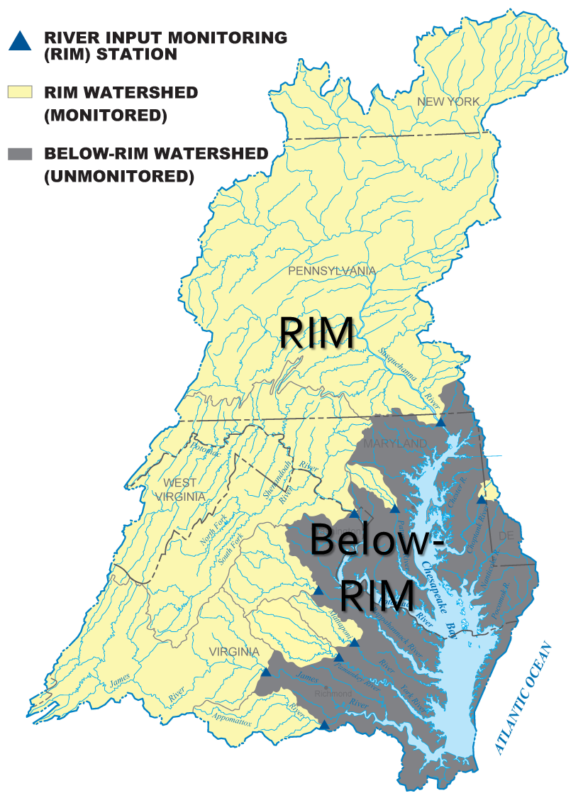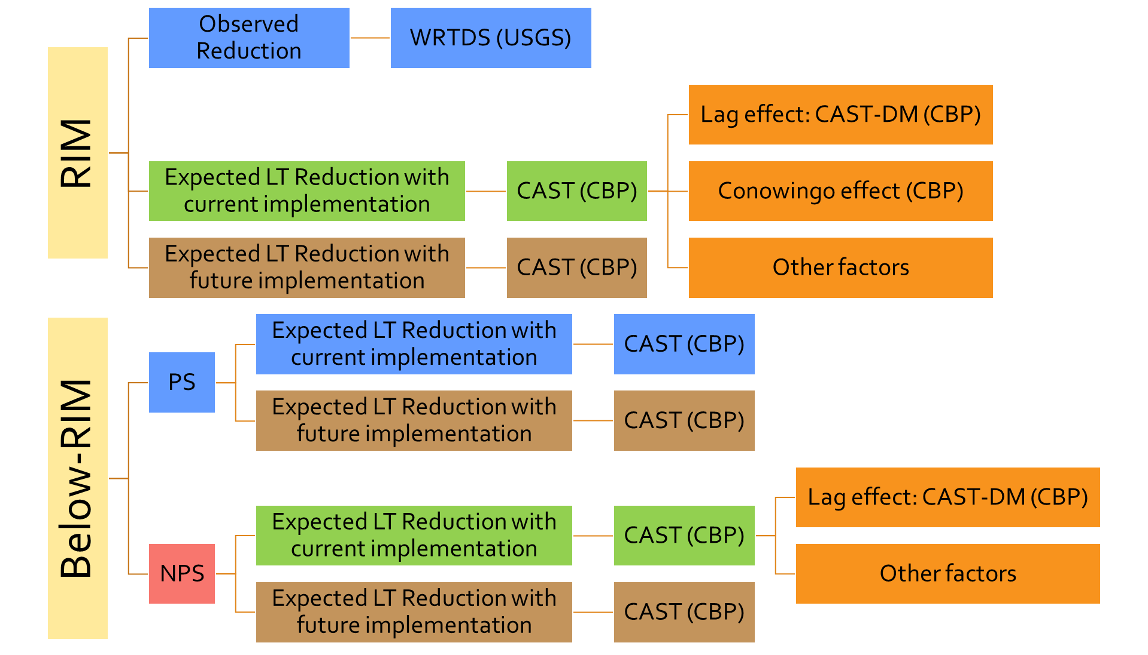

Data were assembled for water years 1995 through 2021 to compute percent change in this period, which were then converted to mass (million lbs) by multiplying the CAST 1995 load. Finally, this indicator quantifies the total amount of reduction required (i.e., baseline [1995] load minus TMDL target load) and breaks it down to four broad categories for each year of assessment: (1) implemented and realized, (2) implemented but lagged, (3) future implementation, and (4) RIM expected but not seen.

- Is the method used to transform raw data into the information presented in this indicator accepted as scientifically sound? If not, what are its limitations?

Refer to information in question 22 above.

- How well does the indicator represent the environmental condition being assessed?

A majority of the loads in this indicator are RIM loads, which are based on observed river discharges and nutrient concentrations and the peer-reviewed WRTDS statistical model. Below-RIM point source loads are also monitored. Atmospheric deposition and below-RIM nonpoint source loads, which make up a relatively small portion of the total load, are based on model estimates.

- Are there established reference points, thresholds, ranges or values for this indicator that unambiguously reflect the desired state of the environment?

The Chesapeake Bay TMDL issued in 2010 set Bay watershed limits of 185.9 million pounds of nitrogen (with an additional allocation of 15.7 to tidal waters from atmospheric deposition, for a total limit of 201.63 million pounds), 12.5 million pounds of phosphorus, and 6.45 billion pounds of sediment per year (https://www.epa.gov/chesapeake-bay-tmdl/chesapeake-bay-tmdl-document). These load targets are based on modeled scenarios that result in the Chesapeake Bay and its tidal tributaries meeting their water quality criteria for dissolved oxygen, water clarity/SAV, and chlorophyll a. For details of the TMDL, refer to U.S. Environmental Protection Agency (2010).

Based on the above target values, this indicator quantifies the total amount of reduction required (i.e., baseline [1995] load minus TMDL target load) and breaks it down to four broad categories for each year of assessment: (1) implemented and realized, (2) implemented but lagged, (3) future implementation, and (4) RIM expected but not seen.

- How far can the data be extrapolated? Have appropriate statistical methods been used to generalize or portray data beyond the time or spatial locations where measurements were made (e.g., statistical survey inference, no generalization is possible)?

Every effort was made to minimize extrapolations beyond the available data.

G. Quality
Please provide appropriate references and location(s) of documentation if hard to find.

- Were the data collected and processed according to a U.S. Environmental Protection Agency-approved Quality Assurance Project Plan? If so, please provide a link to the QAPP and indicate when the plan was last reviewed and approved. If not, please complete questions 29-31. No.

- If applicable: Are the sampling, analytical and data processing procedures accepted as scientifically and technically valid?

Most procedures are published in peer reviewed or government publications. Refer to information in question 22 above.

- If applicable: What documentation describes the sampling and analytical procedures used?

Refer to information in question 22 above.

- If applicable: To what extent are procedures for quality assurance and quality control of the data documented and accessible?

Each data provider has quality assurance protocols that they implement to ensure that high quality data are available for analysis. Refer to information in question 22 above.

- Are descriptions of the study design clear, complete and sufficient to enable the study to be reproduced?

Refer to information in question 22 above.

- Were the sampling, analytical and data processing procedures performed consistently throughout the data record?

Refer to information in question 22 above.

- If data sets from two or more sources have been merged, are the sampling designs, methods and results comparable? Yes. If not, what are the limitations? N/A

- Are levels of uncertainty available for the indicator and/or the underlying data set? If so, do the uncertainty and variability impact the conclusions drawn from the data or the utility of the indicator?

Refer to information in question 22 above.

- For chemical data reporting: How are data below the MDL reported (i.e., reported as 0, censored, or as < MDL)? If parameter substitutions are made (e.g., using orthophosphate instead of total phosphorus), how are data normalized? How does this impact the indicator? N/A

- Are there noteworthy limitations or gaps in the data record? No.

H. Additional Information (Optional)

- Please provide any further information you believe is necessary to aid in communication and prevent any potential misrepresentation of this indicator.

Loads that were estimated for the Below-RIM site areas (nonpoint source loads and atmospheric deposition to tidal waters) should be regarded as modeled. Although these data are calculated using monitoring and modeling derived data, the values represent essentially modeled loads. While this approach is very powerful, it is imperative to clearly label these data as estimated (modeled). In addition, it is important to note that the load estimates from CAST represent the expected (long-term) loads resulting from a given state of the watershed (land use, point source, populations, BMP implementation) as opposed to real-time loads.

References

Chesapeake Bay Program, 2017. Methods and quality assurance for Chesapeake Bay water quality monitoring programs. (Also available online at https://www.chesapeakebay.net/documents/CBPMethodsManualMay2017.pdf.)
Dennis, R., R. Haeuber, T. Blett, J. Cosby, C. Driscoll, J. Sickles, and J. Johnson. 2007. Sulfur and nitrogen deposition on ecosystems in the United States. Journal of the Air and Waste Management Association. December 2007.
Grimm, J.W., and J.A. Lynch. 2000. Enhanced wet deposition estimates for the Chesapeake Bay watershed using modeled precipitation inputs. DNR Chesapeake Bay and Tidewater Programs CBWP-MANTA-AD-99-2.
Grimm, J.W., and J.A. Lynch. 2005. Improved daily precipitation nitrate and ammonium concentration models for the Chesapeake Bay Watershed. Environmental Pollution 135: 445-455.
Hameedi, J., H. Paerl, M. Kennish, and D. Whitall. 2007. Nitrogen deposition in U.S. coastal bays and estuaries. Journal of the Air and Waste Management Association. December 2007.
Hirsch, R.M., D.L. Moyer, and S.A. Archfield. 2010. Weighted Regressions on Time, Discharge, and Season (WRTDS), with an application to Chesapeake Bay River Inputs. 2010, Journal of the American Water Resources Association, 46: 857-880.
Lynch, J.A., and J.W. Grimm. 2003. Improved Daily Nitrate and Ammonium Concentration Models for the Chesapeake Bay Watershed. U.S. Environmental Protection Agency, Chesapeake Bay Program Office, Annapolis, MD.
U.S. Environmental Protection Agency. 2010. Final Chesapeake Bay Total Maximum Daily Load. US EPA Region III, Philadelphia, PA.

¹Outlook: Outlook is the forecasted trajectory for whether the Chesapeake Bay Program is on course to achieving the outcome. An outcome's outlook may be on course, off course, uncertain, or completed. This information will be incorporated into the outcome's progress page. An outcome's course outlook is reviewed and updated during the outcome's Strategy Review System (SRS) Quarterly Progress Meeting in addition to when recent progress is assessed.

²Recent Progress: Recent Progress describes the change in the indicator based on the most recent data collected since the last reporting period. The recent progress icon will reflect this change as an increase, decrease, no change, or completed, depending upon this progress. This information will be discussed at the outcome's Strategy Review System (SRS) Quarterly Progress Meeting.

