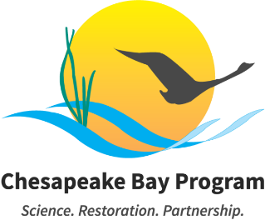

Chesapeake Steward Map 101

April 13, 2026
12:00-1:00pm

Example Meeting Link: Join the meeting via Zoom
Meeting ID: 893 7705 4043 Passcode: 486500
Call: +13017158592

This meeting may be recorded for internal use only to assure the accuracy of meeting notes. To request accommodations, please contact Meredith Lemke at lemkem@chesapeake.org.

Please read the following information carefully, as our meeting policies have changed:

- All meeting attendees' cameras and microphones will be muted at the start of the meeting.
- Access to chat will be provided as well.

Compromised Meeting Plan: If the meeting's privacy is compromised, the meeting staffer will send an email to all Members, alternates, staffers, coordinators, and interested parties. Within the email, you will find a new meeting link and any necessary adjustments to the meeting schedule. Please do NOT share this information publicly or post it to the Chesapeakebay.net webpage.

Purpose: The purpose of this meeting is to discuss the network science theory foundational to the development of the Chesapeake Steward Map as well as to teach interested parties how to join and use the map tool.

Agenda
- Network Science Theory behind the Chesapeake Steward Map 12:00 – 12:20
Meredith will describe network science theory that is foundational to social system mapping.

Requested Action: Non-decisional (i.e., discussion and presentation only).
Lead: Meredith Lemke, CRC / CBP
Materials:
  - Visualizing and Strengthening Networks with Mapping Presentation

- How to Join and Use the Map 12:20 – 12:45
Meredith will lead a brief tutorial on how to join, explore, navigate, and use the Chesapeake Steward Map tool. Participants will be invited to interact with the tool.

Requested Action: Non-decisional (i.e., discussion and presentation only).
Lead: Meredith Lemke, CRC / CBP
Materials:
  - Visualizing and Strengthening Networks with Mapping Presentation
  - Chesapeake Steward Map Webpage

- Questions, Answers, Networking and Open Discussion 12:45 – 1:00
This Chesapeake Steward Map 101 session will end with open discussion and collaboration time for participants to discuss opportunities, voice questions, and troubleshoot challenges associated with using or joining the tool.

Requested Action: Non-decisional (i.e., discussion and presentation only).
Lead: Meredith Lemke, CRC / CBP

- Adjourn 1:00

Next Meeting: May 11, 2026 – 12:00-1:00pm

