Mark Southerland, Rory Coffey, and Paige Hobaugh
Tetra Tech
November 18, 2025

CBP GIT#1 Physicochemical Indicators Draft Report

1. Purpose

This project, “Scope of Work 1: Data Review and Development of Multi-Metric Stream Health
Indicators (Phase 3B: Physicochemical Metric Analysis),” is a continuation of work developed by the Chesapeake Bay Program (CBP) Stream Health Work Group (SHWG) and the U.S. Geological Survey (USGS) to better understand the drivers and stressors affecting stream health throughout the Chesapeake Bay watershed. Currently, the Chesapeake basin-wide benthic macroinvertebrate index of biotic integrity, or “Chessie BIBI,” is the sole indicator of stream health being used by the SHWG. In 2023, the report Phase 3A: Hydraulics and Geomorphology Metric Analysis provided recommendations on hydromorphology indicators to supplement the Chessie BIBI. As was done for that project, this physicochemical indicators project conducted interviews with experts, reviewed data, created a framework, provided a data inventory matrix, made recommendations and provided a model case of potential multi-metric stream health indicators for physicochemical factors. The development of these additional indicators will address the need to better understand and communicate how streams respond to management actions.

This draft report will be reviewed by the SHWG and revised by the authors to address their comments.

2. Interviews with Experts and Literature Review

Tetra Tech conducted a series of interviews with experts in the field to gain technical insights into potential indicators and to identify potentially useful data sources. Interviews were conducted with the following organizations and individuals:

- Interstate Commission on the Potomac River Basin (ICPRB) – Rikke Jepsen
- Maryland Department of the Environment (MDE) – Denise Clearwater
- U.S. Geological Survey (USGS) – Greg Noe, Matt Cashman, Marina Metes, Kelly Maloney, Lindsay Boyle, Rosemary Fanelli, and Peter Tango
- U.S. EPA Region 3-Wheeling – Greg Pond
- Virginia Department of Environmental Quality (VDEQ) – Brock Reggi
- Fairfax County – Chris Ruck

Minutes from these interviews, SHWG meetings, and other comments received are provided in Appendix A—Meeting Minutes.

We also conducted a general literature search to identify journal articles, reports, data, tools, and web information that provide insights into the current state of the science on the use of physicochemical indicators to determine stream health. The search was conducted at a screening level (i.e., not comprehensive of all literature or resources available), but was targeted to capture key approaches and examples. These information sources assisted in developing the framework and informed the development of Appendix B -- Data and Parameters Spreadsheet.

3. Holistic Approach

The definition of stream health is closely aligned with the Clean Water Act goal “to restore and maintain the chemical, physical, and biological integrity of the Nation's waters." To date, the CBP has relied on a measure of biological integrity, the Chessie BIBI, to assess stream health. Recognizing that stream health reflects a wide range of chemical, physical, and biological elements interacting within a watershed, the SHWG is investigating the possibility of developing indicators for other components of stream health—both physical and chemical.

It is important to recognize that physicochemical elements, and indeed all the components of stream health, interact within the watershed ecosystem. Both EPA and CBP have used a Healthy Watersheds conceptual framework that explicitly includes chemical and physical constituents of water quality as indicators of ecological health (Figure 1). This approach views watersheds as integrated systems that can be understood through assessments that capture the interacting dynamics of their essential ecological attributes.

Since aquatic ecosystems are substantially affected by the quality of their water, EPA and states have established water quality criteria for freshwater ecosystems that address important chemical and physical constituents, including:

- concentrations of organic and inorganic constituents, such as nutrients, trace metals, and dissolved organic matter
- additional chemical parameters indicative of habitat suitability, such as pH and dissolved oxygen
- physical parameters, including water temperature and turbidity.

Many of these parameters are dynamic and related to natural watershed processes. For example, dissolved oxygen fluctuations in streams are related to nutrient cycling, biotic activity, stream flow, and temperature.

Examples of national, state, and volunteer water quality assessments can be found on the Examples of Water Quality Assessments for Watershed Health page.

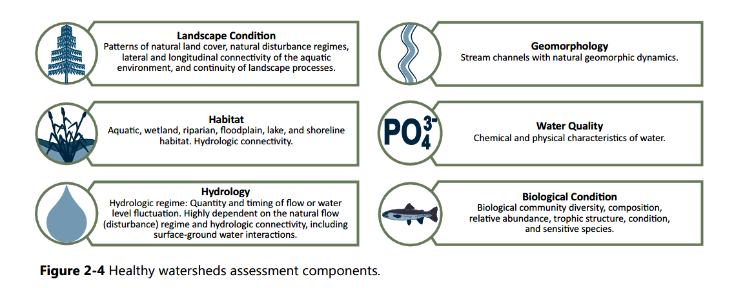
Figure 1. Water quality as one of six types of subindicies that combine to make up the watershed health index (Source: https://www.epa.gov/hwp/integrated-assessment-healthy-watersheds#Water)

Also indicative of a holistic approach to water quality is the USGS approach to identify and track the status of, and trends in, indicators of stream health in the Chesapeake Bay watershed. The USGS team is developing methods to track status (condition) and trends (change over time) for the following seven key indicators of stream health in the Chesapeake Bay watershed (Figure 2):

- Freshwater stream flows
- Nitrogen (N), phosphorus (P), and sediment (Sed) loads in non-tidal streams
- Temperatures of streams
- Hydromorphology of non-tidal streams
- Salinization of freshwater streams
- Toxic contaminants in streams
- Biological aquatic communities in streams.

Two of these seven key indicators are comparable to the Chessie BIBI (biological aquatic communities in streams) and hydromorphology recommendations from Phase 3A (hydromorphology of non-tidal streams), respectively.

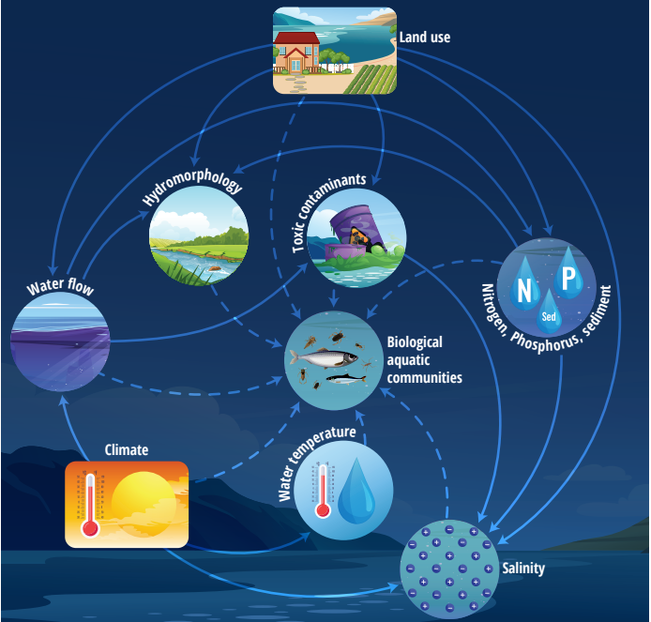

Figure 2. Connections (arrows) among stream health indicators (circles) and system drivers (boxes). Solid lines indicate material links, dashed lines indicator information links. Not all connections are shown. (Source: Austin et al. 2023 )

Physicochemical indicators included in Figures 1 and 2 are similar to those traditionally used to measure functions illustrated by the Stream Functions Pyramid conceptual model (Harman et al. 2012), comprising hydrology, hydraulics, geomorphology, physicochemical, and biology, on the ultimate foundation of geology and climate (Figure 3). Our approach in this project will be to focus on the near-term development of physicochemical indicators within level four of the Stream Functions Pyramid in the context of the supporting geomorphology, hydraulics, hydrology indicators, and landscape-scale indicators influencing the stream corridor.

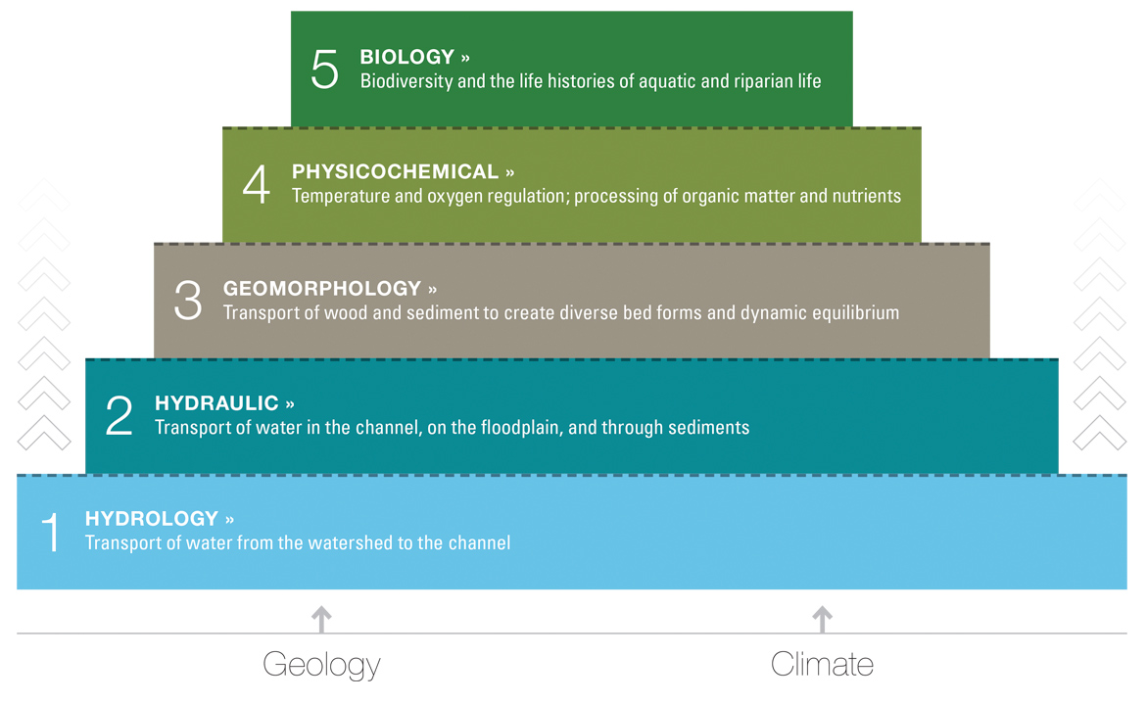
Figure 3. Stream Functions Pyramid (Source: Harman et al. 2012)

4. Potential Indicators

Numerous physicochemical indicators can be used to evaluate the health of streams. Key physical indicators, such as temperature, turbidity, conductivity, and flow provide insights into the stream's habitat characteristics and water clarity. Chemical indicators, such as pH, dissolved oxygen, and the concentration of nutrients (like nitrogen and phosphorus), are vital for assessing the chemical balance of the water and its potential for supporting diverse biological communities. Additionally, the presence of contaminants, including heavy metals and organic pollutants, can significantly impact stream health. Selection of parameters is the first step in the process of developing stream health indicators. There is no systematic technique to formalize the parameter selection process. The final selection is usually based on expert opinion (Delphi method), ecological importance of the parameter, and data availability (Uddin et al. 2021).

Previous and current work can help to guide the selection of indicators. Scientific literature suggests about 8 to 11 parameters are typically used as indicators, but some studies have analyzed as few as 4 to determine stream health. At the same time, it is estimated that up to 69 parameters could potentially be used (Syeed et al. 2023) (Figure 4). USGS suggests that the key water quality indicators of stream health in the Chesapeake Bay watershed are flow, nitrogen, phosphorus, sediment, water temperature, salinity and various toxic contaminants (Austin et al. 2023). In addition, USGS has recently compiled multi-agency water temperature (Clune et al. 2023) and specific conductance (Fanelli et al., 2023) observations for streams within the Chesapeake Bay watershed. EPA’s Rapid Bioassessment Protocol reports that temperature, conductivity, dissolved oxygen, pH, and turbidity are good indicators of adverse impacts to the stream ecosystem and the ability of the stream to support a healthy aquatic community (U.S. EPA 2007). EPA’s National Rivers & Streams Assessment uses acidification (based on acid-neutralizing capacity), total nitrogen, total phosphorus, enterococci, microcystin, and salinity as the key water quality indicators to help determine the condition of rivers and streams (U.S. EPA 2024c). Oregon Department of Environmental Quality (DEQ) has developed a Water Quality Index (WQI) based on 8 common water quality variables: water temperature, pH, dissolved oxygen, biological oxygen demand, total solids, nitrogen, phosphorus, and Escherichia coli (E. coli, fecal coliform and Enterococci are commonly used as indicators of fecal pollution and pathogenic risk to humans – see EPAs Technical Note on Microbial Indicators for more information) (Brown 2016). Washington’s Department of Ecology uses temperature, pH, fecal coliform bacteria, dissolved oxygen, total suspended sediment, turbidity, total phosphorus, and total nitrogen as components of a WQI that informs their stream monitoring program (Hallock 2002). Alternatively, both EPA’s Preliminary Healthy Watersheds Assessments and Restoration and Protection Screening Indicator Database focus only on assessing the extent of impaired versus unimpaired waters (HUC-12 scale), rather than representing pollutant-specific conditions (U.S. EPA 2021, U.S. EPA 2025).

The use of water quality indicators has also been explored for the Chesapeake Bay watersheds by various states and organizations. Maryland’s Healthy, Watersheds Assessment suggests using data on impaired streams together with modeled pollutant loads or concentrations (from the USGS SPARROW model) as water quality indicators (Roth et al. 2022). Pennsylvania DEQ developed a WQI using concentrations of 21 physicochemical parameters (Wertz and Shank, 2019). The Susquehanna River Basin Commission (SRBC) developed WQIs for the Susquehanna River Basin to assess water quality of streams using aluminum, chloride, iron, manganese, nitrate, phosphorus, sodium, sulfate, and total organic carbon (meaningful parameters with adequate sample sizes) (Berry et al. 2020). SRBC reported that alkalinity, calcium, magnesium, pH, and potassium also influence stream biota, but were excluded because of natural variability and underlying geology. The 9 parameters were sorted into three sub-indices or categories to reflect the following threats to water quality: metals (aluminum, iron, manganese), nutrient enrichment (nitrate, phosphorus, total organic carbon), and development (chloride, sodium, sulfate). University of Maryland Center for Environmental Science (UMCES) Eco Health tool for the Chesapeake Bay watershed uses nitrogen, phosphorus, and turbidity to develop a single WQI (UMCES 2025).

The following technical guides provide a history of physicochemical stream assessment methods and potential indicators:

- Development of a Water Quality Index for the Susquehanna River Basin
- EPA Water Quality Assessments for Watershed Health
- Oregon Water Quality Index: Background, Analysis and Usage
- A Water Quality Index for Washington Ecology's Stream Monitoring Program
- Surface water quality profiling using the water quality index, pollution index and statistical methods: A critical review
- A review of water quality index models and their use for assessing surface water quality
- Evaluation of the surface water quality using global water quality index model perspective of river water pollution
- Water Quality Indices: Challenges and Application Limits in the Literature
- A comprehensive review of water quality indices (WQIs): history, models, attempts and perspectives

The preliminary list of prospective indicators below is based on the consensus of information gathered through expert interviews and literature review, initial interpretation of importance to stream health, and potential data availability across the Chesapeake Bay watershed:

- Water Temperature
- Dissolved Oxygen
- pH
- Specific Conductance
- Nitrogen
- Phosphorus
- E. coli
- Suspended Sediment/Turbidity
- Flow/Water Depth/Connectivity

Toxics, pesticides, trace metals, and microplastics are not often considered as indicators, but have been suggested in the literature. CBP recently developed a Framework for Monitoring Plastic Pollution in the Chesapeake Bay that leverages existing monitoring efforts (Southerland et al. 2024).

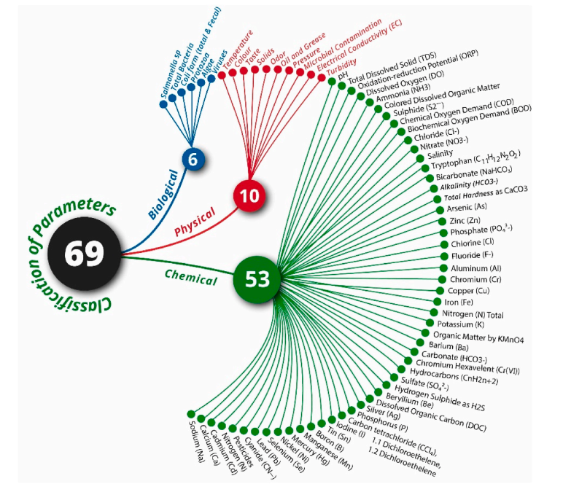
Figure 4. Taxonomy of 69 water quality parameters along their natural factors, e.g., physical, chemical, biological and bacteriological. (Syeed et al. 2023)

5. Data Sources

The nine most promising data sources that can inform the project are listed and summarized below:

- Chesapeake Bay Program Data Hub
- SRBC: Water Quality and Biological Indices for the Susquehanna River Basin
- PA DEPs WQI
- USGS: Data (nutrients, suspended sediment, flow, temperature, conductance, and toxics)
- USGS: Assessments of Stream Health Condition in the Chesapeake Bay Watershed
- EPA: Ecoregion Nutrient Criteria
- EPA: Water Quality Indicator Tool
- EPA: Integrated Assessment of Healthy Watersheds
- University of Maryland Center for Environmental Science (UMCES): Eco Health Tool

Chesapeake Bay Program DataHub
The Chesapeake Bay Program DataHub is a resource for downloading environmental data for the Chesapeake Bay watershed. Datasets available for download include water quality (water quality and calculated physical and nutrient parameters; two datasets – CBI [1949-1982] and CBP [1984-present]), living resources (tidal plankton, tidal benthic invertebrates, nontidal benthic invertebrates [counts, water quality, habitat, and indicator metrics]), fluorescence (chlorophyll a, phytoplankton, vertical and horizontal profiles), and toxics (physical and nutrient parameters). The data are hosted on an Application Programming Interface and datasets are available for download in tab delimited, XML, CSV, and JSON formats. The physicochemical ancillary data that are submitted by state, county, and other monitoring organizations to ICPRB for the Chessie BIBI for 2018-2024 will be available on the Data Hub in May 2025 (with earlier periods currently available).

SRBC: Water Quality and Biological Indices for the Susquehanna River Basin

The SRBC WQI was developed to (1) assess water quality of streams during baseflow conditions and allow for comparisons between monitoring sites within the watershed, (2) allow water quality information to be easily understood and used by decision makers and the public, and (3) serve as the basis for a stressor gradient to allow for the evaluation of biological condition (Berry et al. 2020). The index was developed using 19,142 samples from 2000-2023 at 1,910 unique sites. It converts concentrations of nine commonly monitored parameters (see Section 4. Potential Indicators) into a unitless number between 0 and 100 (the higher the number, the better the water quality). Scoring is comprised of three category scores and an overall water quality score. The first score category compared results across the whole SRB (WQI_{SRB}), the second compared only similarly sized streams to one another, and the third compared similarly sized streams within four main ecoregions (Level III). The nine parameters are grouped into three categories: metals, nutrient enrichment, and development. The three categorical scores are then averaged to produce an aggregate score. The WQI_{SRB} had a significant correlation with biological assemblage and land use data and is considered a useful water quality assessment and biomonitoring tool.

WQI for Pennsylvania Streams

The Pennsylvania WQI, developed by Wertz and Shank (2019), was designed to quantify and communicate anthropogenic stressors in lotic systems across Pennsylvania. The index was developed using data from 828 monitoring sites across Pennsylvania, covering all six major drainage basins (Delaware, Erie, Genesee, Ohio, Potomac, Susquehanna). Data span a 10-year period (2008–2017), with multiple samples per site used to calculate mean annual values, allowing for seasonal and flow-related variability. Unlike traditional indices that rely solely on expert judgment or fixed parameter sets, the Pennsylvania WQI integrates 21 physicochemical parameters and weights them based on their statistical correlation with land use and landscape stressors. This data-driven weighting reduces subjectivity, reflecting both the chemical condition and its likely drivers.

USGS: Data (nutrients, suspended sediment, flow, temperature, conductance, and toxics)

USGS offers several different resources including datasets, tools, and journal articles on aspects of Chesapeake Bay watershed related water quality aspects including nutrients, flow, suspended sediment, temperature, conductance, and toxics.

- Nutrients and suspended sediment
Nitrogen, phosphorus, and suspended sediment loads and trends measured at the Chesapeake Bay Nontidal Network stations: Water years 1985-2023. Calculations of nitrogen, phosphorus, suspended sediment loads, and changes in loads across rivers in the Chesapeake Bay watershed using Chesapeake Bay Nontidal Network stations for years 1985-2023. Load results are provided as both flow-normalized loads and actual loads by year and month using Weighted Regression on Time, Discharge, and Season approach with Kalman filtering. Four data tables are included to describe nitrogen, phosphorus, and suspended sediment conditions across the Nontidal Network: (1) annual loads, (2) monthly loads, (3) trends in annual loads, and (4) average annual yield.
Journal Article - Linking altered flow regimes to biological condition: An example using benthic macroinvertebrates in small streams of the Chesapeake Bay watershed (Maloney et al. 2021). A study that indicates whether altered streamflow is a possible driver of degraded biological conditions. Modeled estimates of hydrologic alteration were paired to a benthic macroinvertebrate index of biotic integrity data for 4522 stream reaches across the Chesapeake Bay watershed to overcome the low number of stream gages for performing regionally scaled assessments of hydrologic alteration for small streams and its effect on freshwater taxa. Separate random-forest models were used to predict flow status for 12 hydrologic metrics that characterize components of flow regimes. The study used the models to predict each hydrologic metric status for each stream reach in the watershed and linked predictions to macroinvertebrate condition samples collected from streams with drainage areas less than 200 square kilometers. When focused only on the stream condition and flow-alteration relationship, degraded macroinvertebrate condition was 3.8-4.7 times more likely in a flow-altered site, 8.7-10.8 times more likely in an urban-focused dataset, and never statistically significant in the agriculture-focused dataset.
- Temperature
Compilation of multi-agency water temperature observations for streams within the Chesapeake Bay watershed. Data that collates stream water temperature observations across the Chesapeake Bay watershed from NWIS, WQP, and USGS AQ Time-Series database. Includes aggregate daily values, continuous data from USGS monitoring stations, discrete data, miscellaneous stream temperature observations collected during discharge measurements.
- Specific conductance
Compilation of multi-agency specific conductance observations for streams within the Chesapeake Bay watershed. Data release of four items related to specific conductance throughout the Chesapeake Bay watershed: (1) site inventory of locations where specific conductance has been collected and compiled (e.g., monitoring location, organization that collected the data), (2) discrete specific conductance observations (e.g., location, value, units), (3) 89 .csv files for all continuous USGS specific conductance data available in the Chesapeake Bay watershed, and (4) a document describing the processing and harmonizing necessary to generate the site inventory and discrete dataset.
- Toxics
Priority Toxic Contaminant Metadata Inventory and Associated Total Polychlorinated Biphenyls Concentration Data: An inventory of available information on toxic contaminants within the Chesapeake Bay Watershed from years 1938-2019. Data comes from National Water Information System, National Water Quality Database, and state agencies. The data contains records for available sites where specific analyte groups, mercury, PCBs, or pesticides have been collected and includes metadata (e.g., media, method, timeframe, frequency of collection).
USGS: Assessments of Stream Health Condition in the Chesapeake Bay Watershed

USGS developed an interactive dashboard depicting information on habitat assessments throughout the Chesapeake Bay watershed that rely on collected and modeled data to build estimates of condition, and localized information generated within the models allows managers to focus on restoration and protection efforts. The goal of this work is to understand and model aquatic communities, physical conditions, water quality, and toxic contaminants in rivers and streams throughout the Watershed.

The assessments include information on aquatic communities (aquatic health and community assessment, stream health and benthic community assessment), physical conditions (hydrogeomorphology, specific conductance, stream temperature, freshwater flows), and additional assessments (toxic contaminants, water quality). The dashboard provides Watershed maps showing general assessment trends and detailed results for predictors (e.g., temperature, stream size) and species (presence/absence) by year.
EPA: Ecoregion Nutrient Criteria

A series of documents that present the EPA's nutrient criteria for rivers and streams in different ecoregions across the US. They contain the EPA's recommendations to states and authorized tribes for establishing their water quality standards. These guidance values are based on observed data and provide reference conditions for nutrient and other parameters (e.g., total phosphorus, dissolved oxygen, total nitrogen, Chlorophyll a, and turbidity).

EPA: Water Quality Indicator Tool
WQI is a screening tool designed to allow analysts to use large datasets to identify where water pollution hotspots occur. WQI plots water monitoring locations and compares the observed values to a criteria or threshold (national 304(a) recommended criteria).
WQI resources include interactive maps, filters to limit surface water monitoring data displayed, and allows users to find permitted NPDES facilities upstream and downstream a monitoring location.
Within the screening tool’s water monitoring stations tab, users can select different time intervals and pollutants and pathogens to be displayed (e.g., total phosphorus, total nitrogen, E. coli, enterococcus, fecal coliforms), monitoring location summary statistics (e.g., time weighted mean, 90th percentile), and criteria definition. Users can filter data geographically, by a minimum number of samples, monitoring station category (e.g., high concern, no concern), HUC-8 subbasin, and water body type. Layers include monitoring stations and pollutant change over time, facility data (e.g., NPDES permitted facilities, non-NPDES facilities), water data (e.g., Assessed and Impaired Waters [ATTAINS]), and land cover data (e.g., Chesapeake Bay Land Use Land Cover [LULC]).
EPA: Integrated Assessment of Healthy Watersheds
The national Healthy Watersheds Program conceptual framework views watersheds as integrated systems that can be understood through assessments, which capture the interacting dynamics of their essential ecological attributes. The development of a watershed health index is based on six indicators related to attributes of watershed health that include landscape condition, habitat, hydrology, geomorphology, water quality, and biological condition. The watershed health index value is relative (i.e., meant for comparing differences among watersheds) and is comprised of sub-index values for each of these attributes. Regarding water quality, EPA and states have established water quality criteria for freshwater ecosystems that address ecological, chemical, and physical parameters including concentrations of organic and inorganic chemicals (e.g., nutrients, dissolved organic matter), chemical parameters indicative of habitat suitability (e.g., pH, dissolved oxygen), and physical parameters including water temperature and turbidity.
The Chesapeake Healthy Watersheds Assessment (Innovate, Inc. 2023) builds upon previous healthy watershed indicators developed for the Chesapeake Bay region. A suite of indicators was developed at the catchment scale to characterize specific components within the general categories of landscape condition, hydrology, geomorphology, habitat, and water quality. Water quality indicators include percent impaired streams; incremental suspended sediment, total phosphorus, and total nitrogen loads by sector (derived from SPARROW models); and CBP modeled loads for total suspended sediment, phosphorus, and nitrogen by sector.
University of Maryland Center for Environmental Science (UMCES): Eco Health Tool
A map-based tool developed by UMCES that scores the ecological, societal, and economic health of regions throughout the Chesapeake Bay Watershed from A (80-100% - very good) to F (0-19% - very poor) using a suite of indicators including nitrogen, phosphorus, turbidity, benthic community, WQI (average of nitrogen, phosphorus, and turbidity). Each indicator has its own webpage with information about the indicator and how it is measured for a health value. The tool also provides a graph view of scores over time (5 years) per region.

6. Framework to Develop Potential Indicators

The second phase of the project used the following framework to evaluate the potential indicators and data sources identified above to determine their likely value and practicality for producing individual physicochemical indicators and/or a composite WQI to assess stream health. The framework builds on the expert interviews and literature review described above and includes the following steps:

- Categorize available physicochemical parameters into three groups based on their importance for stream health (defined as ecological integrity)

  - Most important
  - Moderately important
  - Least important

- Determine the data availability for each important parameter in space and time

  - Spatial coverage across Chesapeake Bay watershed
  - Temporal frequency of sampling relative to natural variability

- Identify the thresholds of concern available or developable for each parameter

  - Water quality standards and criteria
  - Reference benchmarks including using Principal Component Analysis
  - Ecologically relevant relationships

- Identify assessment scale and regionalization needed to capture natural variation

  - Start with ecoregions
  - Modify with geological subregions if needed and feasible
  - Modify with temperature classifications if needed and feasible

- Develop individual metrics or composite indices

  - Options for measuring each parameter, including discrete and continuous concentrations, and how to accommodate variation with natural factors (e.g., DO with temperature and elevation)
  - Metrics that might serve as indicators of multiple stressors such as conductivity (e.g., for salts, metals, pesticides)
  - Metrics for individual parameters based on benchmarks or departure from expected
  - Composite index using different combinatory methods (e.g., weights by expert opinion, proportional to thresholds, percent of failures of metrics) (Figure 5 outlines the basic steps required to develop a composite index value)
  - Transparent composite index with ability to drill down to individual metrics
  - Utility of each indicator method for communication to multiple audiences

- Pilot analyses to test feasibility and performance of metrics and indices as model case

  - Create simple index with select parameters
  - Calculate metrics and indices with MBSS or other data
  - Compare metrics with land use, benthic macroinvertebrate IBI, and fish IBI
  - Determine feasibility of using biological taxa as stressor surrogates

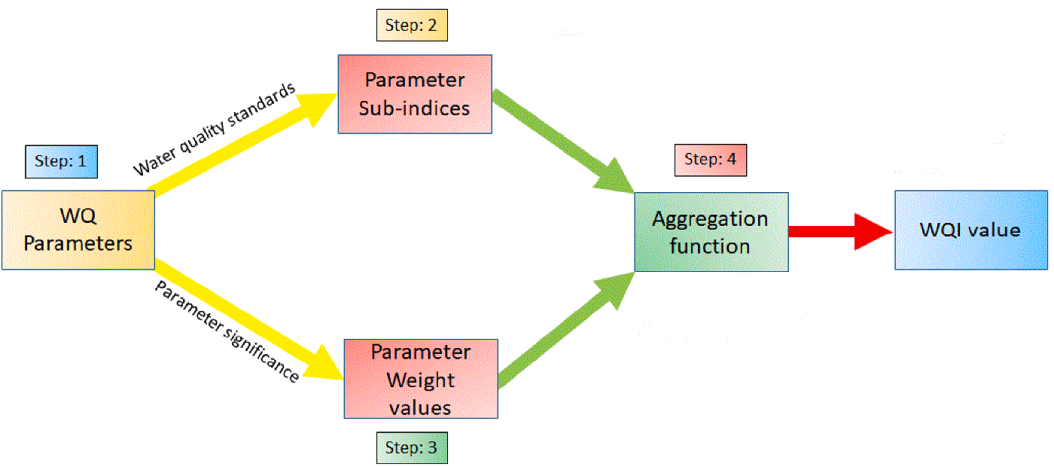

Figure 5. General framework to develop a single WQI (Source: Uddin et al. 2021).

Challenges to Indicator Development

The framework lays out the potential steps to develop a WQI using physicochemical indicators. The expert interviews and literature reviewed, however, suggest that numerous challenges need to be considered when developing physicochemical indicators to determine stream health (Kachroud et al. 2019). Like indicators of biological condition, developing physicochemical indicators is confounded by state-to-state differences in assessment and reporting, as well as limitations in data availability across the states and Chesapeake Bay watersheds (Berry et al. 2020). Specifically, data must be available at an appropriate spatial and temporal scale to capture important processes and develop one or more metrics that can be applied broadly across the Bay watershed.

In addition, the selection of parameters, sub-indexing rules (transforming variables into subindices expressed on a single scale), and metric weightings are all dependent on the designated uses (e.g., drinking water, recreational, aquatic life), water quality criteria, and assessment protocols (Uddin et al. 2021, Kachroud et al. 2019). Some indicators can be highly variable because of sensitivity to natural (e.g., seasonality) and/or human-induced factors (Kachroud et al. 2019). Indicators like dissolved oxygen and temperature also vary naturally throughout the day and throughout the waterbody; therefore, it can be difficult to determine if discrete dissolved oxygen or temperature measurements are a true reflection of overall stream conditions. This makes the identification of appropriate thresholds of concerns a key challenge facing assessment of stream health with physicochemical indicators. Finding optimal thresholds, transformations, scoring, and harmonization across monitoring programs will be required of the SHWG in future meetings and workshops.

Although various WQI models and approaches have been applied both nationally and internationally, there is a lack of standardized methods. Therefore, it is important to determine which existing models or approaches best suit the needs of the SHWG, i.e., whether a new/modified model is needed and how the model should best be applied for streams in the Chesapeake Bay watershed. The strengths of a single composite WQI created from various metrics are simplicity and utility for communication and outreach. However, because a single index simplifies very complex systems it can potentially lose or distort information (known as “eclipsing”) (Berry et al. 2020). This can be caused by inappropriate sub-indexing rules, parameter weightings that do not reflect the true relative influences of parameters, or inappropriate aggregation functions (Uddin et al. 2021, Syeed et al. 2023, Berry et al. 2020). The complexities and challenges most relevant to the Chesapeake Bay streams were further explored as we applied and tested potential indicators under the framework.
- Indicator Development

Developing a WQI helps translate complex physicochemical data into more interpretable insights about stream health for managers, policymakers, and the public. A well-designed indicator facilitates communication, supports trend analysis, prioritizes restoration efforts, and evaluates management effectiveness over time. This section discusses the feasibility of physicochemical indicator development for Chesapeake Bay streams following the framework described in Section 6.

7.1 Physicochemical Indicator Selection

Indicator selection should account for natural variability, anthropogenic influences, hydrology, and the specific management goals or regulatory frameworks in place–this complexity makes it difficult to identify universally applicable metrics for physicochemical indicators of stream health. In addition, stream ecosystems are complex and dynamic, with multiple interacting physical, chemical, and biological processes, which vary spatially and temporally.

We developed a list of prospective indicators based on their perceived importance to stream health and information gathered previously (literature and interviews with experts). Table 1 ranks the indicators in order of importance (based on best professional judgement and scientific literature) and describes why these parameters matter to stream health. The selection of proposed indicators also considered likely data availability across the Chesapeake Bay watershed.

Table 1. Potential indicators and their importance to stream health

Indicator | Why It Matters | Importance
Dissolved Oxygen (DO) | Supports aquatic life; low DO leads to hypoxia and fish kills. | Very High
Temperature | Influences DO, species metabolism, and habitat suitability. | Very High
Total Nitrogen (TN) | Excess TN causes eutrophication and oxygen depletion. | Very High
Total Phosphorus (TP) | Triggers algal blooms and eutrophication. | Very High
Bacteria (e.g., E. coli, fecal coliform, enterococci) | Indicates fecal contamination from human or animal waste; high levels pose health risks for recreation and drinking water. | Very High
pH | Affects chemical reactions and biological health. | High
Conductivity | Indicates dissolved salts and pollution. | High
Turbidity/TSS | Reduces light, affects habitat, and transports pollutants. | High
Flow/Hydrologic Regime | Maintains habitat, sediment transport, and pollutant dilution. | High
Note: Ranking of importance was based on best professional judgment informed by relevant scientific literature (Austin et al. 2023, Chesapeake Progress 2025, U.S. EPA 2024b).

7.2 Data Availability

The Chesapeake Bay Program DataHub is the primary tool for searching and downloading water quality data for the Chesapeake Bay watershed and is, therefore, the most practical source for data to support physicochemical indicator assessment of stream health. Tetra Tech used information from the DataHub—specifically the Nontidal Water Quality Program and Living Resources datasets—to assess the spatial and temporal availability of water quality data on the potential indicators listed above for the period from 2014 to 2023 (most recent 10 years). The Nontidal Water Quality Program includes data for all of the selected parameters. However, the Living Resources datasets only includes sufficient data for water temperature, dissolved oxygen, pH, specific conductivity and flow. A summary of the results is given in Table 2 and Table 3. A more comprehensive breakdown of the spatial and temporal coverage for the suggested parameters is provided in Appendix C Data Matrix (tables and maps).
Table 2. Summary of spatial coverage at various scales across the Chesapeake Bay watershed for selected water quality parameters in the Nontidal Water Quality Program database
Water Quality Parameter | Number of Samples | Spatial Assessment (Number of units with sites)
Water Quality Parameter | Number of Samples | HUC-12s  (Total: 1976) | HUC-8s  (Total: 53) | HUC-6s  (Total: 7) | Ecoregions  (Total: 12)
Water Temperature (WTEMP) | 28779 | 146 | 44 | 7 | 9
Dissolved Oxygen (DO) | 27930 | 146 | 44 | 7 | 9
Stream Flow (FLOW_INS) | 5865 | 49 | 26 | 5 | 7
pH (PH) | 27811 | 146 | 44 | 7 | 9
Specific Conductivity (SPCOND) | 28788 | 146 | 44 | 7 | 9
Total Nitrogen (TN) | 29291 | 146 | 44 | 7 | 9
Total Phosphorus (TP) | 29671 | 146 | 44 | 7 | 9
Total Suspended Solids (TSS) | 28857 | 144 | 44 | 7 | 9
Total Suspended Sediment Concentration (SCC_TOTAL) | 15637 | 113 | 42 | 7 | 8
Fecal Coliform (FCOLI_C) | 3104 | 33 | 16 | 3 | 5
Note: Turbidity is not included in this table as there were less data available than TSS. Approximately 13,000 turbidity measurements were present in the dataset.

Table 3. Summary of spatial coverage at various scales across the Chesapeake Bay watershed for selected water quality parameters in the Living Resources database.
Water Quality Parameter | Number of Samples | Spatial Assessment (number of units with sites)
Water Quality Parameter | Number of Samples | HUC-12s  (Total: 1976) | HUC-8s  (Total: 53) | HUC-6s  (Total: 7) | Ecoregions  (Total: 12)
Water Temperature (WTEMP) | 7266 | 809 | 50 | 7 | 10
Dissolved Oxygen (DO) | 7044 | 803 | 53 | 7 | 10
Stream Flow (FLOW_INS) | 1617 | 277 | 35 | 7 | 9
pH (PH) | 8521 | 816 | 50 | 7 | 10
Specific Conductivity (SPCOND) | 8508 | 804 | 50 | 7 | 10
Note: A limited amount of turbidity data was available in this dataset (<50 measurements).

Spatial coverage across Chesapeake Bay watershed: Our assessment indicates that the spatial coverage of monitoring sites is limited at the HUC-12 scale. Additionally, many of the sites did not have data for all the potential indicator parameters. For HUC-8, HUC-6 and ecoregion scale, monitoring sites were more prevalent across the geographic areas. The Living Resources dataset provided more extensive spatial coverage of monitoring sites than the Nontidal Water Quality Program dataset but does not include data for TN, TP, TSS or bacteria; additionally little turbidity data was available. The amount of data is also smaller than the Nontidal Water Quality Program dataset – see Table 2 and Table 3. Overall, development of indicators at the HUC-8 scale would likely be most useful, but would require expansion of coverage with additional data/monitoring or water quality modeling to fill gaps in locations where current data are absent or sparse.
Temporal frequency of sampling relative to natural variability: The temporal frequency of monitoring data in the Nontidal Water Quality Program dataset varies by station for the period assessed (2014-2023)–not all sites were monitored annually and there are inconsistencies in the frequency of monitoring data (typically monthly at sites). The dataset does, however, provide a large amount data for the selected parameters (Table 2). Oppositely, the Living Resources dataset offers more limited temporal coverage. The majority of monitoring sites have less than 10 measurements per parameter. Aggregation of both datasets and inclusion of other available data (e.g., state monitoring programs, academic studies, citizen science) could help to expand temporal and spatial coverage. However, available monitoring data does not currently account for short-term changes in measurements which is often needed to better understand the natural variability of physicochemical parameters (e.g., temperature, dissolved oxygen).

7.3 Thresholds of Concern

Determining thresholds of concern is a key step in developing effective individual physicochemical indicators or composite WQIs. These thresholds define the point at which a water quality parameter transitions from acceptable to concerning. Limits or thresholds for pollutants (e.g., nutrients, metals, pathogens) are usually based on ecological, human health, or recreational criteria in water quality standards. Table 4 summarizes key thresholds based state water quality standards (VA, WV, MD, PA, NY, DE, DC) and EPA guidance for our list of potential water quality parameters. These thresholds could be used to help guide the scoring of individual indicators or WQIs. It should be noted that each state sets its own criteria based on designated uses (e.g., cold-water fisheries, recreation), which leads to variation in how thresholds are interpreted and monitored. Additionally, thresholds can vary depending on natural watershed conditions (e.g., geology) which affect baseline water quality.

Table 4. Summary of potential thresholds for selected parameters that could guide indicator scoring across Chesapeake Bay watersheds
Water Quality Parameter | Potential Threshold of Health | Comment
Dissolved Oxygen | >5 mg/L (7–10 mg/L preferred) | Based on minimum value for most aquatic life. Can vary depending on temperature, flow, and biological activity.
Temperature | <20°C (cold-water); <30°C (warm-water) | Based on maximum value aquatic life (cold or warm). Can vary depending designated use, region, and season.
Total Nitrogen | <1.0 mg/L | Can vary by ecoregion. Numeric criteria do not exist for states.
Total Phosphorus | <0.05 mg/L | Can vary by ecoregion. Numeric criteria do not exist for states.
Bacteria (E. coli) | <126-235 cfu/100 mL | Based on geometric mean and single sample maximum.
pH | 6.5–8.5 | General range considered to be suitable for aquatic life.
Conductivity | 150–500 µS/cm | Can vary by ecoregion. Numeric criteria do not exist for states.
Turbidity / TSS | <5 NTU; TSS: <25 mg/L | Can vary by ecoregion. Numeric criteria do not exist for states.
Flow / Hydrologic Regime | Assessed via deviation from natural flow | Only narrative criteria exist.

Specifically, thresholds provide a method for determining departure from a level of concern, whether regulatory or stakeholder consensus. When developing an indicator score or an index, water quality measurements are typically converted into a common scale (e.g., 0–100) using selected thresholds. This allows comparison across parameters with different units and ranges. Once thresholds are defined, they can be used to create scoring systems for indicators or indices as for example:

- Binary scoring: Meets threshold = 1, exceeds = 0
- Tiered scoring: Excellent (0–25% of threshold), Good (26–50%), Fair (51–75%), Poor (>75%), e.g., Dissolved oxygen of 8 mg/L: ideal = score of 100; dissolved oxygen of 4 mg/L: threshold of concern = score of 50.
- Continuous scaling: Normalize values to a 0–100 scale based on proximity to the threshold.

Such scoring supports integration of parameters into a WQI and comparison across sites and time. Before applying thresholds, they should be tested with real-world data to ensure they reflect meaningful changes in water quality (e.g., to be explored in our pilot analysis). This ensures indicators or index scores are both credible and robust.

7.4 Assessment Scale and Regionalization

The development of individual indicators or a composite WQI should account for natural variability across the Chesapeake Bay watershed. This variability is influenced by differences in climate, geology, land use, and ecological conditions, which can significantly affect natural baseline water quality parameters. Therefore, the selected assessment scale—such as HUC-12, HUC-8, or ecoregion level—must allow for any needed regionalization of scoring. Whatever regions are chosen should be scored relative to their baseline natural conditions so that unnecessary spatial heterogeneity does not confound interpretation of results (Banda and Kumarasamy 2019).

Incorporating ecoregions and geological subregions into the design of the indicators or WQI will likely enhance ecological relevance and improve utility. For example, temperature thresholds for stream health may differ between cold-water and warm-water systems, which are distributed unevenly across the watershed (Maheu et al. 2016). Similarly, conductivity and nutrient concentrations may vary naturally depending on underlying geology or soil types (U.S. EPA 2024a). By classifying assessments according to ecological regions, the index can better distinguish between anthropogenic impacts and natural variation.

Where feasible, regionalization should be integrated into both indicator scoring and data visualization. This could involve developing region-specific thresholds or weighting schemes, or presenting results in a way that highlights regional differences. Ultimately, regionalization ensures that the indicators or WQI are scientifically robust and relevant across the diverse landscapes.

7.5 Individual Metrics or Composite Indices

Individual physicochemical indicators and composite WQIs are two complementary approaches to assess and communicate the health of streams. Each has distinct advantages and serves different purposes depending on the context and goals (Table 5).

The development of a composite WQI is particularly useful for simplifying complex datasets and making water quality information accessible to non-technical audiences, including policymakers, community stakeholders, and the general public. By translating diverse measurements—such as nutrient concentrations, turbidity, and dissolved oxygen—into a unified score, WQIs facilitate broad comparisons across sites and time periods. They are especially effective for public reporting, environmental education, and high-level decision-making. Additionally, WQIs provide a consistent framework for integrating diverse datasets and informing stakeholders about the status of stream health.

Table 5. Features of individual physicochemical indicators versus a WQI

Feature | Individual Indicators | WQI
Overview | Offers detailed insights | Provides a holistic score
Communication | Requires technical interpretation | Easy to communicate
Sensitivity | Highlights specific problems | May mask specific issues
Flexibility | Parameter-specific thresholds | Customizable weighting
Use Case | Scientific analysis and assessment | Public reporting and policy

In contrast, individual physicochemical indicators focus on specific parameters, each assessed against its own threshold or standard. This approach provides a more detailed and diagnostic view of water quality, allowing stakeholders and managers to identify particular stressors or sources of degradation. For example, elevated nitrogen levels may signal agricultural runoff, while low dissolved oxygen could indicate organic pollution or eutrophication. Individual indicators are important for scientific assessment, as they preserve the specific details needed to understand cause-and-effect relationships in stream health.
Some individual indicators can be grouped to serve as indicators of multiple stressors. For example, elevated nitrogen and phosphorus levels, when observed alongside increased chlorophyll-a and reduced dissolved oxygen, can collectively indicate nutrient enrichment and eutrophication. Conductivity can serve as an indicator for salts, metals, and pesticides. Grouping indicators in this way allows for developing multi-metric indices or stress-specific indicator suites that can communicate complex ecological responses in a structured and interpretable format.

While WQIs offer clarity and simplicity, they can sometimes obscure critical nuances by averaging or weighting parameters. They do not capture all pollutants or account for short-term events, and aggregation can mask specific issues. A water body might receive a “Good” rating overall, even if one parameter exceeds safe limits. Therefore, the use of both approaches in tandem can work best, with a WQI providing a snapshot of overall condition and individual indicators highlighting specific concerns to guide targeted interventions–Figure 6 provides an example.

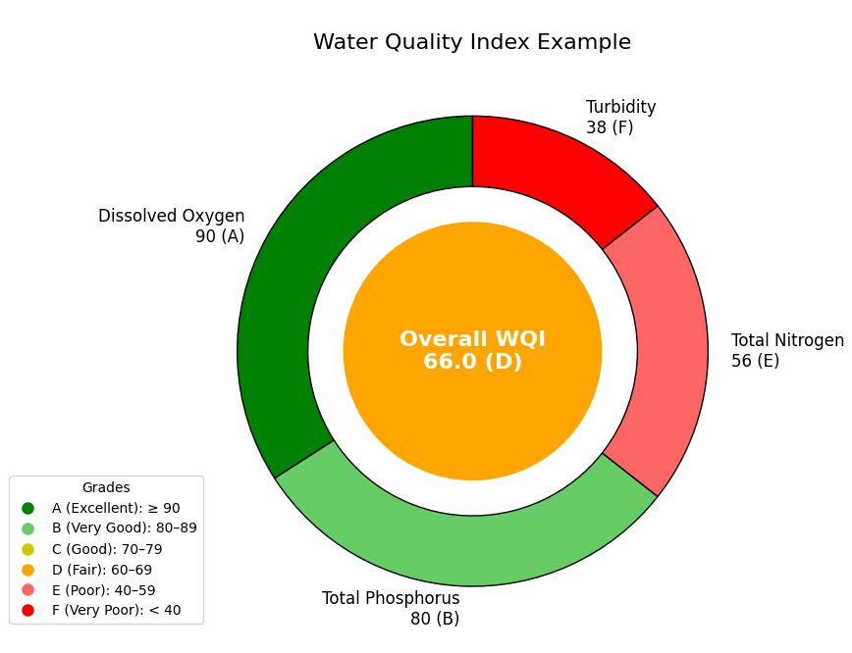
Figure 6. Example visualization combining scoring for individual physicochemical indicators and an overall index that could be applied at various scales
- Examples of Composite Water Quality Indices

WQIs vary in design and application depending on regional priorities, ecological characteristics, and data availability. Five examples are provided in this section, from state-level programs like the Pennsylvania, Oregon, and Washington WQIs, to basin-specific tools such as the Susquehanna River Basin WQI, and broader ecosystem assessments like the UMCES Chesapeake Bay Report Card. Each example offers a unique perspective on how composite WQIs can be created, interpreted, and communicated for Chesapeake Bay watershed. The following summaries explore these indices in detail, highlighting their parameters, spatial and temporal coverage, scoring approaches, and utility in environmental management.

WQI for the Susquehanna River Basin

The WQI for the Susquehanna River Basin (WQISRB) was developed by the SRBC to assess ambient stream water quality under baseflow conditions (Figure 7). Recognizing the need for a basin-wide assessment tool, SRBC developed the WQISRB to integrate multiple water quality parameters into a single index score. This index helps identify spatial patterns, temporal trends, and areas of concern, while also supporting comparisons across stream sizes and land use types. The goal of the index is to provide a consistent, scientifically grounded method for evaluating water quality across diverse monitoring sites and over time, supporting both environmental management and public communication.

Parameters: Nine parameters were sorted into three sub-indices (categories) to reflect each threat to water quality:

- Metals: Al, Fe, Mn
- Nutrient Enrichment: NO3, P, TOC
- Development: Cl, Na, SO4

The selection process considered both data availability and each parameter’s/sub-indices’ ability to represent broader water quality conditions.

Spatial and Temporal Coverage: The index is applied across a network of SRBC monitoring stations throughout the basin (HUC-10 scale). Data are collected under baseflow conditions to minimize variability from storm events and focus on chronic water quality issues. The WQISRB supports both site-specific assessments and basin-wide evaluations, with scoring resolutions that account for stream size and spatial context. This allows for meaningful comparisons between headwaters, mid-sized streams, and large rivers.

Approach: The WQISRB uses a multi-step approach to calculate index scores:

- Parameter Scoring: Each parameter is scored individually based on its deviation from expected or threshold values.
- Weighting: Parameters are assigned equal weights to remove subjectivity over which parameters should be considered most important.
- Aggregation: Scores are aggregated using a weighted arithmetic mean to produce a final index score for each site and sampling event.

Scores range from 0 to 100, with higher scores indicating better water quality. Classification thresholds are used to interpret the scores:

- 80–100: Excellent
- 60–79: Good
- 40–59: Fair
- 20–39: Poor
- 0–19: Very Poor

The index also accounts for high flow conditions and TSS, which can obscure water quality trends. Adjustments are made to ensure that scores reflect true ambient conditions rather than episodic disturbances.
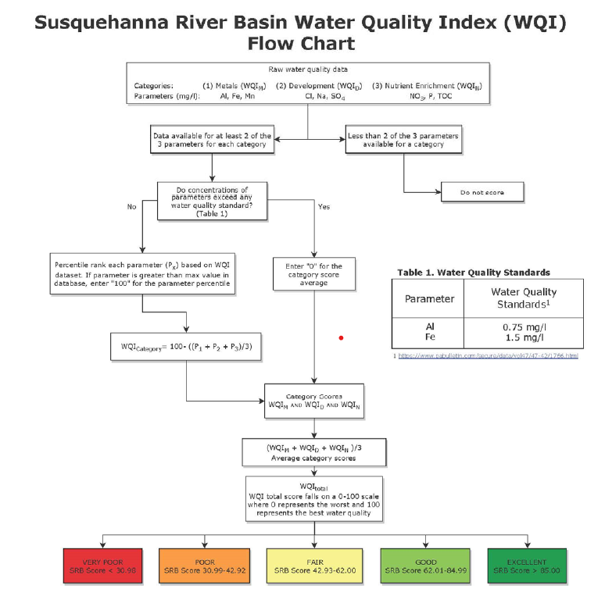
Figure 7. The WQISRB developed to assess ambient stream water quality under baseflow conditions

WQI for Pennsylvania Streams

The Pennsylvania WQI, developed by Wertz and Shank (2019), was designed to quantify and communicate anthropogenic stressors in lotic systems across Pennsylvania. Unlike traditional indices that rely solely on expert judgment or fixed parameter sets, the Pennsylvania WQI integrates 21 physicochemical parameters and weights them based on their statistical correlation with land use and landscape stressors. This data-driven weighting reduces subjectivity, reflecting both the chemical condition and its likely drivers. The scores and methodology can be viewed in the PADEP Water Quality Index User Interface.

Parameters: The WQI incorporates the following 21 physicochemical parameters commonly measured across Pennsylvania’s monitoring network:

- Nutrients (Total Nitrogen, Total Phosphorus, Orthophosphate)
- Metals (Iron, Aluminum, Copper, Zinc, etc.)
- General water chemistry (pH, Alkalinity, Conductivity, Hardness, Sulfate)
- Solids (Total Dissolved Solids, Total Suspended Solids)
- Others (Ammonia, Chloride, Calcium, Magnesium)
Each parameter is normalized using a percentile-based indexing method (5th–99th percentile) and weighted based on its correlation with landscape stressors.

Spatial and Temporal Coverage: The index was developed using data from 828 monitoring sites across Pennsylvania, covering all six major drainage basins (Delaware, Erie, Genesee, Ohio, Potomac, Susquehanna). Data span a 10-year period (2008–2017), with multiple samples per site used to calculate mean annual values, allowing for seasonal and flow-related variability.

Approach: The WQI follows a four-step process:

- Parameter Selection: Based on availability and spatial-temporal coverage
- Sub-indexing: Parameters are indexed on a 0–100 scale using floor and ceiling percentiles
- Weighting: Each indexed parameter is weighted using Spearman correlation coefficients with landscape variables (e.g., land use, point sources)
- Aggregation: Parameters are grouped into four landscape-based sub-indices:
  - Forest
  - Urban
  - Agriculture
  - Land Disturbance
The results are based on how similar a site’s water quality is to water quality dominated by one of the four major land uses/covers, referred to as sub-index score scores. The final WQI score is determined by the lowest sub-index score, representing the dominant stressor. Scores are categorized as Poor (<40), Fair (40–59), Average (60–74) and Good (≥75).

University of Maryland Center for Environmental Science (UMCES) – Chesapeake Bay and Watershed Report Card: Eco Health Tool

The WQI developed by the University of Maryland Center for Environmental Science (UMCES) is a central component of the Chesapeake Bay and Watershed Report Card, which is used to assess and communicate the health of the Chesapeake Bay and its drainage area. Since 2016, UMCES has produced the Chesapeake Bay and Watershed Report Card to provide a transparent and geographically detailed assessment of environmental conditions.

The WQI is one of several ecological indicators used to evaluate the health of aquatic ecosystems in the Bay and its tributaries. The report card is designed to track environmental trends and engage stakeholders and the public in watershed stewardship. The index is part of a broader effort to integrate ecological, societal, and economic indicators into a unified framework for environmental reporting and decision-making.

Parameters: The WQI focuses on four key water quality parameters:

- Total Nitrogen
- Total Phosphorus
- Turbidity
- Conductivity

These parameters were selected for their relevance to nutrient pollution, sedimentation, and freshwater salinization—three major stressors affecting the Chesapeake Bay. Each parameter is assessed against ecological thresholds that reflect the conditions necessary to support aquatic life and maintain ecosystem integrity.

Spatial and temporal coverage: The 2025 report card includes data from over 100,000 miles of streams and rivers, as well as lakes, wetlands, and reservoirs. Spatial resolution is high, with scores reported for individual sub-watersheds and Bay segments. Temporally, the index is updated annually, using the most recent available data—2024 for most water quality parameters and 2023 for aquatic grasses.

Approach: Each water quality parameter is scored individually based on how closely observed values align with ecological expectations. These scores are then combined into a composite WQI score for each watershed region. The scoring system uses a 0–100 scale, with higher scores indicating better water quality. The final WQI score is interpreted using a letter-grade system:

- A (80–100%): Excellent
- B (60–79%): Good
- C (40–59%): Moderate
- D (20–39%): Poor
- F (0–19%): Very Poor

In 2025, the Chesapeake Bay’s overall WQI score was 50% (Grade C), reflecting moderate water quality. While this represented a slight decline from the previous year, long-term trends show gradual improvement, attributed to restoration efforts and pollution reduction initiatives.

Oregon WQI (OWQI)

The OWQI was developed by the Oregon DEQ to assess and communicate the overall condition of water bodies across the state. It serves as a standardized method for evaluating water quality using multiple parameters, offering a general representation of stream health. The OWQI was designed to simplify complex water quality data into a single score that reflects the suitability of water for general uses such as recreation, aquatic life support, and aesthetic value. It is considered useful for tracking long-term trends and identifying areas where water quality is improving or declining. The index supports statewide monitoring efforts and informs management, policy development, and public outreach.

Parameters: 8 parameters were selected for their relevance to aquatic ecosystem health and their ability to reflect impacts from various stressors, including nutrient loading, organic pollution, and microbial contamination:

- Temperature
- Dissolved Oxygen
- pH
- Biochemical Oxygen Demand (BOD)
- Total Phosphorus
- Total Solids
- Ammonia
- Fecal Coliform Bacteria

Spatial and temporal coverage: The index is applied across a network of monitoring stations throughout Oregon’s rivers and streams. Data are collected by DEQ and partner organizations through routine sampling programs. The index is calculated for each site on a monthly basis, allowing for seasonal and annual trend analysis. This temporal resolution helps identify short-term fluctuations and long-term changes in water quality.

Approach: The OWQI uses a scoring system that transforms raw measurements into sub-index values for each parameter. These values are normalized on a scale from 0 to 100, where higher scores indicate better water quality. Each parameter is evaluated against scientifically derived thresholds that reflect ecological and public health concerns. The sub-index scores are then aggregated using a weighted arithmetic mean to produce a final index score for each sampling event.

The final OWQI score is interpreted using a categorical scale:

- 90–100: Excellent
- 85–89: Good
- 80–84: Fair
- 60–79: Poor
- 0–59: Very Poor

This classification system allows for intuitive understanding of water quality conditions and facilitates comparison across sites and time periods.

Washington River and Stream WQI

The Washington River and Stream WQI, developed by the Washington State Department of Ecology, is a tool designed to simplify and communicate water quality conditions across the state’s freshwater systems. The index summarizes complex water quality data into an accessible format.
The WQI offers a more intuitive way to understand whether water quality meets expectations for supporting designated uses. It is not a predictive model but a communication tool that reflects how well water quality aligns with ecological and regulatory expectations.

Parameters: The index incorporates 6 key water quality parameters:

- Temperature
- pH
- Dissolved Oxygen
- Fecal Coliform Bacteria
- Nutrients (e.g., nitrogen and phosphorus)
- Sediment-related measures

For parameters like temperature, pH, fecal coliform, and dissolved oxygen, the index evaluates results against criteria defined in Washington’s Water Quality Standards. For nutrients and sediment, where specific standards may not exist, values are assessed relative to expected conditions within the ecoregion.

Spatial and Temporal Coverage: The WQI is applied to a network of stream monitoring stations across Washington State. Data are collected routinely, and the index is calculated on a monthly basis, allowing for both short-term assessments and long-term trend analysis. This temporal resolution supports the identification of seasonal patterns and changes over time, which are critical for adaptive water resource management.

Approach: The methodology is based on a modified version of the National Sanitation Foundation index. Each parameter is scored individually using rating curves that relate measured values to index scores. These scores are then aggregated to produce a single value for each station and time period.
Scores are interpreted using the following categories:

- 80–100: Lowest concern (meets expectations)
- 40–79: Marginal concern (partially meets expectations)
- Below 40: Highest concern (does not meet expectations)

This scoring system allows for easy comparison across stations and time periods. It also supports statistical trend analysis, which can reveal improving or declining water quality conditions. Notably, the index can be adjusted for flow conditions, which has been shown to reveal masked trends in water quality improvement.
- Recommendations for Further Indicator Development

Tetra Tech recommends the following steps to development of a scientifically robust physicochemical indicators or WQI:

- Define Clear Objectives and Use Cases

- Clarify the primary purpose of the WQI or indicators: e.g., public communication, regulatory compliance, restoration prioritization, or trend tracking
- Tailor the design of the index or indicators to meet these objectives, balancing simplicity and scientific needs
- As the Model Case—we recommend that the objective of the physicochemical indicator be Chesapeake Bay watershed-wide assessment of stream health over time

- Prioritize Core Indicators

- Use the list of 9 potential physicochemical indicators (i.e., DO, temperature, TN, TP, bacteria, pH, conductivity, turbidity/TSS, flow/hydraulic regime) as a foundation
- Prioritize indicators with:
  - High ecological relevance
  - Strong data availability
  - Clear thresholds of concern
- Consider grouping indicators into stressor-specific suites
- Recognize that available parameters may not optimally represent stream health stressors (e.g., TN and TP include non-biologically available forms; single flow, DO, and temperature measurements don’t capture dynamic effects on organisms; conductivity is incomplete measure of salt stress, but may also act as a proxy for metals)
- As the Model Case—we recommend grouping these indicators into Nutrient Enrichment (TN, TP), Salinization (pH, conductivity), Habitat (DO, temperature, flow, turbidity/TSS) and Human Health (bacteria)

- Address Data Gaps and Spatial Coverage

- Consider expanding data coverage to the HUC-12 scale, where current data are sparse, through water quality modeling using high-resolution input data (e.g., comparable to methods for Chessie BIBI)
- Supplement the CBP DataHub with additional datasets (e.g., state monitoring programs, academic studies, citizen science) if feasible
- Ensure temporal sampling frequency aligns with natural variability and assessment needs
- As the Model Case—we recommend compiling indicator data on the HUC-8 scale and applying the indicator to each of the ecoregions in the Chesapeake Bay watershed

- Establish Scientifically Defensible Thresholds

- Use Chesapeake Bay-specific guidance, and state/national standards (e.g., EPA, USGS) to define thresholds
- Validate thresholds using historical data and expert input
- Develop flexible scoring systems (binary, tiered, or continuous) to accommodate different indicator types
- As the Model Case—we recommend using state water quality standards and EPA guidance to establish thresholds for each of the indicators

- Build on Existing Frameworks

- Leverage existing indices such as the UMCES Chesapeake Bay Report Card, Susquehanna River Basin WQI, Pennsylvania WQI and others as models
- Adapt successful elements (e.g., scoring systems, parameter selection, communication tools, regionalization) to the Chesapeake Bay watershed context
- As the Model Case—we recommend following a scoring method and approach similar to the SRBWQI for selected indicators

- Engage Stakeholders and Provide Accessibility

- Document all methods, thresholds, and data sources
- Provide guidance for interpretation and use by different audiences
- Consider involving state agencies, NGOs, researchers, and community groups in:
  - Indicator selection
  - Threshold setting
  - Index design and testing
- As the Model Case—we recommend SHWG use its normal avenues to gather input at appropriate stage, which may be the overall stream health indicator suite including biological, hydro morphological, and physicochemical

- Develop Appropriate Approach

- Use a composite WQI for broad communication and trend analysis
- Maintain individual indicators for scientific assessments and targeted management
- Consider developing an interactive dashboard for visualizing WQIs and individual indicator scores, mapping of stream health across watersheds, and exporting reports for communication and decision-making
- As the Model Case—we recommend a dual approach led by a composite WQI with associated Individual Indicators

- Test the Model Case

- Test the WQI and individual indicators in a subset of watersheds
- Evaluate performance using real-world data and stakeholder feedback.
- Refine scoring, weighting, and communication strategies
- Next Step—we have taken the model case recommendations listed above and applied them to data derived from Chesapeake Bay DataHub in Maryland, where the results were then be compared to land use and biological assessments
- Test of the Model Case

10.1 Approach

Threshold-based scoring was implemented using a min-max scaling approach to normalize water quality parameters to a 0–100 scale. This scoring approach reflects how closely each parameter aligns with ideal and poor water quality conditions (defined thresholds) and facilitates integrating parameters with different units and threshold ranges (e.g., pH, temperature, nutrients) into a WQI. For example, if the ideal concentration of total phosphorus is ≤0.02 mg/L and the upper tolerance limit is ≥0.1 mg/L, values within this range can be scaled linearly—values at or below the ideal receive a score of 100, while those at or above the upper limit receive a score of 0. Intermediate values are scored proportionally based on their position between the thresholds. This enables consistent, transparent scoring across parameters and is useful when there is a need to apply regulatory or ecological benchmarks. It can be adapted both for parameters where lower values are better (e.g., nutrients, turbidity) or where higher values are better (e.g., dissolved oxygen). Indicator scores therefore reflect how close a sample is to optimal conditions, enabling effective communication, monitoring, and decision-making.

This approach was applied to a subset of water quality stations from the Chesapeake Bay Program DataHub - Nontidal Water Quality Program dataset within the Northern Piedmont ecoregion. The parameters and thresholds used are shown in Table 6. The thresholds were based on available values for the ecoregion and are applied for illustrative purposes only in this model case. To characterize different types of water quality stressors, eight parameters were classified into four sub-indices: Nutrient Enrichment (TN, TP), Salinization (pH, conductivity), Habitat (DO, temperature, TSS), and Human Health (fecal coliform). Equal weights were assigned to all parameters within each category to reduce subjectivity in determining parameter importance. As no readily available thresholds exist for flow/hydraulic regime, it was excluded from consideration in this test of the model case.

Table 6. Parameters and thresholds used in the model case for the Northern Piedmont ecoregion
Water Quality Parameter | Thresholds | Basis
Dissolved Oxygen | - 7 to 10 mg/L: Score =100 (ideal)  - <7 mg/L: Score decreases linearly to 0 at 3 mg/L  - >10 mg/L: Score decreases linearly to 0 at 15 mg/L | Possible thresholds based on state water quality standards
Temperature | - ≤20°C: Score = 100 (ideal)  - >20°C and <30°C: Score decreases linearly  - ≥30°C: Score = 0 (poor) | Possible thresholds based on state water quality standards
Total Nitrogen | - ≤0.64 mg/L: Score = 100 (ideal)  - >0.64 and <3.66 mg/L; Score decreases linearly  - ≥3.66 mg/L: Score = 0 (poor) | Possible thresholds applicable to the Northern Piedmont ecoregion from UMCES (Eco Health Tool)
Total Phosphorus | - ≤0.01 mg/L: Score = 100 (ideal)  - >0.01 and <0.09 mg/L; Score decreases linearly  - ≥0.09 mg/L: Score = 0 (poor) | Possible thresholds applicable to the Northern Piedmont ecoregion from UMCES (Eco Health Tool)
Bacteria (fecal coliform) | - ≤200 CFU/100mL: Score = 100 (ideal)  - >200 CFU/100mL and <400 CFU/100mL : Score decreases linearly  - ≥400 CFU/100mL: Score = 0 (poor) | Possible fecal coliform thresholds from legacy water quality standards
Conductivity | - ≤42 µS/cm: Score = 100  - >42 to ≤544: Score decreases linearly  - ≥544 µS/cm: Score = 0 (poor | Possible thresholds applicable to the Northern Piedmont ecoregion from UMCES (Eco Health Tool)
pH | - 6.5 to 8.5: Score =100 (ideal)  - <6.5: Score decreases linearly to 0 at 5.5  - >8.5: Score decreases linearly to 0 at 9.5 | Possible thresholds based on state water quality standards
Total Suspended Solids | - ≤10 mg/L: Score = 100 (ideal)  - >10 and <80 mg/L: Score decreases linearly  - ≥80 mg/L: Score = 0 (poor) | Possible thresholds based on available guidance (e.g., U.S. EPA, 2003).
Note: The thresholds used for the Northern Piedmont ecoregion are applied for illustrative purposes only in the model case. Final thresholds should reflect Chesapeake Bay-specific guidance, and state/national standards (e.g., EPA, USGS), historical data and expert input. Flow/hydraulic regime was excluded from consideration for the test of the model case as no readily available thresholds exist .

Scores were estimated for each water quality station (Nontidal Water Quality Program) in the Northern Piedmont. The scores were subsequently aggregated (arithmetic mean) temporally by year and spatially by HUC-8 watershed and for the ecoregion. To assess and compare scores at the HUC-8 scale, we focused on three HUC-8 watersheds in the ecoregion that are dominated by different land use types (MRLC 2019):

- Lower Susquehanna watershed (HUC-8 ID: 2050306)
  - Dominant land use: ~49% agriculture
  - Other land uses: ~27% forest, ~20% urban, ~5% other
- Gunpowder-Patapsco watershed (HUC-8 ID: 02060003)
  - Dominant land use: ~36% urban.
  - Other land uses: ~20% agriculture, ~29% forest, ~14% other
- Rapidan-Upper Rappahannock watershed (HUC-8 ID: 02080103)
  - Dominant land use: ~55% forest.
  - Other land uses: ~33% agriculture, ~7% urban, ~4% other
By comparing scores across watersheds with distinct land use profiles, we aimed to identify patterns and potential drivers of water quality scores. We also assessed and compared annual WQI scores to Chessie BIBI scores from 2014–2023 at applicable water quality station locations. These aggregated scores provided a spatial and temporal overview of water quality conditions across the Northern Piedmont ecoregion. The results below highlight trends, differences among watersheds, and relationships between WQI scores and biological integrity as indicated by the Chessie BIBI.

10.2 Results

WQI Scores at Ecoregion and HUC-8 Scales

Generally, stations in the Northern Piedmont ecoregion had a combination of moderate to good water quality conditions (60–80 range) from 2014 to 2023, indicating generally acceptable physicochemical conditions. Several stations in the southern and central portions of the ecoregion achieved scores above 80, reflecting better water quality. In contrast, stations in the northern agricultural areas exhibited lower scores, suggesting localized stress. Figure 8 maps WQI score estimates for the year 2020 across stations. Similar spatial trends were apparent in other years included as part of the model case.

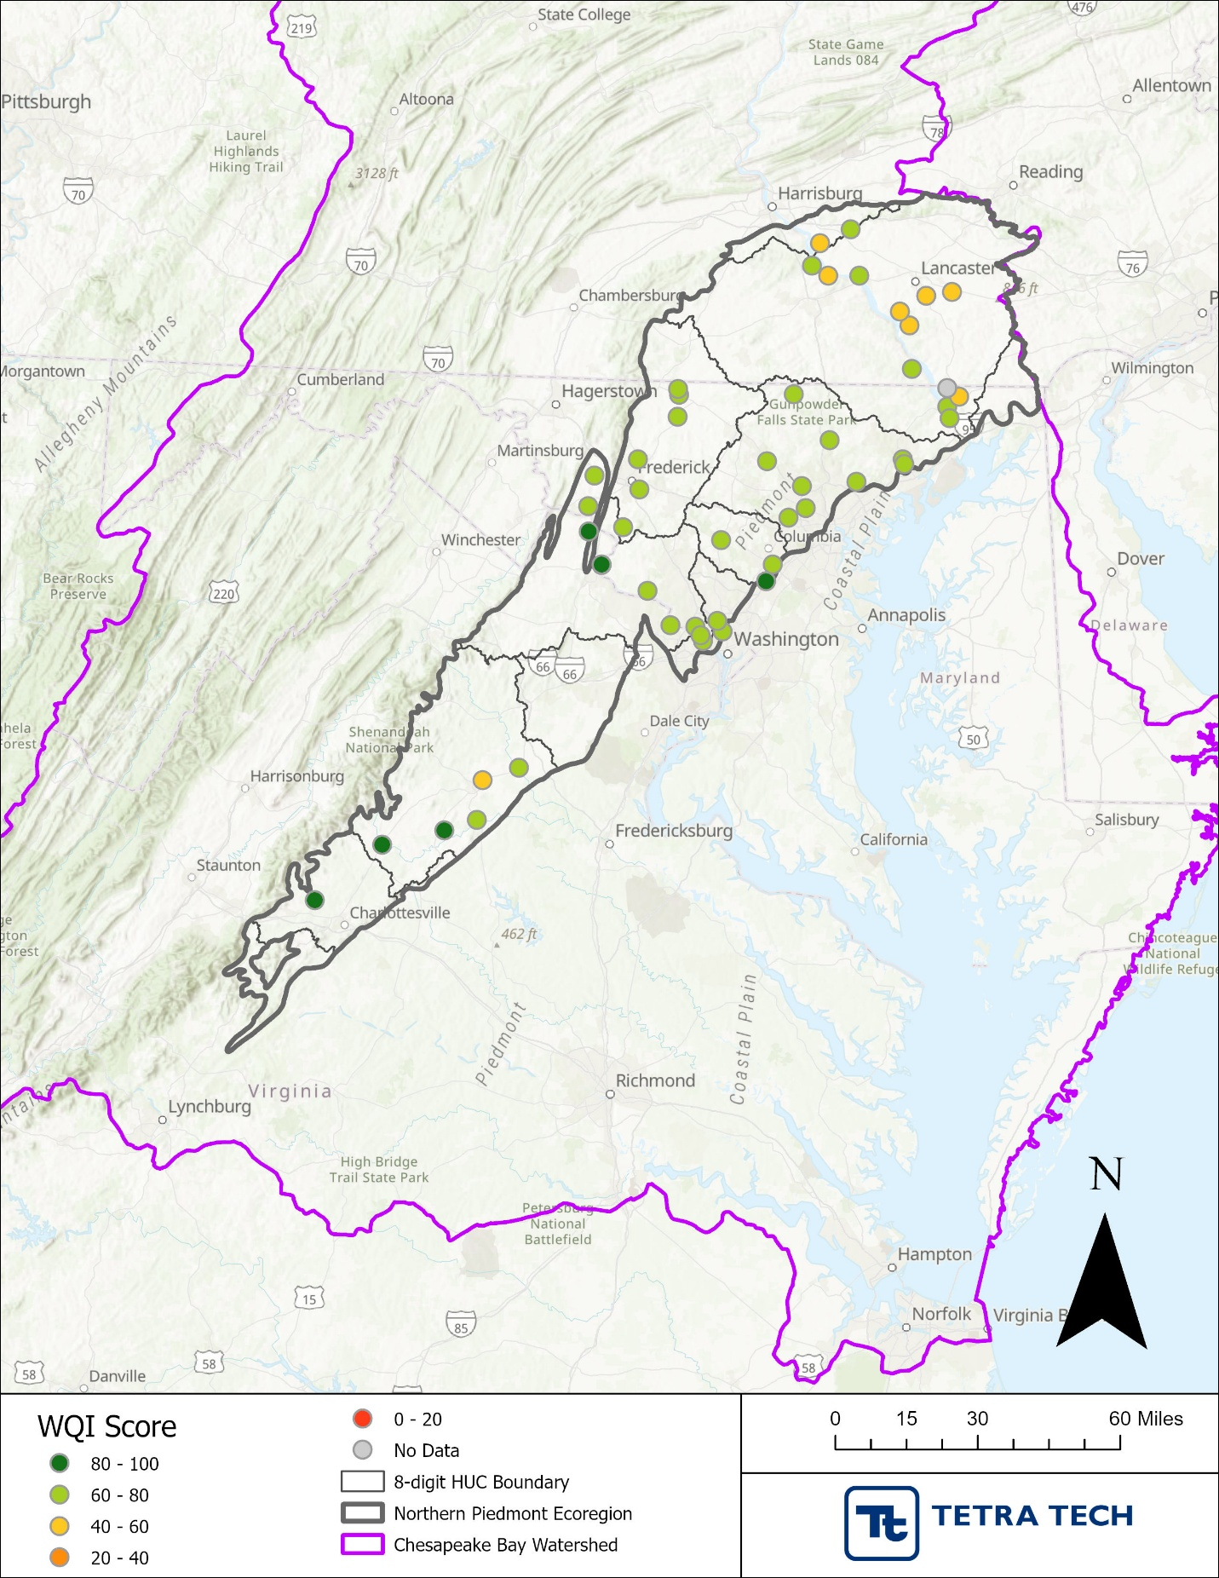Figure 8. 2020 WQI scores for monitoring stations in the Northern Piedmont ecoregion

Figure 9 shows overall WQI scores from 2014 to 2023 for the Northern Piedmont ecoregion and selected HUC-8 watersheds. Across the ecoregion, WQI scores were relatively stable, averaging around 66–70 with minor deviations. This regional trend reflects moderate water quality conditions overall, with slight improvements in recent years. Within the ecoregion, the three selected watersheds show distinct patterns. Rapidan-Upper Rappahannock consistently recorded the highest scores (approximately 70–75 early in the period, rising to near 80 by 2023), reflecting its predominantly forested land cover (less disturbed). Gunpowder-Patapsco exhibited gradual improvement from about 68 in 2014 to nearly 77 in 2023, while Lower Susquehanna maintained the lowest scores, fluctuating between 58 and 63 throughout the period. These differences suggest that land use strongly influences water quality, with forested watersheds achieving better conditions than those dominated by agriculture or urban development.
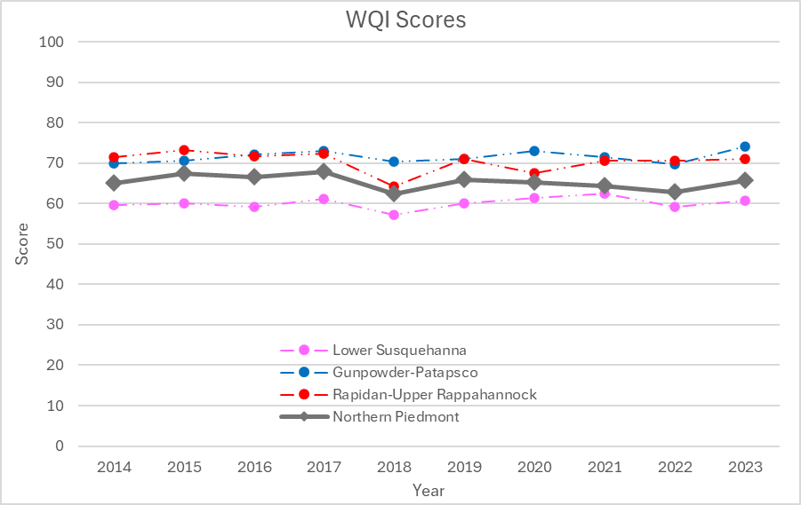
Figure 9. WQI scores for the Northern Piedmont and three selected watersheds from 2014–2023

Category-level WQI scores for the Northern Piedmont ecoregion reveal clear differences among stressor types from 2014 to 2023 (see Figure 10). Habitat scores (temperature, dissolve oxygen and total suspended solids) were consistently high (around 81–87), indicating relatively stable parameter conditions, while salinization scores (pH and conductivity) remained moderate and steady near 73–75. Nutrient enrichment (TP and TN) had the lowest scores, fluctuating between 40 and 53, suggesting persistent nutrient-related challenges. Human health scores declined to near 50, reflecting increased variability in fecal coliform levels. Nutrient enrichment and human health (fecal waste) were therefore the primary drivers of lower water quality scores for the ecoregion.

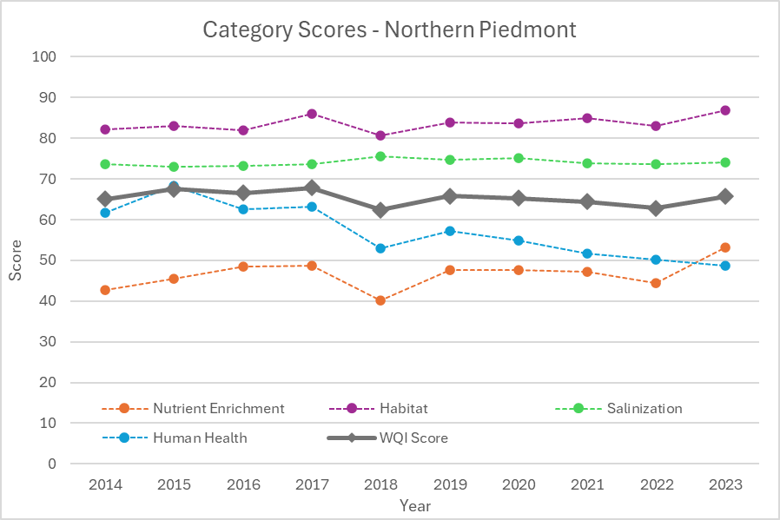
Figure 10. Category-level indicator scores for the Northern Piedmont ecoregion from 2014–2023. Nutrient Enrichment: total phosphorus and total nitrogen; Habitat: dissolved oxygen, temperature and total suspended solids; Salinization: pH and conductivity; Human Health: fecal coliform.

Figure 11 illustrates category scores for Rapidan-Upper Rappahannock, Gunpowder-Patapsco, and Lower Susquehanna watersheds. Higher overall WQI scores in the Rapidan-Upper Rappahannock watershed WQI scores (70–80) are driven by strong salinization scores (near 90) and stable habitat parameter scores (around 80–85). Nutrient enrichment and human health categories were more variable, with nutrient scores ranging from 50 to 65 and human health scores declining after 2016. In the Gunpowder-Patapsco watershed (moderate overall WQI scores: 68–76), the habitat score was consistently high (85–90) and salinization scores were steady near 75; however, nutrient enrichment remained lower (50–65) and human health fluctuated widely. For the Lower Susquehanna watershed, lower overall WQI scores (58–63) were driven by persistently low nutrient enrichment scores (20–32). Nutrient enrichment is the most limiting factor across all watersheds, particularly in agricultural landscapes, while urban watersheds potentially face additional challenges related to human health indicators associated with fecal waste.

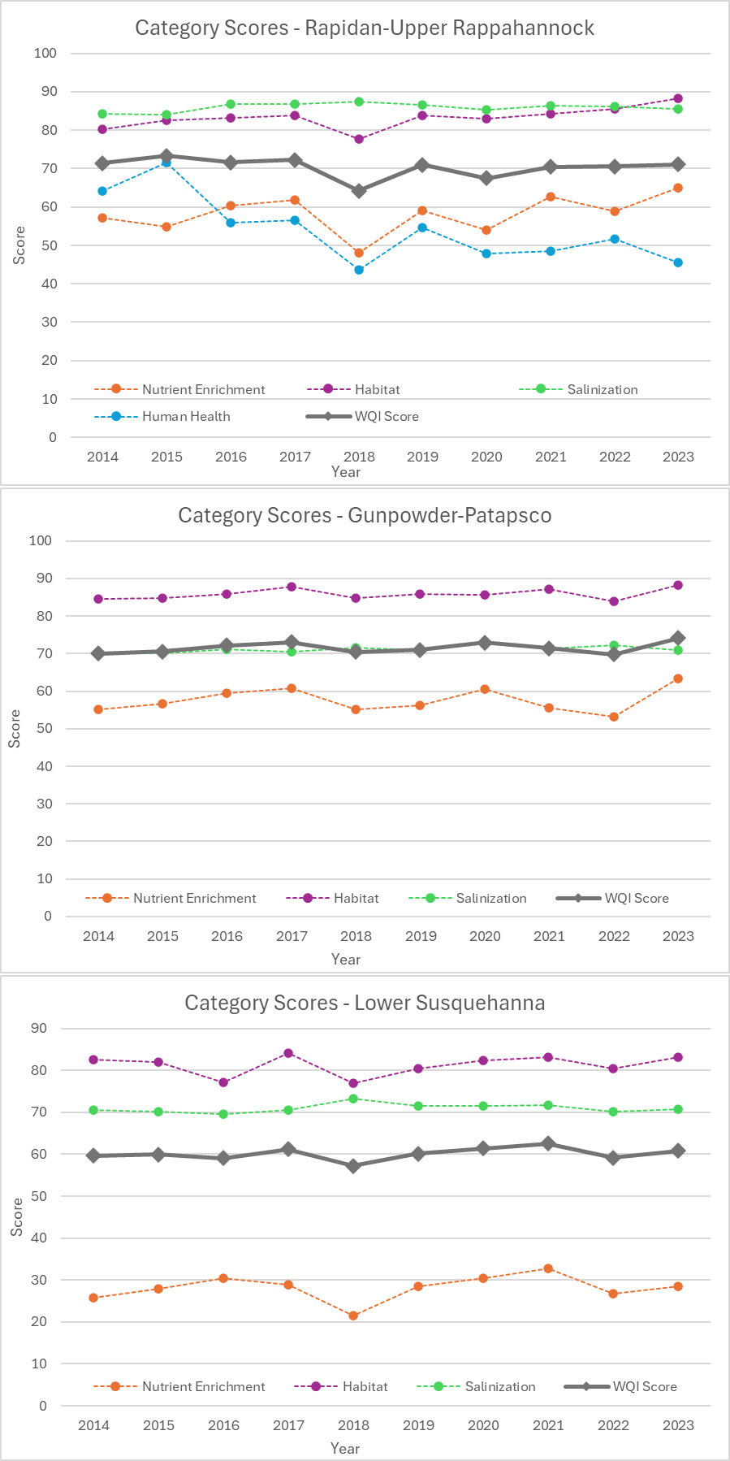
Figure 11. Category-level indicator scores for Rapidan-Upper Rappahannock (top), Gunpowder-Patapsco (middle), and Lower Susquehanna watersheds (bottom) from 2014–2023. Note: No fecal coliform data (human health) was available for the Gunpowder-Patapsco and Lower Susquehanna watersheds.

Comparison of WQI and Chessie BIBI Scores

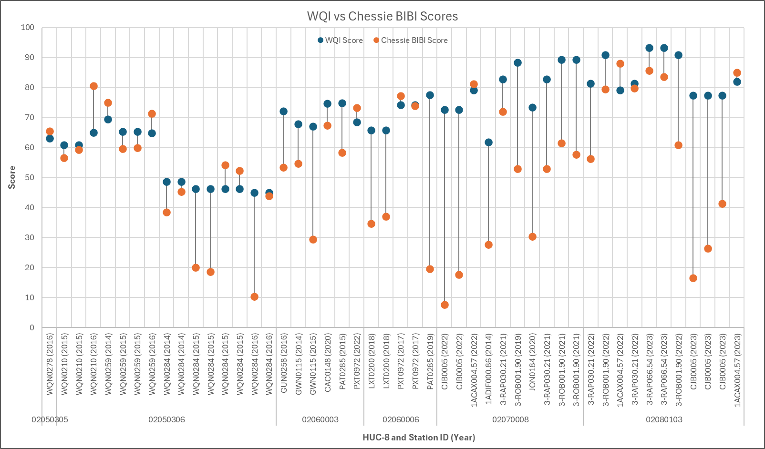
WQI scores and Chessie BIBI scores were compared across multiple stations, selected watersheds, and years in the Northern Piedmont ecoregion. Figure 12 displays the scores at specific water quality stations. WQI scores ranged from approximately 40 to 95, while BIBI scores exhibited greater variability, spanning from 0 to about 80. A clear pattern emerged—stations with higher WQI scores generally corresponded to higher BIBI scores, indicating a positive relationship between physicochemical water quality and biological integrity. However, several stations with moderate WQI scores (40–75) showed very low BIBI scores (<20), suggesting that factors beyond the measured water quality parameters—such as physical habitat quality or flow alteration—may influence benthic communities at these locations. Across all stations, WQI scores generally trended higher than Chessie BIBI scores, which exhibited greater variability and more frequent low values.
Figure 12. Comparison of WQI and Chessie BIBI scores across applicable stations (n = 17) and years in the Northern Piedmont ecoregion. Note: Not all water quality stations had comparable Chessie BIBI scores. WQI scores reflect averages at applicable stations.

At the HUC-8 watershed scale, annual WQI scores and Chessie BIBI scores were estimated (arithmetic mean based on all data) and compared across the Lower Susquehanna, Gunpowder-Patapsco and Rapidan-Upper Rappahannock watersheds. Figure 13 displays the results for each watershed. Clear differences emerge in how land use influences the relationship between WQI and Chessie BIBI scores. The Rapidan-Upper Rappahannock watershed, which is predominantly forested (55%), consistently showed higher, comparable WQI (75–81) and Chessie BIBI scores (65–85). In contrast, estimated WQI scores for the more urban (36%) Gunpowder-Patapsco (~70-75) improved slightly over time but BIBI scores (30–44) were persistently low, suggesting that water quality improvements may not offset habitat and hydrological stressors associated with urban land use. The Lower Susquehanna watershed, dominated by agriculture (49%), exhibited consistent WQI scores between 2014 and 2023 (high 50s to low 60s) but highly variable BIBI scores (increasing to ~68 in 2020, <40 in 2022, ~50 in 2023), possibly due to habitat stress from agricultural production.
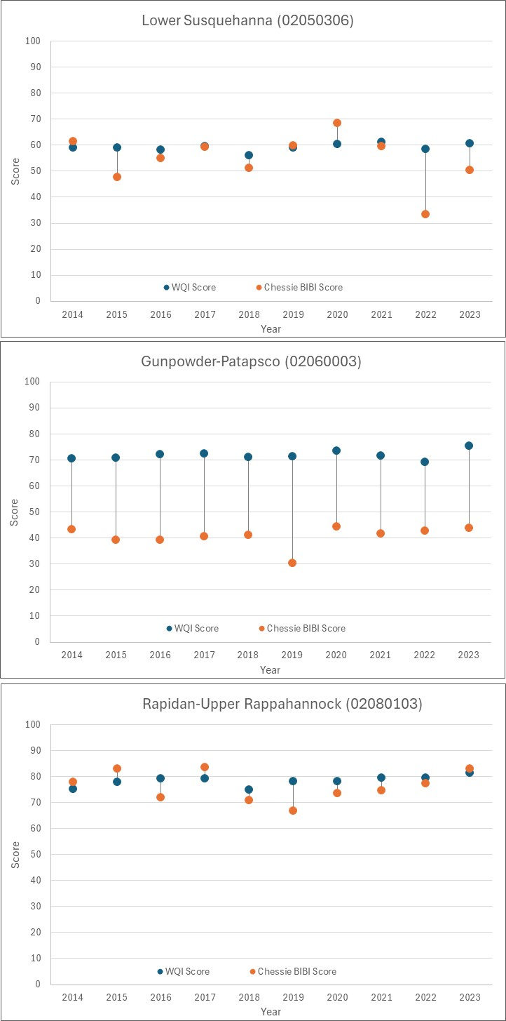
Figure 13. Trends in WQI and Chessie BIBI scores for the Lower Susquehanna watershed (top), Gunpowder-Patapsco (middle) and Rapidan-Upper Rappahannock (bottom) watersheds from 2014–2023.
The divergences between indicator scores highlights the complexity of linking physicochemical indicators to biological outcomes in diverse landscapes. Comparing a WQI with biological integrity indices like the Chessie BIBI introduces several layers of uncertainty. WQI aggregates physicochemical parameters into a single score, necessarily emphasizing the physicochemical conditions included. In contrast, BIBI reflects the health of benthic macroinvertebrate communities, which respond to a broader suite of stressors, including habitat structure, flow regime, sedimentation, and thermal variability. These differences mean that improvements in WQI scores may not always translate into higher BIBI scores, as biological responses can often lag behind water quality changes or be constrained by physical habitat degradation. At the same time, physicochemical indicators can be complementary to biological and hydromorphological indicators and provide for a more robust overall assessment of stream health.
- Bibliography

Austin, S.H., M.J. Cashman, J.W. Clune, J.E. Colgin, R.M. Fanelli, K.P. Krause, E. Majcher, K.O. Maloney, C.A. Mason, D.L. Moyer, and T.M. Zimmerman. 2023. Tracking Status and Trends in Seven Key Indicators of Stream Health in the Chesapeake Bay Watershed. Fact Sheet 2023-3003. USGS. https://doi.org/10.3133/fs20233003
https://www.usgs.gov/publications/tracking-status-and-trends-seven-key-indicators-stream-health-chesapeake-bay-watershed

Banda, T.D., and M.V. Kumarasamy. 2019. Development of Water Quality Indices (WQIs): A review. Pol. J. Environ. Stud. 29:3. https://doi.org/10.15244/pjoes/110526.

Berry, J.L., L.Y. Steffy, and M.K. Shank. 2020. Development of a Water Quality Index (WQI) for the Susquehanna River Basin. Publication No. 322. Susquehanna River Basin Commission. https://www.srbc.gov/our-work/reports-library/technical-reports/322-water-quality-index-2020/docs/water-quality-index-2019.PDF.

Brown, D. 2016. Oregon Water Quality Index: Background, Analysis and Usage. Oregon Department of Environmental Quality, Laboratory and Environmental Assessment Program, Hillsboro, OR. https://www.oregon.gov/deq/FilterDocs/wqmreportingmethodsF.pdf

Chesapeake Bay Program. (n.d.). CBP Water Quality Database (1984-present). Chesapeake Bay Water Quality Database. https://www.chesapeakebay.net/what/downloads/cbp-water-quality-database-1984-present

Chesapeake Progress. 2025. Water Quality Standards Attainment and Monitoring. https://www.chesapeakeprogress.com/clean-water/water-quality

Clune, J., J.E. Colgin, and T.M. Zimmerman. 2023. Compilation of multi-agency water temperature observations for streams within the Chesapeake Bay watershed. USGS.
https://www.usgs.gov/data/compilation-multi-agency-water-temperature-observations-streams-within-chesapeake-bay

Fanelli, R.M., A.J. Sekellick, and W.B. Hamilton. 2023. Compilation of multi-agency specific conductance observations for streams within the Chesapeake Bay watershed. USGS.
https://www.usgs.gov/data/compilation-multi-agency-specific-conductance-observations-streams-within-chesapeake-bay

Hallock, D. 2002. A Water Quality Index for Ecology’s Stream Monitoring Program. Publication No. 02-03-052. Washington Department of Ecology, Environmental Assessment Program, Olympia, WA. https://apps.ecology.wa.gov/publications/documents/0203052.pdf

Harman, W., R. Starr, M. Carter, K. Tweedy, M. Clemmons, K. Suggs, and C. Miller. 2012. A Function-Based Framework for Stream Assessments and Restoration Projects. EPA 843-K-12-006. U.S. EPA, Office of Wetlands, Oceans, and Watersheds, Washington, DC. https://www.epa.gov/sites/default/files/2015-08/documents/a_function_based_framework_for_stream_assessment_3.pdf.

Innovate, Inc. 2023. Revisiting the Chesapeake Healthy Watersheds Assessment: Updated Health and Vulnerability Assessments for Catchments within the Chesapeake Bay Watershed. Prepared by Innovate!, Inc. for Chesapeake Bay Program, Maintain Healthy Watersheds Goals Implementation Team. https://d18lev1ok5leia.cloudfront.net/chesapeakebay/documents/CHWA_FinalReport_ForPublic.pdf

Kachroud, M., F. Trolard, M. Kefi, S. Jebari, and G. Bourrié. 2019. Water Quality Indices: Challenges and Application Limits in the Literature. Water 11:361. https://doi.org/10.3390/w11020361

Maheu, A., N.L. Poff, and A. St-Hilaire. 2016. A Classification of Stream Water Temperature Regimes in the Conterminous USA. River Research and Applications 32:896-906. https://doi.org/10.1002/rra.2906.

Maloney, K.O., Carlisle, D.M., Buchanan, C., Rapp, J.L., Austin, S.H., Cashman, M.J., and J.A. Young. 2021. Linking Altered Flow Regimes to Biological Condition: an Example Using Benthic Macroinvertebrates in Small Streams of the Chesapeake Bay Watershed. Environmental Management 67, 1171–1185. https://doi.org/10.1007/s00267-021-01450-5

Multi-Resolution Land Characteristics (MRLC) Consortium. 2019. National Land Cover Database 2019 (NLCD2019). https://www.usgs.gov/centers/eros/science/national-land-cover-database

Roth, N., B. Pickard, M. Southerland, and P. Hobaugh. 2022. Maryland Healthy Watersheds Assessment: Applying Health and Vulnerability Assessments to Maryland’s Tier II Waters. Prepared by Tetra Tech, Inc., Owings Mill, MD, for Chesapeake Bay Program, Maintain Healthy Watersheds Goal Implementation Team, Annapolis, MD. https://www.chesapeakebay.net/files/documents/MDHWA_FINAL-2022-07-15_updated-2022-12-19.pdf.

Southerland, M., R. Murphy, P. Hobaugh, J. Roberts, K. Somers, N. Roth. 2024. “Framework for
Monitoring Plastic Pollution in the Chesapeake Bay.” Annapolis, MD. Tetra Tech. 51p.

Syeed, M.M.M, M.S. Hossain, M.R. Karim, M.F. Uddin, M. Hasan, and R.H. Khan. 2023. Surface water quality profiling using the water quality index, pollution index and statistical methods: A critical review. Environmental and Sustainability Indicators 18:100247. https://doi.org/10.1016/j.indic.2023.100247

Uddin, M.G., S. Nash, and A.I. Olbert. 2021. A review of water quality index models and their use for assessing surface water quality. Ecological Indicators 122:107218 https://doi.org/10.1016/j.ecolind.2020.107218

UMCES (University of Maryland Center for Environmental Science). 2025. ECO Health Report Cards: Chesapeake Bay Watershed Health. https://ecoreportcard.org/report-cards/chesapeake-bay/watershed-health/.

U.S. Environmental Protection Agency. 2003. Developing Water Quality Criteria for Suspended and Bedded Sediments (SABS). Potential Approaches. Draft.

U.S. Environmental Protection Agency. 2021. Download Preliminary Healthy Watersheds Assessments. https://www.epa.gov/hwp/download-preliminary-healthy-watersheds-assessments.

U.S. Environmental Protection Agency 2024a. Ecoregions Publications. https://www.epa.gov/eco-research/ecoregions-publications

U.S. Environmental Protection Agency. 2024b. Factsheets on Water Quality Parameters. https://www.epa.gov/awma/factsheets-water-quality-parameters

U.S. Environmental Protection Agency. 2013. Level III and IV Ecoregions of the Continental United States (published 20130416), accessed July 14, 2025 at URL https://www.epa.gov/eco-research/level-iii-and-iv-ecoregions-continental-united-states

U.S. Environmental Protection Agency. 2024c. National Rivers and Streams Assessment: The Third Collaborative Survey. EPA 841-R-22-004. U.S. EPA, Office of Water and Office of Research and Development, Washington, DC. https://riverstreamassessment.epa.gov/webreport

U.S. Environmental Protection Agency. 2007. Rapid Biological Assessment Protocols: An Introduction. https://cfpub.epa.gov/watertrain/pdf/modules/rapbioassess.pdf.

U.S. Environmental Protection Agency. 2025. RPS Indicators. https://www.epa.gov/rps/overview-indicators.

U.S. Geological Survey. 2022. Watershed Boundary Dataset (refreshed 202506), accessed July 14, 2025 at URL https://www.usgs.gov/national-hydrography/watershed-boundary-dataset

Wertz, T. A., and M. K. Shank. 2019. Land use from water quality: development of a water quality index across Pennsylvania streams. Ecosphere 10(11):e02947. 10.1002/ecs2.2947

Appendix A. Meeting Minutes

Appendix B. Data and Parameters Spreadsheet

Appendix C. Data Matrix

