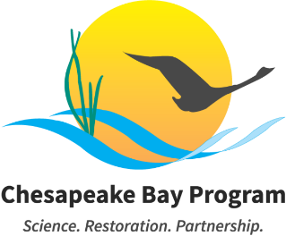

Education Workgroup – April 2026

April 6, 2026
10:00-11:30am EST

Example Meeting Link: Join the meeting via Zoom
Meeting ID: 829 2491 4650 Passcode: 871059
Call: +16469313860
Visit the meeting webpage for meeting materials and additional information.

This meeting may be recorded for internal use only to ensure the accuracy of meeting notes. To request accommodations, please contact Meredith Lemke at lemkem@chesapeake.org.

Compromised Meeting Plan: If the meeting's privacy is compromised, the meeting staffer and coordinator will send an email to all Members, alternates, staffers, coordinators, and interested parties. Within the email, you will find a new meeting link, instructions on sharing this information with external partners, and any necessary adjustments to the meeting schedule. Please do NOT share this information publicly or post it to the Chesapeakebay.net webpage.

Purpose: The purpose of this meeting is to discuss the purpose and structure of the 2026 Education Summit and how the outcomes will advance the development of our management strategies and workplans.

Agenda
- Welcome & Introductions 10:00 – 10:10
New members are welcome to introduce themselves and state leads are invited to provide updates in the table at the bottom of the agenda.
Non-decisional
Lead: Elise Trelegan, NOAA

- Education Summit Planning & Discussion 10:10 – 11:00
Workgroup members will recap the overarching goals and plan for the May Education Summit. State leaders will overview their individual agendas and invitation lists.
Non-decisional
Lead: Olivia Wisner, MDNR
Materials:
- Draft Education Summit Agenda (forthcoming)

- Chesapeake Bay Program Logistics & Management Strategy Brainstorm 11:00 – 11:15
Workgroup leadership will give an update on the next steps for development of management strategies and how this relates to the Education Summit.

Non-decisional
Lead: Meredith Lemke, CRC/CBP; Shannon Sprague, NOAA
Materials:
- Management Strategy Template Outline (Draft)

- Environmental Literacy Indicator Tool (ELIT) Survey 11:15 – 11:25
Workgroup leadership will provide an update on the 2026 ELIT Survey timeline and request that states identify any state-specific questions by June.
Non-decisional
Lead: Elise Trelegan, NOAA
Materials:
- Environmental Literacy Indicator Tool (ELIT)

- Wrap-Up 11:25 – 11:30
Workgroup staff will highlight action items and provide reminders about upcoming activities.

- Adjourn 11:30

NEXT MEETING: Monday, July 6th, 10:00-11:30am EST

State / Jurisdiction | State or Regional Capacity Building Update
Regional
VA
PA
NY
DC
MD
DE

