GDAT Log of Edits

November 16, 2022

Color Codes:
Green = Approved by MB, ready to incorporate into next version.
Blue = Approved by GIT 6, ready to go to MB
Yellow = Approved by GDAT, ready to go to GIT 6

Edit # | Subject | Page # | Issue and Status
1 | Quotes from Watershed Agreement | 4-5 | Issue: “Chesapeake Bay Program Vision and Principles” section on pages 4-5 are all direct quotes, but that is not obvious from the document. Add introductory sentence, the words, “Vision” and “Principles”, and quotation marks. Also, replace numbers for the 14 principles with bullets to reflect how they are presented in the Watershed Agreement and to avoid impression that some are more important than others.  Status: Approved by MB, 6/9/22
2 | Use of the word “citizen” | 6 | Issue: Use of the word “citizen” is exclusionary. Replace with “community”.  Status: Approved by MB, 6/9/22
3 | Roles of staff | 7 | Issue: Lack of recognition in the Governance Document of the critical role conducted by staff (all agency staff, not just EPA) was raised as a concern at the 2021 Biennial Meeting. On the other hand, there is concern about the inappropriateness of the partnership’s Governance Document dictating the responsibilities of agency employees. Is there a middle ground we can find that recognizes their contributions and generally defined their roles without impinging on an employer’s right to determine their staff’s activities?  Status: MB approved 6/9/22 following language to be added on page 7 immediately after Figure 1:  “The roles and responsibilities of the organizational units identified in Figure 1 are described in the appropriate sections of this Governance Document below. The Chesapeake Bay Program Office assigns staff time to assist in the critical coordination, administration, and technical support necessary for the efficient operation of organizational units.”
4 | Election of EC Chair outside of annual meeting | 8 | Issue: Current language on “Leadership and Management” of the EC (pg 8) is awkwardly written regarding process for election of EC Chair outside of the annual meeting.  Status: MB approved (6/9/22) following language to be added to “Leadership and Membership” section on page 8:  “2. Leadership and Membership - In the event that a new EC Chair must be selected at a time outside of the annual meeting, PSC members will act as a proxy for their EC member by soliciting their input. In such circumstances, a A decision will be made at the next PSC meeting on behalf of the EC. The decision will be memorialized in writing and signed by signatory representatives on the PSC on behalf of the EC members.”
5 | Clarifications of EC Operations | 9 | Issue: Advisory Committees requested clarification of EC Operations that EC respond to Advisory Committee recommendations within 90 days. Subsequent discussions with Management Board also requested clarification that these actions are required just 1/year to avoid confusion in cases in which EC meeting more than once in a year.  Status: Based on Management Board and GIT 6 input, GDAT approved (1/5/22) following changes:  - “Ground Rules: The structure of the EC meeting is coordinated by the Chair with assistance from the EPA CBPO under guidance of the full PSC. The format, location, and content (e.g., presentations, breakout sessions, participants, speaking roles, and other participation details) of the EC meetings are to be determined well in advance of the meeting to ensure it is efficient and effective. At one meeting per year, the EC will:  - elect or re-elect a Chair, and  - receive the annual recommendations of the Advisory Committees and direct the partnership to respond to the Advisory Committee recommendations within 90 days.”  Approved by MB, 6/9/22
6 | Use of the word “citizen” | 20 | Issue: Use of the word “citizen” is exclusionary. Replace with “residents” and “community” in separate locations.  Status: Approved by MB, 6/9/22
7 | Unavoidable absence from meetings | 22 | Issue: How to address the situation in which some members of a group cannot be present due to circumstances beyond their control (ex. federal government shutdown).  Status: Based on Management Board and GIT 6 input, GDAT approved (1/5/22) insertion of the following section under “Process for Decision-Making”:  “B. UNAVOIDABLE ABSENCE FROM MEETINGS  In a situation such as a government shutdown, state of emergency, or other extraordinary circumstance beyond a member organization’s control that prohibits a representative of the member organization from participating in a previously scheduled meeting, the meeting may still occur for the purposes of updating attending members; however, any decisional items must be deferred.”  Approved by MB, 6/9/22
8 | Use of the word “citizens” in the Management Strategies section. | 26 | Issue: Use of the words “citizen” and “citizens” is no longer appropriate.  Status: GDAT approved following language change:  “Participation in Management Strategies or in the achievement of Outcomes is expected to vary based on differing priorities across the watershed. This participation may include sharing knowledge, data or information, educating citizens or members stakeholders, working on future legislation and developing or implementing programs or practices.”  GIT 6 did not approve above changes at their 3/16/22 meeting. Instead referred back to GDAT. There was concern that the word “stakeholder” is not common term with the public. GDAT discussed at 4/6/22 and 4/20/22 meetings and agreed (4/20) on the following for forwarding back to GIT 6:  “This participation may include actions such as sharing knowledge, data or information, educating citizens or members of the community, working on future legislation and developing or implementing programs or practices.”  Approved by GIT 6, 6/8/22  Approved by MB, 7/14/22
9 | Diversity WG recommended changes to GIT Membership | 14-15 | Issue: Diversity WG recommended several changes to GIT Membership criteria and discussed with GIT 6 at 3/16/22 meeting.  See Attachment 3 for specifics.  Status: GDAT and members of Diversity WG discussed on April 6, 2022. Resulting edits approved by GDAT and ready for submission to GIT 6 at June 8, 2022 meeting are presented in Attachment 3.  Approved by GIT 6, 6/8/22  Approved by MB, 7/14/22
10 | Replace “Chairman” or Chairmanship” | 9  14 | Issue: At their 3/16/22 meeting, GIT 6 suggested replacing the words “Chairman” or Chairmanship”.  Status: Subsequent search of Version 4.0 revealed that the word “Chairman” no longer exists in the Governance Document. All instances have been replaced with “Chair”. However, the word “Chairmanship” appears 4 times: once on page 9 (EC section) and 3 times on page 14 (GIT section).  At the 4/20/22 GDAT meeting, GDAT approved the following changes to be forwarded to GIT 6 at the 6/8/22 meeting:  “Federal members serve for the duration of their appointment to their agency, The Chesapeake Bay Commission (CBC) Chair serves for the duration of their chairmanship term.” (pg 9)  “At the end of a two-year term, the GIT collectively discusses the renewal or change of their Chairmanship, Vice-Chairmanship or Co-Chairmanship the Chair’s, Vice-Chairs’ or Co-Chairs’ leadership terms. Both the GIT and the MB must concur on the renewal of the Chair, Co-Chair or Vice-Chairs. The renewal of a Chair or Co-Chairs will have the concurrence from both the GIT and the MB. (pg 14).  Approved by GIT 6, 6/8/22  Approved by MB, 7/14/22
11 | Use of the word “citizen(s)” | 4  5  15  20  21 | Issue: In addition to the three cases in Issue #3 above, there are several other locations in which the term “citizen” or “citizens” appear in the Governance Document which have not been resolved:  - Pg 4 (2X): quotes from Watershed Agreement  - Pg 5 (1X): quotes from Watershed Agreement  - Pg 15 (1X): “Citizens Advisory Committee”  - Pg 20 (1X): “Citizens Advisory Committee”  - Pg 21 (1X): URL for “Citizens Advisory Committee”  Status: Three instances on pages 4-5 are exact quotes from Watershed Agreement and have been addressed via Issue #6 above.  Three instances on pages 15, 20, and 21 are on hold pending recommendations from Citizens Advisory Committee discussions.  At 3/16/22 GIT 6 meeting, it was agreed that changing the name of the Citizen’s Advisory Committee probably requires EC action.  Edits on pages 4 and 5 were approved by EC on 10/11/22 and should be updated in Governance Document.  Edits on pages 15, 20, and 21 are still pending
12 | Alternative Decision-Making | 21(?) | Issue: Page 21 states that although consensus is the preferred decision-making process, “There are, however, situations in which consensus is inappropriate or in which consensus is not necessary for progress to be made.” With the exception of super-majority votes for EC, PSC, and MB, the document does not identify other situations in which consensus is inappropriate. Do they exist? If so, we should identify and describe them?  Status: See Attachment 1 provided by Greg A for further discussion.  Further discussion at 2/16/22 identified three options:  Option A: It is not a big problem now, so “park it” - i.e. leave unchanged unless and until it becomes an issue and/or to be addressed if we have a new Watershed Agreement.  Option B: Add text after the above sentence on page 21 which says something like, “Alternatives to consensus (ex. simply majority vote or leadership decision) are appropriate in situations in which, a) the stakes (consequences) are low, b) time does not allow for reaching consensus, c) the vote / decision is open and transparent, AND, d) the program’s “Ethical Behavior Guidelines” are followed.  Option C: Delete the sentence, “There are, however, situations in which consensus is inappropriate or in which consensus is not necessary for progress to be made.” from the Governance Document (pg 21).
13 | GIT / Workgroup Chair membership |  | Issue: Should GIT and Workgroup Chairs be members of the GIT / Workgroup? The Governance Document is silent.  Status: GDAT (10/13/21) discussed that many (most) GITs and WGs have always operated as if the chairs are members. However, others have raised the point that some groups have assumed that the chairs are NOT members in order to allow for neutrality.  The “Ethical Behavior Guidelines” section (pg 6) currently states,  “Chairs and Co-Chairs of meetings are expected to be particularly sensitive to potential conflicts of interest by themselves resulting from decisions of the group and conduct the meetings and their input accordingly.”  Is this language sufficient, does is need to be modified, or do we need a new section specifically saying whether or not chairs and co-chairs are members?
14 | Clarification on process for approval and issuance of EC Directives | 24 | Issue: Kevin Dubois requested consideration of additional language and time for review and approval of proposed EC Directives. See Attachment 2 below for Kevin’s proposed edits which would appear on page 24 of Version 4.0.  Status: Is this an issue for the Governance Document or for FOD to address? Carin will bring to FOD when appropriate and report back.
15 | Additional DEIJ Language |  | Issue: Version 4.0 included many proposed DEIJ additions but not all that have been identified in the DEIJ Implementation Plan. The un-addressed edits need to be discussed.  Status: Dave should follow-up with Bo to generate a list of the additional edits and recommended text.
16 | Tribes |  | Issue: How / should we address native American tribes in the Governance Document?  Status: This may be a long-term issue that is out of our control. We should keep this on our list, but not expect any direction in the immediate future.
17 | Management Strategies Section | 26 | Issue: The last several sections of Version 4.0 (Sections VI – XI) are all focused on “process” with the exception of Section IX (Management Strategies). Section IX is out of place and should be moved elsewhere.  Status: This was discussed at the 4/20/22 GDAT meeting. In addition to the above, there were other concerns with this section. In particular, In particular, the 2nd paragraph which seems to confound (or at least not be clear) on the role/intent of the signatories vs the strategies themselves. A couple initial edits discussed (but not finalized) in the first couple sentences were:  “Participation in Management Strategies or and in the achievement of Outcomes is expected to vary by signatory based on differing priorities across the watershed. This Signatory participation may include…”  Carin is going to work on revisions to this section and come back to GDAT for discussion at 5/4/22 meeting.
18 | Use of the word, “stakeholder(s)” | 4 (2x)  19  20 (2x)  26 (4x)  27 | Issue: There is concern that the word “stakeholder(s)” a) is not in common usage anymore, and b) is interpreted by some to suggest those who have a monitory interest in the Bay and, therefore, is exclusionary.  The word occurs 10 times in the current version of the Governance Document. Do we want to replace it?
19 | GIT Leadership and Membership section | 14-15 | Issue: Current language on GIT Leadership and Membership is very wordy and confusing. Can it be made simpler to understand? Perhaps including use of a flow-chart or table?  Status: Dave will work on alternative language for discussion at 5/4/22 GDAT meeting.

ATTACHMENT 1

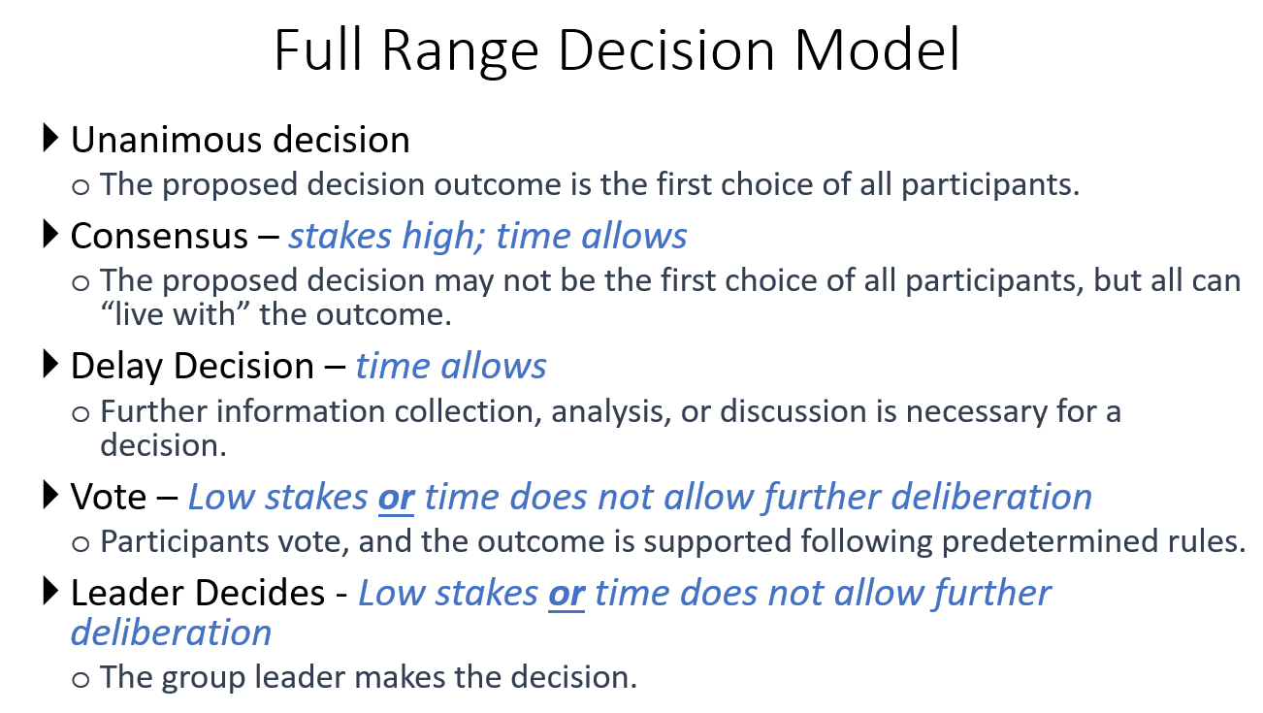

ATTACHMENT 2

Kevin Dubois proposed edits to “Process for Issuance of Executive Council Directives” (Version 4.0, page 24):

“Process for Issuance of Executive Council directives:
EC directives specify the will of the EC on future actions that the Chesapeake Bay Program partnership should undertake. EC directives do not necessarily represent a commitment of resources by any individual EC member, but rather define the collective desire of the EC for work by the partnership.

Proposed EC directives are first submitted to MB for approval. If approved by the MB, the MB will be directed to immediately coordinate with their PSC representative and brief the MB-approved directive up to their leadership to identify any issues that would inform approval, amendment, or dissent during the PSC review. Regardless of meeting schedule, the MB will have at least one month to accomplish this coordination. After the 31-day review period, the directive, informed by the coordination, will be scheduled for review and discussion at the next available PSC meeting. the directive is then forwarded to the PSC for approval. The proposed directive must be received by the PSC at least 2 weeks in advance of the PSC meeting at which it will be discussed. After discussion, all PSC members will be given 30 days to coordinate with their respective EC member. At the next available PSC meeting following coordination with EC members, the PSC will be polled for the record on a) their EC member’s position on issuance of the directive as per the CBP Consensus Continuum and, b) their EC member’s commitment to sign the directive no less than one month in advance of the EC meeting.”

ATTACHMENT 3 (#1 of 2)
Following are edits proposed by Diversity WG and approved by GDAT for consideration by GIT 6 at their June 8, 2022 meeting.
- Leadership and Membership: Each GIT has either one Chair and one Vice Chair, or Co-Chairs. While the Chair, Vice Chair or Co-Chairs can be from federal or state agencies or from organizations such as NGOs, at all times either the Chair, Vice Chair or one Co-Chair must be from federal or state agencies. GIT Chairs are non-voting members of the MB. GIT Chairs, Vice Chairs or Co-Chairs serve two-year renewable terms, with concurrence of the MB. New GIT Chairs, Vice Chairs or Co-Chairs will be designated by the MB with recommendations from GIT members, taking into consideration the partnershp’s DEIJ goals and commitments to increase the diversity of its leadership. At the end of a two-year term, the GIT collectively discusses the renewal or change of their Chairmanship, Vice-Chairmanship or Co-Chairmanship. The renewal of a Chair or Co-Chairs will have concurrence from both the GIT and the MB. Otherwise, the Vice-Chair assumes the role of Chair with concurrence from the GIT and the MB, and the new Vice-Chair will be selected by GIT members. In the event that the Vice-Chair declines the nomination, the GIT will nominate a new Chair and gain concurrence from the MB. In the case of a Co-Chair arrangement, it is preferable that one of the Co-Chairs remains in place and a new Co-Chair is brought in at either the one-year or three- year point in time in order to stagger leadership transition and offer consistency for the team. The GIT Chair is responsible for coordinating with the MB on strategic plans for achieving high-priority restoration outcomes as well as periodically providing updates to the MB on progress and roadblocks encountered through the SRS process. The MB works closely with GIT leaders while also empowering them to have the greatest discretion possible over short-term adjustments to execution of strategic plans to allow quick adaptations to changing internal and external circumstances. The Chairs and Vice Chairs, or Co-Chairs, shall be individuals representing agencies with significant authority in that GIT’s topic area and those individuals should be at a management level or leaders within their organization.

The GITs and their respective workgroups strive to maintain a membership that appropriately represents the signatories to the Agreement, Advisory Committees, expertise in the field, people at various points in their careers, federally and state recognized tribes and the diversity of ethnicities and cultures, including people of color and underrepresented groups in the watershed. Membership should be based on the following construct to the maximum extent possible (Table 1):
- Members from each signatory (oOne each with an alternate identified. In order to encourage future succession planning and more diverse representation, either the full member or the alternate should be an emerging leader within the organization.) (9)
- At-large members (up to 6 with option to identify an alternate)
- One advisor from each GIT Workgroup (invited)
- One advisor from each CBP Advisory Committee (invited)

ATTACHMENT 3 (#2 of 2)
Following are “implementation” recommendations by the Diversity WG. Purple are notes from March 16, 2022 GIT 6 Meeting