Proposed Locations/Justification for Future Hypoxia Buoy Locations

These locations were chosen through careful deliberation and consideration over several factors, including scientific, management, and logistical. The following were heavily considered when making decisions:
Logistical:
- Maximizing data collection - locations where hypoxia data is most valuable
- Buoy safety - locations that minimize the potential for boat strikes
- Maintenance factors - locations that are more environmentally and physically efficient to service during trips
Scientific and Management:
- Spatial area/depths - covering different areas and depths to ensure that adequate area is sampled
- Continuity with previous sites
- Locations with habitat restoration focus and modeling focus

Proposal: NCBO team presents the options for 5-7 stations within the Choptank and Potomac geographies

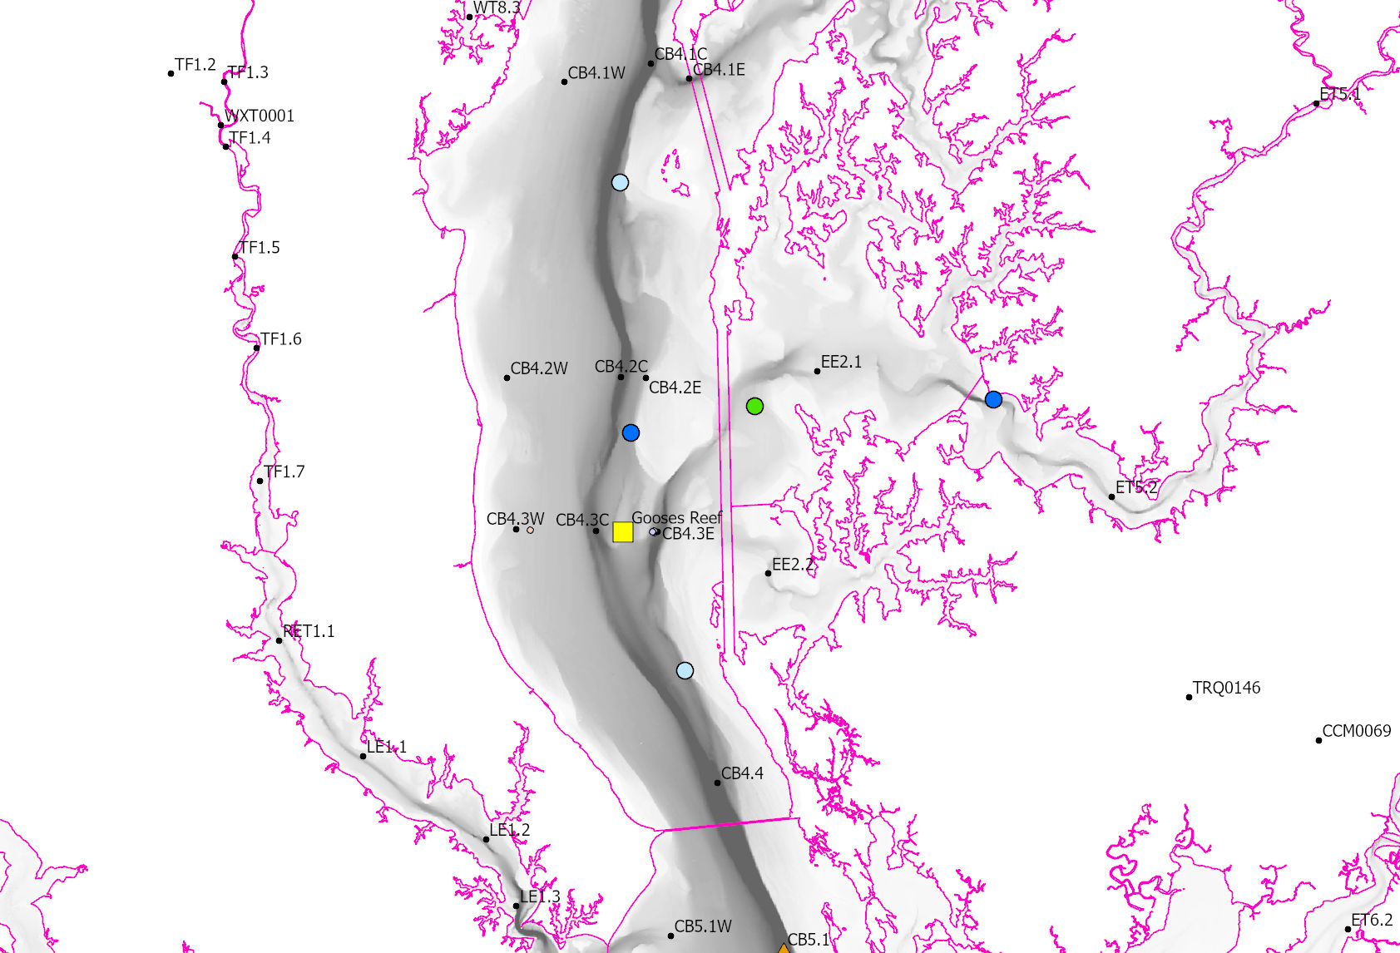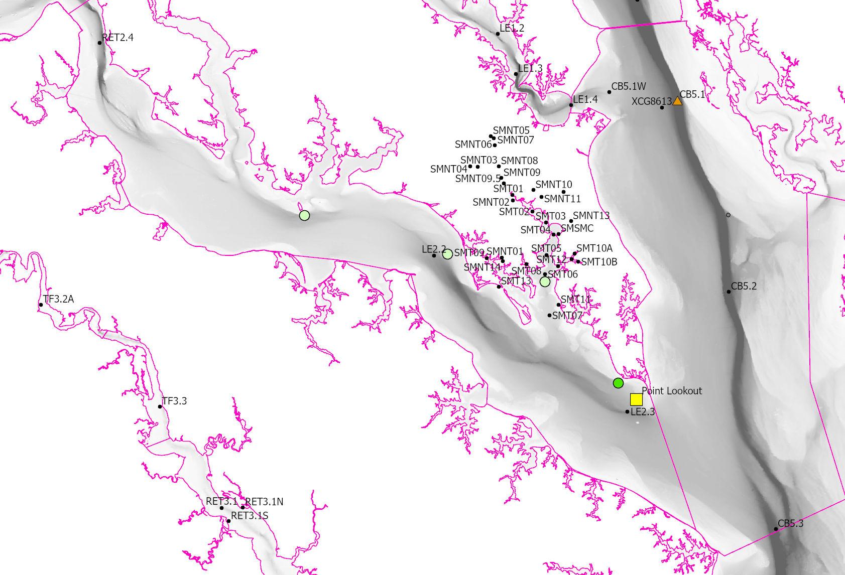
Map of Proposed Locations

Choptank: 3 stations; main-bay off the mouth of the Choptank and 2 stations within the Choptank.
Location Specific Justification: Diversity of water depths, coverage of spatial area, habitat variability
Lower Potomac: 1-2 stations; repeat of last year's station and upstream station that includes the Saint Mary’s.
Location Specific Justification:
Feedback Requested: At this stage we are asking for the identification of “fatal flaws” or “strong objections.” As mentioned, these sites were chosen based on large numbers of considerations, including maintenance. Please be prepared to come to the next Hypoxia Meeting (Monday March 4, 2024 from 2:00 pm - 3:30 pm with any feedback or objections.

