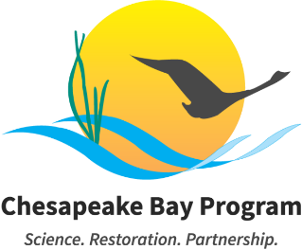

Education Workgroup – January 2025

January 5, 2025
10:00-11:30am EST

Meeting Link: Join the meeting via Zoom
Meeting ID: 829 2491 4650 Passcode: 871059
One tap mobile: +13017158592,,82924914650#,,,,*871059#
Visit the meeting webpage for meeting materials and additional information.

This meeting may be recorded for internal use only to assure the accuracy of meeting notes.
To request meeting accommodations, please contact Meredith Lemke at lemkem@chesapeake.org.

Please read the following information carefully, as our meeting policies have changed:
- All meeting attendees' cameras and microphones will be muted at the start of the meeting until participants are verified.
- Compromised Meeting Plan: If the meeting is interrupted by spam users or technical difficulties, the meeting staffer and coordinator will send an email to all Members, alternates, staffers, coordinators, and interested parties. Within the email, you will find a new meeting link, instructions on sharing this information with external partners, and any necessary adjustments to the meeting schedule. Please do NOT share this information publicly or post it to the Chesapeakebay.net webpage.

AGENDA
Purpose: The purpose of this meeting is to discuss the purpose and structure of the 2026 Education Summit.

Welcome & Introductions 10:00 – 10:10
Welcome new members! State leads please provide updates in the table at the bottom of the agenda.
Lead: Meredith Lemke

Watershed Agreement / Chesapeake Bay Program Update 10:10 – 10:15
Workgroup leadership will give an update on the adoption of the revised Watershed Agreement and next steps for the partnership related to structure/governance and the development of Management Strategies.
Lead: Shannon Sprague
Requested Action: Informational

Environmental Literacy Summit Planning & Discussion 10:15 – 11:25
Workgroup members will discuss logistics and agenda development for the upcoming Education Summit. There will be an opportunity for states to discuss:
- What state priorities would you like to advance in each outcome area? Who do you need in attendance to help you accomplish it?
- What examples/models/data would you like to include in the opening presentation for each outcome?
Leads: Olivia Wisner, Elise Trelegan, Shannon Sprague
Materials: Discussion Document
Requested Action: Decisional related to Summit purpose, format, and overarching agenda structure.

Wrap-Up 11:25 – 11:30
Workgroup staff will highlight action items and provide reminders about upcoming activities.
NEXT MEETING: Monday, April 6th 10:00-11:30
Lead: Meredith Lemke
Requested Action: Informational

Adjourn 11:30

UPDATES

State / Jurisdiction | State or Regional Capacity Building Update
Regional | ELIT update
VA
PA
NY
DC
MD
DE

