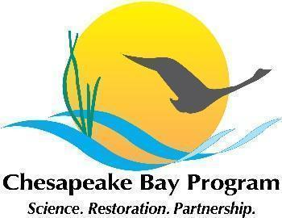

Maryland Oyster Restoration Workgroup Meeting Notes
March 18 2024, 9:30am-12:30pm

Video call link: https://meet.google.com/wcr-jcxd-aiv

Or dial: (US) +1 971-770-2791‬ PIN: 635 416 126‬#‬‬

Agenda

-Welcome, and note that this is a public meeting
-Shout out to DNR for this great piece on oyster restoration
-All-but-finished 2023 Annual Update review. Stephanie and Andrew Button (VMRC) will be presenting this info to the Fish GIT on Wednesday.
-Manokin spat study update and discussion
-2023 monitoring data
-Planning for 2024 seeding season
-Planning for fall 2024 monitoring
-Other business and updates

