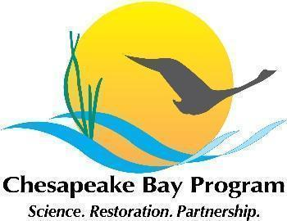

Maryland Oyster Restoration Workgroup Meeting Notes
March 18 2024, 9:30am-12:30pm

-Welcome, and note that this is a public meeting
-Shout out to DNR for this great piece on oyster restoration
-All-but-finished 2023 Annual Update review. Stephanie and Andrew Button (VMRC) will be presenting this info to the Fish GIT on Wednesday.
-Manokin spat study update and discussion
- Miss Kay may be in the water soon; DNR will check
- DNR has sampling design done, and sample locations defined
-2023 monitoring data
-Planning for 2024 seeding season
- Hatchery will start spawning next week; seedings should start mid-to-late April.
- per previous discussions, these are the planting priorities, in order from highest to lowest:
  - Manokin seed-only – avoid sites near MN 84 & MN 85 until construction is complete
  - Manokin substrate & seed – pending results from spat study (to allow for results of the spat study to inform these plantings)
  - Tred reseed from 2021 (one site only)
  - Little Choptank reseed from 2022 (6 sites)
  - Tred & Little Choptank reseed from 2023 (7 sites- 1 in Tred, rest in LC)
  - Manokin study sites (if needed)

- Pending results of Manokin spat study, these will be the planting densities for Manokin:
  - For SO sites with average pre-restoration density < 25 oysters/m2, plant at 4M SOS/acre
  - For SO sites with avg. pre-restoration density >= 25 oysters/m2, plant at 3M SOS/acre
  - For all constructed (SS) sites, plant at 3M SOS/acre

-Planning for fall 2024 monitoring
- Consider having our next workgroup meeting focus on this

-Harris Retrospective:
- Standing agenda item should be check in on Harris retrospective
- Team Action item - each member review existing draft in full to enable a final draft/edit to start in June (once monitoring work is complete)
- What will final product look like? What will review process need to be? Working assumption may be that this will be a peer-reviewed publication, likely targeting Restoration Ecology as the journal. But need to talk with the full team next meeting.

-St Marys:
- St Marys meets goal reefs need monitoring years- Jennica has draft assigned them- stephanie to review, and get them into the geodatabase. (St Marys reef due to 3 year in fall 2024).
- St Marys reef balls will be placed into St Marys this year by CBF and CCA. This group won’t monitor them.
- St Marys control- one of them was leased; what do we do with this? We knew this was a possibility when we laid out the controls; plan was to just lose that control reefs if the lease was let; so now we should just go down to tow controls. Have Paco make note in geodatabase that this happened; is no longer a control.

-Other business and updates
- NOAA & ORP will meet to go over monitoring year modifications based on the ‘last’ 2nd year class plantings, and related geodatabase edits needed.

