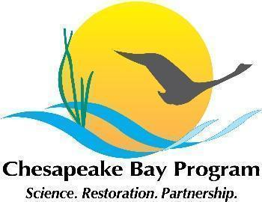

Maryland Oyster Restoration Workgroup Meeting Notes
July 15 2024, 9:30am-12:30pm

Video call link: https://meet.google.com/iot-pnfh-zre

Or dial: (US) +1 405-346-8270‬ PIN: 725 207 669‬#

Agenda

- Agenda TBD

