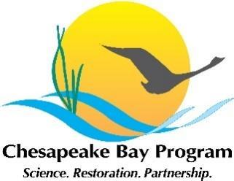
Education Workgroup Meeting, Quarter 4
SLIDES
Monday, October 6, 2025
10:00 am - 11:30 pm Virtual meeting via Zoom Link
Or dial in by phone: +1 646 931 3860
Meeting ID: 829 2491 4650
Passcode: 871059

10:00 Welcome

10:10 Environmental Literacy Outcomes
Results of the public feedback period and what is on the horizon for workgroup actions in 2026.

10:15 EL Forum & Summit
Brief recap on the focus of the Virtual Environmental Literacy Forum (12/11 and 12/17). Discussion on timing, participation, and agenda topics for EL Summit (winter 2026).

11:00 ELIT/Tracking the Outcomes
Update on the status of ELIT. Discussion about timing of the 2026 survey.

11:10 State and Regional Capacity Building Updates
If you have updates that are relevant to the Education Workgroup membership (i.e. state policies, standards, frameworks, state-to-district communications/training, etc.) add a brief update to the table below.

State / Jurisdiction | State or Regional Capacity Building Update
Regional | Sustainable Schools CoP
VA
PA
NY
DC
MD
DE

11:25 Closing Announcements

11:30 Adjourn

