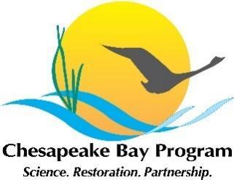
Protected Lands Workgroup
July 2024 Meeting
Wednesday, July 31 – 2:30 – 4:30 pm
Meeting Location: Virtual
Google Meet joining info

Video call link: https://meet.google.com/hkb-xvfc-thh
Or dial: (US) +1 731-435-3160 PIN: 643 120 139#

More phone numbers:
https://tel.meet/hkb-xvfc-thh?pin=8444808193803

Attendees
Anthony Bobo | Ashton Berdine | Aurelia Gracia
Ben Alexandro | Britt Slattery | Chase Douglas
Coral Howe | Joel Dunn | Katherine Brownson
Kerri Batrowny | Michelle Campbell | Peter Claggett
Sara Coleman | Sophia Waterman | Steve Storck
Wendy O’Sullivan | Meredith Lemke | Becky Gwynn

2:30 PM Welcome/ Introductions
2:40 PM Review of 2024 Action Plan
Aurelia Gracia (NPS) - Review 2024 items and point of contacts.
2024 PLWG Actions
1.1 – Develop or improve communication materials and resources for public outreach.
1.1.a – Create a map or language outlining ecosystem services.
1.1.a.i – Coordinate with WG members to compile outreach communication tools.
1.1.b. – Spread awareness for CCP Narrative Toolkit.
1.1.b.i – Utilize one jurisdiction as an example for CCP Narrative Toolkit.
1.1.b.ii – Consult CBP Strategic Engagement Team to gain an understanding of what themes would be most effective with landowners.
2.1 – Collaborate with WG members to increase awareness for conservation programs and policies.
2.1.a – Develop a shared doc to share information on programs and policies.
2.1.b – Present on a specific land conservation program that exists within the Chesapeake Watershed.
3.1.a.i – Coordinate presentations that will increase awareness for diversity, equity, and land conservation.
4.1 – Coordinate data collection among jurisdictions and acquire missing numbers.
4.1.a – Convene GIS experts from each jurisdiction.
4.1.b – Identify and engage key stakeholders representing local land trusts, agencies, orgs.
4.1.c – Consolidate new acquired numbers to update the number of protected lands.
Action Item: Workgroup members can choose actions to work towards. The goal is to then have responsible parties for these actions discuss the work they’ve done on these actions at the next PLWG Quarterly Meeting.

Sara Coleman (Maryland DNR) - Review 2.1.a document and Maryland programs.
Sara Coleman presented a document which has a broad summary of programs separated by state jurisdiction. This document is working towards action ‘2.1.a Develop a shared doc to share information on programs and policies.’
Action Item: Contribute information about programs in your jurisdiction to this document.
Ben Alexandro: We’re hoping to have a research assistant join in the fall who will research conservation funding mechanisms and what drives conservation in the different jurisdictions. This resource from Sara and the team will be a great jumping off point related to that.
Ben Alexandro (Chesapeake Conservancy) - Survey questions for Narrative Toolkit
Action Item: Review the Narrative Toolkit and respond to the 3 questions below for Ben.
Narrative Toolkit: https://www.chesapeakeconservation.org/wp-content/uploads/2023/07/Narrative-Toolkit-Tools-for-Communicating-Conservation-Messages.pdf
This toolkit was made to help create a shared narrative to bolster communication of conservation messages across the Bay watershed. We would like to put on a workshop to help walk folks through this toolkit.
- Narrative Toolkit: Provides all the guidance for using the narrative and tools.
- Message Box: As described in the toolkit, this template helps you create your own messaging based on the narrative.
- Spiel Worksheet: The toolkit includes instructions on how to use this template for crafting your pitch.
- Visual Tools: The toolkit includes examples of how to use images to help communicate your messages; files of powerpoint slides, images and more can be found here.
- https://www.chesapeakeconservation.org/wp-content/uploads/2023/07/Message-box.pdf

Questions:
- What are the biggest messaging and communications challenges you have? (Be as specific as possible, including which audiences you are trying to reach).
- What questions do you have regarding the toolkit?
- What is an ideal outcome from a training session on the toolkit – what would you learn or walk away with?
3:00 PM GIS Community of Practice
Steve Storck (Chesapeake Conservancy) - Present on findings from community of practice meetings.
Steve Storck presented about the methods and findings from the GIS community of practice meetings related to research on the Date of Establishment for protected lands data. Whether lands have a date of establishment or not affects how progress towards the Protected Lands Outcome is measured. This measurement of progress is also relevant to many other GITs and Workgroups.
Date of Establishment (DOE) Interview Themes
- Have data in another dataset not reported to CBP
- Only have if provided by the submitter
- Have recent data but older records are too difficult to find (paper)
DOE - Worked on vs. not worked on
- Easements are most commonly being worked on
- Older state-owned lands provide the least info
- Older federal lands are frequently not being worked on
- There are individuals who are supportive of and resistant to working on this.
CBP perspectives on why doing this work is valuable:
- Need for meaningful Protected Lands Indicator
- Need to assess 2025 Conservation Goals
- Need for land change model
- Need for Watershed Implementation Plan Reporting
- Need for tracking of Healthy Watersheds
- Current reporting is misleading
In Pennsylvania, Irina Beal increased local data for the date of establishment from 14% to 90%. This data is used in multiple ways, including to show how investments in land conservation have resulted in positive outcomes.
CBP Protected Lands Indicator – Where do we go from here?
- How do we improve our data quality?
- When do we update our indicator?
- Do we enforce a data quality standard?
- How do we better report change over time?
- How do we make Protected Lands a SMART goal for Beyond 2025?
- What guidance, mandates, leadership is needed to meet a new standard?
- What resources are needed to meet the data completeness goal?
Collecting data is a lot of work in many cases, so individuals have expressed that they need to receive directives so that they can devote time and energy towards it.
There was some discussion about whether we enforce a data quality requirement – enforce that the 13 required fields are fully completed.
Peter Claggett (USGS) - Review the need for a date of establishment and how jurisdictions can provide support in the process.
Open Discussion:
Peter: From the Healthy Watershed perspective the land portion is a key component, but we can only do that if we know where the conservation has taken place. We’re seeing that we’re losing forests and gaining housing developments, data centers, and solar fields. We’d like to counter that decline by overlaying increasing protected lands, because pervious surfaces are one of our indicators. But that protected lands dataset doesn’t exist, so we can’t do that. The other outcomes could also use this information about where the protected lands are to inform and promote their outcomes. We can’t say how far we’ve come if we don’t have the data on what we’ve done (and when). It’s critical also to inform 30 by 30 and 50 by 50 efforts.
Ben: I completely agree, Peter. It is imperative for us to actually see where we’re going, what progress we’re making, so we can see whether we’re actually attaining our goals. I agree with the questions that Steve raised: What is really needed? How do we get this to be prioritized, funded, and get the capacity for people to do this?
Steve: When you have to go into paper records, it does become a lot of work. So there should be some assistance to do that. But I also think the mindset is the difficult part right now.
Joel: It seems like there’s 2 challenges:
- to do the investigative work on what lands have been protected (looking backwards)
- a lack of a commitment from agencies to commit to this data collection standard on newly protected lands (looking forwards)
Joel: Could we partner with a title company to do that research for us that then we could enter into the records? I wonder whether we could look into funding from the Bay Program or privately to do some of this research.
Joel (chat): Could states be provided with an incentive if they modified their documentation process?
- Katie (chat): @Joel, I think that would be essential for getting the states to do it. I have heard a lot of hesitation about agreeing to "additional" monitoring or tracking without additional funding to support it
- Sara (chat): I also think additions to parks/other land units will be very difficult to track
Steve: John and Peter worked on a funding mechanism (not necessarily to work with a title company). I don’t know whether it got in late, or there was a misunderstanding on whether it’s needed.
Peter: It did get presented in time for this year’s process, but there were some issues with this year’s process. The decision makers decided that it wasn’t going to get funded this year due in part to a misunderstanding that they thought the funding would already be covered from other sources. This dataset is critical and in line with discussions that the Bay Program is having about breaking down silos and better collaborating because this data can be used by so many different parts of the Program.
Katie: I think that there is some education needed about what “raising conservation up” actually means for the Bay Program. Maybe CCP and some other key players should start planning some key priorities to show the Bay Program where and how conservation should actually be prioritized by the Bay Program.
Aurelia: We’re hoping that by presenting these findings that it raises awareness about the date of establishment. We’re hoping by having this conversation early we can help states think about data collection moving forward.
Becky: From a VA perspective – we have a working group composed primarily of the key state land purchasers. It would surprise me if their records don’t contain the date their lands were acquired. Thinking about what is the portal that gets that info from each of these state agencies. I’d like to talk to people about this.
Aurelia: Once John is back we can set up a meeting between you, John, Steve, and some of the other GIS experts. (Action Item)
Sara: I think if we have a clear process going forward, I think it’s pretty easy to collect the data.
Aurelia: We understand that this group here is not composed of the GIS experts who are collecting the data. But we hope that you all can be advocates to your offices and jurisdictions to prioritize this moving forward.
Kerri (DE): Our governor has set an initiative to have a state-wide land inventory. I don’t know when that actually is going to be released, but they’re working to put that together. I think that’s a good first step. I see a problem when it comes to merging data sets from different agencies who do or do not collect certain metadata like the dates of acquisition (Fish and Wildlife collects, but Parks does not).
Britt: Do some agencies see an issue with collecting the data going forward?
Kerri: Fish & Wildlife and Parks store their data differently. And when the land parcels are merged, it is a challenge.
Aurelia: Do you think if there was some type of program, interns, or funding to establish and find these dates – would your offices be interested in that?
Kerri: Yes, having that data would be very useful.
Michelle: I’m thinking about how that would look here. I’m not sure if we even have a layer of our protected lands. it would possibly need to be compiled from NPS and one easement group here in DC. In terms of public lands, though, I don’t know how that would look for us at all.
Steve: I haven’t been able to get in touch with anyone in the DC government that knows who owns or submitted data for the layers from DC. We have access to the layers but we don’t know who the owner of them is (it was submitted to a general dataset).
Steve: The federal dataset in WV does not have a date of establishment. In WV, since a majority of protected lands are federal that would be very significant.
Ashton: I’m not sure if anyone has kept that dataset up, but it wouldn’t be that difficult to update that dataset. I’ll look into whether the Conservation Fund has the horsepower to take that up again. (Action Item)
3:40 PM Coordination Among Conservation Groups
Britt Slattery (NPS) - Review meeting outcomes from July meeting for strategic conservation collaboration.
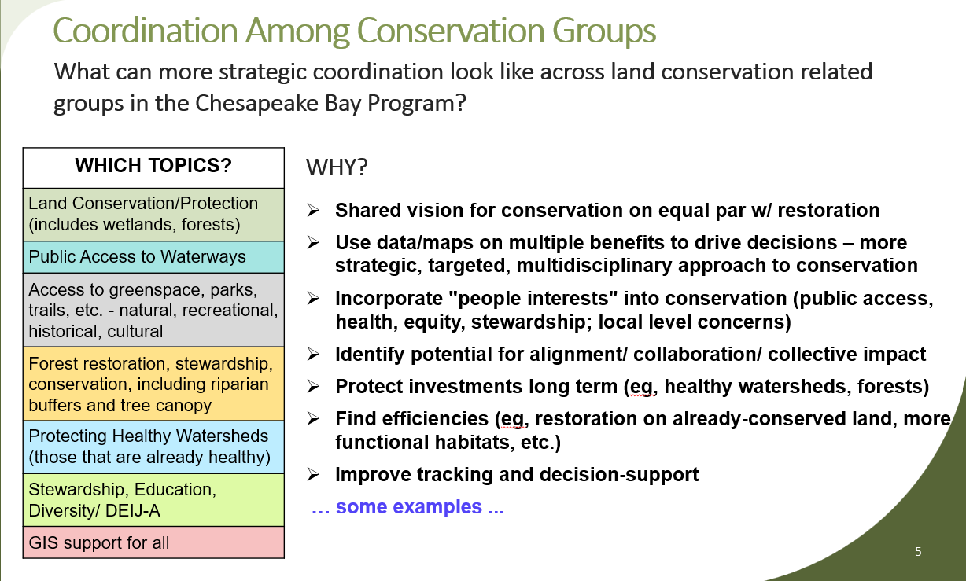
Open Discussion:
Britt: There’s multiple groups across the Bay Program who are working on things with mutual benefits, so we started thinking about ways for more strategic collaboration about conservation.
One of the things that I’ve been thinking about is: how do we share across states, ideas for better taking advantage of the land and water conservation funds particularly for underserved communities? Our next step is thinking more thoroughly about – do we need a separate group? Or do we just need to do more of what we’re doing here, e.g., joining each other's meetings?
Wendy: We talked about the concept of linking and leveraging the outdoor recreation economy driving conservation and funding. There’s a boom in outdoor recreation businesses and economies, so we should leverage that more.
Peter: In terms of how we can coordinate, we talked about whether we dovetail on the November CCP meeting (rather than a lot of small meetings). Maybe we could have a mini summit.
Peter: For example, there’s so much crossover with Healthy Watershed and Protected Lands, Public Access, Climate Resiliency, Forestry WG, and others. We should have all of them meet to talk about the overlap of their shared goals. We want to get them all in the same meeting to identify areas of mutual interest and try to figure out what our relative roles are and how we can be more effective and efficient in meeting those goals.
4:00 PM National Park Service and Trust for Public Land’s Community Assessment
Aurelia Gracia (NPS) - Brief project review and demonstration of roadmap
NPS Chesapeake Gateways just wrapped up a project with the Trust for Public Lands. This was to create a mapping tool to show how parks can be used to address community needs.
The map was built to show the prioritized communities of need identified with a list of 22 criteria.
Open Discussion:
Ben: After identifying these places, I’m wondering about next steps, how do we go into the communities to help them conserve what they want to conserve?
Wendy: Also, the 3 detailed examples were made as a model for other locations to become more in depth. This project was funded by Chesapeake Gateways but the idea came out of both this group and CCP. Every community in the census data has been run through the 22 criteria matrix, and has received their score. The model has been created. So now, how do we get other places to go through a similar process?
4:15 PM Chesapeake Conservation Partnership
Ben Alexandro (Chesapeake Conservancy) - Announcement for CCP Annual Meeting open registration period.
Chesapeake Conservation Partnership will be hosting its Fifteenth Annual Meeting, “Chesapeake United: Strategies for Cross Border Conservation”
- Where: The Claggett Center, 3035 Buckeystown Pike, Adamstown, MD
- When: 10:00AM November 19th to 3:00PM November 20th
- Contact:
  - Ben Alexandro, balexandro@chesapeakeconservation.org
  - Chase Douglas, cdouglas@chesapeakeconservation.org
Early bird registration ends August 2nd. If you have any questions or need assistance please email cdouglas@chesapeakeconservation.org
https://interland3.donorperfect.net/weblink/WebLink.aspx?name=E333504&id=47&formid=472&Preview=true
4:25 PM Close Out/ Next Steps
Aurelia Gracia (NPS) - Awareness for Beyond 2025 comment period.
Action Item: The Beyond 2025 open comment period is open through August 30th. Send comments to comments@chesapeakebay.net

