Enhancing Science Collaboration to Support the Chesapeake Bay Watershed Agreement (working update January 2023)
Need: The 2014 Chesapeake Bay Watershed Agreement requires additional monitoring, modeling, and analysis to help decision makers effectively achieve goals and associated outcomes. Chesapeake Bay Program (CBP) science activities are coordinated through the Scientific, Technical Assessment, and Reporting (STAR) team. Over the past several years, STAR had a heavy emphasis on water-quality activities as the partners implemented the Bay Total Maximum Daily Loads (TMDLs). STAR is evolving to have more of an ecosystem-based science mission and to support the Goal Implementation Teams (GITs) in identifying, organizing, and addressing their science needs.

Overview of Purpose and Functions
Purpose: Enhance Chesapeake Bay science and capacity by increasing collaboration among science providers to provide monitoring, modeling, and analysis needed to update, explain, and communicate ecosystem condition and change to support the CBP Goal Teams.

The major functions of STAR (shown on figure 1) include:
- Manage CBP-funded monitoring networks and collaborate with monitoring organizations to utilize and enhance additional networks to address the outcomes in the Chesapeake Bay Watershed Agreement.
- Ensure data comparability and integrity.
- Update, and deliver, the status and trends (indicators) of ecosystem conditions.
- Explain ecosystem condition and change.
- Expand modeling to better understand and predict ecosystem response.
- Coordinate science support for climate change activities.
- Enhance information management, access, and GIS support.
- Produce synthesis products and reports to better communicate scientific results and aid in science informed management decisions.
- Manage and coordinate the Strategic Science and Research Framework to identify, track, and address the CBP science needs.
- Coordinate the maintenance of existing science partner relationships and creation of new relationships to support completion of science needs and science capacity for Watershed Agreement outcomes.
- Provide science-based approaches to address multiple Watershed Agreement outcomes.

Figure 1 shows the relationship to the GITs, Scientific and Technical Advisory Committee (STAC), and major functions of STAR. STAR efforts (such as explaining ecosystem change or synthesis products) provide science support to address issues that benefit multiple outcomes. Other technical expertise to address these functions exists within the GITs and with science providers (federal, state, and academic partners) involved in the CBP. STAR will facilitate collaboration between science providers and GITs to carry out these functions and accomplish additional science needs. The collaboration is critical to effectively provide the science needed to support the GITs as they monitor, assess, and report progress to achieve the goals and outcomes of the Watershed Agreement. STAR would help promote their efforts and products of the CBP science partners to decision makers to encourage science informed management decisions. The STAR has a collaborative relationship with STAC; with STAC providing scientific and technical guidance to the CBP on measures to restore and protect the Chesapeake Bay. To provide this guidance, STAC hosts workshops and reviews to produce a report that includes specific recommendations for the CBP and partners. More information on STAC-STAR roles is provided below.

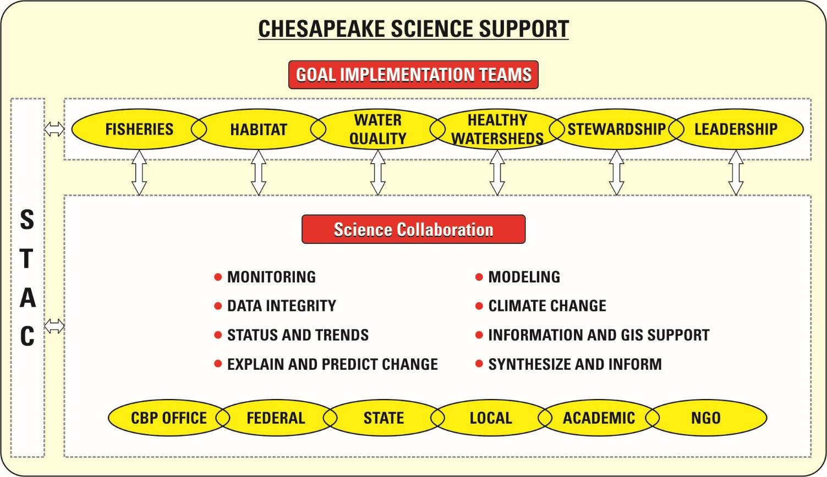
Figure 1: Major functions and science providers of the Science Coordination Team and relation to Goal Teams and STAC.

Description of STAR Functions and Workgroups Roles
The following is a description of the major functions of STAR and anticipated support needs.
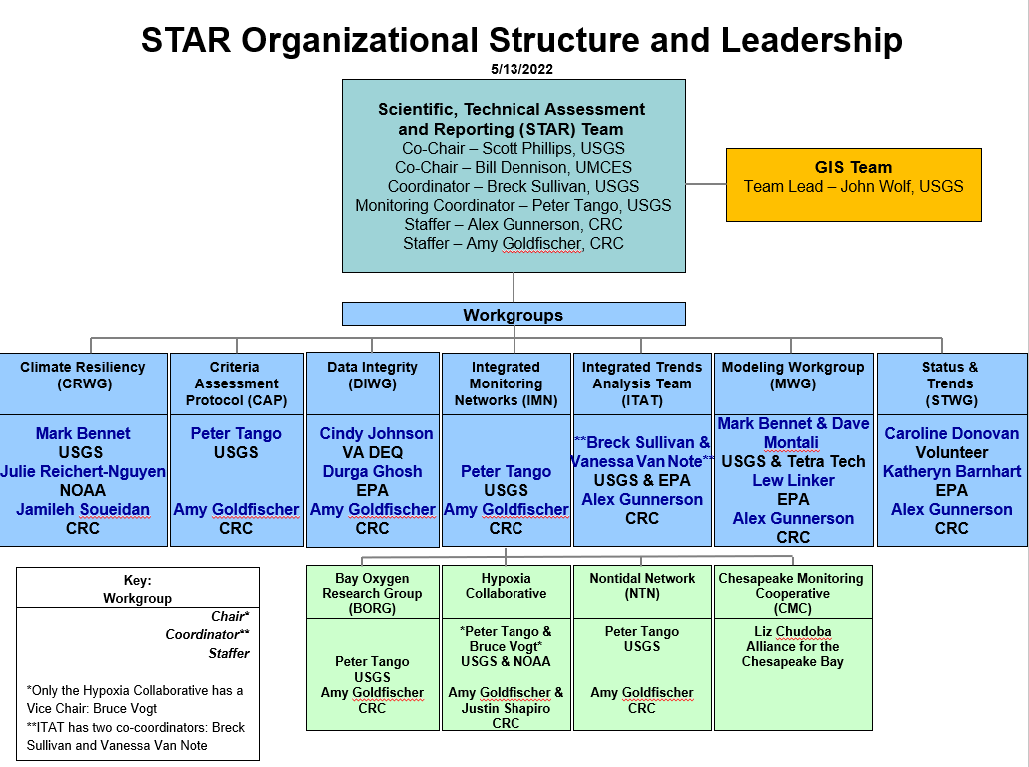
Figure X.

Manage CBP monitoring networks and expand efforts to address the outcomes in the Chesapeake Bay Watershed Agreement.
The CBP currently manages several water-quality monitoring networks – Tidal and Nontidal water quality, tidal benthic, submerged aquatic vegetation, and community monitoring. . The networks are complex with multiple partners collecting data. Sustained and improved monitoring will allow the CBP partners to assess and evaluate progress from restoration and conservation efforts, while identifying gaps where more attention is needed in the future. There is additional monitoring that needs to be conducted to address the outcomes of the Watershed Agreement. STAR will work with the CBP GITs to support sustaining monitoring networks already existing for outcomes, improve coordination and efficiency for outcomes with gaps in their monitoring networks, and assist in development of new monitoring design plans for outcomes lacking monitoring networks. The initial work is too evaluate and enhance the core CBP monitoring networks, followed by assessing options to address monitoring needed for outcomes in the Watershed Agreement.
- Anticipated Needs:(1) Address the development, maintenance, and improvement of CBP core monitoring networks (2) Identify and confirm long-term funding to sustain enhancements CBP core monitoring networks (3) Coordinate with multiple GITs and agencies/partners to address monitoring needs for 2014 Chesapeake Bay Watershed Agreement
- Primary Workgroup: Integrated Monitoring Networks WG

Ensure information comparability and integrity. The STAR will lead coordination of CBP partners to ensure the comparability and the integrity of data collected from monitoring networks. An ongoing function is to ensure the quality of data generated from the CBP water-quality networks. An increasing future need will develop approaches to assess and improve comparability of information from additional networks that will be used to support outcomes of the Watershed Agreement. Evaluating the use of community-based data will be an important task.
- Anticipated Needs: (1) Extra help with data management needed for expanding monitoring networks and data. (2) Develop Quality Assurance guidelines for non-traditional partners to use as alternatives for conventional sample analysis methods.
- Primary WG: Data Integrity WG

Update status and trends (indicators) of ecosystem conditions.
Many of the GITs and associated WGs have the lead responsibility to update CBP indicators. STAR will collaborate with the GITs and science providers to update indicators, or plan for additional indicators that are needed for the Watershed Agreement. The CBP GIS group would oversee compilation and support of spatial data related to the indicators. The STAR will work with the CBP communications team to have the results reported on the CBP Chesapeake Progress site and the annual Bay Barometer.
- Anticipated Needs: (1) Develop and maintain new indicators needed for the outcomes in the Chesapeake Bay agreement. Will require streamlining the process through information sharing. (2) Identify influencing factors and their relationship with indicators and outcome success.
- Primary Workgroup: Status and Trends team, which includes the Indicator Coordinator working with Goal Team coordinators, GIS team, and CBP Web Team.

Explain ecosystem condition and change. Explaining ecosystem condition and change for the entire Chesapeake Bay requires gathering researchers and analysts from various governmental, academic, non-profit, and private organizations to enhance understanding of spatial and temporal patterns with a focus in water quality. The unique role of STAR is having established relationships with science providers to identify linkages among the ongoing research activities of participating individuals and organizations. STAR also works with GITs and science providers to enhance technical expertise and conduct analysis of and synthesis of the science on changes in water quality, living resources, and habitats conditions. These efforts are focused on priority science topics identified by GITs to enhance progress towards their respective outcome.
- Anticipated Needs: (1) Prepare and distribute Tributary Summaries to serve as a communication tool on water quality changes to inform management decisions. (2) Integrating tidal and nontidal water-quality trends results to understand relationship between watershed loads and response to the estuary.
- Primary WG: Integrated Trends Analysis Trends

Enhance modeling to better understand and predict ecosystem response. Modeling to understand the impacts of a changing ecosystem, such as the infilling our major reservoirs and the impacts of climate change on ecosystem response is complex. In addition, modeling needs to support the evaluation of management decisions to achieve outcomes in the Watershed Agreement. Modeling is an integrating tool and the concept of multiple models will be used to create a collaborative environment for integrating disparate scientific studies. The modeling would need to expand out from water quality and address/coordinate with ecosystem modeling efforts supporting other goal and outcomes. Opportunities to better collaborate with CBP science providers from federal and state agencies, academics, and non-profits will be explored to expand modeling capacity and support aligning other outcomes with the CBP watershed and estuary models.
- Anticipated Needs: (1) Developing finalized watershed modeling plan through 2025. (2) Exploring linkages with the models between living resources and ecosystem services to address outcomes in the Watershed Agreement.
- Primary WG: Modeling Workgroup

Coordinate Science Support of Climate Change Activities
STAR will coordinate efforts to address climate effects for the CBP since it is a cross-cutting topic for the CBP. In many cases, the effect of climate on individual outcomes is not well understood, and in other cases, it is established and moving forward. The adopted management approach will require coordination across the GITs and STAR providing advisory and scientific support to ensure that efforts to incorporate climate change in the outcomes’ strategies are consistent and complementary. The Climate Resiliency WG will focus on addressing the two outcomes of the Climate Resiliency Goal in the 2014 Chesapeake Bay Watershed Agreement.
- Monitoring and Assessment Outcome to “Continually pursue, design and construct restoration and protection projects to enhance the resiliency of Bay and aquatic ecosystems from the impacts of coastal erosion, coastal flooding, more intense and more frequent storms and sea level rise”
- Adaptation Outcome: Continuously pursue, design and construct restoration and protection projects to enhance the resiliency of Bay and aquatic ecosystems from impacts of coastal erosion, coastal flooding, more intense storms and more frequent storms and sea-level rise.
- Anticipated Needs: (1) Update and develop indicators to help track progress of the climate outcomes to connect them more to management applications. (2) Increase understanding of sea level rise impacts and build capacity for marsh resilience.
- Primary WG: Climate Resiliency WG

Enhance information management, access, and GIS support
The CBP Data Center will continue to enhance data systems and tools to more effectively manage, share, and access data. The Data Center will continue its core function to manage information to support the needs of CBP. The data center will have to expand partnerships with other providers to effectively manage and share information needed by the CBP to address the outcomes in the ​2014 Chesapeake Bay Watershed Agreement​​. The CBP GIS team will provide a wide variety of geographic research and support to the Chesapeake Bay Program Partnership. They will lead topics on characterizing landscape condition, implications for vulnerability and resilience, and enhanced data management and visualization through estuarine geographic research, web development, data development, and data visualization and communication projects. All of these activities would be coordinated through STAR.
- Anticipated Needs: To support the ongoing need for current, high-resolution land use and land cover (LULC) data to achieve the outcomes in the 2014 Chesapeake Bay Agreement and given the costs and preparation time required to produce such data, a long-term production strategy is required. Also, additional support is needed in technical assistance for GITs and Workgroups for GIT Funding and other initiatives.
- Primary Teams: CBP Data Center and GIS team

Produce synthesis products and reports to better communicate scientific results and aid in science informed management decisions. STAR will work with STAR workgroups and GITs to identify technical topics where a synthesis product would help communicate results to decision makers. STAR would work with the GITs, science providers, and CBP communications team to summarize technical results of above efforts, communicate the findings, and share management implications with a wider range of audiences. Prepare communication products that are tailored to specific audiences and ensure the science is correctly portrayed. A focus will be on synthesizing the scientific work of STAR workgroups to explain and communicate the health of and changes in the Chesapeake Bay ecosystem.
- Anticipated Needs: Coordinate the maintenance of existing cooperator relationships and creation of new relationships to support dissemination and utilization of communication products.
- Primary Teams: STAR, CBP Communications Team

Manage and Coordinate the Strategic Science and Research Framework
The CBP developed the Strategic Science and Research Framework (SSRF), which lays out a process to track and update science needs across the 31 outcomes of the Watershed Agreement. SSRF is used to gather short-term and long-term science needs consistently and transparently as part of the CBP Strategy Review System (SRS), which provides an adaptive management approach to assess progress on each outcome. SSRF is used to (1) assess if needs are being met, (2) help prioritize needs requiring resources, (3) identify science partners that can help meet those needs, and (4) enhance CBP science capacity and knowledge. STAR manages the tracking of the science needs through the continuous update of the CBP Science Needs Database which is used to engage stakeholders and identify opportunities to better align or evolve resources. STAR coordinates the resource assessment to first consider capacity and knowledge of science support teams within the CBP and if additional support is needed, provide a strategic approach for partner resources to address a science need.
Anticipated Needs: Expanded capacity to address the science priorities which requires the engagement of the broader scientific community to (1) translate and disseminate existing science and (2) encourage and implement additional research to inform management of the Chesapeake Bay and its watershed.
Primary Team: STAR

Relationship between STAR and STAC
STAR has a collaborative relationship with STAC and each has a distinct role:
- STAC provides independent review and recommendations to the CBP to enhance science (monitoring, modeling, and research) for decision making.
- STAR coordinates with science providers and GITs to address the monitoring, modeling, and analysis needed to achieve the outcomes in the Watershed Agreement which may include carrying out the STAC recommendations.

STAC supports the CBP adaptive management process through its efforts to identify critical science needs and potential emerging issues through its various proactive and reactive efforts (e.g., workshops, reviews, whitepapers) and connect them back to CBP outcomes (Figure X). They play a key role in SSRF by using their quarterly meetings as an opportunity for outcome leads to share a subset of their science needs with the academic community to assess current efforts to address any of the science gaps and potentially drive research directions. It also provides STAC members an opportunity to comment on science needs that may be missing.

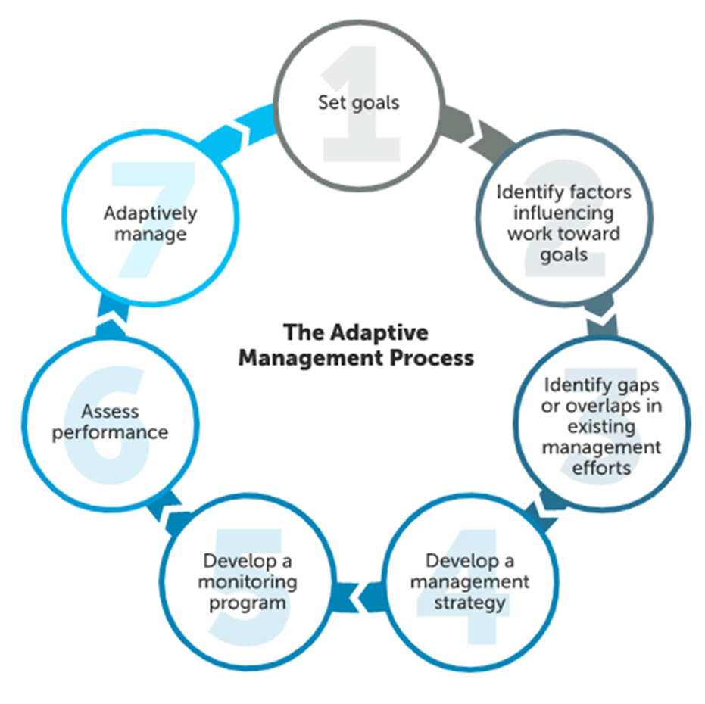
Figure x. Chesapeake Bay Program decision framework for adaptative management used with STAC

Additional STAC roles in SSRF may expand to:
- Provide input on Outcome science needs through connections to STAC workgroup recommendations
- Use STAC’s network to share the science needs database
- Advocate for research and associated funding to partners and CBP leaders to address science needs
Additional STAC member roles in SSRF may expand to:
- Serve as a conduit of capacity for their academic institution
- Present relevant research findings to GITs
- Consider new research to address needs
- Have students consider science needs for internship or graduate work

Next steps to implement STAR purpose and functions
- Enhance collaboration with each GIT. STAR will increase collaboration with each Goal Team by (1) having a STAR liaison to each Goal Team, and (2) working more closely with Goal Team coordinators and CRC staffers to find resources to meet their science needs and help prioritize unmet GIT science needs.

- Increase interaction with STAC. The STAR will work closely with STAC to identify additional science provides to assist GITs. We will also work with STAC and GITs to identify cross-cutting topics and organize technical exchanges or propose workshops to address the topics.

- Increase interaction with CBP Science, Analysis, and Implementation Branch (SAIB). Share science needs from GITs to drive SAIB priorities. Encourage participation of SAIB members in SSRF meetings. Collaborate with SAIB on opportunities to align modleing, monitoring, data management, and GIS needs with GIT science needs.

- Enhance science coordination. Bring new and emerging natural and social science topics to STAR meetings and identify recommendations from the key findings. Based on the recommendations of STAC workshops, STAR will help identify science needs from these recommendations and coordinate with relevant outcomes to track them through SSRF.

- Expand membership. STAR will expand its membership to include science providers to be on its workgroups to carry out each of its major functions. STAR will also work with the Goal Teams to have chairs of their technical workgroups interact with STAR so they can enhance collaboration monitor, assess, and explain ecosystem change. STAR will target additional participants for their meetings based on the topic to expand science providers present.

- Refine Meetings. STAR will have three types of meetings: (1) full membership meetings (every month), (2) leadership meetings (3 – 4 times per year), and (3) Strategic Science and Research Framework meetings (Cohort presents month after their Quarterly Progress Meeting to the CBP Management Board). The full membership meetings will focus on supporting and informing science needs of the GITs. They would have key presentations of findings and collaboration opportunities that should be of interest to multiple GITs. The leadership meetings will focus on reviewing progress of STAR workgroups to provide the science requested by the GITs and synergies of work among the STAR workgroups. SSRF meetings will serve as a venue for a representative from each outcome in the respective SRS cohort to present their updated science needs to STAR members for an in-depth discussion of their needs and potential cross-GIT collaborations and resources to support those needs.

- Expand Science Capacity. Collaborate with outcome leads to structure science needs in an actionable format for partners to understand and support. Continue to engage federal and state agencies and nonprofits to expand science capacity and aim to increase collaboration with these groups. Increase partnerships with academic institutions to support science priorities of the CBP.

- Expand Communication Product Awareness. Share products in Quarterly STAR newsletters and reserve time on STAR meetings to announce or present on products. Collaborate with CBP Communications Team to have a science highlight in their blogs, press releases, or social media outlets.

