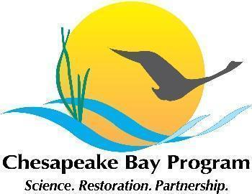

Virginia Oyster Restoration Workgroup Meeting Notes
July 24 2024, 1-3pm

Video call link: https://meet.google.com/jtr-gqip-twc

Or dial: (US) +1 505-903-6934‬ PIN: 404 793 903‬#

Agenda

- Agenda TBD

