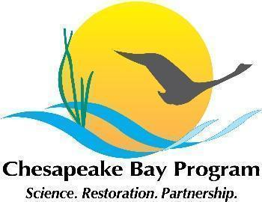

Virginia Oyster Restoration Workgroup Meeting Notes
November 13 2024, 1-3pm

Video call link: https://meet.google.com/tun-hkvk-xyk

Or dial: (US) +1 336-914-1205‬ PIN: 300 038 042‬#

Agenda

- Agenda TBD

