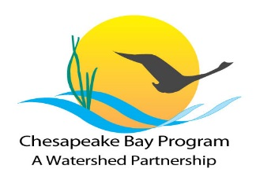
A Snapshot of Chesapeake Bay Program’s Diversity Initiative

EXPANDING the diversity of the workforce and participants in restoration and conservation activities engages a wide range of people of all races, income levels, faiths, genders, ages, sexual orientations and disabilities, along with other diverse groups.

IDENTIFYING community groups not currently represented in the leadership, decision making and implementation of current conservation and restoration activities and create meaningful opportunities to engage them.

BECAUSE

Leadership in Chesapeake Bay efforts should reflect the diversity of the constituents that live in the watershed and use its resources. Here’s how we’re planning to make this a reality…
2016-2017 Diversity Action Plan
Employment and Professional Engagement
- Each state and federal agency will explore opportunities to hire or designate a Diversity coordinator to strengthen Diversity coordination efforts across the watershed.
- Monthly update for stakeholders – Grants, Internships/job postings, events across watershed.
- Furthering connections with Community Colleges and Historically Black Colleges/Universities (HBCUs) such as Morgan State, Bowie State and Norfolk State University.
- Promoting green careers pipeline among schools, universities, service providers.

Enhancing Communications and Outreach
- Consistent communication and collaboration with community leaders from diverse communities across Chesapeake Watershed.
- Providing content to CBP Communications staff for website.
- Working with community stakeholders on innovative outreach tools for Fish Consumption Advisories (FCA).
- Reviewing NFWF grant RFP guidance and promoting program among diverse communities.

Page 1
Tracking and Assessment of Diversity
- Conducted baseline data research for racial and ethnic demographics for Chesapeake Bay Watershed.
- Developed and launched new Diversity Indicator for Bay Program Partnership.
- Explore options to track additional diversity indicators for Chesapeake Bay Program partnership.
- Consulting with Green 2.0 for tracking metrics.

Promoting and Integrating Environmental Justice
- EPA revised its 2016 Annual Grant Guidance to the Bay states to address diversity, environmental justice and the use of EJ Screen.
- Identify how to integrate environmental justice concerns into the work of the Bay Program.
- Aligning EJ organizations to place-based EJ issues within Watershed – Southeast Care Coalition Annual EJ Empowerment Luncheon in Newport News, VA.
- Piloting Chesapeake Bay watershed-specific EJ SCREEN tool for climate resiliency, toxics and public access outcomes.

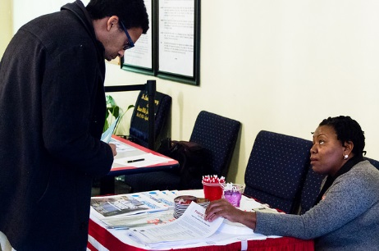
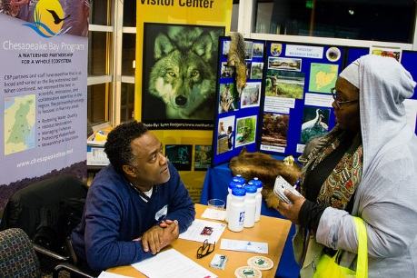

Questions or Suggestions?
Stay Connected. Get Involved.
Be Part of the Process. Visit the Diversity page today.
http://www.chesapeakebay.net/managementstrategies/strategy/diversity
Contact Us
Reggie Parrish
reginald.parrish@epa.gov

Darius A. Stanton
Stanton.Darius@epa.gov
Page 2

