Streamlining Integrated Infrastructure Implementation Workshop
Dig Once Strategy Development
June 9, 2016

Workshop Report

DRAFT, November 7, 2016

Sponsored By:
Alliance for the Chesapeake Bay
Local Government Advisory Committee (LGAC)

Funding:
National Fish & Wildlife Foundation (NFWF)


Prepared By:
Alliance for the Chesapeake Bay
Hirschman Water & Environment, LLC
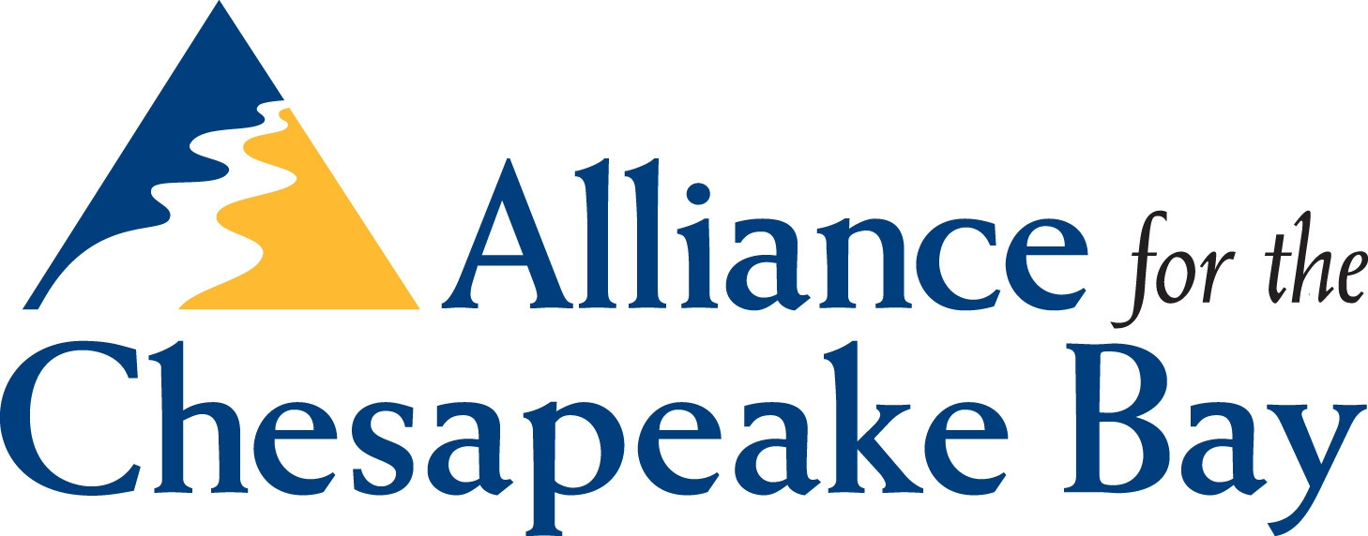

1. Workshop Overview and Focus
The focus of this workshop was to explore better ways to integrate green infrastructure (GI) into other infrastructure projects, such as roads, school and park improvements, and other capital projects. The workshop was hosted by the Alliance for the Chesapeake Bay (ACB) in conjunction with the Local Government Advisory Committee to the Chesapeake Executive Council (LGAC), with funding from the National Fish & Wildlife Foundation (NFWF). Mary Gattis, Director of Local Government Programs for ACB, was the lead facilitator for the workshop.
The workshop was held on June 9, 2016 at the Eisenhower Hotel in Gettysburg, Pennsylvania. The organizers targeted certain sector representatives for attendance in order to achieve the necessary cross-section of experiences and points of view. Figure 1 shows the breakdown of attendees by type of organization. A total of 52 individuals attended the 1-day workshop.
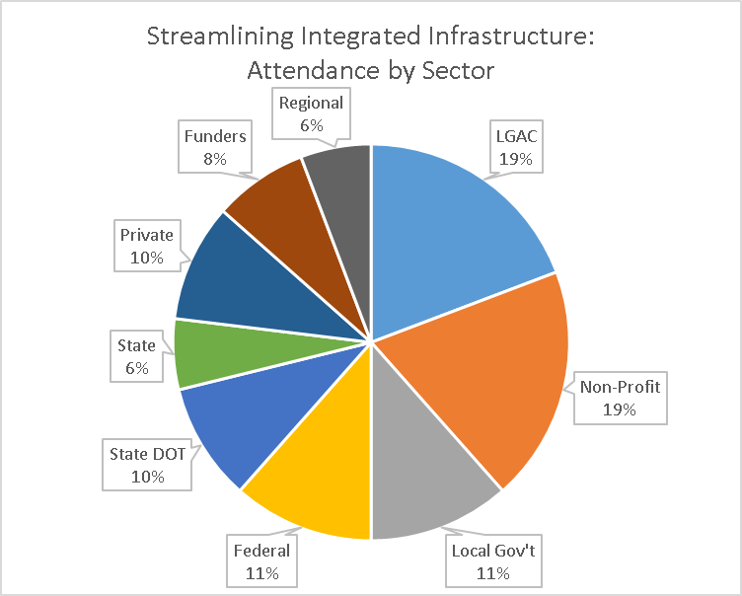
Figure 1. Representation of 52 Workshop Attendees
Prior to the workshop, the following problem statement and workshop goal were sent to attendees as part of the agenda. This was done in order to maintain a clear focus for the workshop, as the topic of green infrastructure has many facets, each of which could fill the entire agenda for a one-day event.
Problem Statement: Only recently has stormwater infrastructure (e.g., pipes, inlets, quality and quantity treatment practices) begun to be considered a full part of municipal infrastructure, alongside roads, water lines, sewer systems, utilities (gas, electric), etc. This recognition of stormwater infrastructure is quite variable among Chesapeake Bay localities. However, as communities across the watershed face the challenge of complying with Municipal Separate Storm Sewer System (MS4) permits and Total Maximum Daily Load (TMDL) plans, among other pollution reduction requirements, significant capital investments in stormwater infrastructure will be required. One option to address these challenges is to integrate stormwater infrastructure (especially green infrastructure) with other capital projects for roads, utilities, parks, schools, and other projects, in order to streamline the process and achieve more cost-effective solutions. However, before this approach can be successful, administrative, procurement, funding and financing, staffing, and operational systems need to be adapted to optimize the process.
Workshop Goal: Develop recommendations for streamlining implementation of capital and maintenance projects that incorporate green stormwater infrastructure.
This report provides a summary of the workshop, and addresses the key issues and challenges with GI integration, potential solutions at varying levels of commitment, resources and case studies noted during the workshop, and other topics discussed by participants that were beyond the specific scope of the workshop.
2. Issues Identified by Participants
The morning session allowed participants to brainstorm the major issues that affect the integration of GI into other infrastructure projects. The six topics below are a consolidation of the issues discussed during that session.
2.1. Funding & Financing
The availability and timing of grants do not always line up with integrated GI project timelines. For some projects, the grants must be completed before the often lengthy process of integration with other infrastructure projects. Several participants also noted that grants do not often pay for critical project stages, such as feasibility, planning, and prioritizing among candidate projects. Without these “early” steps, many projects can meet significant challenges with feasibility. Long-term maintenance was discussed as a significant funding challenge, but the general sentiment of the group was that the responsibility of funding long-term maintenance must fall on the local government. Some expressed the need for more balance and diversity in funding and financing to move away from the current reliance on grants.
2.2. Qualified Personnel & Available Guidance
Successful implementation of GI projects requires qualified personnel and adequate technical guidance. Guidance is needed at all levels – federal, state, and local – because each has a role to play in funding, authorizing, implementing, and allocating pollutant removal credits for GI projects. The following categories represent needed expertise at the local level: municipal program and project management (e.g., procurement and managing hired consultants), design (including planting/landscaping plans), installation, and long-term maintenance. The latter is particularly critical, as there seems to be a disconnect between the available maintenance resources and what is actually required to meet even a basic level-of-service standard. Frequent turnover at the local level also plays a role in the lack of successful project execution.
As for technical resources, the group expressed that a one-size-fits-all approach is not appropriate, and design guidelines should be flexible enough to address context (e.g., urban, suburban, rural, roads, public facilities).
2.3. Municipal Processes & Commitment
The phrase “Dig Once” was used on the workshop agenda and in the morning discussion. “Dig Once” refers to the objective that GI projects be installed while the ground is already disturbed or excavated for other projects, such as road or other public infrastructure improvements.
This approach has efficiency and overall cost benefits, but also requires a high level of collaboration and integration between municipal departments, especially those involved in capital project planning, design, and implementation. This streamlining does not occur overnight, but requires a level of commitment (state to local) and willingness to make some mistakes along the way; to learn and change using an adaptive management approach (defined in Figure 2) in order to improve the processes and relationships. Often, a higher level of collaboration and additional partners will inevitably slow the process down, which can be an issue with the timing of grants, as noted above.
Integration also includes addressing barriers or excessive burdens to GI implementation often embedded in local and state codes and regulations. This is an important planning-level issue that may determine whether GI is even a viable option in some communities.
Adaptive Management
Adaptive management is an ongoing, science-based process through which the Chesapeake Bay Program plans, implements and evaluates its restoration efforts. In simple terms, adaptive management is “learning by doing”: taking action with acknowledged uncertainties, carefully monitoring outcomes, transparently assessing progress and redirecting efforts when necessary.
Figure 2. Definition of Adaptive Management as Defined by the Chesapeake Bay Program

It was made clear at the workshop that even the best collaboration and technical know-how is no substitute for an important intangible for project success – local government commitment to see projects through from concept to construction to long-term maintenance, including the willingness to make mistakes and improve the process by learning from experience. This is a keen insight as it acknowledges the inherent risks and uncertainties with GI and signifies that importance of local governments practicing adaptive management.
2.4. Planning, Prioritizing & Feasibility
This category is related to the one above (2.3), but deserves its own section, namely because there are often important steps in the early stages of GI planning that are not funded or considered, and skipping these steps can jeopardize successful implementation down the road.
To realize cost efficiencies, GI projects must be envisioned, evaluated, and planned long before they are actually implemented. Much of this upfront work has to do with integrating GI into the capital project planning process, ensuring that GI is at least considered with other capital projects, and that candidate projects are prioritized on the basis of feasibility, cost/benefit (e.g., pollutant removal and TMDL credits), and other factors.
Some of this upfront work can be time-consuming and expensive. Therefore, a balance must be struck between doing extensive early planning (e.g., mapping of utilities and municipal infrastructure) and meeting cost and schedule expectations. The flip side is that some of these issues can turn into “project killers” if not identified at the planning stage. An example would be unmapped utilities that end up being extremely expensive or even infeasible to relocate.
Another important step for planning and prioritizing is identifying (and scoring) the “co-benefits” of candidate GI projects. Local government implementers often realize that elected officials, public works directors, planners, ratepayers, taxpayers, community groups, and citizens are motivated more by issues other than pollution reduction. Such issues include flooding and drainage, drinking water protection, creating community green spaces and health benefits, or providing new green jobs. Emphasizing these benefits of GI may garner more project support than the pounds of nutrients removed. This also points to the need for more outreach and education on the benefits of GI.
All of these issues can be summarized as creating a cogent “project pipeline” that has early buy-in and foresees problems that may come up in the future. Some attendees pointed out a related issue concerning prioritization: many GI projects may never get prioritized (vis-à-vis stream restoration or street sweeping) due to current Chesapeake Bay Program (CBP) and State best management practice (BMP) crediting protocols. These protocols send strong signals to local governments who must meet specific TMDL targets with limited budgets.
2.5. Regional Collaboration & Peer-to-Peer Networking
As workshop attendees can attest, implementing GI is not a simple process, and many rural or underserved areas (or even more sophisticated places) may not have the staffing or project management capacity to sustain the effort. There is a need to look to regional collaboration and systems to bundle projects and cost-share among multiple municipalities. There is also a role for regional coordinating agencies and design guidance, as well as peer-to-peer networking and sharing of lessons learned.
3. Strategies and Recommendations for Selected GI Issues
The afternoon session involved participants working in small groups to develop recommendations for certain issue categories. Participants were given the opportunity to work with two of the five issue groups, and then recommendations were presented and discussed by the whole group.
This section outlines several of the key findings and recommendations from the groups. The information is presented in three overarching categories that consolidate much of the small group discussion. These categories are not precisely the same as those outlined in Section 2 or the specific topic areas assigned to each group. The reason for this is that the group discussions ranged rather freely, addressing multiple topics with various overlapping ideas and recommendations. This is not unexpected for this type of workshop, and is emblematic of the energy and creativity that participants brought to the discussions. The three categories listed below are an effort to consolidate and categorize in order to present the group discussions in a more orderly fashion:
3.1. Municipal processes and planning
3.2. Pooling resources and regional collaboration
3.3. Funding and financing
Each subsection below provides a general overview of the recommendations as well as a table that lists specific recommendations in increasing order of complexity or the level of effort required to implement the idea. The intent of these tables is to convey that all of the recommendations are valid, but that some may be able to be implemented early or as incremental steps toward a larger goal.
3.1. Municipal Processes and Planning
(Addresses Section 2 Issue Areas 2.2, 2.3 and 2.4)
The groups identified a range of strategies to enhance municipal processes and planning that lead to successful GI implementation. Much of this concerns early planning, better communication between departments, and identifying key partners. Other solutions involve actually changing codes, developing new plans, adding staff, and working at higher levels to send the right signals to local governments that its hard work to implement GI will be rewarded through the TMDL and MS4 compliance programs.
Table 3.1 presents the strategies in categories that generally represent increasing commitment, complexity, or level of effort.

Table 3.1. Recommendations for Municipal Processes and Planning
Organized as increasing levels of sophistication
1. Tools & Increased Communication & Coordination  Can likely be implemented with existing staff resources, interns, organization partners, or other means. | - Identify and engage partners (utilities, public works, Capital Improvement Plan (CIP) administration, parks, schools, etc.) very early in the process, starting with CIP planning.  - When communicating, clearly establish purpose, need, and context for GI. Be sure to identify and perhaps quantify co-benefits for drainage, drinking water, community health, employment opportunities, etc.  - Educate elected officials, keeping the message simple and compelling.  - Develop “plug and play” tool that makes it simple to understand and communicate to public works or CIP staff how GI can be integrated when infrastructure is built or repaired.  - Add GI sites to GIS and infrastructure layers and maps available to the public (potential done regionally).
2. Changing or Enhancing Municipal Codes, Policies & Processes  Would require a more involved process to develop new plans and change or add policies, perhaps involving more staff time and institutional commitment. | - Identify and change local codes and policies that present impediments for GI.  - Adopt policies to consider GI with all departmental concept and CIP planning.  - Develop a watershed plan that identifies and prioritizes specific GI projects; this enhances chances for funding (grants and CIP).  - Develop procedures to identify and prioritize candidate GI projects.  - Build a feasibility step into project planning. This should include (among other items) utility mapping, infiltration/soil/geotechnical testing, analysis of constraints, and, importantly, ranking and prioritizing candidate projects. The feasibility step can also identify parts of a project that do not have to be full GI, such as handicap ramps and walkways, certain parking areas, etc.  - Ensure that all projects have maintenance agreements with a duration of at least 10 years.
3. Staffing  Will require further commitment to add staff and fund ongoing training programs. | - Identify a “GI champion” within the local government (or at a regional agency) to serve as a point person for coordination.  - Provide ongoing training to deal with staff turnover.  - Provide in-house training, career advancement, and other incentives to build capacity for long-term GI maintenance. Alternately, this function could be outsourced to help create green jobs in the community. Utilize appropriate certification programs such as Chesapeake Bay Landscape Professional (CBLP) and certifications for permeable pavement installers.  - Conceivably, develop or integrate regional position to manage functions listed above.
4. Policies at Higher Levels  Issues that are outside the immediate control of local governments, but local advocacy is needed to influence the outcome. | - Work with the CBP and states to send stronger signals and rewards for local GI implementation. Current BMP crediting system may be a disincentive for GI.
Many examples of exceptional municipal processes were mentioned by the groups, including: City of Lancaster, PA and Lancaster County Planning Commission, City of Takoma Park, MD (green streets), Berkley Springs, WV, and Riversmart in the District of Columbia (DC), among others. Other valuable resources were identified at the workshop related to processes and methods for incorporating other infrastructure elements (e.g., on-road bike lanes) into infrastructure projects, or tools, such as checklists that have been developed for other applications (e.g., Environmental Protection Agency (EPA) Flood Resilience Checklist). These topical examples provide valuable lessons and models for GI integration. Other technical resources through the U.S. Army Corps of Engineers and American Public Works Association (APWA) state chapters were also noted.
See Appendix A for specific resources and examples mentioned by these groups, including technical resources, available certifications, and other materials.
3.2. Pooling Resources and Regional Collaboration
(Addresses Section 2 Issue Area 2.5)
This group was quite unanimous that parties involved in GI implementation have much to learn from each other, and that resources of staff time, funds, and technical assistance are often inadequate within any one jurisdictional boundary. The groups promoted a range of strategies that involved varying levels of collaboration between local governments and other regional entities, ranging from peer-to-peer learning opportunities to actual cooperative program management.
Table 3.2 presents three levels of increasing collaboration, and it may be possible to start with the “simple” information exchange level and evolve to more advanced levels as the programs mature.
Table 3.2. Recommendations for Pooling Resources and Regional Collaboration
Organized as increasing levels of regional collaboration
1. Platform for Peer-to-Peer Learning  Can likely be handled with an incremental level of coordination by existing regional agencies with local cooperation. | - Develop a platform for practitioners to share case studies, lessons learned, credible guidance, and other resources. Some prefer that this NOT be another website.  - Offer regional tours, awards and recognitions.  - Develop shared GIS and data platforms (example: DC’s open data platform).
2. GI Regional Expert  Would require supplemental funding and local buy-in to authorize enhanced coordination. | - Hire a regional expert, supported by local entities pooling resources and supplemented by grants. The term “circuit rider” may have been used, where there is some precedent for that model in the Bay watershed. A regional expert could also be identified through an existing regional entity, such as a soil & water district, regional planning agency, or similar consortium. It was pointed out that this model already exists for other governmental functions.
3. Cooperative/regional programming  Requires actual programmatic shifts and some surrender of local autonomy. | - Develop or enhance cooperative programming for funding, GIS, project identification and prioritization, CIP planning, procurement and purchasing, project management, and other functions directly related to implementation.
The groups were also very constructive in providing existing examples of regional collaboration: the Upper Susquehanna Coalition, Carroll County, MD, York County, PA consortium, 4-Mile Run, Anacostia Restoration Plan, and the Eastern Shore of MD. The groups also noted other possible partners or sources of assistance: Chesapeake Bay Commission, WashCOG, U.S. Communities, Chesapeake Legal Alliance, the National Association of Regional Councils (NARC), Government Finance Officers Association (GFOA), American Planning Association (APA), and the International Municipal Lawyers Association (IMLA, model codes). This list is not exhaustive, but provides some resources that participants may not have been previously familiar. Appendix A contains brief descriptions and web links for many of these resources.
3.3. Funding and Financing
(Addresses Section 2 Issue Area 2.1)
All participants were fully aware of that substance that “makes the world go around,” and cognizant of the need to diversify funding and financing sources. Many projects have relied heavily on grants, as this is still the early stage of GI implementation. Stable, local funding sources are available in some cases, but are generally not adequate to address all the needs and strategies noted in this report. In addition, grants have helped local GI champions tackle “proof of concept” projects as a way to build support within their own organizations. In this way, grants have been extremely helpful to move the ball forward, but obviously inadequate for GI implementation to reach the next level of sustained project implementation.
Table 3.3 presents two categories related to funding and financing, the first involving local options and the second concerning how funding agencies can better align programs with local GI implementation needs.
Table 3.3. Recommendations for Funding and Financing: Local to Higher Levels
1. Local Options  Options that involve local discretion and strategic partners. | - Communities should consider dedicated funding mechanisms to GI implementation, as more widespread use of these tools will become critical in the future. Some communities have dedicated funding through stormwater utilities, but many do not, and do not have the political capital at present to adopt one. Some communities have opted to dedicate a certain percentage of general fund revenues to a stormwater fund (e.g., Fairfax County, VA).  - Communities should consider state revolving funds (e.g., Pennsylvania Infrastructure Investment Authority (PENNVEST)) to supplement grants.  - Communities should consider partnering with state transportation departments (DOTs) to jointly fund projects of mutual benefit.  - Communities should consider Community Based Public Private Partnerships (CBP3) and other strategies to leverage private investment. This can also be used to gain access to federal funds through Housing and Urban Development (HUD) and other agencies.  - Communities should make use of resources through the GFOA, Environmental Finance Center (EFC) and others (see Appendix A).
2. Funding Agencies  Funder considerations about aligning with the local process. | - Examine current funding strategies to achieve better alignment with local CIP cycles. Ensure proper use of some funds for feasibility and watershed planning to ensure that the funded implemented projects are worth the effort.  - Many infrastructure grant programs exist at the state and federal levels (e.g., DOT Tiger, PA Parks), but could be better “weighted” to provide extra incentives for infrastructure projects to incorporate GI.
4. Additional Issues to be Addressed by the Broader Stormwater Community
This workshop had a specific focus on the strategies and processes for integrating GI into infrastructure projects. As with all such workshops, the discussions can inevitably range to other topics that are relevant to the original focus, but summon a wider universe of causes, players, and potential solutions. This report attempts to address the original focus. However, the purpose of this section is to at least document broader issues that were discussed, as they are all important and critical for the long-term success of stormwater management and GI in their broader contexts.
- Maintenance: There are obviously many deficiencies and challenges in maintaining all of our BMPs (not just the ones that are part of infrastructure projects). It is certainly acknowledged that the stormwater community must increase capacity, commitment, and institutional structures for maintaining public and private BMPs across the Chesapeake Bay Watershed. In this context, the participants stressed that BMP maintenance associated with infrastructure projects must be considered very early in the planning process, as this will influence design choices and ultimately costs and resources for the responsible agency.
- BMP Design Standards and Planting Guidelines: This is another broad topic that covers all categories of BMPs. The Bay states have all updated or are in the process of updating design specifications. There is a large and ongoing learning curve with discovering which plants do well in various BMPs, are most appreciated by the public, and meet site distance and other public safety requirements. The learning process is also about experimenting with the maintenance regimes for different planting palettes. There are many fine AND poor examples in the Bay Watershed to learn from. A number of newly-minted certification programs (e.g. Chesapeake Bay Landscape Professional) are attempting to address this issue.
- Technical Expertise in Design, Construction and Maintenance: Stormwater is certainly an expanding field, and expertise continues to build in the government, private, non-profit, and academic sectors. Many participants at the workshop stressed the importance of peer-to-peer learning, and this will continue to be an important strategy for all stormwater applications.
- Regulatory Drivers, BMP Pollutant Removal Crediting, and Bay Program Policies: This workshop focused on processes at the local level. However, every local agency or organization is influenced profoundly by the policies and directives that originate at the Bay Program and Bay State levels. These policies send signals down to the local level about which BMPs will be the most cost-effective in achieving reduction targets, how BMPs should be tracked, and what actions constitute compliance with permit conditions. In this context, some GI projects associated with local infrastructure may be “downgraded” as a local priority, given limited budgets and resources and the relative advantage of other options (at least as measured by the narrow metric of pollutant removal versus a broader suite of co-benefits). This is obviously more content than can be considered in a one-day workshop, and many hands are needed to continuously improve the overall process for selecting and crediting restoration strategies.
5. Resources & Case Studies
During the workshop discussions, many examples were provided, some good and some emblematic of key issues that must be addressed. Appendix A catalogues these resources and provides brief descriptions and web links (as available).
6. Conclusion
There are a number of opportunities to bolster the use of GI within each of the three overarching categories (Municipal processes and planning; Pooling resources and regional collaboration; Funding and financing) that should be considered first locally, then regionally, then at higher levels. Many of the local recommendations focus on educating staff and elected officials about the importance of GI implementation, and the efficiency that can be gained by integrating GI into existing CIP development. Continual training for local staff is essential given the high turnover and changing priorities within local governments. The regional opportunities, some that exist using current entities and resources, and others that will require pooling additional resources, will require greater coordination amongst a collection of local governments. There are many existing examples of collaborative efforts being undertaken, and those should be used as models for others looking to have a greater impact on the Chesapeake Bay watershed. Lastly, state and federal governments play a critical role to provide guidance, incentives, and resources to support local and regional entities in their efforts to improve GI implementation. This report can be used to start a dialogue to begin truly integrating GI into existing work being done at the local level, and should be continually referenced as communities move forward in establishing long-term processes for undertaking new and innovative strategies to improve the local water quality and the Chesapeake Bay.
7. Next Steps

Utilize the Forum Report from the Green Infrastructure Forum: A Dialogue about Dealing with Stormwater in the Lower Susquehanna, held June 26, 2013 at the Penn State Harrisburg Campus by the Penn State Center for Green Infrastructure and Stormwater Management.

