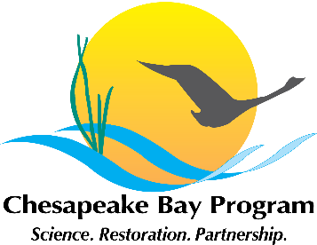
Stewardship Goal Implementation Team (GIT)
June 1st, 2016, 1:00 – 3:00
National Park Service
410 Severn Avenue, Suite 314, Annapolis, MD
https://epawebconferencing.acms.com/git5
Call-in#: 866-704-1637 Passcode: 269 490#

1:00 Welcome / Introductions (Chuck Hunt, GIT Chair)

1:05 Management Strategy Highlights (Workgroup Leads, All)
Purpose: Team leads will provide highlights from their final management strategies. Priority themes for 2016/2017 will be highlighted as well as opportunities for collaboration with other Agreement outcomes will be identified.

- Diversity
- Public Access
- Environmental Literacy
- Land Conservation
- Citizen Stewardship

2:00 Cross-Goal Team Project: Identifying Geographic Areas that Benefit Multiple CBP Outcomes (Kristin Saunders)
Purpose: Kristin will provide an overview of this new project and discuss with participants unique stewardship related opportunities for engagement in this project.

2:20 GIT Project Funding 2017 Schedule (Kristin Saunders)
Purpose: Kristin will provide an update on the process to identify and select 2017 projects for GIT funding.

2:30 BMP Effectiveness Project (Mark Sievers, James David-Martin)
Purpose: Mark will provide a brief overview of this project and identify next steps for the Stewardship GIT to engage in this project.

2:45 2016 Future Meetings (All)
Purpose: Participants will discuss future meeting topics and meeting frequency.

3:00 Adjourn

