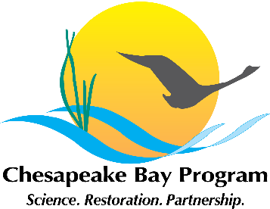
Stewardship Goal Implementation Team (GIT)
Meeting Agenda
National Park Service
410 Severn Avenue, Suite 314
August 3, 2015 12:30– 2:00
Call-in#: 866-704-1637 Passcode: 269 490#

Welcome / Introductions (Chuck Hunt, Chair)
- Welcome Lauren Imgrund

Plans to develop Work Plans (Amy, All)
- Final template
- Schedule
- Workgroup plans / next steps

2016 GIT support grant award process and schedule (Amy, All)
- Schedule and process
- Project concept sharing

Current GIT support grant award updates (Jaime Baxter)

Adjourn
- Next meeting – September 14

