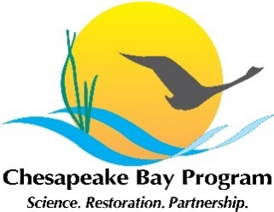
Wetland Workgroup Meeting
October 18, 2019 | 10 am – 1 pm
Chesapeake Bay Program Office |Conference Room 305
Conference Line: (929) 205 6099
Meeting ID: 207 034 925
https://zoom.us/j/207034925
*If you are joining by webinar, please open the webinar first, then dial in.

10:00 am Introductions

10:05 am Welcome & Opening Comments
- Our progress from the September 2019 meeting (Pam Mason, Workgroup Chair)
- BMP Expert Panel Report update (Pam, Carin Bisland)
- Today’s meeting purpose, goals and overview (Sherry Witt, facilitator)

10:15 am A Second Look: What Keeps Us from Getting Wetland Acres in the Ground? (Sherry Witt/everyone)
- Reaffirm our September 10th workgroup meeting of the barriers to progress and the four ways to achieve our goals
- Reflect our input in our workgroup products (Logic & Action Plan and the Management Strategy)

10:35 am Our Steps to Achieving our Goals? (Sherry Witt/everyone)
- Do our current actions still apply?
- What are we are we currently doing to overcome our barriers?
- What further efforts or information is needed to address these barriers?
- What are our essential actions needed to address these gaps?

12:45 pm The Way Forward
- Future agenda topics (Sherry)
- Our progress and next steps (Sherry/Pam)
- Future meeting dates and process (Pam)

1:00 pm Adjourn

