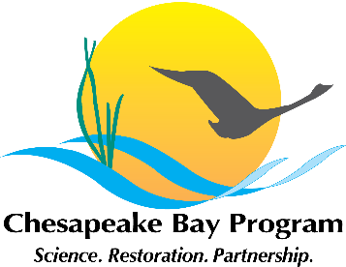
Stewardship Goal Implementation Team (GIT)
National Park Service
410 Severn Avenue, Suite 314, Annapolis, MD
December 1st, 2014, 12:30– 2:00
Call-in#: 866-704-1637 Passcode: 269 490#

12:30 Welcome / Introductions (Kristin Saunders, GIT Chair)

12:40 Management Strategy Update (Outcome Leads, All)

Outcome leads will provide an update on the status of management strategy development and what will be provided to the Management Board on December 15th.

- Public Access
- Environmental Literacy
- Land Conservation
- Citizen Stewardship

1:15 GIT Project Funding Update (Jaime Baxter, Amy Handen)

1:45 2015 Meeting Schedule (All)

2:00 Adjourn

