Chesapeake Bay Program
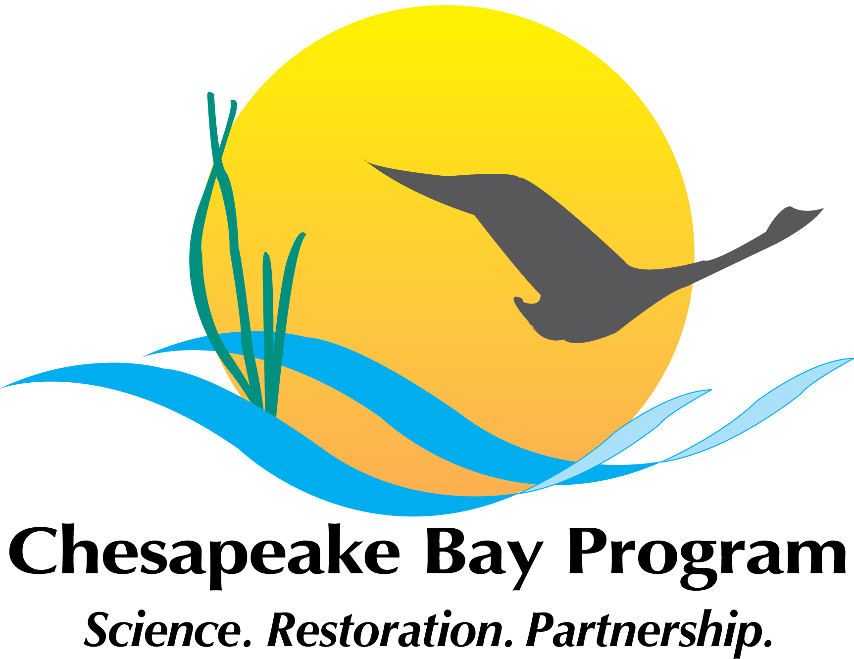
Plastic Pollution Action Team
Web Meeting #6
April 13, 2021
1:00 PM – 3:30 PM

Please join my meeting from your computer, tablet or smartphone.
https://global.gotomeeting.com/join/567847573
You can also dial in using your phone.
United States: +1 (872) 240-3212
Access Code: 567-847-573
*New to GoToMeeting? Get the app now and be ready when your first meeting starts:
https://global.gotomeeting.com/install/989295277
**************************

Upcoming webinars and other information about plastic pollution:
We will provide this information on all future agendas for PPAT meetings. It is highly recommended that folks get on Clean Ocean Action’s weekly microplastic article listserv. If interested, please contact Catie Tobin at CTobin@CleanOceanAction.org.

If PPAT members have any webinars, papers, new articles, funding opportunities etc. please forward to justin.shapiro@noaa.gov)

Papers:
P.T. Harris, L. Westerveld, B. Nyberg, et al., Exposure of coastal environments to river-sourced plastic pollution, Science of the Total Environment (2021),https://doi.org/10.1016/j.scitotenv.2021.145222

AGENDA

01:00 Introductions and Announcements
Matt Robinson (DOEE) - Action Team Chair

01:10 Presentation on Draft Science Strategy
Bob Murphy and Jennifer Flippin, Tetra Tech

01:30 Discussion on Science Strategy
Bob Murphy and Jennifer Flippin, Tetra Tech

03:00 Future of the PPAT
Matt Robinson (DOEE), Action Team Chair, & Kelly Somers (EPA Region III), PPAT Vice Chair
3:30 Adjourn

