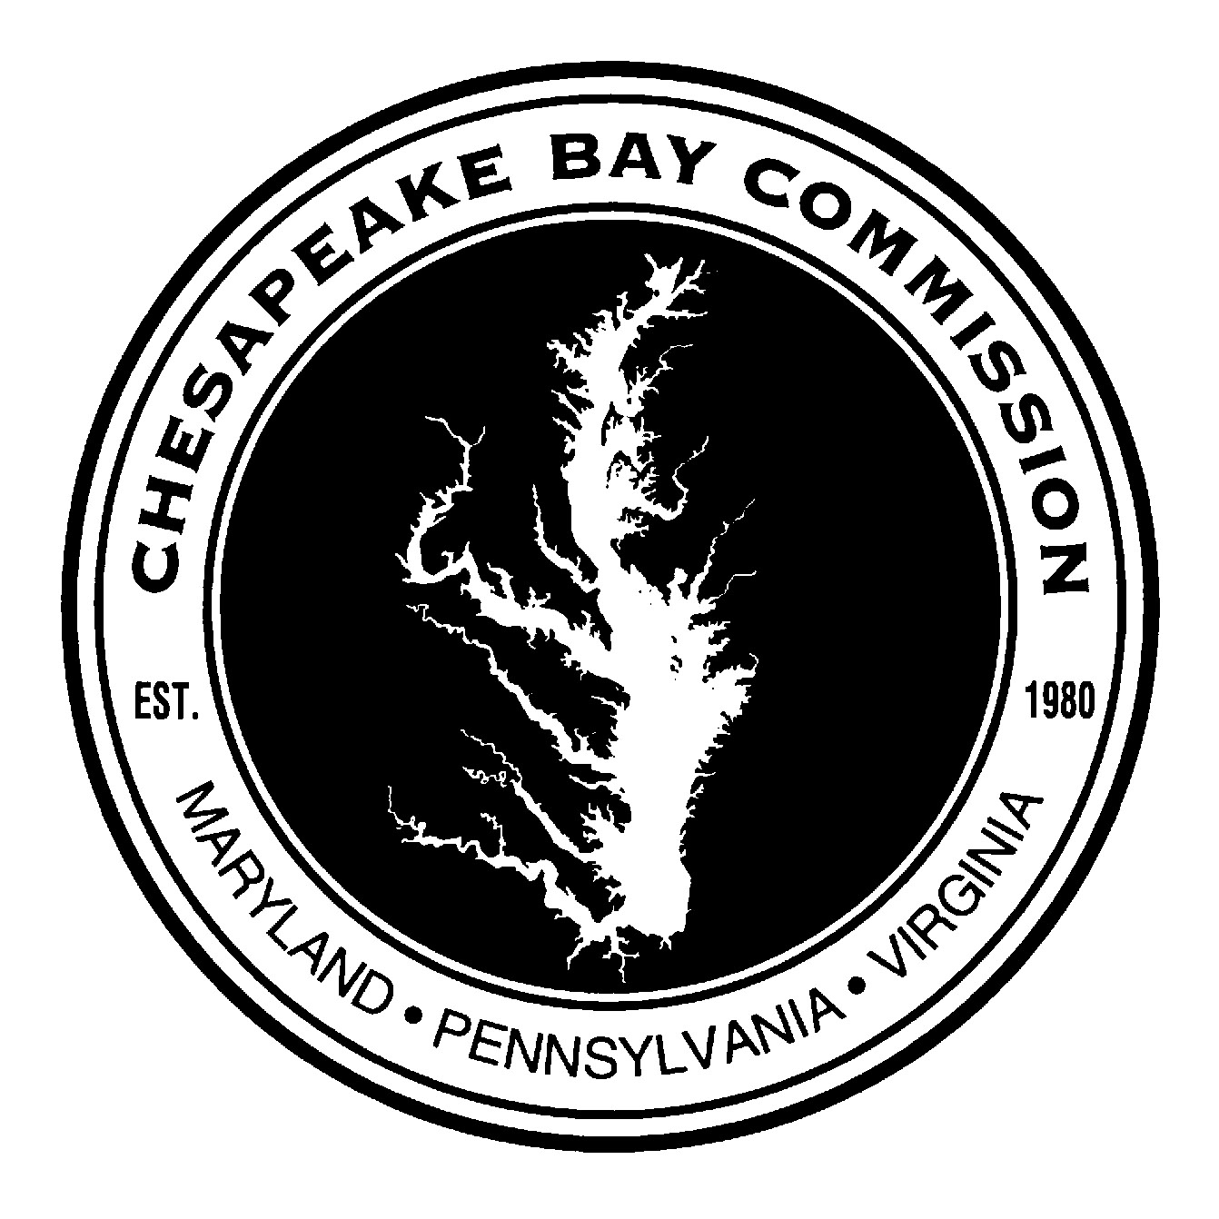
Federal Agency Budget Results
Agency | FY19 Funding Level | FY20 Request | Results | Notes
Environmental Protection Agency
Geographic Programs – Chesapeake Bay | $73M | $90M | $85M | Added “effective basins” program to target funds
National Park Service
Chesapeake Bay Gateways and Trails Program | $2M | $3M | $3M | Program also explicitly authorized for FY2020
Army Corps of Engineers
Construction – Chesapeake Bay Environmental Restoration and Protection | $50M/$0 | $10M | $100M/$25M | Increased programmatic account, set aside $25M for programs with a comprehensive restoration plan.
Construction – Chesapeake Bay Oyster Recovery | $50M/$0 | $5M | $100M/$5M | Increased programmatic account, set aside $5M for oyster restoration.
Geological Survey
Ecosystem Science and Monitoring – Chesapeake Bay | $12.85M | $12.85M | $14.85M
Additional Interior Bill Programs
EPA Clean Water State Revolving Fund | $1,394,000,000 | $1,394,000,000 | $1,394,000,000
EPA Non-Point Source Grants (Section 319) | $170,915,000 | $170,915,000 | $177,915,000
EPA Pollution Control Grants (Section 106) | $230,806,000 | $230,806,000 | $230,806,000
USFWS Cooperative Landscape Conservation | $12,500,000 | $12,500,000 | $12,500,000
USFWS Habitat Conservation – Coastal Program | $13,375,000 | $13,375,000 | $13,375,000 | $1,750,000 set aside for the Chesapeake Bay Nutria Eradication Project
USDA Forest Stewardship | $20,500,000 | $20,500,000 | $21,000,000
DOI Land and Water Conservation Fund | $438,303,000 | $438,300,000 | $495,103,000
Additional Energy and Water Bill Programs
USACE Poplar Island | $8,100,000 | $8,100,000 | $17,300,000 | Includes funds from other accounts
USACE Aquatic Ecosystem Restoration (Section 206) | $12,000,000 | $12,000,000 | $10,000,000
USACE Emergency Streambank and Shoreline Protection (Section 14) | $10,000,000 | $10,000,000 | $8,000,000
Commerce, Justice, Science Bill
NOAA Habitat Conservation and Restoration | $56,384,000 | $61,384,000 | $57,125,000
NOAA Regional Councils and Fisheries Commissions | $40,175,000 | $40,175,000 | $40,247,000
NOAA Bay-Watershed Education and Training (BWET) | $7,500,000 | $7,500,000 | $7,750,000
NOAA Sea Grant College Program | $80,000,000 | $93,500,000 | $87,000,000 | Includes Marine Aquaculture Program
Agriculture Bill
NRCS Conservation Operation | $819,492,000 | $875,000,000 | $829,628,000

