Draft
September 26th, 2015
Governance Policy of the Urban Stormwater Group

Signatory Members (one each, with an alternate identified, starting with the 10/14 list)

- Delaware
- District of Columbia
- Maryland
- New York
- Pennsylvania
- West Virginia
- Virginia
- US EPA
- Chesapeake Bay Commission

Local Government Implementers: Up to two local or regional government representatives per state. Nominations will be accepted from all USWG members, advisors and interested parties, and the selection of local government implementer members will be determined by the USWG signatory members, with consideration to their level of commitment, skills and perspectives (e.g., geographic diversity and expertise).

At-large Members (up to 3, with an option to identify an alternate). May consist of non-governmental organizations, state highway agencies, private sector experts, federal agencies, academic institutions and other organizations. Nominations will be accepted from all USWG members, advisors and interested parties, and the selection of at-large members will be determined by the USWG signatory members, with consideration to their level of commitment, skills and perspectives (e.g., geographic diversity and expertise).

Interested Parties: individuals that participate in USWG meetings, but who do not have a decision-making role.

Decision-making for the USWG will be done by the signatory, local government and at-large members through a unanimous or consensus based process (i.e., all parties can live with the decision) that ultimately concludes in the polling of members to determine the will of the group.

If, after substantial negotiation, consensus cannot be reached among the members, consensus will be sought from the signatory members, particularly on those issues that are deemed time-sensitive by the CBP partnership. In time sensitive instances, the USWG agenda will clearly note those decisions where consensus will be sought from the signatory members when broad consensus cannot be achieved.

If consensus cannot be reached at the signatory stage, all USWG members will be polled, and the decision will be elevated to the next decision-making body (WQGIT) along with a brief description of the positions of the polled members. When being polled, members will be asked to indicate their perspective, based on the five stages in the consensus continuum shown in Figure 1 (UMD, CLOC).
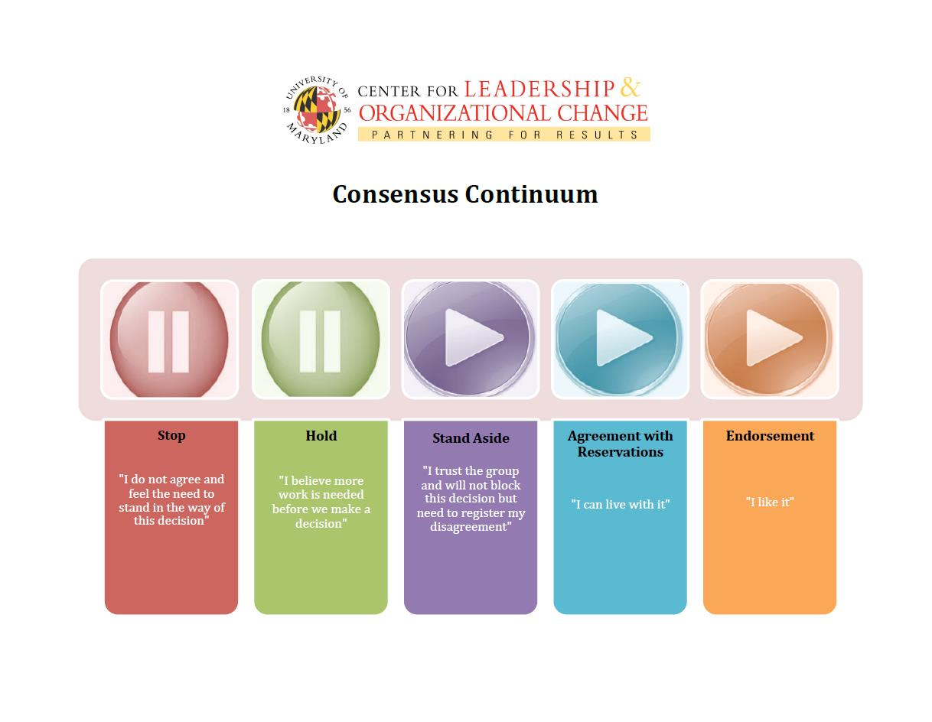
Figure 1. The Consensus Continuum

