Importance: The Bay cannot be restored without water that is clean, clear and rich in oxygen. Currently, the Bay and its rivers receive too much nitrogen, phosphorus and sediment for the ecosystem to remain healthy. The primary sources of these pollutants are agricultural runoff and discharges, wastewater treatment plant discharges, urban and suburban runoff and septic tank discharges, and air deposition.
Goals: Reduce computer-simulated nitrogen loads to the Bay by 75.39 million pounds, from 282.66 million in 2009, to 207.27 million by 2025; phosphorus loads by 4.68 million pounds, from 19.23 million in 2009, to 14.55 million by 2025; sediment loads by 1,334 million pounds, from 8,675 million in 2009, to 7,341 million by 2025.*
Nitrogen Status and Trends: Computer simulations of pollution controls implemented between July 2009 and June 2011, calibrated using monitoring data, indicate that nitrogen loads to the Bay would have decreased 15.67 million pounds to 266.99 million*. For additional information, go to http://www.chesapeakebay.net/indicators/indicator/reducing_nitrogen_pollution.
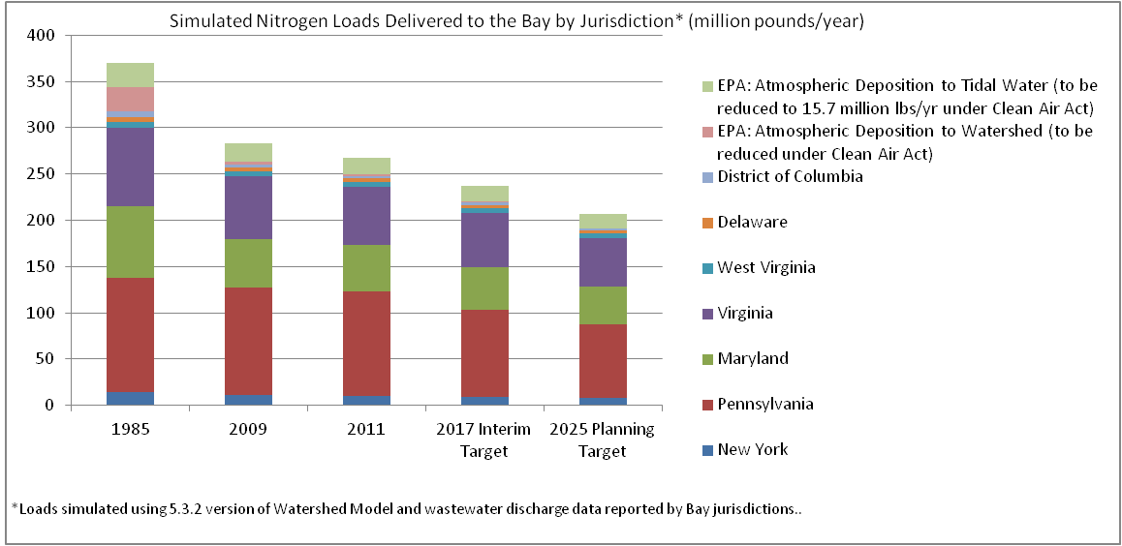
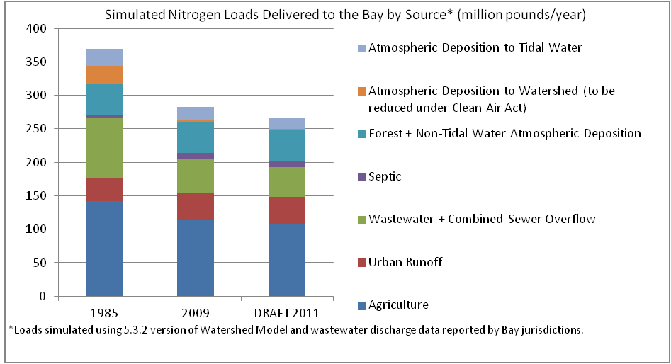

Phosphorus Status and Trends: Computer simulations of pollution controls implemented between July 2009 and June 2011, calibrated using monitoring data, indicate that phosphorus loads to the Bay would have decreased 0.9 million pounds to 18.33 million*. For additional information, go to http://www.chesapeakebay.net/indicators/indicator/reducing_phosphorus_pollution.
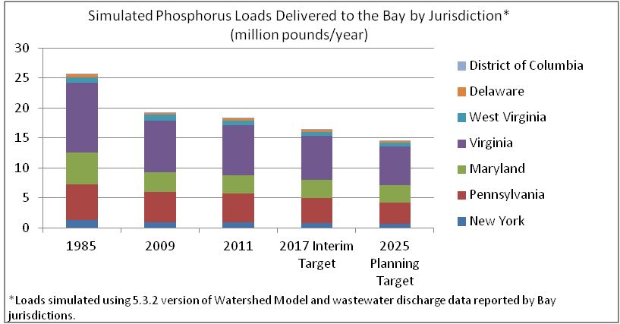
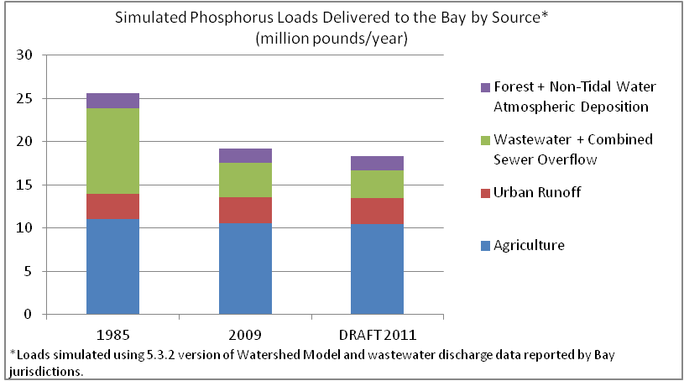

Sediment Status and Trends: Computer simulations of pollution controls implemented between July 2009 and June 2011, calibrated using monitoring data, indicate that sediment loads to the Bay would have decreased 396 million pounds to 8,279 million*. For additional information, go to http://www.chesapeakebay.net/indicators/indicator/reducing_sediment_pollution.
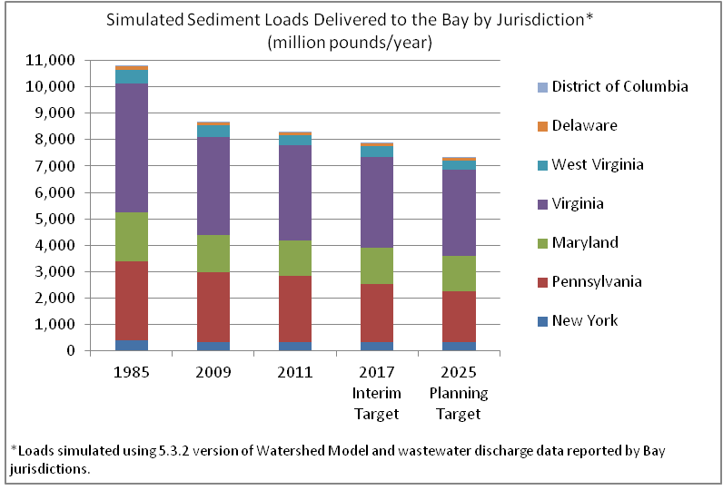
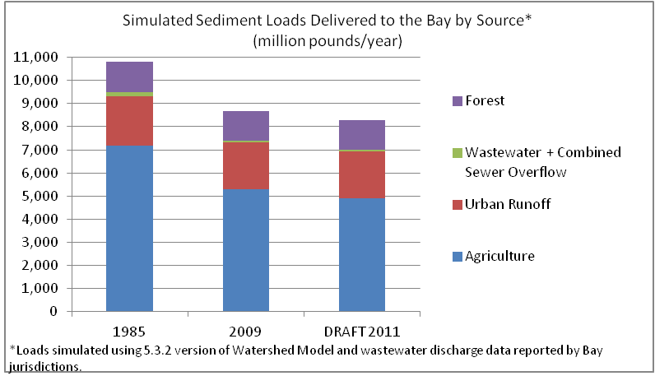

* Loads simulated using 5.3.2 version of Watershed Model and wastewater discharge data reported by the Bay jurisdictions. The Chesapeake Bay Program Watershed Model uses actual wastewater discharge data, which is influenced by annual weather conditions, to estimate wastewater pollution. The Model estimates pollution from other sources such as agriculture or urban runoff using average weather conditions. Loads include atmospheric deposition of nitrogen to tidal waters and the portion of atmospheric deposition to the watershed that is EPA's responsibility to reduce under the Clean Air Act. Planning targets, established in August 2011represent the actions, assumptions, and “level of effort” necessary to meet the TMDL.

