Jurisdiction X
2012-2013 Milestones to Reduce Nitrogen, Phosphorus and Sediment

Introduction
In 2008 the Chesapeake Executive Council charged the seven jurisdictions to develop two-year milestones for pollution reduction to the Chesapeake Bay and to track the pace of restoration. The two-year milestones provide short-term objectives and are part of an overall accountability framework to assess progress on restoration goals. When fully implemented, the seven Watershed Implementation Plans (WIPs) will ensure that practices are in place by 2017 to reduce the load by 60 percent. By 2025, all practices necessary to meet the target loading levels will be in place. The two-year milestones allow jurisdictions the opportunity to adapt implementation strategies outlined in their WIPs as necessary to meet those goals and achieve the Total Maximum Daily Load (TMDL) standard. [Jurisdiction’s] 2012-2013 milestone commitments are to reduce nitrogen by xx pounds, phosphorus by xx pounds, and sediment by xx tons by the end of 2013, compared to the 2009 baseline.

Jurisdiction X’s Pollutant Reduction Progress and Future Targets by Source Sector

Nitrogen Phosphorus Sediment
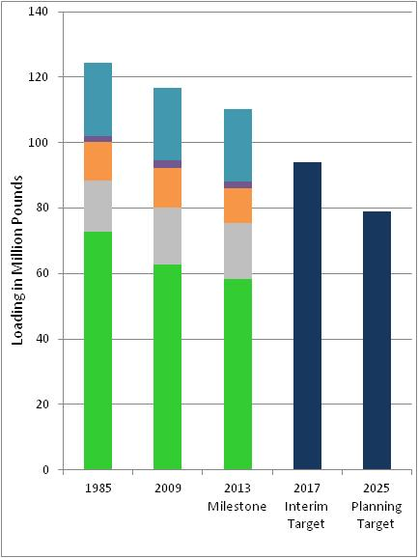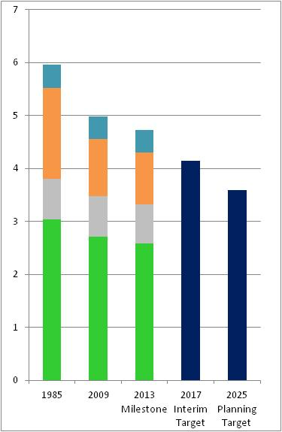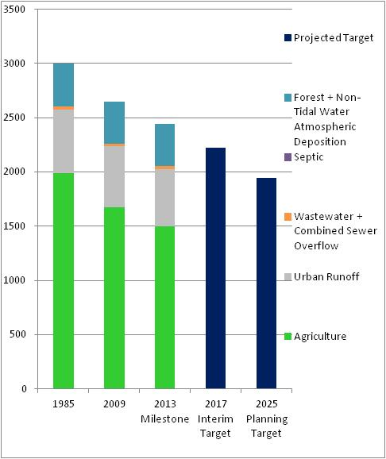

Milestone Highlights:
Jurisdiction to provide a few sentences to address or clarify the information in the charts above. Sample language: “Jurisdiction’s” 2013 milestones for nitrogen is on track to meeting the targets for 2017. Greater reductions for phosphorus will not occur until 2015 due to proposed regulatory changes.
Jurisdiction X 2012-2013 Milestones to Reduce Nitrogen, Phosphorus and Sediment (continued)

Pollutant Reduction Controls, Practices and Actions in 2012-2013 Milestone Targets
(Highlight key numeric targets or practices from the 12-13 Milestones. This includes actions that are not in the input deck i.e.,
# of inspections or rain gardens, but still has a numeric target)

Pollutant Controls, Practices, and Actions | Progress through 2011 |  | 2012-2013 Targets
Agriculture
xxx |  | xxx | xxx
xxx |  | xxx | xxx
xxx |  | xxx | xxx
xxx |  | xxx | xxx
xxx |  | xxx | xxx
Urban Runoff
xxxx |  | xxx | Xxx
xxxx |  | xxx | Xxx
xxxx |  | xxx | Xxx
xxxx |  | xxx | Xxx
xxxx |  | xxx | Xxx
Wastewater +Combined Sewer Overflow
Plants upgraded and in compliance with TMDL WLAs |  | xxx | xxx

For the full details of Jurisdiction X’s target implementation milestones, please see (EPA to include weblink)

2012-2013 Commitments

- include some key programmatic milestones and the dates)
- Xxxx
- Xxxx
- Xxxx
- Xxxx
- Xxxxx
- Xxxx
- Xxxx
- Xxxx
- Xxxx
- Xxx
- Xxx
- Xxxx
- Xxxx

For the full details of Jurisdiction X’s programmatic milestones, please see (provide web link here)

