Nutrient and Sediment Trends in the Chesapeake Bay Watershed.

Prepared by the U.S. Geological Survey, Principals’ Staff Committee Meeting, May 2012

Issue: The U.S. Geological Survey (USGS), in partnership with the Chesapeake Bay Program (CBP), uses the CBP nontidal monitoring network (map 1) to measure changes in nutrients and sediment in the Chesapeake Bay watershed. The data from the network are summarized in an upcoming USGS report about trends of nitrogen, phosphorous, and sediment concentrations in the Bay watershed. The trends are part of the proposed integrated approach to better assess and communicate progress toward attainment of water-quality standards and relation to practices being implemented for the Bay TMDL.

Results from Upcoming USGS Report on Trends in Nutrients and Sediment:
Watershed trends for nitrogen, phosphorus and sediment are provided for two periods, long-term changes (1985-2010) and over 10 years (2001-2010). Long-term changes are provided for 31 sites while trends for the last 10 year are provided for 33 sites (see table).
- Nitrogen Trends
  - Long term: Since 1985, nitrogen concentrations have improved (decreased) at about two thirds of the monitoring stations. Two sites showed degrading conditions (see map 2).
  - Short term: Over the past 10 years, improvements were observed at just under half of the monitoring sites, while most sites had no significant change.
- Phosphorus Trends
  - Long term: Since 1985, phosphorus concentrations have improved at 70 percent of monitoring sites and worsened at 4 sites (see map 3).
  - Short term: Over the past 10 years, phosphorus concentrations improved at 1/3 of the sites, while most sites had no significant change.
- Sediment Trends
  - Long term: Since 1985, sediment has decreased at about 30 percent of the sites. About 40 percent of the sites showed no significant change (see map 4).
  - Short term: Only 3 sites showed improvements, 9 sites showed degrading conditions with most sites showing no significant trends.
Summary of trends for nitrogen, phosphorus, and sediment in the Bay watershed
Pollutant  Trend Period | Improving  sites | Degrading  sites | Sites with  No Trend
Nitrogen
Long Term 1985-2010 | 21 | 2 | 8
Recent 2000-2010 | 14 | 2 | 17
Phosphorus
Long Term 1985-2010 | 22 | 4 | 5
Recent 2000-2010 | 12 | 4 | 17
Sediment
Long Term 1985-2010 | 10 | 8 | 13
Recent 2000-2010 | 3 | 9 | 21

Additional background information:
- The watershed trends are part of the proposed integrated approach to better assess and communicate progress toward water-quality standards and it relation to the Bay TMDL, which would include three primary pieces of information:
  - Implementation of water-quality practices
  - Trends of nitrogen, phosphorus and sediment in the watershed.
  - Attainment of dissolved oxygen, chlorophyll-a, and water clarity/SAV standards.
- The concentrations of nutrients and sediment in rivers vary greatly each year because they are influenced by changes in the amount of annual rainfall. The USGS has developed techniques to adjust for the effects of rainfall variability in order to better evaluate if long-term changes in waterway conditions are related to human activities and management efforts. These techniques, called “flow-adjusted trends,” provide information on how nutrient and sediment concentrations would change over time if they were not influenced by changes in river flow.
- Multiple factors are affecting water-quality changes in the watershed. The primary factors include (a) changes in nutrient sources, (b) changes in land use, (c) population increases, (d) implementation of management actions, and (e) the influence of watershed characteristics.
- These long-term trends suggest that pollution-reduction efforts, such as improved controls at wastewater treatment plants and practices to reduce nutrients and sediment from farms and suburban lands, are improving water-quality conditions in many areas of the watershed. However, nutrients, sediment, and contaminants will need to be further reduced to achieve a healthier Bay and streams.
- The trends, especially over the past 10 years, are affected by lag times between implementing practices and improvements in nitrogen, phosphorous, and sediment. More information on lag times is available in a USGS fact sheet: http://md.water.usgs.gov/publications/fs-091-03/html/index.html
- The USGS is developing additional techniques to assess changes in nutrient and sediment loads. This new method, known as Weighted Regressions on Time, Discharge, and Season (WRTDS), compliments our historical statistical approach for quantifying loads and flow-adjusted concentration trends such that we can now determine changes in nutrient and sediment loads and better compare results to CBP water-quality goals.
- The watershed trend results will be published in a USGS report: Langland, Blomquist, Moyer, and Hyer, 2012: Nutrient and Suspended-Sediment Trends, Loads, and Yields and Development of an Indicator of Stream-water Quality at Nontidal Sites in the Chesapeake Bay Watershed, 1985-2010, U.S. Geological Survey Scientific Investigations Report 2012- (in final review).

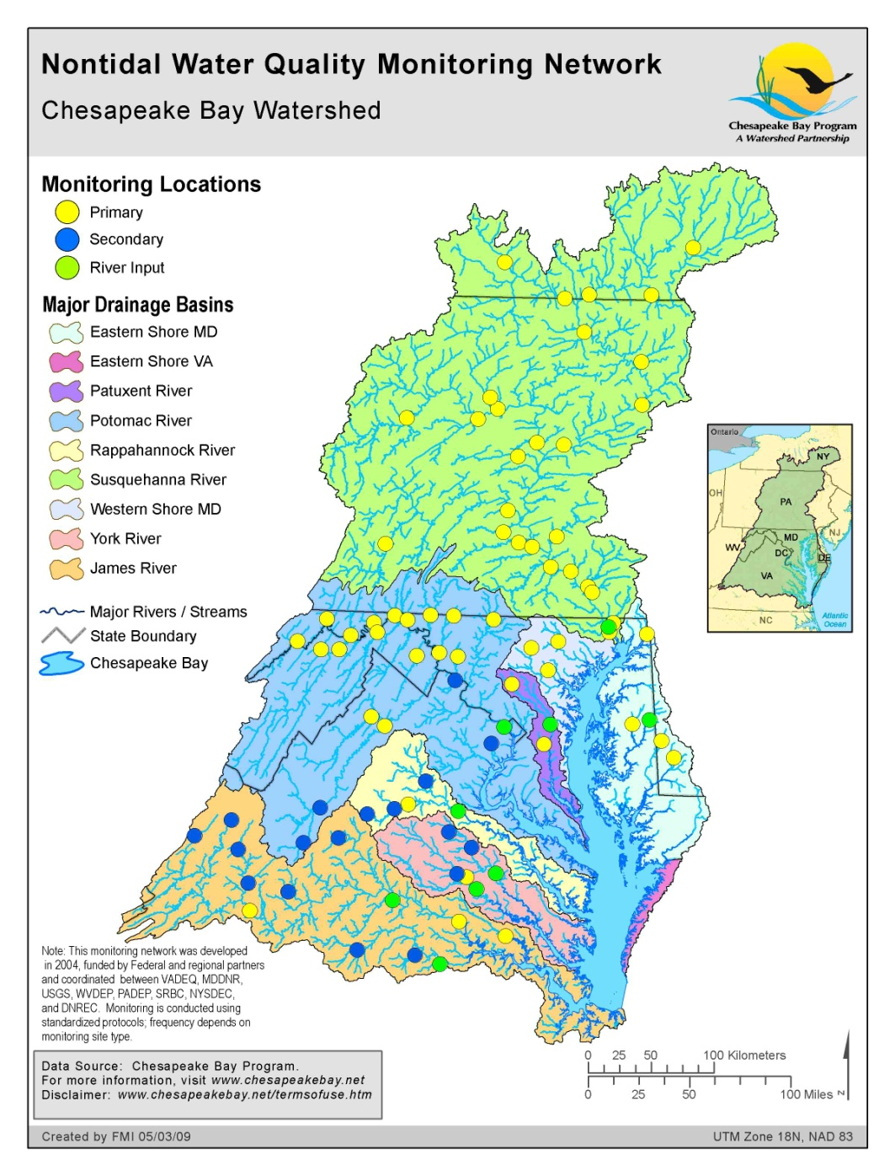

Map 1: Monitoring sites in the nontidal network. A subset of these sites is included in an annual water-quality update. More sites are being added during 2011 and 2012.

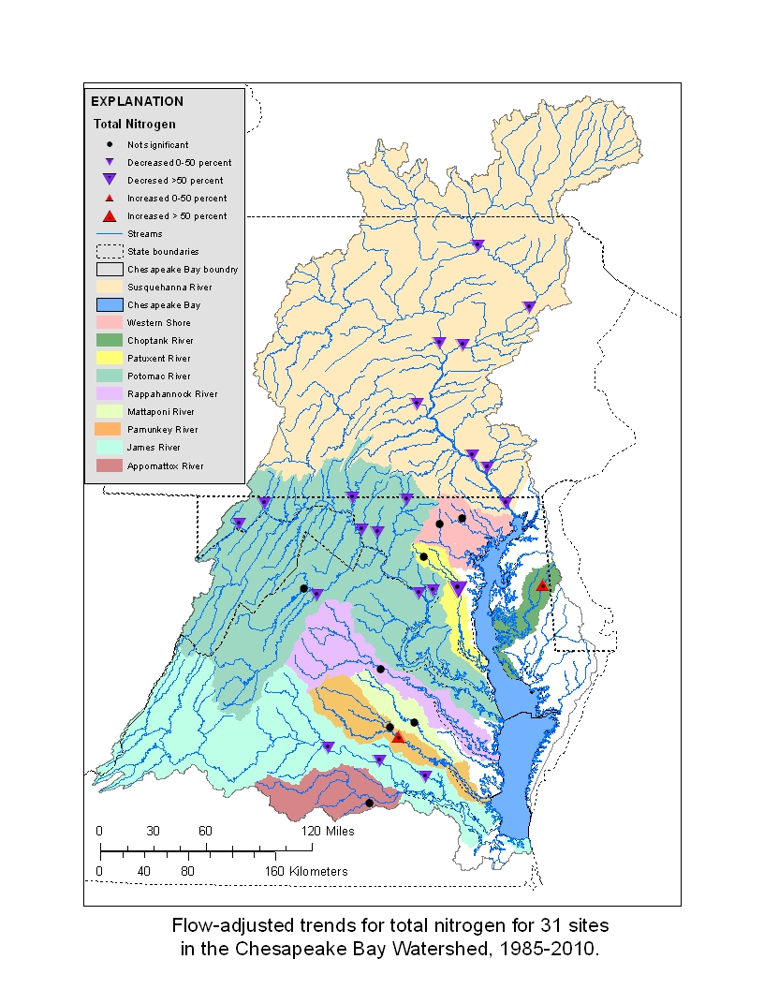

Map 2: Long-term Flow-Adjusted Concentration Trends for Nitrogen, 1985-2010

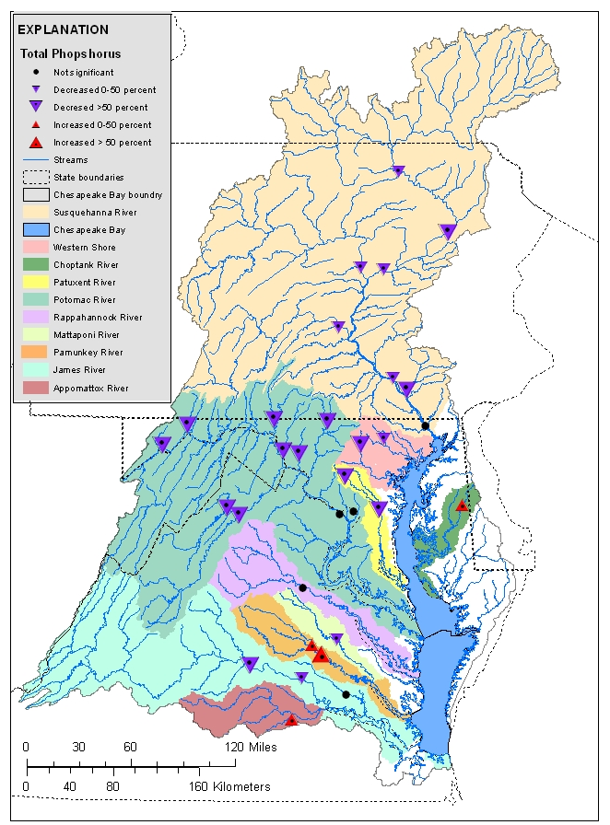
Map 3: Long-term Flow-Adjusted Concentration Trends for Phosphorus, 1985-2010

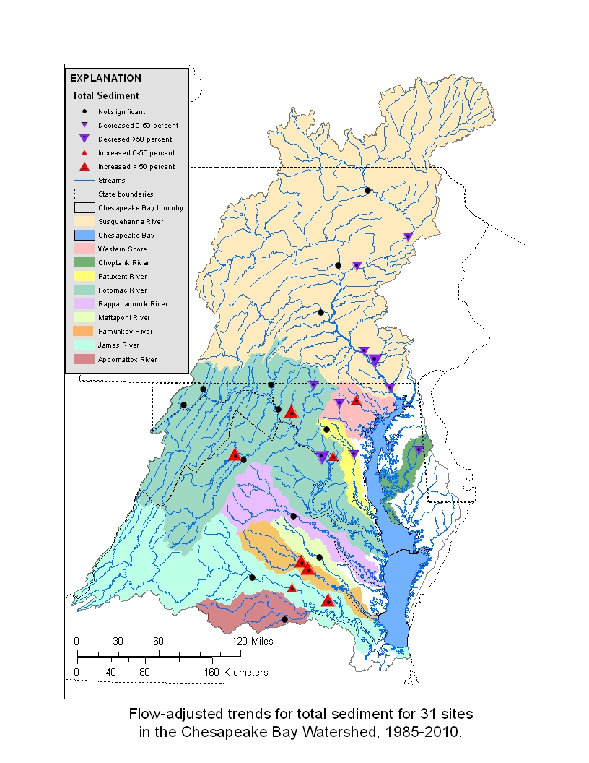
Map 4: Long-term Flow-Adjusted Concentration Trends for Sediment, 1985-2010

