

TO: Citizens Advisory Committee to the Chesapeake Executive Council

FROM: Nominating Committee

DATE: November 16, 2015

RE: 2016 CAC Officers

The Committee is pleased to offer the following recommendations for your consideration:

Chair: Charlie Stek, MD
Vice Chair: Paula Jaskinski, VA

Respectfully submitted:

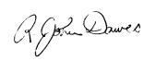
R. John Dawes
Chair, Nominating Committee

