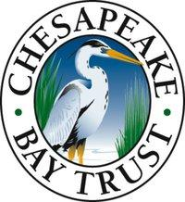
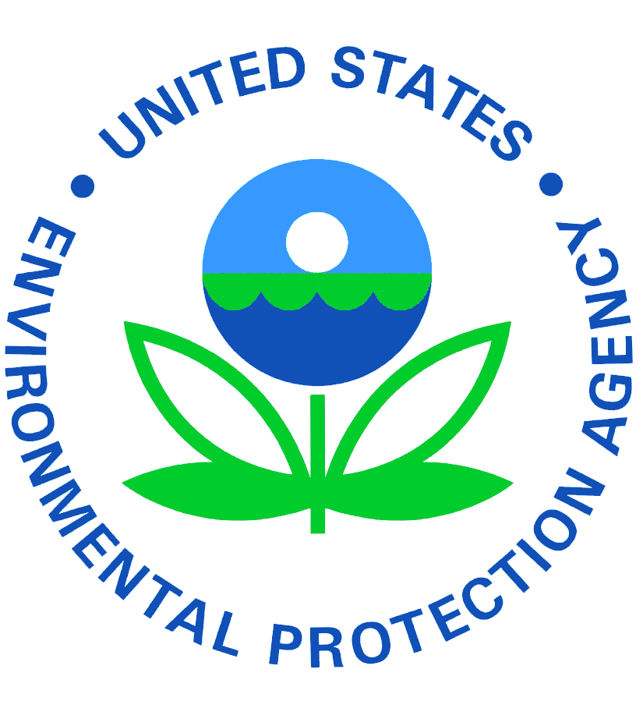

Behavioral Consultation

Overview
Changing human behavior is critical for meaningful effects on most environmental issues. Traditional marketing campaigns that focus on awareness and education typically fail because they do not address the underlying motivations for behavior. A plethora of research exists to demonstrate that information-intensive approaches do little to foster long-term changes in behavior. Community-based social marketing (CBSM) has emerged as an effective alternative to these campaigns. The approach has been used worldwide to effectively motivate behavior change across a wide range of domains. Read more at cbsm.com.

We look forward to working with you to help you meet your team’s environmental goals by fostering behavior changes in your target audience. The goal of these two-hour consultations is to provide a starting point for developing and refining your team’s future behavior change campaign. Depending on your team’s goals, we will help you develop an actionable plan to: select meaningful behaviors, identify barrier/benefit research strategies, apply a variety of behavior change tools, design effective program strategies, employ pilot testing, and conduct evaluation.

Training Follow up
The consultations serve as a more in-depth, personalized next step after the training. Many of the activities in each of the GIT teams’ workplans would benefit from the incorporation of behavior change campaigns. During the first SRS round, almost every single workgroup identified local engagement and communications as areas where significant work is needed to progress toward meeting your outcomes. Community-Based Social Marketing is a process designed to inspire behavior change and by learning the foundations of this model, it will help you to understand why looking at particular audiences, benefits, barriers and behaviors really are vital components in any work you do to meet your outcomes. The training will provide the foundation – a consultation will apply it to your team’s specific goals and context.

Details
There will be four consultations available for selected projects within the Chesapeake Bay Program (CBP) organization structure. In each consultation session, Action Research will work with your team in depth to apply CBSM principles, customizing them to your program and goals, brainstorming solutions to challenges, and provide customized recommendations that fit your unique circumstances. The session will result in support for the next steps your team can take to develop your own behavior campaign, such as: (1) how to use existing data to select and prioritize behaviors; (2) how to conduct barrier/benefit research; and/or (3) how to develop and pilot test strategies. Brief bios of our team members are available at the end of the end of this document.

Considerations for Selection
There are only four free consultation spots available. Our goal is to identify teams that are well suited to apply the consultation recommendations to their projects. We are looking for teams/projects with:

- At least one team member attending the October 31st one day training
- Defined environmental outcome(s)
- Defined target audience(s)
- Defined target behavior(s)
- Existing foundational audience research, or resources to conduct foundational audience research, if needed
- Responses to the pre-consultation worksheet
We have identified your team as well suited for a consultation. By October 18th, please reach out to Amy Handen (amy_handen@nps.gov) or Rachel Felver (rfelver@chesapeakebay.net) to discuss the opportunity.

Pre-Consultation Worksheet
We suggest starting this worksheet prior to the October 31st training. For any questions contact Katy Phelps (phelps@actionresearch-inc.com).
Team name: _Habitat GIT: Wetlands Work Group__________ Participating members’ names: _Jennifer Greiner, Megan Ossmann, Pam Mason, Kevin Du Bois, Christine Tombleson
Question | Answer
What is your projects’ desired environmental outcome? | -Tidal and nontidal wetland restoration creation and rehabilitation  -Increasing the implementation of living shorelines practices among property owners for shoreline erosion control.
What are the audiences that have an impact on that goal? Which audiences does your team want to/already target? Why these audiences? | -NGO, SWCD, Ag and Urban and shoreline property owners  -Waterfront property owners, local wetland boards, contractors, homeowners, regulatory staff (local and State).  -Kevin - want to primarily target contractors since they appear to be contacted first and have the most influence on homeowner decision-making (who become vested in solution strategies early on)  -Christine – want to target more specifically property owners
What behaviors can the audience take that significantly impact your desired outcome? | -Homeowners choosing to install a living shoreline when and if appropriate over conventional projects.  - Choosing wetlands over other BMPs  -Contractors need to understand how to make money by installing living shorelines and understand how to write service contracts (and make money) for vegetation/project maintenance, enhancing species diversity, adding flowers and other aesthetic enhancements.  -For regulators, they need to start denying shoreline hardening projects when a living shoreline project is a viable option. Regulators also need to understand how living shoreline support other local/State programs/initiatives (State Outdoor, Recreation, Tourism and Wildlife Plans, etc.).
Which of these behaviors do your projects seek to motivate? Why did your team choose these behaviors? Are there other behaviors you want to work on? | -Christine: Choosing to install a living shoreline when and if appropriate. This is the behavior that will improve water quality, habitat and other ecosystem services along the shoreline and allow wetlands to persist during sea level rise. This is the main behavior (it is big)  -Kevin: We primarily focus on freshwater wetland restoration by conversion of agricultural land. More work needs to be done with saltwater wetlands and in urban/suburban communities.  -Pam: Increase confidence in the effectiveness of tidal wetlands for protection. Increase by-in from regulatory decision makers. Motivate program partners to promote wetland projects
What audience research is available to your team on these behaviors? For example, have you surveyed this audience? Has other research been conducted on this audience that you’re aware of? | -Kevin: The Virginia Institute of Marine Science conducted a survey of attitudes regarding the implementation of living shorelines. The Elizabeth River Project also conducted a survey of attitudes (through Water Words that Work).  -Pam: Wetland works website. NSF VIMS project results pending.  -Christine: We (VIMS) have periodically surveyed the audience in the past. We did a Living Shoreline preference survey twice. I believe there is other research that has been conducted on property owners.
What resources do you have to complete additional audience research, if needed? | -CCRM staff  -One-off grants
What outreach does your team currently use to influence your behavior(s)? (include these materials with this worksheet) | -CCRM has a living shoreline website, brochures, on-site advisory assistance, on-line shoreline best-management recommendations portal  -CBP Communications Workgroup. Marsh Resilience Summit.  -Wetlands Work website (www.wetlandswork.org)
To change your program, do you need approval from other individuals or groups who would not be present at the consultation? | Consensus of the Wetlands Workgroup, Review by the Management Board, Principals Staff Committee and Executive Council
Are there specific mandates or requirements you must meet in your team’s work? | -The CBP has a goal to create or reesstablish 85,000 acres of tidal or nontidal wetlands and enhance an additional 150,000 acres of degraded wetlands by 2025, primarily on agricultural or natural landscapes.  -CCRM is required to provide technical advisory services and locations of where living shorelines are appropriate.

Sample Completed Worksheet
The example responses below are not meant to be what the “best” answer would be, but to provide clarity on the questions.
Question | Answer
What is your projects’ desired environmental outcome? | Improvement in water quality (N, P)
What are the audiences that have an impact on that goal? Which audiences does your team want to/already target? Why these audiences? | Residential, agricultural. We primarily do outreach to agricultural owners because they are using more fertilizer, but we are doing more work with residential run off
What behaviors can the audience take that significantly impact your desired outcome? | 1. Reduce fertilizer use 2. Install rain gardens 3. Install rain barrel 4. Xeriscaping
Which of these behaviors do your projects seek to motivate? Why did your team choose these behaviors? Are there other behaviors you want to work on? | We primarily focus on rain gardens right now, as we got a grant to purchase and give workshops on them, and developed a partnership with the local Master Gardeners. We also want to work more on full xeriscaping.
What audience research is available to your team on these behaviors? For example, have you surveyed this audience? Has other research been conducted on this audience that you’re aware of? | We have evaluation surveys from our workshops, and there are case studies on http://chesapeakebehaviorchange.org/. We also leverage the experience of the Master Gardeners
What resources do you have to complete additional audience research, if needed? | We have two staff members who would have availability to do a literature review and to do small scale work. We plan to apply to the Chesapeake Bay Trust for an Outreach and Restoration Grant next cycle to do additional research if needed.
What outreach does your team currently use to influence your behavior(s)? (include these materials with this worksheet) | We currently have our workshop materials and recruitment materials
To change your program, do you need approval from other individuals or groups who would not be present at the consultation? | We need approval from our Board of Directors
Are there specific mandates or requirements you must meet in your team’s work? | Yes, we are mandated to host at least 3 educational workshops a year.

Action Research Team

Doug McKenzie-Mohr, Scientific Advisor

QUALIFICATIONS

For over three decades Dr. McKenzie-Mohr has been working to incorporate scientific knowledge on behavior change into the design and delivery of community programs. He is the founder of community-based social marketing and the author/co-author of three books on the topic. One of these books, “Fostering Sustainable Behavior: An Introduction to Community-Based Social Marketing,” has been recommended by Time Magazine and with over 50,000 copies in print has become requisite reading for those who deliver programs to promote sustainable behavior.

Dr. McKenzie-Mohr has worked internationally with a diverse array of governmental and non-governmental agencies, assisting them in identifying the barriers to behavior change and in developing and evaluating community-based social marketing initiatives to overcome these barriers. More than 70,000 program managers have attended workshops on community-based social marketing that he has delivered internationally. His work has been featured in the New York Times and he is the recipient of the American Psychological Association’s inaugural award for innovation in environmental psychology and the World Social Marketing conference’s inaugural award for contributions to the field of social marketing. He is a former Professor of Psychology at St. Thomas University in New Brunswick, Canada where he co-founded the Environment and Society program.
EDUCATION
- Ph.D. University of Waterloo
- M.A. University of Waterloo
- B.A. Honors, University of Manitoba (First Class Honors)
SELECTED COMMUNITY BASED SOCIAL MARKETING EXPERIENCE
- Audubon, North Carolina shoreline nesting CBSM strategies
- Agriculture and Agri-food Canada, Reducing farm watershed impacts
- County of San Diego, CBSM Watershed Protection training
- Efficiency Nova Scotia, Residential Energy Conservation CBSM Pilot
- Hawaii Energy, Commercial Energy Conservation CBSM Pilot
- Monterey Bay Aquarium, Advisor Seafood Watch Program
- Ontario Ministry of Natural Resources, Species at Risk Program
- Southwest Florida Water Management District, CBSM watershed protection strategies

Jennifer Tabanico, President
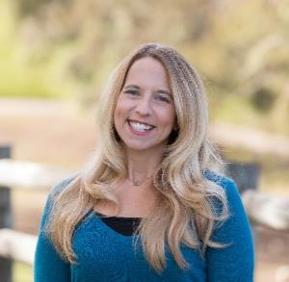
QUALIFICATIONS
Ms. Tabanico has 17 years of experience working directly with government agencies to develop, implement, and evaluate behavior change campaigns. She has managed projects and maintained positive communications with a range of public and private clients including American Forest Foundation, Build it Green, the Oregon Coast Aquarium, the Cities of Oceanside and San Diego, the Counties of Orange and San Diego, the New York State Energy Research Development Authority (NYSERDA), and the Urban Sustainability Directors Network (USDN). Ms. Tabanico has authored academic and technical publications in the areas of environmental attitudes, social influence, and community-based social marketing. Her work has been published in a variety of outlets including the Journal of Environmental Psychology, Social Influence, Social Marketing Quarterly, and the Handbook on Household Hazardous Waste.
EDUCATION
- M.A. in Experimental Psychology, California State University San Marcos
- B.A. in Psychology, Minor in Criminology, California State University San Marcos
SELECTED PROJECT EXPERIENCE
Ms. Tabanico is responsible for overall project design and contributing behavioral expertise.
- American Forest Foundation: Audience research to inform outreach to private forest owners; Development of recommendation for promoting the use of conservation easements and sustainable harvesting practices.
- City of Cupertino: Audience research and development of two pilot programs to reduce greenhouse gas emissions (reduce water heater temperature and install smart thermostats).
- County of San Diego Watershed Protection Program: Audience research and outreach development to promote a range of pollution prevention and water quality protection: (1) pet waste, (2) over-irrigation, (3) litter, (4) watershed education, and (5) erosion control.
- County of Orange Stormwater Pollution Prevention Program: Audience research and outreach development to promote a range of pollution prevention and water quality protection: (1) litter, (2) pesticide use, and (3) public outreach communications.
- National Fish and Wildlife Foundation: Consult on the application of behavioral science to promote a range behavior changes that support conservation.

Kaitlin Phelps, Senior Project Manager
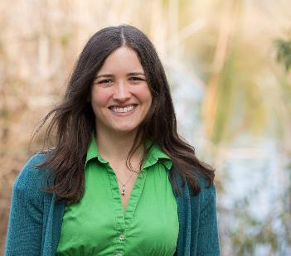

QUALIFICATIONS
Over the past 8 years, Ms. Phelps has focused on creating sustainable communities through effective programming that fosters voluntary behavior change. Her areas of expertise include strategies to change behavior, program evaluation, and social science research. She has applied this expertise across a multitude of environmental and sustainability topics, including recycling, composting, watershed stewardship, water conservation, and energy conservation.

EDUCATION
- M.A. in Natural Resources & Environment: Behavior, Education, & Communication, University of Michigan
- B.A. in Environmental Science, Social Sciences, Washington University in St Louis

SELECTED EXPERIENCE
- American Forest Foundation: Survey and focus group audience research to inform outreach to private forest owners; Development of program recommendation for promoting the use of conservation easements and sustainable harvesting practices.
- Baltimore County, MD: Research design of pilots focused on environmental education and outreach to reducing litter and pet waste pollution in target watersheds.
- California Efficiency Water Partnership: Online survey research to conserve residential water by increasing replacement of lawns with water efficient landscaping.
- City of Bowie, MD: Research design of pilots to foster tree planting and tree maintenance behaviors.
- City of Sunnyvale, Environmental Services Department: Literature reviews and interview research and marketing to increase commercial organics recycling.
- Keep American Beautiful Recycling at Work: Online survey research with businesses to understand barriers to recycling in the workplace.
- Massachusetts Department of Environmental Protection and Division of Ecological Restoration: Research and multiple pilots to conserve residential water by reducing summer lawn watering, include mail surveys and intercept interviews.
- New York State Energy Research and Development Authority (NYSERDA): Survey and literature research on a variety of workplace and individual energy efficiency behaviors.
- StopWaste (County of Alameda, CA): Mail survey and telephone survey audience research to improve residential organic recycling rates.
- Virginia Department of Forestry: Mail survey to identify woodland landowner barriers to legacy planning.

Foundational audience research can be defined as literature reviews, intercept interviews, focus groups, and mail or phone surveys, with the goal of gathering information about your target audience’s current behaviors, attitudes, challenges, and motivators. The key element is information gathered “outside of the office” – meaning you can make data driven decisions about your audience, rather than based on assumption. Resources needed to conduct research depends on the goals, but likely at least includes staff time to review literature. Research recommendations will be designed with the team’s resources in mind.

