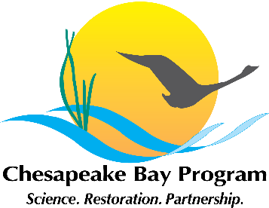
Citizen Stewardship Outcome Meeting
February 9, 2015, 1:00-4:00
Chesapeake Bay Program Office
Fish Shack Conference Room
410 Severn Avenue, Annapolis, MD
Conference Line: 866-704-1637
Passcode: 269 490#
https://epa.connectsolutions.com/git5/

1:00 Welcome / Introductions (Kristin Saunders, Stewardship Goal Implementation Team Chair)

1:15 Review of Our Task: Management Strategy Development (Amy Handen)

Background: The 2014 Chesapeake Bay Watershed Agreement states that the Chesapeake Bay Program’s Goal Implementation Teams (GITs) will develop Management Strategies for the Outcomes that support the Agreement’s goals by June 2015. The Stewardship GIT is responsible for the development of a management strategy and baseline indicator for the Stewardship goal and outcomes. This meeting is focused specifically on the development of a draft Citizen Stewardship Outcome management strategy and method to measure progress.

Stewardship Goal:
“Increase the number and diversity of local citizen stewards and local governments that actively support and carry out the conservation and restoration activities that achieve healthy local streams, rivers and a vibrant Chesapeake Bay.”

Citizen Stewardship Outcome:
“Increase the number and diversity of trained and mobilized citizen volunteers with the knowledge and skills needed to enhance the health of their local watersheds.”

1:30 Interpreting the Citizen Stewardship Framework (Al Todd)

Al will provide an updated framework for thinking of the levels of citizen engagement and how this will be used as a framework for discussing the management strategy. Al will lead a discussion to identify additional examples that illustrate actions underway for engaging stewards at each level.

2:00 Factors Influencing Increase in Citizen Stewardship (Jamie Baxter)

At the kickoff meeting in November, participants brainstormed factors influencing the ability to increase citizen stewardship. Jamie will review what was heard and share how these factors have been categorized within the citizen stewardship framework. Participants will be asked to identify and prioritize factors influencing accomplishment of this strategy.

2:45 Management Approaches to Addressing Factors (Al Todd and Jamie Baxter)

Participants will break into small groups and discuss actions that could be taken to address the factors influencing achievement of citizen stewardship goal. Actions taken by Chesapeake Bay Program, federal, state, and NGOs will be identified and prioritized by citizen stewardship framework category.

3:30 Measuring Progress (Jamie Baxter)

Jaime will provide an update on GIT Project funding to assist in the effort to quantify progress in increasing citizen stewardship.

3:45 Next Steps for Management Strategy Development? (Amy Handen)

Amy will share the schedule for finalizing the Citizen Stewardship Management Strategy Draft, how meeting participants can continue to participate, and the upcoming public input process.

4:00 Adjourn

