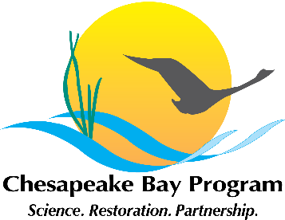
Citizen Stewardship Outcome Meeting Minutes
February 9, 2015, 1:00-4:00
Chesapeake Bay Program Office
Fish Shack Conference Room
410 Severn Avenue, Annapolis, MD

1:00 Welcome / Introductions (Kristin Saunders, Stewardship Goal Implementation Team Chair)

1:15 Review of Our Task: Management Strategy Development (Amy Handen)

Amy reviewed the background of the Citizen Stewardship effort and the tasks for the day, including developing a common understanding of the outcome and the revised the citizen stewardship framework, as well as reiterating thoughts from the last meeting to make sure it still fits with the group’s current thinking, and gathering further details including actual action items to be included in the Management strategy.

Background: The 2014 Chesapeake Bay Watershed Agreement states that the Chesapeake Bay Program’s Goal Implementation Teams (GITs) will develop Management Strategies for the Outcomes that support the Agreement’s goals by June 2015. The Stewardship GIT is responsible for the development of a management strategy and baseline indicator for the Stewardship goal and outcomes. This meeting is focused specifically on the development of a draft Citizen Stewardship Outcome management strategy and method to measure progress.

Stewardship Goal:
“Increase the number and diversity of local citizen stewards and local governments that actively support and carry out the conservation and restoration activities that achieve healthy local streams, rivers and a vibrant Chesapeake Bay.”

Citizen Stewardship Outcome:
“Increase the number and diversity of trained and mobilized citizen volunteers with the knowledge and skills needed to enhance the health of their local watersheds.”

1:30 Interpreting the Citizen Stewardship (Al Todd)

Al provided an updated framework for thinking of the levels of citizen engagement and how this will be used as a framework for discussing the management strategy. Al led a discussion to identify additional examples that illustrate actions underway for engaging stewards at each level.

Revised Citizen Stewardship Framework

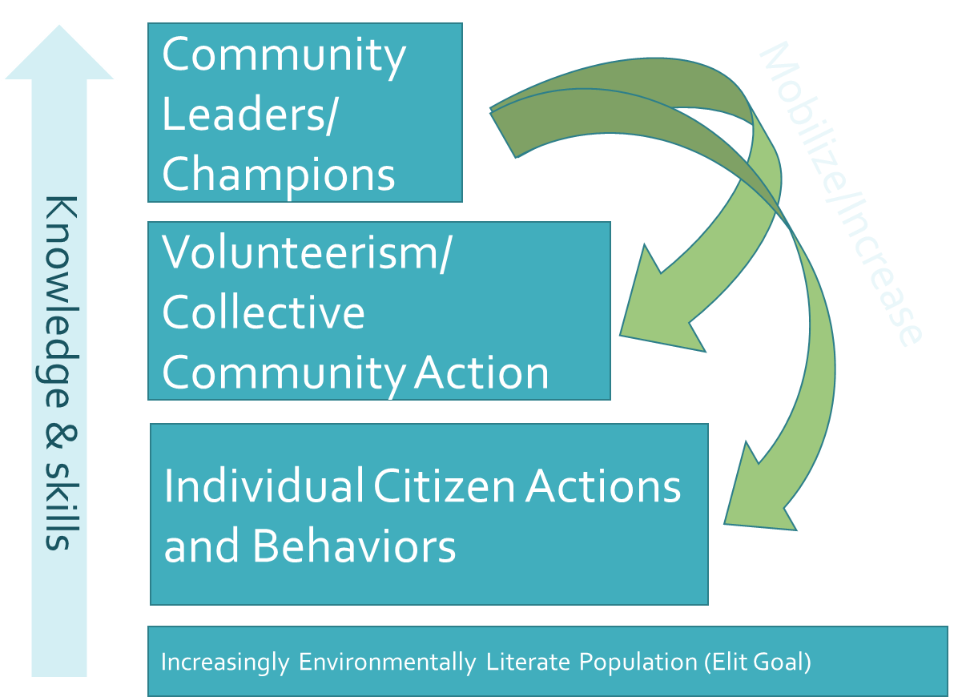
Mobilize/Increase

- This framework is useful to organize citizen actions into three different categories of citizen involvement. The framework has been reconfigured from the pyramid so it does not look like a hierarchy anymore.

  - Community Leaders / Champions- highest level of action- most stewardship efforts rely on a local champion – building up local champions to lead community action and engage individuals in their community
  - Volunteerism / Collective Community Action- doesn’t involve leadership, but gets people active and engaged in their community
  - Individual Citizen Action- behavioral change on the individual level
  - These levels are leveraged and related, the more times you mobilize leaders they can then foster more volunteerism in their community which hopefully leads to greater behavior change.

- Even though stewardship may have been a traditional focus of the bay program, it is a cross cutting issue in many of the developing management strategies.
- This strategy is meant to reflect where the partners , Bay program, and NGOs can work together to facilitate the work being done by citizen volunteers and leaders.
  - Four elements to the outcome include:
    - 1. Looking to increase the scope and scale of citizen stewardship
    - 2. Increasing diversity (defining diversity in multiple ways, business, faith based groups)
    - 3. Giving citizens the knowledge to take action
  - One way this group can collectively to develop support for all of these stewardship actions is by showing that the power of citizen action can move the needle.

The group was then asked for comments on the framework, and whether it was clear enough that they could easily organize their efforts within the framework

Comments on connecting to diverse audiences

Greg –Where does policy work fit into this framework? Including specific issue advocacy, and engaging local governments?
    - Jamie- There is a Local leadership outcome that is being used to specifically raising political local leaders. We should discuss how to fold engaging local government into this management strategy, and what role the Bay Program can play in developing strategies to advance these efforts
    - Al- Original discussion around this group was not around building up advocacy support but more to focus on how to build up citizen knowledge and skills so that they can take action
    - Kristin- This is an issue that will show up in multiple places and is an example of the cross cutting issues that the Bay Program is focusing on now. The factors influencing section will be used to look for these cross cutting issues

Ann - The discussion and the framework has been focused more heavily on the storm water runoff issues and stewardship, but agriculture is also a big issue in PA. We should be aware of issues that have greater regional significance.

Sacoby- To connect with a more diverse audience, who do not traditionally have an interest in water quality we need to take a more holistic approach
    - Integrate community ecosystems – find your points of intervention
    - Connect water quality to Equality, and Environmental Justice issues

Greg- When addressing Agricultural audiences it is not necessarily the farmers who are the land owner to engage in BMPs

Comments on translating actions in the framework to metrics

Charlie – What are the three actions that stewards can take, that will have the biggest effect on restoration or pollution?
    - Jamie- There has been some previous studies in prioritizing stewardship actions. But it greatly varies on location and scale. The data and information is not there yet.

Jen- We need to focus on what is measureable throughout this process (ex. Grant funding) and it is important to talk about metrics throughout the entire process
    - Jamie- We are approaching metrics by focusing on the framework to draw out what we have an interest in measuring, then narrowing it down to what we can measure and what activities are the most influential to the environment

2:00 Factors Influencing Increase in Citizen Stewardship (Jamie Baxter)
Broken into external factors, and capacity factors

Jamie introduced the ‘Factors Influencing Success’ category of the Management Strategy and described the categories we would be using to classify the actions, External Factors and Capacity Factors. The group was then asked to offer their own examples of factors within each category.

- External Factors ex.- Lack of social norms to encourage scaled up adoption of behaviors Lack of access, use and broad level appreciation of natural resources
- Capacity Factors ex.- Inability to reach all to inform, raise awareness link with actions, Lack knowledge and use of marketing strategies to encourage behavior adoption, Lack organization and program capacity to engage volunteers/build leaders

Complied Factors

CAPACITY FACTORS

- Policy does not incentivize programs
  - Grant funds are not sustainable and there are restrictions on use
  - Partnerships leveraging non-profit partners by local/state govt
  - Lack of specific regulatory requirements for citizen action / outreach – education/behavior change that would drive localities to invest money to support citizen stewardship programs (ie MD MS4 permits are weak on outreach/education/behavior change programs)
  - Need to change the approach of the Bay community to be more inclusive (avoid trickle down community engagement)
  - Need to co-create programs with the communities being served

- Lack of good measures and targeting
  - We should prioritize stewardship actions considering probability of success, penetration and impact
  - There is little to no documentation on the quantifiable impact of effective outreach programs improving water quality
  - Lack of science showing which behaviors and civic actions lead to biggest changes in Bay health
  - No common metric to track
  - It is challenging of tracking voluntary actions at the local level

- Need increase program impact and capacity (social marketing)
  - Need a positive way to “communicate” success (Not report cards)
  - We are not using the correct venues or not diversifying media outlets (eg Spanish speaking radio, Christian radio, African American publications, AARP).
  - Funding concentration has been on implementation for the past 10+ years – not education – we need to place more value on education
  - We are not a diverse group therefore we cannot connect to a diverse audience
  - Need to improve capacity of NGOs to design audience – oriented programming
  - Need to integrate factors and interest – ex WQ and fishing. We need to Know more about the public so we can relate to them - need to connect environment to things people care about on a day to day basis
  - Lack of volunteers. Often there is a lack of interested people to get involved with a local group, unless there is a hot button issue involved. Often the same groups of people volunteer year after year.
  - Very little sharing of resources and success of effective outreach programs between groups doing similar work
  - External capacity – Lack of an easy way for mildly interested people to become involved. Need to develop ongoing support.
  - Need to breaking down barriers, preventing people from engaging in stewardship
  - Social marketing ability and support ($)
  - Lack of resources needed to get boots on the ground to get things done. High competition for resources.
  - Diversity in our work, line of work and/or knowledge of diverse audiences desires and needs.

- Collective Impact at local level
  - Lack of programs that are speaking to engaging ‘upstream’ ‘midstream’ and ‘downstream’ audiences. (Example: Speaking to HOAs who have grass cutting regulations - mid stream audience)
  - There are different levels of organizations working on this and there is a lack of synergy and intentionality through formal partnerships between NGOs and local governments, as well as between NGOs and NGOs.
  - Move intentional programs that seek to advance people in stewardship through short term, midterm, long term (stewardship framework)
  - Lots of existing outreach programs that need to be ‘audited’ for audience orientation and integration with community audience interest and desires. (We don’t need only new programs, but improving existing programs)
  - Lots of small organizations with lots of different priorities, not enough rolling up at local level, so our efforts come across as scattered.
  - Need to develop organized and consistent messaging across the board with NGOs involved and with development and delivery
  - Small groups spend a lot of time planning and organizing, it would be more effective to work collaboratively
  - Conflicting messages and priorities across organizations.

EXTERNAL FACTORS

- The assumption that access to the water will lead to behavior change and civic actions for water quality is rarely the case
- The environmental movement is to crisis focused in its messaging and is desensitizing the public
- We must find easy approaches to stewardship in order to overcome peoples apathy
- People may respond better to clear, straight forward, easily attainable goals
- Need for directed messaging to specific behaviors
- We don’t always meet people where they are, we need to be more relevant to the general public
- We need to be able to show a more immediate effect, it takes too long to learn of progress or (lack thereof) that people lose interest and give up
- Lack of awareness that individual actions have an impact, whether it be a positive or negative impact
- We are competing with existing social norms
- There is a lack of incentives / disincentives, it is cheaper to be lazy, bad choices are rewarded by the economy
- Disconnection of the people to natural world
  - There is a lack of connection to a resource, we need to address questions like, how does it affect me? My health? My wallet?
  - No universally sense of urgency, Lack of connection to public health and our goals
- Too much competition for individuals time and attention
- Lack of ongoing support and money for successful programs, which enable programs to strengthen and develop. Instead funds are going to reinventing new programs
- Need to change the market place in which people make decisions. Ex. If rain barrels cost too much how do we bring the price down?
- How do we holding organizations and governments accountable to report the metrics when the behavior change and civic action is voluntary
- Anti / negative communications
  - Negative political rhetoric ex. Rain tax
- Lack of systematic environmental education

2:45 Management Approaches to Addressing Factors (Al Todd and Jamie Baxter)

Participants broke up into small groups and discussed actions that could be taken to address the factors influencing achievement of citizen stewardship goal. Actions taken by Chesapeake Bay Program, federal, state, and NGOs were identified and prioritized by citizen stewardship framework category.

GROUP 1

Develop Branding Campaign
- Provide some way to disseminate information down to local audience, local leaders and/or out to public. Unified message that could be built on.
- Doesn’t necessarily have to be environmental. To reaching local leaders we could be using other reasons besides natural resource improvement to reach them.
- Adaptable to other areas
- General topics – not specific
- Example: Chesapeake Club
- Local governments take action but don’t do enough because don’t have enough base of people to propel it.

Increase diversity
- Not only on this group but in other venues.
- This could be accomplished through:
- Staff recruiting
- Develop curriculum
- Scholarships
- People don’t see themselves as environmental advocates
- How can this be successful? What models can be transferable?

Support Citizen Monitoring Programs
  - Example: PA citizen volunteer monitoring program
  - Experts, training sessions, study design, interpret results, tools to help local groups
  - Budget cuts have caused these programs to go away
  - Not a place to put data so that it can be used
  - Quality of data
  - Engaging Senior groups
  - Citizen Monitoring grant EPA/ACB grant – coordination of groups, develop standardized protocols
  - Building off of water quality monitoring – building on citizen monitoring efforts

Additional ideas:
- Citizen led inspection programs
- Citizen support for local ordinance implementation
- Outreach approach that unique to audiences (menonite, amish)
- Getting Bay Program data analyzed in a way that is important to local level
- Sustained funding for long term implementation to state, local – consistency and accountability.
- What are the big three problems?

GROUP 2

Establish integrated social marketing process / campaign / message
- Funded at high level
- Consistent central message, give groups the tools they need to implement
- Need tools to localize message
- Integrated, organized, consistent message
- Foot soldiers go out and share message
  - Chesapeake Club – prevent spring fertilization of your lawn, message on beer coasters, this worked
- Ongoing, annual process – things come out every year
- Deliver messages differently to different groups/generations
- Know who the trusted messengers are
- Message is geared toward behavior change – prompts, incentives, etc.
- Feedback loop to identify priorities we have missed
- Bay Program initiative – feeds into state/local govt/local group

Challenge Bay program to look at programs that are working (and have metrics attached), embrace and fund replications (example - watershed stewards academy)

Share successful models – don’t reinvent the wheel
- Look outside the watershed, look nationally
- San Francisco Bay, Puget Sound
- Bottom line, how does it affect me – flooding, public health

Develop strategy that brings residents and their local governments together (education workshops)
- What does the Clean Water Act mean to your local govt
- What tools does it give you?
- Where and how can residents find this information to inform voting?

GROUP 3

Prioritize the behaviors that can have a positive impact on water quality
- If this prioritization is done by the CBP, then the state agencies should have the ability to shift some of them based on local conditions and needs.
  - CBP provides broad list of prioritized stewardship behaviors that are most beneficial to water quality – advertises these to the people in the CB watershed; the people then support their NGOs to work on promoting these behaviors; NGOs promote the behaviors but also work at a higher level of advocacy to to influence local elected officials/other citizens to promote the behaviors, include metrics for successful citizen engagement in local comprehensive plans, and push these metrics up to the state level.
  - Conceptually, the CBP should use the existing watershed science to prioritize the best stewardship behaviors, but then grassroots efforts (NGOs, local govt staff) should be undertaken to get individuals to implement the behaviors and make them “institutionalized” throughout the levels of planning and government from the bottom up.

GROUP 4
- Develop capacity for community based social marketing , Develop a social marketing Tool kit
- Collaborate funding advice, for developing consistent messaging
- Making sure we are not reinventing the wheel (fund replication of a successful program or campaign)
- Think of the transferability of a campaign or strategy upfront
- Evaluate midway, so that we could adaptively manage our approach
  - Sharing success and failures with one another
- Increase training opportunities at the local level including in multimedia, and social marketing
- Develop marketing materials, and develop templates for consistent message that can be used by different organizations outreach efforts while still maintaining their own identity
- Federal level- Granting agencies should look for awarding holistic grants ex. Community improvement grants should also take into consideration the environment

3:30 Measuring Progress (Jamie Baxter)

Jaime provided an update on GIT Project funding to assist in the effort to quantify progress in increasing citizen stewardship.

- Amy- Since there is no existing baseline, in the strategy we will highlight existing efforts in each category as examples
- Kristin- Looking at the baseline work and then looking at the database that NFWF has that relates the grants given for citizen stewardship
- Jamie- metrics criteria
  - 1. has to collect and share data in a way that improves the design and capacity of the programs that do the work (only way it will help more the needle) help to target efforts, help to design programs
  - 2.need to attempt to have a methodology that can predict / quantify the effect of these actions on water quality, at scale
  - 3. use these tools to demonstrate why it is important to engage citizens in this work and invest in these programs- these are the criteria that where put into an RFP to develop this metric
- Jamie- how are we going to do it, will not be determined today over the next year but we will be asking to form an advisory team to help guide this work, but we will use the framework, and we will need to determine which behaviors are important to measure, behavior index are a cost effective way to do this, there are other ways to do this as well – where grant funding goes (need to explore how effect this is as a metric)
- Greg- states will be questioning what are we measuring for the strategy by June
- Jamie- the state action in the strategy would be to participate in the development of the metrics
- Kristin- since the citizen stewardship outcome is so new it is behind the pack compared to the other outcomes in development, but we are still on tract, we think it is important to all be in agreement on what is important to be in the metrics
- Jen- Who are we asking to input to these metrics, what scale are we asking for information, in what sort of interface are we asking for the data and from who?
- We need to make sure that these metrics are useful, and should look to see if there are cross overs with the diversity outcome
- Jamie- behavior index can help to show which populations are taking action and which are not
- S. Wilson –will you be using a Logic modeling process to go through the goal and strategy and metric , would be helpful for diversity outcome and reaching long term goals
- Amy- we are using a decision framework model in fleshing out the strategy

3:45 Next Steps for Management Strategy Development? (Amy Handen)

- March 1, 2015- Revise and complete DRAFT Management Strategy
- February, 2015 – December, 2015- Begin development of Stewardship Index
- March 15 – April, 2015- Public review of DRAFT Management Strategy
- Finalize Management Strategy, draft work plans by June, 2015

Attendees

Bruce Staffrom - Interstate Commission on the Potomac
Elise Bruner - Blue Water Baltimore
Dana Puzey - Blue Water Baltimore
Steve Raabe - Opinion Works
Alison Fox - Alliance for the Chesapeake Bay
Donna Morelli - Alliance for the Chesapeake Bay PA office
Phil Stafford – Maryland Department of the Natural Resources
Lou Etgen - Alliance for the Chesapeake Bay
Phil Miller – Delaware Department of Natural Resources and Environmental Control
Kristen Fleming - Maryland Department of the Natural Resources
Ann Devine - Pennsylvania Department of the Environment Protection
Shannon Sprague - National Oceanic Atmospheric Administration
Julie Walker – Chesapeake Research Consortium
Amy Handen, National Park Service
Greg Evans – Virginia Department of Forestry, Citizens Advisory Committee
Charlie Stek – Citizens Advisory Committee
Kasey Wetzel – Chesapeake Bay Trust
Jen Dindinger– University of Maryland Sea Grant
Jamie Baxter – Chesapeake Bay Trust
Al Todd- Alliance for the Chesapeake Bay
Kristin Saunders – Stewardship Goal TeamChair; Maryland Department of the Natural Resources
Jake Riley – National Fish and Wildlife Foundation
Virginia Witmer- Virginia Department of Environmental Quality
Alan Hartman – West Virginia Department of Environmental Protection
Sarah Felker- Elizabeth River Project – River Star Homes
Nissa Dean – Alliance for the Chesapeake Bay
Jessica Blackburn – Citizens Advisory Committee
Suzanne Etgen – Anne Arundel Watershed Stewards Academy
Mary Gattis – Alliance for the Chesapeake Bay; Local Government Advisory Committee
Sacoby Wilson- University of Maryland

