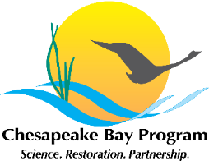
Citizen Stewardship Management Strategy
Stewardship Goal Implementation Team
February 5th Working Draft

1. Executive Summary

To be developed.

2. Outcomes and Baselines

The long-term success and sustainability of the Chesapeake Bay restoration effort will ultimately depend on the actions and support of the 17 million residents of the region who call the watershed home. The cumulative impact of these millions of individuals and their daily actions can both positively and negatively affect the health of watersheds, streams and rivers. Hundreds of local conservation and watershed organizations in addition to a growing number of community associations, religious institutions and others are leading efforts at the local scale to engage and empower citizens to restore local streams, reduce pollution, protect the environment and improve their communities. The efforts of these groups and of community leaders also result in an ever increasing number of citizens adopting behaviors and taking individual actions that ultimately reduce our collective impact on the Bay. A growing army of local citizen volunteers who donate their time, talent and resources to our shared goals will build a larger, broader, and more diverse constituency of citizen stewards that will support many of the Goals and Outcomes outlined in the Agreement.

Stewardship Goal: Increase the number and the diversity of local citizen stewards and local governments that actively support and carry out the conservation and restoration activities that achieve healthy local streams, rivers and a vibrant Chesapeake Bay.

Citizen Stewardship Outcome: Increase the number and diversity of trained and mobilized citizen volunteers with the knowledge and skills needed to enhance the health of their local watersheds.

Baseline:
Meeting the water quality, restoration and conservation goals contained in the Agreement depends on engaged citizens who both support stewardship in the larger community and take personal action to carry it out. Commitments for increasing citizen action and stewardship have always been a part of the Chesapeake Bay Program Partnership. A goal committing to fostering individual responsibility and stewardship of the Bay’s resources was first included in the 1987 Agreement. Chesapeake 2000 reaffirmed that commitment with a stewardship and community engagement goal to “Promote individual stewardship and assist individuals, community-based organizations, businesses, local governments and schools to undertake initiatives to achieve the goals and commitments of this agreement.” In the 2010 “Strategy for Protecting and Restoring the Chesapeake Bay Watershed,” a goal to “Foster a dramatic increase in the number of citizen stewards of every age who support and carryout local conservation and restoration” was committed to by the Chesapeake Bay Federal Leadership Committee.

The commitment over time to increasing local stewards by federal, state and local governments, as well as nonprofit entities has been significant. It is less clear how these commitments have been translated into action and what those actions have accomplished. While tracking and evaluation for individual programs exists, there has not yet been a watershed-wide attempt to measure the progress and results of the collective citizen stewardship efforts.

3. Jurisdictions and agencies participating in the strategy

Signatory Participation: State of Maryland, District of Columbia, Commonwealth of Pennsylvania, Commonwealth of Virginia, State of West Virginia, Chesapeake Bay Commission, Federal Government

Local governments, watershed associations, and nonprofits play a key role along with the signatories in engaging local stakeholders and ensuring successful implementation of this outcome.

4. Factors influencing ability to meet goal

Individual Citizen Actions

Social norms that encourage adoption of individual actions and behaviors
- Public display of a behavior change by a growing percentage of a population can accelerate adoption of behaviors by others
  - Smoking cessation campaigns
  - If 60% of houses on street have a sign stating their commitment to river friendly lawn care, the remaining houses are more likely to join in.

Access to and use of the outdoors by all citizens
- Appreciation of natural resources comes from positive experiences in natural places
- Access to outdoors
- Utilization of access
- Language barriers

Organizational and programmatic capacity to effectively scale up citizen outreach programs

- Ability to reach all citizens with information that raises public awareness of issues and actions needed to address them
- Information that quantifies the value of environmental work in terms that relate to all audiences
- Continued need to translate of science in language and visuals applicable to all audiences
- Definition of citizen stewardship tends to lack relevance with some audiences
- Need to continually build knowledge among citizens of how their individual actions can make a difference in their community

- Knowledge and use of incentives that encourage behavior change:
- Outreach programs that are informed by research that identifies specific barriers and benefits to the adoption of individual behaviors. (Program evaluation and social science repeatedly find that awareness of a problem alone does not produce the desired behavior change. We cannot rely only on education to reliably bring about the kind of broad-scale stewardship needed.)
- Local government and NGO programs not all designed appropriately or funded adequately to affect individual actions at a community or watershed scale.

Volunteerism / Collective Community Action

Capacity of organizations to develop, implement, and sustain effective volunteer / stewardship programs
- Funding (sustained, long term)
- Organizational capacity
- Program design
  - Qualifications / capacity to ensure proper program design
  - Involvement of communities/stakeholders in program design to ensure programs represent communities targeted
  - Benefits of volunteer action are of value to participants
  - Dissemination of information / opportunities
    - Effective targeting of volunteers on program availability and opportunities
  - Program / organization evaluation/tracking participation
- Access to information and data that assist in prioritizing actions that will best benefit local communities and that have the greatest probability for success.

Citizen Leaders / Champions

Capacity of organizations to develop and implement effective leadership programs
- Funding (sustained, long term)
- Organizational capacity
- Program design
  - Qualifications / capacity to ensure proper program design
  - Involvement of communities/stakeholders in program design to ensure programs represent communities targeted
  - Capacity (training staff / educators) to develop and carry out effective leadership programs
  - Training resources (curriculum, etc.)
  - Program / organization evaluation/tracking participation
- Access to information and data that assist in prioritizing actions that will best benefit local communities and that have the greatest probability for success.

Current efforts
To help define citizen stewardship and provide a structure for identifying stewardship actions that could guide Bay Program strategies and support local efforts, the following framework has been developed. The framework recognizes the role individual citizens, community leaders, NGO’s, state and local governments and others play in inspiring, persuading, educating and motivating millions of watershed residents whose actions and support collectively amount to significant gains in Bay Program goals and outcomes. This management strategy is organized around the premise that there is a continuum of citizen stewardship and one can enter at any level. On-going progress towards a greater number and diversity of trained and mobilized citizens restoring and protecting their local watersheds requires recognition of successful actions at each level along this continuum. These levels are:

- Individual Citizen Action: Adoption of individual actions and behaviors (can be broken down by action type category such as landscape practices, transportation choices, energy use, waste reduction and reuse, water use, etc.)

- Community Action: Engagement in volunteerism / collective community efforts that initiate and maintain engagement in stewardship actions (stream clean ups, tree plantings, sojourns, conservation corps, citizen monitoring programs, etc.)

- Citizen Leadership: Emergence of local champions / leaders who catalyze individual and collective action (water keepers, stewards academy graduates, community leaders, citizen advocates, NGOs, etc.)

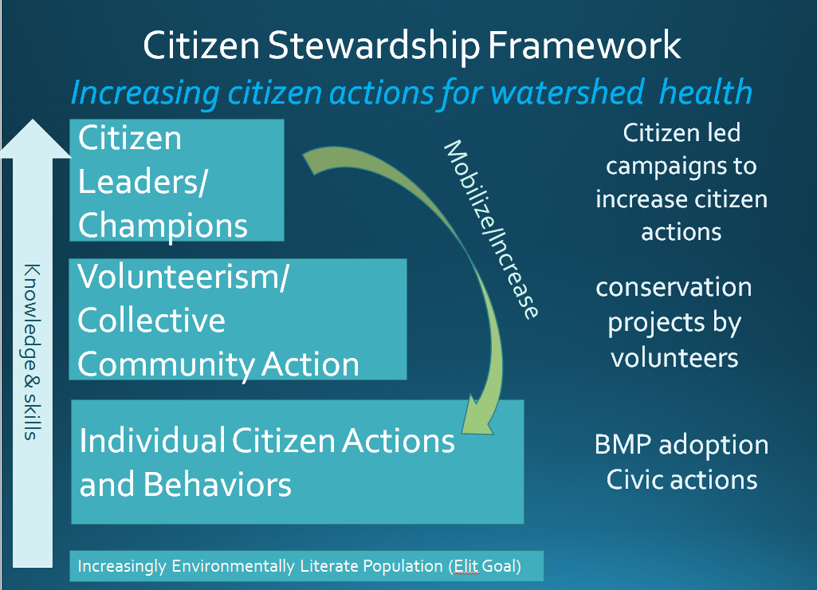

Current Citizen Stewardship Efforts

There are many successful efforts that are already being taken by jurisdictions, agencies and organizations that address the three levels of citizen stewardship.

Individual Actions and Behaviors
Description/Who: Citizens, homeowners, residents,
NGO Program Examples:
- Homeowner outreach programs that promote actions and behaviors such as rain barrels, rain gardens, changes to specific lawn care practices, downspout disconnections, conservation landscaping, leaf litter removal, proper pet waste disposal, tree planting, Septic maintenance and upgrades, proper disposal of fats, oils, and grease, and others
- Recycling
- Carpooling
- Bay friendly buying practices
- Reduce your stormwater website (ACB)SMART Tracker Tool (MD Sea Grant, ACB to track homeowner actions
- Social Marketing Technical Assistance Providers – 19 Technical Assistance providers were trained and received a certificate in social marketing in effort to build the number of individuals within the Bay community that are knowledgeable and available to assist others in developing audience oriented programming
- Contractor training programs building mid-stream support for Stew programs
MD Examples:
- Stormwater Rebate Programs administered by local governments
- The development of a crowd sourced database to collect and promote shared research, results and materials of ongoing stewardship programs is underway. This effort is being undertaken as a result of a recommendation made at the Spring 2014 Residential Stormwater Forum; the tool will be developed with stakeholder input and will seek to address recommendations already made at the Forum.
- The development of a stewardship index is also underway. The index will provide a necessary starting measure for citizen stewardship, local leadership, and diversity outcomes of the stewardship goal. This would build upon existing efforts to measure the penetration and probability rate of homeowner best management practices (e.g. rain gardens, rain barrels, etc.), assess local NGO capacity and volunteer activity and local government leadership and capacity by identifying key data gaps and filling them as needed. All relevant data would contribute to an analysis that would generate an initial index of behavior to advance local restoration goals and serve as a much needed baseline from which to measure future progress.
VA Examples: River Star Homes
PA Examples:
DC Examples:
WV Examples:

Volunteerism and Collective Community Action
Description/Who: Citizens, homeowners, residents participate, engaging in HOA, Church, NGO organized efforts.
NGO Program Examples:
- Citizen monitoring (ACB River Trends, ALLARM )
- Project Clean Stream (ACB and partners)
- Earth Conservation Corps (other conservation corps)
- Restoring the Environment and Developing Youth (READY - ACB)
- Oyster growing programs (CBF, ORP)
- Education programs
- Bay and River Sojourns
- RiverWise (ACB)
MD Examples:
VA Examples:
PA Examples: Senior Environment Corps, ALLARM
DC Examples:
WV Examples:

Citizen Leadership
Description/Who: Citizens, homeowners, residents engaged in training; taking active leadership roles
NGO Program Examples:
- Watershed Stewards Academy
- Water Keepers
- Bridging the Watershed (AFF)
- Chesapeake Watershed Forum
- Chesapeake Stormwater Network
MD Examples:
VA Examples:
PA Examples:
DC Examples:
WV Examples:

Current gaps / Factors Influencing Stewardship Efforts
Several organizations have recently produced reports attempt to identify current activities, trends and gaps in citizen stewardship programs. These include:

- The Trust with NFWF held a Residential Stormwater forum in spring of 2014. The forum convened key stakeholders engaged in residential stormwater outreach programs to review, discuss and develop recommendations to increase the use of tools and technical assistance and encourage partnerships that will increase the impact of these expanding programs. Forum participants were engaged in an effort to identify gaps, and recommend actions to address barriers to advance effective and sustainable stewardship programming; recommendations from the Forum participants are as follows:

- There is a need for systematic support and coordination between NGO’s and local governments to develop and cooperatively implement effective SW outreach programs; with an eye towards avoiding overlapping/ duplicative research and programming and consider efforts to develop a common brand for outreach programs where appropriate.
- An effort should be undertaken to document the case for more public investment in Stormwater outreach using social marketing best practices
- There is a need to coordinate broad, comprehensive development and implementation of audience research available for application at local level.
- More coordination of “mid-stream” activities and approaches to avoid duplication and find economies of scale – e.g. contractor training/certification, audit software, design templates, etc.
- Numerous outreach programs already exist that could benefit from enhanced understanding of their audience. There is a need to develop and promote tool for a rapid assessment/audit of outreach programs to encourage incorporation of social marketing best practices into existing program design.
- While there a first group of technical assistance providers has been established, there is a need to expand and promote the stormwater outreach technical assistance provider (TAP) network; this would be accomplished through additional TAP training courses.
- The need to develop common measures to evaluate stewardship program success

- In 2011 and 2012 the Trust worked with a group of graduate students from the University of Michigan to assess the types of outreach programs underway in the Chesapeake Bay Watershed. This study demonstrated that the majority of Trust grantees seek to motivate individuals to protect the Bay (97%) and that a significant percentage of program leaders (62%) seek to measurably change behavior in a given target audience as a primary goal of their existing outreach work. The Michigan team’s research uncovered two key points among others: 1) several Chesapeake Bay organizations are already using social science tools to tackle known barriers to behavior change, and 2) most organizations are applying these tools separately of a social science framework such as Social Marketing. These two outcomes are positive for the Bay community as it means there is a foundation for social science application and there is room to improve behavior change efforts through increased application of social science processes. The Michigan team’s research resulted in a number of recommendations, which follow:

- There is a need to foster a greater understanding of how to develop strategic behavior change programs that are audience oriented; in particular there is a need to address misperceptions about the relationship between awareness and behavior change
- Many ongoing programs do not understand their target audience. There is a need to provide NGOs with increased professional development opportunities to learn about effective behavior change strategies, in particular methods for understanding and working with the audience served by the programming.
- Creation a behavior change group or case study repository where NGOs can share outcomes of work categorized by specific behaviors, this repository should include a template for grant recipients’ and NGOs evaluative results to standardize reported information and help grant recipients find needed information more easily.
- NGOs are not sufficiently market focused and audience driven. There is a need to provide NGOs with opportunities to strengthen their audience targeting, recruitment, and assessment skills. Although many survey respondents reported that they target specific audiences, interview results suggest that Bay organizations may be targeting too broad an audience, or may not be effectively engaging with targeting audiences to develop audience oriented programming.

National Fish and Wildlife Foundation:

Chesapeake Bay Program Science and Technical Advisory Committee (STAC):

Insert additional report findings/stakeholder feedback:

Actions, tools or technical support needed to empower local government and others
There are a number of efforts underway to increase the capacity of effective stewardship programs at the local level. This management strategy will attempt to identify those efforts and outline additional strategies to empower stewardship programs regionally. This strategy will also highlight the close relationship of citizen stewardship with Local Leadership and Diversity Outcomes.

5. Management Approach

Long term success of the Watershed Agreement depends on the support and action that arises from local citizens and local conservation groups. Local government leaders must have the capacity and tools to address watershed issues and the citizen support to implement watershed restoration policies and incentives. State and federal agencies rely on partnerships with local leaders and conservation groups to achieve their goals and government funding is critical for catalyzing and leveraging private action. The base of the environmental movement and its leadership must be more diverse and inclusive.

Actions that the Program can undertake to address the factors affecting the citizen stewardship goal and outcome includes:

Individual Citizen Actions

Identify and adopt methods to measure and communicate the impact/effectiveness of individual actions

Increase organizational capacity to achieve results from homeowner programs
- Develop and disseminate templates for successful programs
- Transfer lessons learned – share best outreach and engagement practices
- Provide technical assistance for setting up programs

Share best practices and successful models.
- Create a repository of market, social, and audience research to support stewardship work; include research and data from local, state, and federal governments, nonprofit, and private sector sources; synthesize and disseminate to partners

Develop and implement strategic behavior change programs
- Facilitate “well-informed” behavior change program development, implementation, and evaluation. Support social marketing campaigns that encourage behavior change, including engagement of non-traditional and diverse citizens. Conduct audience research focused on understanding barriers and perceived benefits to behavior change

Increase direct engagement of diverse organizations and communities
- Explore and expand approaches that fund, support and implement citizen engagement programs with and led by under-represented communities.
- Build the capacity of under-represented communities to develop, fund and implement effective citizen outreach programs.
- Support programs that increase student involvement and implementation for “greening” of school grounds.
- Expand the reach of education and citizen outreach programs to the faith community, minority groups and businesses.
- Engage local governments to integrate individual action and behavior approaches in local stormwater reduction and other watershed programs.

Increase public access (see public access strategy)
- Increase public access
- Increase access in underserved communities
- Increase awareness of public access

Volunteerism/Collective Community Action

Invest in successful volunteer recruitment and engagement programs
- Foster sustainability of successful programs that support volunteerism.
- Advocate for increased financial investment from federal, state, local and private funders.
- Identify mechanisms to provide long-term support for citizen engagement

Support citizen participation in science and monitoring efforts

Increase effectiveness of program designs
- Foster partnerships and collaboration to overcome the challenge of limited resources.
- Communicate and measure success to help visualize the change and build support
- Help organizations prioritize actions that will best benefit local communities and that have the greatest probability for success.

Access to information
- Share information and data that assist organizations prioritize actions that will best benefit local communities and that have the greatest probability for success.

Citizen Leaders/Champions

Provide financial investment
- Provide seed capital for leadership programs and foster sustainability.
- Identify potential sources of financial investment from federal, state, local and private funders.
- Provide long-term support for citizen engagement

Increase organizational capacity
- Develop template for successful programs
- Provide technical assistance for setting up programs

Increase effectiveness of program design
- Develop and transfer model programs
- Share information and data that help citizen leaders prioritize actions that will best benefit local communities and that have the greatest probability for success.
- Support and create forums for technical training and leadership support related to priorities of the Chesapeake Watershed Agreement

a. Local Engagement

To be developed.

6. Monitoring Progress

Over the next year, the Stewardship Goal Implementation Team will identify the types of measures that might be most effective in measuring citizen stewardship. It will also engage in a process to develop a stewardship index that would provide much needed base line metric(s) for the citizen stewardship outcome with particular attention paid to better understanding the diversity of citizens engaged in stewardship activities. This would build upon existing efforts to measure the penetration rate of homeowner best management practices (e.g. rain gardens, rain barrels, etc.), assess the extent of community engagement by local NGO’s through volunteer and leadership development activities. The intent is for this effort to identify key data gaps and fill them as needed. All relevant data would contribute to an analysis that would generate an initial stewardship index that will include an index of individual behavior change that will help quantify the extent to which citizen stewardship programs advance local restoration goals. The soon to be developed stewardship index will serve as a much needed baseline from which to measure future progress.

This metric will contribute to an increased awareness on how tuned in citizens are to Chesapeake Bay Program issues and strategies. It will also provide insight into the effectiveness of programs and approaches, predict/quantify the value of citizen actions, and increase or maintain support for investments in local outreach and engagement.

7. Assessing Progress

Once the metric is developed, data will be collected and progress will be assessed in a way that is consistent with the metric recommendations once it is developed. Biennial evaluation will be conducted to ensure that adequate progress is being made.

8. Adaptively Manage

The Stewardship Team will convene throughout the year to discuss goals and achievements in meeting the stewardship outcome. A biennial evaluation will be conducted on the management strategy and work plan to ensure that adequate progress is being made. This evaluation will allow for opportunities to re-assess where the group is in achieving the citizen stewardship outcome and adjust strategies as appropriate.

9. Biennial Workplan

To be developed

