D R A F T

Technical Report SRH-XXXX

Dam Removal Analysis Guidelines for Sediment - Version 2

Prepared for Subcommittee on Sedimentation
Federal Advisory Committee on Water Information

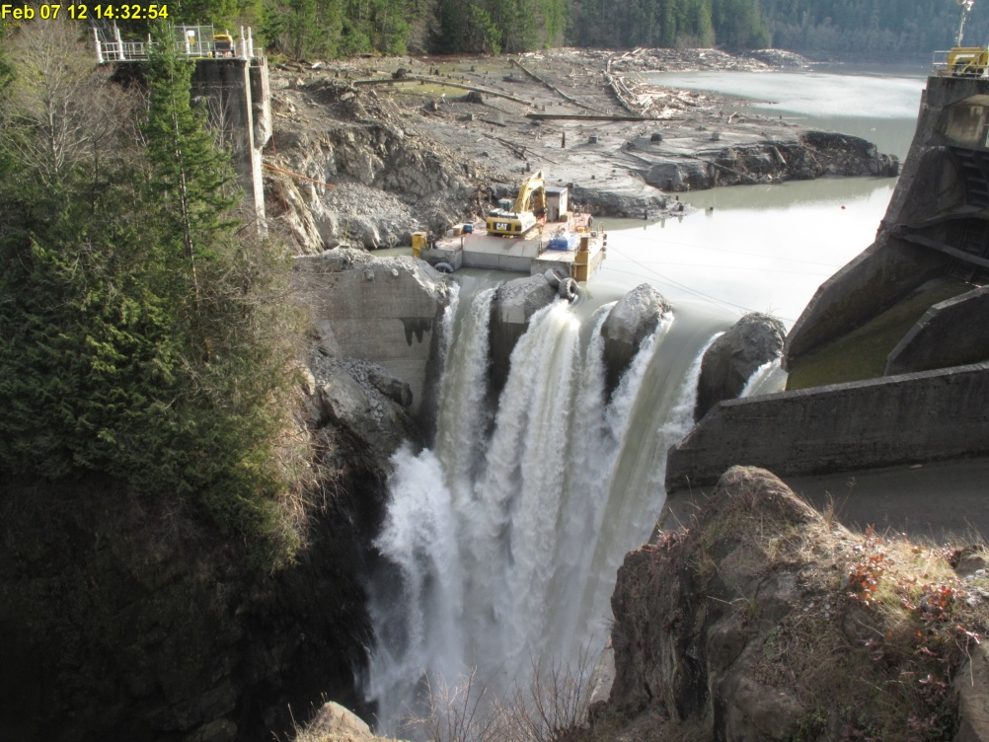

Mission Statements

The mission of the Department of the Interior is to protect and manage the Nation’s natural resources and cultural heritage; provide scientific and other information about those resources; and honor its trust responsibilities or special commitments to American Indians, Alaska Natives, and affiliated island communities.

The mission of the Bureau of Reclamation is to manage, develop, and protect water and related resources in an environmentally and economically sound manner in the interest of the American public.

BUREAU OF RECLAMATION
Technical Service Center, Denver, Colorado

Technical Report SRH-2017-xx

Dam Removal Analysis Guidelines for Sediment - Version 2

Prepared: Timothy J. Randle, Ph.D., P.E., D.WRE.
Supervisory Hydraulic Engineer, River Hydraulics and Sedimentation Group

Prepared: Jennifer Bountry, M.S., P.E.
Hydraulic Engineer, River Hydraulics and Sedimentation Group

The information presented in this guideline has been vetted by subject matter experts in two interagency workshop settings including university, private consultants, and government representatives.

SUBCOMMITTEE ON SEDIMENTATION

Formed in 1939, the Subcommittee on Sedimentation (http://acwi.gov/sos/index.html) reports to the Federal Advisory Committee on Water Information (ACWI), which is under the U.S. Department of the Interior, Assistant Secretary for Water and Science. The Subcommittee includes nearly all Federal agencies concerned with water and sediment, some universities, and some non-governmental organizations. The objectives of the Subcommittee are listed below:

- Determine the major sediment-related problems and issues facing the United States in the 21st century.
- Coordinate the development of countermeasures to reduce sediment problems on our water resources.
- Provide standardized information and data that are scientifically defensible for policy-makers.
- Coordinate and pool the resources of the participating agencies in order to effectively share information and consolidated sediment databases and address important sediment problems.
- Promote the analysis of sediment data from a watershed or river basin perspective.

Agricultural Research Service, National Resources Conservation Service, & U.S. Forest Service | U.S. Department of Agriculture
National Oceanic and Atmospheric Administration | U.S. Department of Commerce
U.S. Army Corps of Engineers | U.S. Department of Defense
Bureau of Land Management, Bureau of Reclamation, National Park Service, Office of Surface Mining, & U.S. Geological Survey | U.S. Department of Interior
Federal Highway Administration | U.S. Department of Transportation
U.S. Environmental Protection Agency, Federal Energy Regulatory Commission, Tennessee Valley Authority | Other federal representatives
American Society of Civil Engineers, Colorado Water Resources Research Institute, Consortium of Universities for the Advancement of Hydrologic Science, Inc., Missouri Water Resources Research Center, National Center for Earth-surface Dynamics, Universities Council on Water Resources | Professional organizations and research centers

DISCLAIMER

The Dam Removal Analysis Guidelines for Sediment are intended to assist engineers and scientists with determining the level of sediment data collection, analysis, and modeling for dam removal projects using a risk-based approach. The guidelines may not address every unique dam removal case or circumstance nor the uncertainties that may be discovered as a result of dam removal. No warranties are implied or expressed by these guidelines. The guidelines are not intended to be a regulatory document, but are intended to capture the best practices for sediment analysis related to dam removal.

SEDIMENT TERMINOLOGY

In this guideline, sediment is referred to by three classifications: particle grain size, transport mechanism, or sediment source as defined below:
- Particle grain size
  - Fine Sediment (<0.062 mm)
    - Clay (< 0.004 mm)
    - Silt (0.004 to 0.062 mm)
  - Coarse Sediment (> 0.062 mm)
    - Sand (0.062 to 2 mm)
    - Gravel (2 to 32 mm)
    - Cobble (32 to 256 mm)
    - Boulder (> 256 mm)
- Transport Mechanism
  - Bedload: particles that are rolling, sliding or saltating in either continuous or intermittent contact with the bed
  - Suspended Load: particles moving in the water column above the bed
- Sediment Source
  - Bed-material load: sediment in transport that is comprised of particles that are found in appreciable quantities in the channel bed.
  - Wash load: sediment in transport that is typically finer than the bed-material load and not found in appreciable quantities in the bed.

ACKNOWLEDGEMENTS

The development of these guidelines was only possible with the dedication and hard work of many people working under the sponsorship of the Subcommittee on Sedimentation. The guidelines benefited greatly from the input during workshops in 2008 and 2009 by numerous technical experts working in the field of dam removal representing federal and state agencies, universities, private consultants, and non-governmental agencies. Matt Collins (NOAA) led a section on monitoring and mitigation that is attached as an appendix. Joe Rathbun (Michigan Department of Environmental Quality) led a section on contaminants. The U.S. Geological survey hosted the 2008 workshop in Portland, Oregon and a field trip to the Marmot Dam Removal Project on the Sandy River, Oregon. Rose Wallick, Chauncey Anderson, Jon Major, Kurt Spicer, and Heather Bragg are acknowledged for their effort in organizing the workshop and field trip. Acknowledgements go to the leaders of the technical teams who summarized the ideas into the first draft components of the guidelines. The reservoir erosion and sedimentation group was led by Peter Downs of Stillwater Sciences, the downstream river sediment transport and deposition group was led by Will Graf of the University of South Carolina, and the water quality group was led by Chauncey Anderson of the U.S. Geological Survey. The Pennsylvania Fish and Boat Commission hosted the 2009 workshop. Scott Carney is acknowledged for his efforts in organizing the workshop venue and a field visit to two local dam removal projects. The guideline additionally benefited from a dam removal database and interactions among a group of scientists gathered to review and disseminate the state of science in dam removal studies at the U.S. Geological Powell Center in 2014 and 2015.

List of workshop participants in October 2008 at Portland, Oregon and affiliation at time of workshop.
2008 Workshop Participant | Affiliation
David Admiral | American Society of Civil Engineers, West Consultants
Chauncey Anderson | U.S. Geological Survey
Dick Bauman | Bureau of Reclamation
Jerry Bernard | National Resources Conservation Service
Jennifer Bountry | Bureau of Reclamation
Jeff Bradley | American Society of Civil Engineers, West Consultants
Curt Brown | Bureau of Reclamation
R. Scott Carney | Pennsylvania Fish and Boat Commission
Dan Cenderelli | U.S. Forest Service
Brian Cluer | National Marine Fishery Service
Mathias Collins | National Marine Fishery Service
Yantao Cui | Stillwater Science
Pete Downs | Stillwater Science
John Esler | Portland General Electric
Stanford Gibson | U.S. Army Corps of Engineers
Doug Glysson | U.S. Geological Survey
Chris Goodell | West Consultants
Will Graf | University of South Carolina
Gordon Grant | U.S. Forest Service
Blair Greimann | Bureau of Reclamation
Craig Hickey | University of Mississippi
Bill Jackson | National Park Service
Yafei Jia | University of Mississippi
Cassie Klumpp | Bureau of Reclamation
Karl Lee | U.S. Geological Survey
Mary Ann Madej | U.S. Geological Survey
Christopher Magirl | U.S. Geological Survey
Jon Major | U.S. Geological Survey
James MacBroom | Milone and MacBroom
Marty Melchior | Interfluve
Charles Podolk | National Center for Earth-Surface Dynamics
Cynthia Rachol | U.S. Geological Survey
Tim Randle | Bureau of Reclamation
Joe Rathbun | Michigan Department of Environmental Quality
John Remus | U.S. Army Corps of Engineers
Stephen Scott | U.S. Army Corps of Engineers
Mike Shannon | Agricultural Research Service
Gary Smillie | National Park Service
Tim Straub | U.S. Geological Survey
Desiree Tullos | Oregon State University
Rose Wallick | U.S. Geological Survey
Marcin Whitman | California Department of Fish and Game
Andrew Wilcox | University of Montana
Laura Wildman | American Rivers
Brian Winter | National Park Service

List of workshop participants in October 2009 at State College, Pennsylvania and affiliation at time of workshop.
2009 Workshop Participant | Affiliation
Chauncey Anderson | U.S. Geological Survey
Travis Bauer | Bureau of Reclamation
Jerry Bernard | National Resources Conservation Service
Jennifer Bountry | Bureau of Reclamation
Scott Carney | Pennsylvania Fish and Boat Commission
Dan Cenderelli | USDA Forest Service
Matt Collins | National Marine Fishery Service
Yantao Cui | Stillwater Science
Joanna Curran | University of Virginia Engineering
Pete Downs | Stillwater Science
Brian Graber | American Rivers
John Gray | U.S. Geological Survey
Jeffery Hartranft | Pennsylvania Department of Environmental Protection
Lisa Hollingsworth-Segedy | American Rivers
Vincent Humenay | Pennsylvania Department of Environmental Protection
Christopher Magirl | U.S. Geological Survey
Jim MacBroom | Milone and MacBroom
Marty Melchior | Interfluve
Katie Ombalski | Clearwater Conservancy of North Central Pennsylvania
Charles Podolak | National Center for Earth-Surface Dynamics
Tim Randle | Bureau of Reclamation
Joe Rathbun | Michigan Department of Environmental Quality
Matt Romkens | Agricultural Research Service
Gary Smillie | National Park Service
Sara Strassman | American Rivers
Tim Straub | U.S. Geological Survey Illinois
Marcin Whitman | California Department of Fish & Game
Shelby Zelonis | University of South Carolina

TABLE OF CONTENTS

SUBCOMMITTEE ON SEDIMENTATION iv
DISCLAIMER v
SEDIMENT TERMINOLOGY v
ACKNOWLEDGEMENTS vi
INTRODUCTION 1
NAVIGATING THE DOCUMENT 3
DAM CONSTRUCTION AND REMOVAL BACKGROUND 4
Dam Construction in the United States 4
Dam Removals in the United States 7
Dam Removal Challenges 11
Dam Removal and Sediment Management Alternatives 12
Dam Removal Guidelines and Resources 13
RESERVOIR SEDIMENTATION PROCESSES 15
Upstream Delta Extent 18
Sedimentation Rates 18
Legacy Sediment 18
Trap Efficiency 18
Reservoir Operation Effects on Sedimentation 20
SEDIMENT GUIDELINES OVERVIEW 22
Guideline Objective 22
Guideline Applicability 22
Guideline Development 22
Using Risk to Guide Level of Investigation 23
Establishing the Sediment Analysis Team 24
GUIDELINE APPLICATION 26
CASES OF NEGLIGIBLE RESERVOIR SEDIMENT 28
Estimate if the Reservoir Has the Potential to Store Sediment 28
Conduct Field Reconnaissance to Look for Reservoir Sediment 28
Evaluate if the Reservoir Sediment Volume is Negligible 29
Coarse Reservoir Sediment 29
Fine Reservoir Sediment 29
Final Determination of Negligible Sediment 30
DATA COLLECTION STEPS 31
Step 1: Identify Project Objectives, Concerns, and Benefits 31
Step 1a: Identify Project Objectives 31
Step 1b: Establish Communication Plan 32
Step 1c: Identify Sediment Concerns for Risk Analysis 34
Step 1d: Identify Benefits from Sediment Release 36
Step 2: Collect Reservoir and River Data 36
Step 2a: Determine the Dam and Reservoir Operations History 36
Step 2b: Determine the Watershed Context 38
Step 2c: Conduct Reservoir Sediment Survey 38
Reservoir Sediment Survey Data Collection Tips 39
Step 2d: Measure the reservoir sediment sizes and spatial deposition patterns 39
Reservoir Sediment Size Data Collection Tips 40
Step 2e: Describe the Hydrology 40
Step 2f: Determine the Potential for Contaminants 41
Step 2f.1 Watershed contaminant source investigation for “due diligence” 41
Step 2f.2 Determine if contaminant testing is needed 41
Step 2f.3 Conduct screening-level sampling 42
Step 2f.4 Conduct definitive survey 43
If additional information on contaminant distribution is desired, for example to delineate “hot spots”, then: 43
Step 2g: Determine the General Downstream River Characteristics 43
STEP 3: DETERMINE RELATIVE RESERVOIR SEDIMENT VOLUME AND PROBABILITY OF IMPACT 44
Step 3a: Estimate the reservoir sediment volume and size gradation 44
Step 3b: Determine if the reservoir is still trapping sediment 44
Step 3c: Compute Mean Annual Load 45
Step 3d: Compute Probability of Sediment Impact 45
Example Calculations 46
STEP 4: REFINE POTENTIAL SEDIMENT CONSEQUENCES AND ESTIMATE RISK 49
Step 4a: Identify Consequences 49
Step 4b: Group Consequences into Low, Medium, and High Categories 51
Step 4c: Compute Risk of Sediment Impact 52
Low Risk Dam Removals 52
Medium Risk Dam Removals 52
High Risk Dam Removals 53
STEP 5: DAM REMOVAL AND SEDIMENT MANAGEMENT ALTERNATIVE SELECTION 54
Step 5a: Select Dam Removal Plan 54
Step 5b. Select Sediment Management Plan 55
Step 5c: Modify the Plans Based on Contaminants 56
Step 5d: Modify the Plans Based on Erosion Resistant Materials 56
Step 5e: Modify the Plans Based on Threatened or Endangered species 57
Step 5f: Consider the Case of Multiple Dam Removals 57
STEP 6: CONDUCT SEDIMENT ANALYSIS BASED ON RISK 58
Step 6a: Develop a Conceptual Model 60
Step 6b: Estimate the Proportion of Reservoir Sediment Erosion 66
Predicting the Volume of Reservoir Sediment Erosion 69
Assessing Reservoir Sediment Stability 71
Step 6c: Predict Downstream Sediment Effects 72
Total Stream Power Calculations 73
Mass Balance Calculations 74
Sediment Wave Model 75
Sediment Transport Capacity Calculations 76
Geomorphic Analysis 77
Numerical Modeling, Laboratory Modeling, and Field Experiments 78
UNCERTAINTY, MONITORING, AND ADAPTIVE MANAGEMENT STEPS 84
Step 7: Assess Uncertainty 84
Reservoir Sediment Volume Uncertainty 84
Sediment Grain Size Distribution Uncertainty 85
Contaminant Uncertainty 85
Stream Flow Hydrograph Uncertainty 85
Sediment Transport and Deposition Uncertainty 86
Step 8: Determine If Sediment Impacts are Tolerable 86
Step 9: Develop Monitoring and Adaptive Management Plan 86
SUMMARY 88
REFERENCES 90
Appendix A: Tips on Collecting a Representative Set of Sediment Samples for Potential Contaminant Analysis 97
Appendix B: Sediment Transport Capacity Computations 100
Streamflow discharge 100
Channel hydraulic data 101
Coarse reservoir sediment unit weight and particle size gradation 102
Selection of a predictive sediment transport equation 103
Sediment Transport Capacity Computation Steps 103
Appendix C: Flow Charts to Assist With Impact Evaluation of Contaminated Sediments 108
Appendix D: Tips for Monitoring 112

List of Figures

Figure 1. Dams exist in a wide variety of sizes and serve a wide variety of purposes. 1
Figure 2. Old Oaken Bucket Dam taken in April 2007. Photograph provided by Matt Collins, NOAA. 5
Figure 3. The rate of dam construction peaked during the 1950s to 1970s (2013 NID). 6
Figure 4. Spatial distribution of NID dams (2013) across the United States. 7
Figure 5. Compilation of dams removed and dams with at least one published study (a) by dam height and (b) the cumulative number of dams removed by year (Bellmore et al., 2016; American Rivers, 2014). 8
Figure 6. Spatial distribution of dam removals within the United States (Bellmore et al., 2016 and American Rivers, 2014). 8
Figure 7. Elwha and Glines Canyon Dam in Washington State, removed 2011 to 2014. 9
Figure 8. Brantley Dam in New Mexico that was built to replace McMillan Dam. 10
Figure 9. Reservoir sediment profile with delta and lakebed sediment deposits (after Morris and Fan, 1997). 15
Figure 10. Four basic patterns of reservoir sediment deposition: delta, tapering, wedge, and uniform (Morris and Fan, 1997). 16
Figure 11. Looking upstream at Lake Mills delta on the Elwha River in Washington State. 17
Figure 12. Reservoir sediment profile after the reservoir has filled with sediment. 21
Figure 13. Workshop group discussions and field visits to assist with dam removal guideline development. 23
Figure 14. Downstream view of turbidity plume released from breaching of Savage Rapids Dam in Oregon (left photo), and temporary removal of sediment aggradation just downstream of dam at water intake. 24
Figure 15. Sediment analysis steps for dam removal. 27
Figure 16. Probability of sediment impact based on ratio of reservoir sediment volume (Vs) to mean annual sediment load (Qs). 45
Figure 17. Matrix to estimate the risk of sediment impacts from the probability of occurrence and the consequence should the impact occur. 49
Figure 18. Recommended Sediment analysis and modeling tasks for each sediment risk category. 55
Figure 19. Conceptual model of sediment erosion from the reservoir modified from Doyle et al. (2003) and Cannatelli and Curran (2012). 57

List of Tables

Table 1. U.S. Dam Removals > 16 m. 10
Table 2. Recommended expertise for the sediment analysis team. 24
Table 3. The relationship of probability of sediment effects with time and distance downstream. 45
Table 4. Reservoir sediment unit weights reported by Morris and Fan (1988). 86
Table 5. Initial unit weights of reservoir sediment reported by Lara and Pemberton (1982). 86

INTRODUCTION

Dams serve many useful purposes, but with the very large number of dams in the United States, and around the world, dams occasionally need to be removed for a variety of reasons. When dams are removed, special consideration may be needed for the sediments that have been trapped within the reservoirs. The potential impact of these reservoir sediments during and after dam removal can range from negligible to very significant. These guidelines propose that the level of sediment data collection, analysis, modeling, and mitigation be proportional to the risk of potential impacts from the reservoir sediment.

People have been building dams for thousands of years to utilize fresh water resources provided by our world’s rivers, streams, and lakes. The constructed dams come in a variety of sizes, serve a variety of purposes, and have a variety of environmental effects (Figure 1). The World Register of Dams (WRD) documents information for larger dams with heights over 15 m (www.icold-cigb.org/GB/World_register/world_register/general_synthesis.asp accessed 9/4/2015). Within WRD, the oldest dam noted is the Proserpina Dam in Spain, built in 130 A.D.! The world’s tallest three dams are several hundred meters high - located in Tajikistan (335 m), Iran (315 m), and China (305 m). In ancient times, dams were typically built for water supply or irrigation. According to the World Register of Dams, irrigation is still by far the most common purpose of dams worldwide. Among “single purpose dams” in WRD, 49 percent are for irrigation, 20 percent for hydropower (production of electricity), 13 percent for water supply, 9 percent for flood control, 5 percent for recreation, and less than 1 percent for navigation and fish farming. Some dams were constructed to provide benefits for recreation, wildlife, fishery enhancement, and sediment retention. Many dams were constructed to provide multiple purpose benefits from their reservoirs (e.g., water supply, flood control, hydropower, and recreation).

Figure 1. Dams exist in a wide variety of sizes and serve a wide variety of purposes.

Dams continue to be an important part of the worldwide infrastructure with new dams being built each year. However, many dams built several decades to centuries ago have structural or recreational safety issues or reservoirs full of sediment that impact water management operations. In other cases, the original purpose of the dam is no longer needed, the dam is abandoned, no longer economical to operate, or there may be significant environmental benefits achieved if the dam were removed. While dams provide numerous benefits, they also alter the continuity of water, sediment, wood, nutrients, and biota between the watershed area upstream and downstream of the dam. Some of the environmental effects that may occur from large dams or river basins with numerous dams include:

- Impaired migration of fish and other aquatic organisms
- Blocked river boat passage
- Trapped sediment, wood, and nutrients important for river ecosystem health
- Inundated and altered reservoir landscape subjected to rapidly fluctuating water levels
- Altered downstream river flow patterns, temperature, and dissolved oxygen
- Altered downstream river morphology and riparian zones

Dam removal may be a viable management option to restore lost ecosystem processes when the operational purpose of a dam and reservoir are no longer needed, can be met through alternative means, or the costs to address safety and infrastructure exceed the cost of decommissioning. For example, a pumping plant with proper fish screens constructed along the channel margin may negate the need for a diversion dam that impedes fish passage. Electricity generated from a hydroelectric dam could be generated by other power plants. Structural damage resulting from natural disasters such as flooding or earthquakes may be too costly to repair relative to project benefits, or the structure may simply be abandoned and at risk for failure due to lack of maintenance. On the other hand, water storage and flood control benefits provided by many large dams provide critical water management resources that would be difficult to replace if the dam were removed. Even with small dams no longer being utilized for water resources, dam removal may not always be a preferred option by some because of the historical significance of the structure and intrinsic value to the local community. In the absence of sustainable sediment management, more dams will be removed in the future as their reservoirs fill with sediment and no longer provide benefits.

Case studies of dam removals over the last several decades have found that rivers are resilient and ecosystem processes and aquatic species respond favorably to restore connectivity with upstream sediment, wood, and nutrient loads. Very small dams or weirs often don’t trap much sediment and their removal may only have a negligible effect from a sediment perspective. However, many dams have been removed from streams with downstream reservoirs, water intakes, and sensitive species. Dam removal, and the downstream release of reservoir sediment, can have short-term, but notable impacts on the downstream channel and aquatic habitat. Characterizing the quantity and quality of reservoir sediment, and expected river response as a result of dam removal, can inform the rate and style of dam removal with consideration of potential consequences. Possible resources that could be affected from the erosion and downstream release of reservoir sediment include the aquatic environment and river health, water use and infrastructure (e.g. water intakes, wells), flood stage, and restoration of the reservoir and upstream channel topography. Consequently, reservoir sediment management costs can be a substantial portion of the total cost of dam removal.

These sediment analysis guidelines have been developed to provide engineers, scientists, and resource managers with a risk-based approach for determining the level of data collection, analysis, and modeling to evaluate a dam removal project and the type of sediment management actions that may be needed. These guidelines have been developed for a wide range of dam removals and sediment issues. Simplified analysis procedures are recommended for dam removal cases with little or no (negligible) sediment.

In addition to sediment impacts from dam removal, these guidelines may have some applicability for the practice of passing upstream sediment loads through or around the reservoir for long-term sustainable management. For example, California reservoirs are estimated to have filled with 2.1 billion m³ of sediment, with 200 reservoirs losing more than half their capacity (Minear and Kondolf, 2009). While this only resulted in a statewide decrease in reservoir capacity of 4.5%, reservoirs do not have to be completely full to impact dam and reservoir operations.

NAVIGATING THE DOCUMENT

This section highlights what the reader can expect from key guideline discussions.

Dam Construction and Removal Background – Briefly, learn about the history of U.S. dam construction and removals, and general challenges associated with removing a dam. Get an overview on dam removal and sediment management strategies, and find additional dam removal resources including other guidelines, databases, and technical documents.

Reservoir Sedimentation Processes – Refresh your knowledge on the physical processes leading to reservoir sedimentation and get acquainted with common terminology used throughout the guideline document.

Sediment Guidelines Overview – In this section the reader will find a high-level perspective of the guidelines covering the following topics:

- statement of guideline objective
- applicability of guidelines including what to do if you suspect your reservoir sediment volume is negligible or contains contaminants
- background on how the guidelines were developed
- understanding how anticipated risk is used to guide the level of sediment data collection, analysis, and the mitigation of impacts
- recommendations for setting up a sediment analysis team of experts

Guideline Application – This section walks the reader through steps to apply the guideline. The section includes:
- flow chart of key analysis steps,
- how to iteratively apply the guideline, beginning with simple computations and, when needed, advancing to more complex tools

Cases with Little or No Sediment – Readers who suspect there is little to no sediment stored behind a dam can jump to this section to verify sediment assumptions with simple computations. If sediment assumptions are incorrect (e.g. sediment volume is not negligible), the reader is directed to proceed with the full sediment analysis steps of the guideline.

Data Collection – Steps 1 and 2 of the guideline are described. Step 1 identifies project objectives and sediment concerns along with communication plan development. Step 2 provides recommendations for level and type of reservoir and river data collection. This step also includes how to determine if an intermediate analysis is necessary for presence of contaminants before continuing with other steps.

Analysis - Steps 3 to 6 of the guideline are described. This section provides guidance on how to utilize data collected in Steps 1 and 2 to determine the level of analysis needed for a dam removal project based on the identified probability and risk of sediment impacts. The section walks the reader through a range of potential analysis levels from simple computations and conceptual models for low risk cases to more complex, quantitative models for cases with higher risk of sediment impacts.

Uncertainty, Monitoring, and Adaptive Management – After completing data collection and analysis, Steps 7 to 9 help the user assess uncertainty, work with stakeholders and decision makers to determine if sediment impacts are tolerable. Based on the outcome of discussions, this section provides guidance on establishing a monitoring and adaptive management program that tie back to original project objectives, areas of risk, and uncertainty identified in prior steps.

DAM CONSTRUCTION AND REMOVAL BACKGROUND

Dam Construction in the United States

The earliest dam construction documented in the U.S. was in 1640 - the 1.8-m high Old Oaken Bucket Pond Dam near Scituate, Massachusetts (NID, 2013). As more settlers arrived, tens of thousands of dams were estimated to be built in the mid-Atlantic region of the eastern U.S. to support mills, forges, and other industries that needed mechanical hydropower throughout the 17th to early 20th centuries (Merritts et al, 2010). Merrits et al (2010) notes that typical dam heights in this era were 2 to 3 m and built on small order streams. Larger dams came later as the country grew in population, required increased navigation, and expanded agriculture into the drier western portion of the U.S. The history of federal involvement in U.S. dam construction goes back at least to the 1820s, when the U.S. Army Corps of Engineers (USACE) built wing dams to improve navigation on the Ohio River (Billington et al, 2005). The work expanded after the Civil War, when Congress authorized the USACE to build storage dams on the upper Mississippi River and regulatory dams to aid navigation on the Ohio River. In 1902, when Congress established the Bureau of Reclamation (initially named the “Reclamation Service”), the role of the federal government increased dramatically and large dams began to be built on the country’s western rivers. In addition, numerous canal networks were established in the early 1900’s to deliver water to newly formed irrigation districts in the west. Dams for flood control, water supply, and recreational use were also built by the Natural Resources Conservation Service who has constructed 11,800 dams in 47 states since 1948 (www.nrcs.usda.gov/wps/portal/nrcs/main/national/programs/landscape/wr/, accessed September 17, 2015).

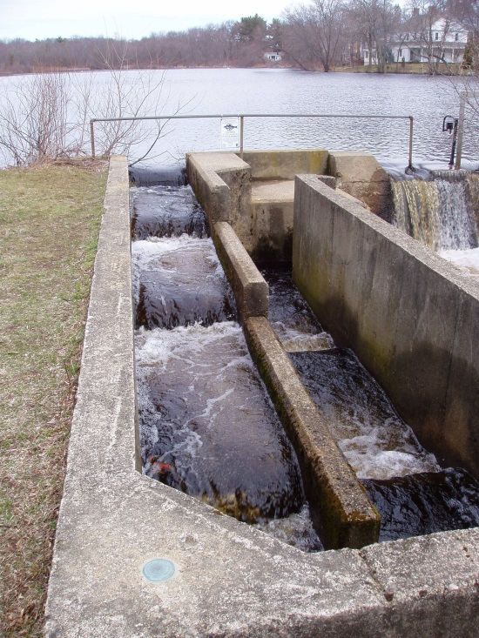
Figure 2. Old Oaken Bucket Dam taken in April 2007. Photograph provided by Matt Collins, NOAA.

The USACE maintains the National Inventory of Dams (NID) to track construction of federal, state, and some private dams in the U.S., including information about the dam such as height, dam type, and purpose. The current NID, published in 2013, includes information on 87,000 dams that are either more than 8 m (25 feet) high (45 percent of dams listed), hold more than 61,700 m³ (50 acre-feet) of water, or are considered a significant hazard if they should ever fail (http://nid.usace.army.mil). As of 2013, the average dam age is 55 years, with a standard deviation of 23 to 86 years old. In addition to the 87,000 dams, there are estimated to be many other generally smaller dams (perhaps millions) that do not meet the minimum height, storage, or hazard criteria to be included in the NID. The rate of dam construction documented in the NID significantly increased in the 1950’s to 1970’s and has since slowed after many of the prime dam sites were already developed (Figure 3). However, according to NID, 212 new dams were constructed between 2010 and 2012 with the majority ranging between 4 to 16 m, and five exceeding 32 m.

Figure 3. The rate of dam construction peaked during the 1950s to 1970s (2013 NID).

The 87,000 dams in the NID are widely distributed throughout the United States, with the largest amounts per state (over 5,000) in Texas, Kansas, Missouri, and Georgia (Figure 4). Of the dams in the inventory, less than 2 percent are over 30 m high. The primary purposes for the U.S. dams in the NID include recreation at 31 percent, flood control at 17 percent, fire protection at 13 percent, irrigation at 9 percent, water supply at 7 percent, and hydropower at 3 percent. According to the NID, Oroville Dam, on the Feather River in California, is the tallest dam in the United States, measuring in at 235 m. The dam with the largest impoundment is Hoover Dam, on the Colorado River in Nevada, which stores approximately 37 billion m³ of water. The dam that provides the most hydroelectric power in the United States is Grand Coulee Dam, on the Columbia River in Washington, which generates 6180 megawatts of power.

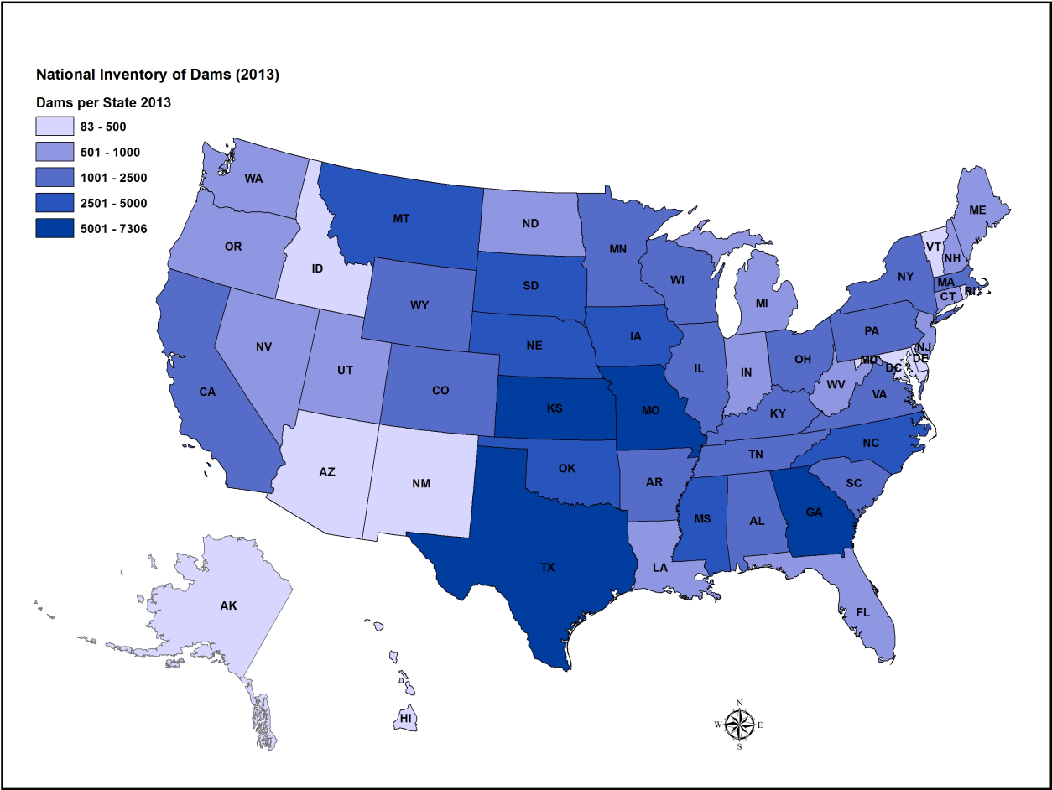
Figure 4. Spatial distribution of NID dams (2013) across the United States.

Dam Removals in the United States

The rate of dam removal has been notably increasing since the 1970’s (Figure 5). American Rivers reported in 2014 that 1,185 dams have been removed in the United States since 1912, and that the majority of the dams (971) were removed within the past 20 years, with 72 occurring in 2014 alone (American Rivers, 2015). Most of these dams were small and removed without the benefit of sediment analysis guidelines. For context, the total number of removals documented so far in the U.S. is less than 1.5% of all the dams listed in the NID. The need to consider dam removal as one of the possible river restoration tools is anticipated to continue in the future. Dam removal may be a preferred alternative for cases with aging or abandoned dams with hazard issues or intakes no longer operational due to sedimentation. Removal can often accomplish increased environmental benefits that can in part be obtained by reconnecting the supply of sediment, wood, and nutrients to areas from the upstream watershed to the river downstream of the dam.

Figure 5. Compilation of dams removed and dams with at least one published study (a) by dam height and (b) the cumulative number of dams removed by year (Bellmore et al., 2016; American Rivers, 2014).

Figure 6. Spatial distribution of dam removals within the United States (Bellmore et al., 2016 and American Rivers, 2014).

The large majority of dams that have been removed (nearly 90 percent) are less than 8 m high. However, several U.S. dams have recently been removed that have expanded experience with larger and more complex reservoir sediment volume releases associated with dam removal (Table 1). Unfortunately, only a handful of these larger dams have scientific literature to document sediment erosion and transport response to dam removal. Even basic documentation on the reservoir pool is often lacking.

Dam removal of all sizes has occurred across the country, with the most dam removals documented in Pennsylvania, the Great Lakes region, northeast, and along the west coast (Figure 6). An interactive map with dam removal site information within the United States can be found at www.AmericanRivers.org/DamRemovalsMap.

Large Dam Case Study Highlight: Elwha and Glines Canyon Dams, Washington
Some of the large dam removal cases take many years to accomplish, but removal can quickly arise out of unique circumstances too. The Glines Canyon and Elwha Dams on the Elwha River dams were removed from 2011 to 2014 to restore fish passage and connect the downstream river to the pristine upstream watershed within Olympic National Park in Washington State (Figure 7, Warrick et al, 2015). Glines Canyon Dam tops the list in Table 1 for having the largest dam height and reservoir storage capacity. Lake Mills behind this dam also had the largest reservoir sediment volume. Nearly two decades of complex planning and mitigation negotiations occurred prior to the concurrent removal of both dams with water users to address water quality impacts, regulatory agencies to address impacts to fisheries, and consideration of flood impacts to local land owners. The combined reservoir sediment volume of 21 million m³ was so large, river erosion was the only economically viable option and a phased dam removal was utilized over three years to manage sediment release volumes.

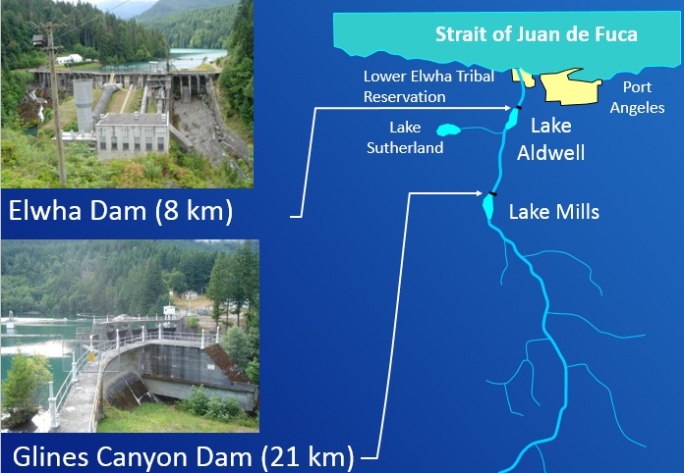
Figure 7. Elwha and Glines Canyon Dam in Washington State, removed 2011 to 2014.

Small Dam Case Study Highlight: Idylwilde Dam, Colorado

A large rainstorm hit Colorado in September 2013, causing severe damage to numerous roads and infrastructure. Idylwilde Dam, used for up to 900 kW of hydropower since 1925 by the City of Loveland, CO, was up for relicensing in 2016 (www.cityofloveland.org). Idylwilde Dam was 17 m high and the reservoir storage and stored sediment was only a fraction of the Elwha Dams. The dam had been destroyed in the 1976 Big Thompson flood and rebuilt. After the 2013 rainstorm, the City of Loveland determined the cost of disposal and demolition would be much less than planned repairs needed to relicense the dam in 2016. Moreover, nearly 115,000 m³ of sand to cobble sized sediment stored in the upstream reservoir could be utilized to repair the federal highway, a county road, and another private road. Removal was completed a few months later and reservoir sediment repurposed to assist with road repairs.

Case Study Highlight: McMillan Dam, New Mexico and Lake Bluestem Dam, Kansas

McMillan Dam, built in the late 1800’s was removed, but then replaced with Brantley Dam in the 1980’s on the same river a short distance downstream (Figure 8). The removal of McMillan Dam on the Carlsbad River in New Mexico illustrates an example of reservoir sedimentation compromising the operation and function of the project. A similar occurrence happened with the removal of Lake Bluestem Dam that was removed because it became partially inundated by a new downstream dam constructed by the USACE. Regardless of whether a dam is removed to restore river connectivity or replaced with a new and improved dam, sediment management is an important step in the planning and implementation of a dam removal. On McMillan Dam, the reservoir sediment was largely left in place.

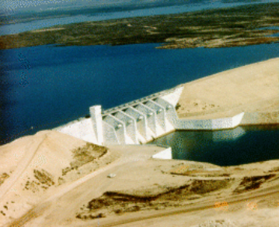
Figure 8. Brantley Dam in New Mexico that was built to replace McMillan Dam.

Table 1. U.S. Dam Removals > 16 m.
Dam Name¹ | State¹ | Year  Removed¹ | River/Basin¹ | Dam Height¹ (m) | Reservoir Storage Capacity (m³)
Glines Canyon Dam | WA | 2011 to 2014 | Elwha River | 64 | 46,626,000²
Occidental Chem Pond Dam D | TN | 1995 | Duck Creek | 49
Condit Dam | OR | 2011 | White Salmon River | 38 | 1,600,000²
Elwha Dam | WA | 2011 | Elwha River | 33 | 9,991,200²
Atlas Mineral Dam | UT | 1994 | Colorado River basin | 28
Two Mile Dam | NM | 1994 | Santa Fe River | 26 | 616,800³
Monsanto Dam #7 | TN | 1990 | Duck River | 24
Lake Bluestem Dam | KS |  | Walnut River | 21
McMillan Dam | NM | 1989 | Pecos River | 20 | 101,886,200
Hunters Dam | WA |  | Hunters Creek | 20
Furnace Creek Dam | PA | 2014 | Furnace Creek | 19
Birch Run Dam | PA | 2005 | Birch Run | 18
Rhone Poulenc Dam #19 | TN | 1995 | Quality Creek | 18
Prairie Dells Dam | WI | 1991 | Prairie River | 18
Willow Falls Dam | WI | 1992 | Willow River | 18
Mounds Dam | WI | 1998 | Willow River | 18
Idylwilde Dam | CO | 2013 | Big Thompson River | 17 | 55,500⁴
Indian Rock Lake Dam | MO | 1986 | Tributary to  Tyrey Creek | 17
C-Lind Dam #1 | CA | 1993 |  | 17
Bluebird Dam | CO | 1990 | Ouzel Creek | 17
Grangeville Dam | ID | 1963 | Clearwater River | 17
Vaux #2 Dam | MT | 1995 | Lone Tree Creek | 17
Sweasey Dam | CA | 1970 | Mad River | 17
¹Source: American Rivers, 2015
²Source: Bellmore et al, 2016
³Source: Friends of the Earth, American Rivers, and Trout Unlimited. December 1999. Dam removal success stories.
⁴Source: City of Loveland, 2010

Dam Removal Challenges

The challenges to removing a dam include decisions related to policy, social issues, funding availability, and technical information that helps inform possible management strategies (USSD, 2015). Policy decisions center on how the water resources should be managed and include legal constraints and regulatory requirements. If the dam and reservoir are still providing benefits, then policy decisions have to be made about whether or not those benefits will still be provided, perhaps through alternate means, or compensated. Policy decisions may include broader resource management topics than the benefits provided by the dams such as environmental or cultural resources. Environmental resources may include aquatic and terrestrial organisms, vegetation, water quality, and ascetics. Cultural resources may include historical or archeological assets, along with traditional cultural properties of Native Americans.

Social challenges can play an important role in how to approach the decision whether to remove a dam. Dam operators and owners, water users, landowners adjacent to reservoirs, and recreationalists may all have unique considerations and opinions about a dam and reservoir and whether removal is the best decision. In some cases, mitigation may be an important component of dam removal discussions involving social concerns. For example, perhaps a new greenway with bike paths, fishing access, and river raft launch sites can be included to replace lost lake recreational opportunities. Communication is a critical aspect to engage local partners and stakeholders and should consider local circumstances, potential consequences, and benefits identified with a given project. Project leaders may consider use of media outlets such as social media, press releases, and public information meetings to facilitate getting important messages out to the public from engineers, scientists, and managers. Non-profit organizations focused on ecosystem restoration can be a good resource to help facilitate getting messages out to the community related to dam removal.

Funding has to be obtained for dam removal, including the engineering and science investigations and the permitting requirements. Decisions have to be made on who will pay for dam removal and any compensation for lost benefits of the dam and reservoir. Often funding is a limiting factor on whether and when a dam removal will move forward, even when the owner and interested parties agree to remove a dam. Many projects require supplemental funding beyond what a dam owner can accommodate, particularly for large reservoir sediment volumes or contaminated sediments.

Technical challenges include the determinations of how to safely and efficiently remove the dam and at what rate, how to care for the stream flow during dam removal and how to provide any required fish passage, how much of the dam and related facilities have to be removed to achieve the policy objectives, how to manage the reservoir sediment, and how to deal with uncertainty and changing conditions during and shortly after the dam removal. Engineers and scientists are often tasked with estimating the effects of dam removal, including the direction, magnitude, and extent of the effects as well as the timing and duration of the effects. Water and sediment will often be the primary drivers while the resources of concern may include such things as aquatic habitat, water use (municipal, agricultural, and industrial), recreation, flooding, and cultural resources, and public safety.

Dam Removal and Sediment Management Alternatives

In a broad sense, dam removal alternatives can range from partial or complete dam removal and rapid to phased (e.g. staged) dam removal. There are many alternative methods to removing a dam, including mechanical excavation or demolition, blasting, or cutting. The selection of a dam removal strategy may incorporate how the timing of flow and sediment releases to the downstream system affect resources. For example, dam removal may be selected during in-water work periods, during a low flow period, avoiding critical aquatic species use, or timed to occur just before a storm event. The Guidelines for Dam Decommissioning Projects (USSD, 2015) is a good reference for dam removal alternatives and methods.

The selection of a reservoir sediment management strategy often depends on the vision for the post-removal reservoir landscape, along with tolerance for downstream sediment releases. Reservoir sediment management alternatives could include river erosion, mechanical removal, stabilization, or some combination. River erosion alternatives rely on the power of the stream channel to erode all or a portion of the reservoir sediment for transport downstream. Mechanical removal alternatives rely on hydraulic or mechanical dredging or excavation of the reservoir sediment. Stabilization alternatives attempt to keep the sediment within or near the reservoir area over the long term. The volume of reservoir sediment, relative to the stream’s mean annual sediment load, and concentration of any contaminants, relative to background levels, are key parameters for determining environmental impacts and for helping to choose the sediment management alternative. Sediment management may also include the excavation of a pilot channel to initiate river erosion along a prescribed alignment through the reservoir or mechanically shaping the remaining reservoir sediments to remain in a more stable condition. These sediment management actions may be only needed along certain reaches of the reservoir.

Dam Removal Guidelines and Resources

Because of the growing number of dam removal projects, several publications have been written related to the general aspects of dam decommissioning or removal:
- Guidelines for Dam Decommissioning (American Society of Civil Engineers, 1997)
- Dam Removal - A New Option for a New Century (Aspen Institute, 2002) ̶ focus on policy decisions related to dam removal.
- Dam Removal: Science and Decision Making (H. John Heinz III Center for Science, Economics and the Environment, 2002) ̶ documents the results of panel findings on small dam removals and a guideline on how to blend science into the dam removal decision-making process.
- Dam Removal Research Status and Prospects (H. John Heinz III Center for Science, Economics and the Environment, 2003) ̶ documents a workshop on science and state of knowledge of dam removal through a series of papers on research, physical processes, policy, social perspectives, economics, and ecology.
- Dam Decommissioning Chapter of the Erosion and Sedimentation Manual (U.S. Department of the Interior, Bureau of Reclamation, 2006)
- Guidelines for Dam Decommissioning Projects (U.S. Society on Dams, 2015)

Several state guidelines for dam removal projects have also been developed including:
- Stream Barrier Removal Guideline for Maine (Collins et al, 2007)
- Massachusetts Dam Removal and the Wetland Regulations (Massachusetts Department of Environmental Protection, 2007)
- Michigan Dam Removal Guidelines for Owners (;; Michigan Department of Natural Resources, April 2004)
- Guidelines to the Regulatory Requirements for Dam Removal Projects in New Hampshire (New Hampshire Department of Environmental Services, Revised 2007)
- Dam Removal and Barrier Mitigation in New York State (New York State Department of Environmental Conservation, date unknown)
- Small Dam Removal in Oregon – A guide for Project Managers (Hay, 2008)
- Texas Dam Removal Guidelines (Texas Commission on Environmental Quality, September 2006)

As part of an inter-discipline synthesis working group on dam removal at the U.S.G.S Powell Center, reports were developed on what the scientific community has learned over the last decade of dam removals (Tullos et al, 2016; Bellmore et al, 2016). Additionally, a database was developed that identifies scientific publications relevant to the emerging field of dam removal science (https://www.sciencebase.gov/catalog/item/55071bf9e4b02e76d757c076). The database includes publications supplemented with the American Rivers dam removal database, the USACE NID database, the U.S. Geological Survey (USGS) National Water Information System, and aerial photos to estimate locations when coordinates were not provided. Publications were located using the Web of Science, Google Scholar, and Clearinghouse for Dam Removal Information (http://library.ucr.edu/wrca/collections/cdri/reports.html) at the University of California at Berkley. (http://www.lib.berkeley.edu/WRCA/CDRI/search.html).

Workshops focusing specifically on dam removal have been convened by ASCE. In addition, sessions highlighting dam removal have been convened at numerous conferences in the last decade, providing additional case study and management resources: Federal Interagency Sedimentation Conference, 2010 and 2015; U.S. Society on Dams, American Geophysical Union.

There have been some articles describing sediment processes that occur during the removal of a dam which are highlighted in the reservoir sedimentation context section of these guidelines (Morris and Fan, 1997; Conyngham. 2009; Conyngham and Wallen, 2009; Doyle, et al. 2003; Reclamation, 2006; Cannatelli and Curran. 2012).

The American Society of Civil Engineers produced and published the “Monograph on Sediment Dynamics upon Dam Removal” (ASCE, 2012). This publication provides detailed information on sediment processes and modeling related to dam removal.

The Geological Society of America produced and published “The Challenges of Dam Removal and River Restoration” (Edited by De Graff and Evans, 2013).

RESERVOIR SEDIMENTATION PROCESSES

The section focuses on the spatial variation of reservoir sediment deposits and the temporal reservoir sedimentation history to help inform expectations of river responses following reservoir drawdown and dam removal. All reservoirs formed by dams on natural rivers are subject to some degree of sediment inflow and deposition. Reservoirs tend to be very efficient sediment traps because of the very low flow velocities (Morris and Fan, 1997, Reclamation 2006). The coarsest sediment particles tend to deposit first, at the upstream end of the reservoir, while finer particles tend to deposit farther downstream. If the reservoir retention time is short, the finest particles may pass through the reservoir, especially during periods of high flows. Sand, gravel, and cobble tend to deposit as a delta at the upstream end of the reservoir while silt and clay tend to deposit along the reservoir bottom (Figure 9). In addition, wood of all sized (twigs to large logs) can accumulate throughout the reservoir sediment deposit. When fine sediments reach the dam without being released downstream, a muddy lake condition is formed and the deposits tend to be level (Morris and Fan, 1997).

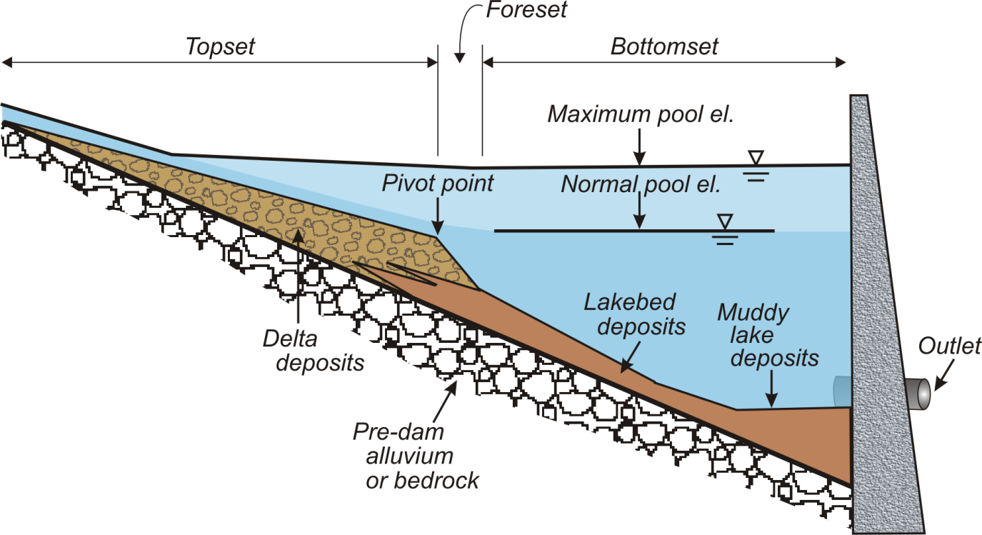
Figure 9. Reservoir sediment profile with delta and lakebed sediment deposits (after Morris and Fan, 1997).

In the late 1800s, a USGS geologist, Grove Karl Gilbert (1885) defined the formation of reservoir deltas relative to Bonneville Lake. Conceptually, the reservoir sediment deposits can be divided into three main longitudinal zones: Topset beds, foreset deposits, and bottomset beds (Gilbert, 1885; Julien, 1995; Morris and Fan, 1997; Bridge, 2003). Topset beds are the delta deposits created by rapidly settling coarse sediment. Foreset deposits represent the face of the delta advancing into the reservoir. Forest deposits are differentiated from topset beds by relatively finer grain sediment and a much steeper slope, usually at the angle of repose for the grain sizes composing the delta. The downstream limit of bed material transport in the reservoir corresponds to where the topset beds end and the foreset deposits begin. The pivot point at the downstream end of the topset bed will progress downstream with continued reservoir sedimentation. Bottomset beds, often referred to as lakebed sediment, are the fine sediments deposited beyond the delta by turbidity currents or non-stratified flow. Lakebed sediment often deposit across the entire inundated landscape beneath the reservoir surface, including the reservoir hillslopes. The reservoir deposits may also include woody material of varying sizes.

The longitudinal slope of the delta topset may be about one-half of the predam channel slope. The actual delta slope depends on the sediment grain size, reservoir level fluctuations, and flow velocity or shear stress. The average of foreset slopes observed in Reclamation reservoir resurveys is 6.5 times the topset slope. However, some reservoirs exhibit a foreset slope considerably greater than this; for example, Lake Mead’s foreset slope is 100 times the topset due to the coarse sediment gradation (Strand and Pemberton, 1982; Reclamation, 2006).

The delta deposits may contain both coarse and fine sediments, while the bottomset beds are composed primarily of fine sediments (Morris and Fan, 1997). However, coarse sediments can be found within layers of the bottomset beds due to tributary sediment inflows, erosion of the exposed delta during reservoir drawdown, reservoir slope failures, and extreme floods.

The longitudinal deposition patterns will vary with the reservoir pool geometry, sediment inflow rate and grain size, and the amount and frequency of reservoir fluctuations. Reservoir sediment deposits can exhibit four basic types of patterns depending on the sediment inflow characteristics and reservoir fluctuations (Morris and Fan, 1997; Figure 10). Multiple deposition patterns can exist simultaneously in different areas of the same reservoir.

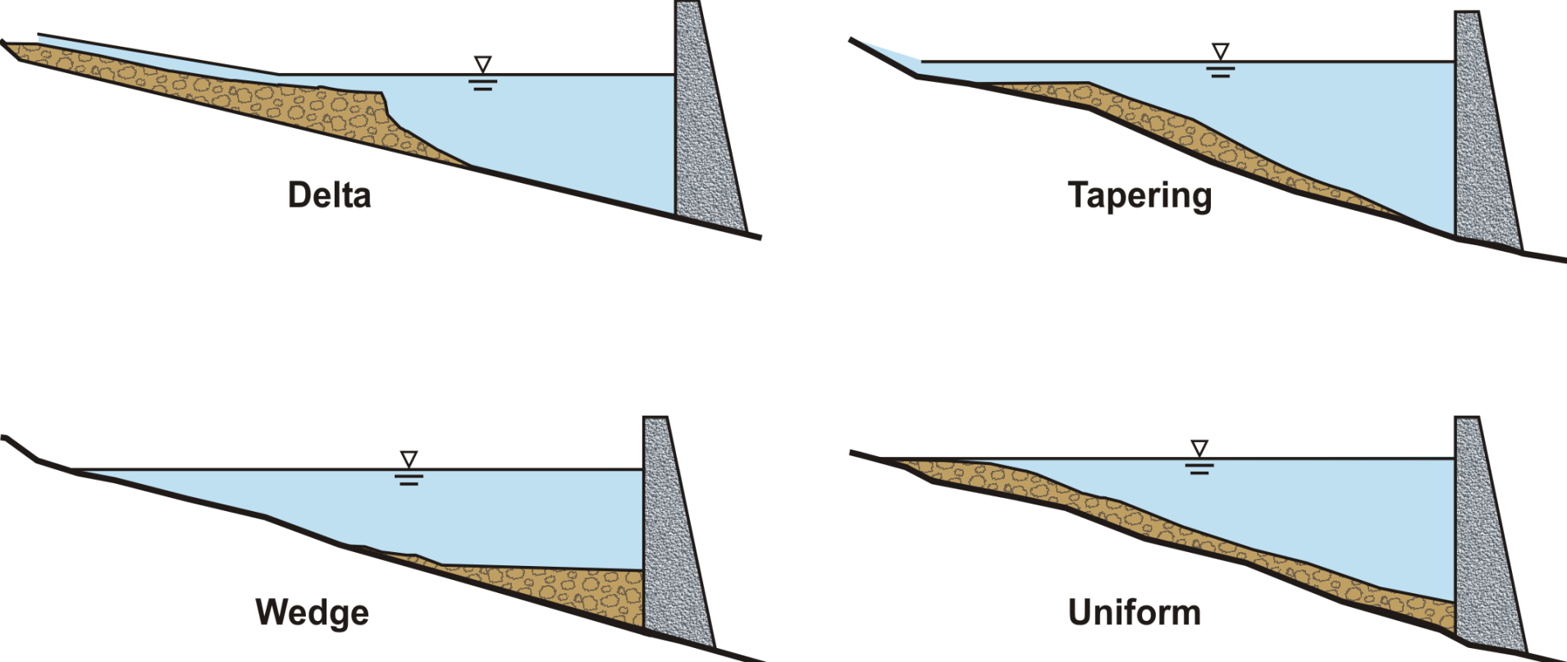
Figure 10. Four basic patterns of reservoir sediment deposition: delta, tapering, wedge, and uniform (Morris and Fan, 1997).

The four basic longitudinal patterns of reservoir sedimentation presented in Figure 10 are described below:
- Delta deposits are at the upstream end of the reservoir and contain the coarsest fraction of the sediment load. The delta may consist entirely of coarse sediment when the retention of water is short. However, the delta may also include a significant fraction of fine sediment when the retention time is long (Figure 11).

- Wedge-shaped deposits are thickest at the dam and become thinner in the upstream direction. Wedge-shaped deposits are typically caused by the transport of fine sediment to the dam by turbidity currents. Wedge-shaped deposits are also found in small reservoirs with a large inflow of fine sediment, and in large reservoirs operated at low water level during flood events, which causes most sediment to be transported near the dam.

- Tapering deposits are progressively thinner in the downstream direction. This is a common pattern in long reservoirs normally held at a high pool level, and reflects the progressive deposition of fine sediments in the downstream direction.

- Uniform deposits are unusual, but do occur in narrow reservoirs with frequent water level fluctuation and a small fine sediment load.

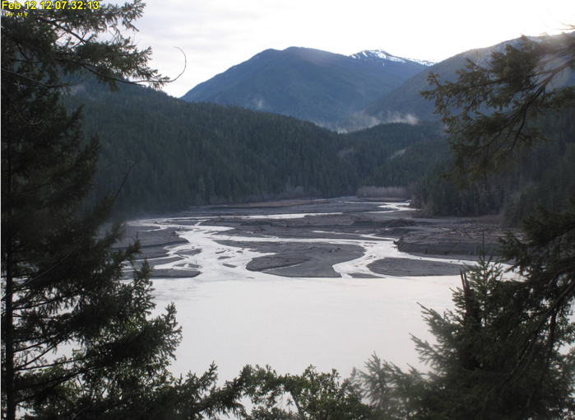
Figure 11. Looking upstream at Lake Mills delta on the Elwha River in Washington State.

Upstream Delta Extent
As the delta builds in thickness over time, eventually the sediment deposit will progress upstream and above the normal reservoir water surface elevation, with one or more channels flowing through and along the delta. For the sediments deposited above the normal reservoir pool, vegetation will likely grow, further encouraging flow into more narrow and distinct channel paths. As the roughness increases on the delta surface with the accumulation of wood and vegetation, the backwater depth of the upstream channels will also increase. Through this process, the delta will expand further upstream into narrower riverine corridors beyond the original reservoir pool formed by the dam. While these upstream areas may look like river corridors, they may contain the coarsest portion of the delta deposits and eventually incise upon dam removal.

Sedimentation Rates
Reservoir sedimentation rates are not constant and vary with the sediment loads of the inflowing streams. The volume of reservoir sedimentation can increase substantially during floods. The inflowing reservoir sediment loads vary with discharge, the type of precipitation (rainfall or snowmelt), vegetation, wildfire, and land use.

Legacy Sediment
Some reservoirs can have sedimentation due to historical land clearance of agriculture and activities such as milldam construction by European settlers, (early 1600s to mid-1800s depending on region). Often the reservoirs upstream of milldams quickly become full of sediment, and new, larger dams were built that buried or inundated the older dams. Especially in the east and Midwest, sediment runoff could also infill riparian wetlands and raise floodplains converting them to terraces rarely inundated. These sediments are sometimes referred to as legacy sediment, and can result in complex sedimentation patterns when identifying reservoir sedimentation lateral and upstream extent from a modern dam.

Trap Efficiency
Reservoirs will normally trap all of the inflowing coarse sediment until the reservoir is nearly full and reached its sediment storage capacity. However, even with a deep reservoir pool, a portion of the clay and silt-size sediments can still be transported through the reservoir, especially during periods of high inflows. The portion of inflowing sediment deposited in the reservoir is known as the sediment trap efficiency, which is the ratio of the deposited sediment to the total sediment inflow. The trap efficiency depends primarily upon the fall velocity of the various sediment particles; flow rate and velocity through the reservoir (Strand and Pemberton, 1982); as well as the reservoir size, depth, and shape; and operation rules of the reservoir. The particle fall velocity is a function of sediment particle size, shape, and density; water viscosity; and the chemical composition of the water and sediment. The reservoir sediment trap efficiency tends to decrease over time as sediment fills the reservoir. However, the trap efficiency also decreases temporarily during floods as flow velocity increases through the reservoir.

A small reservoir pool behind a diversion dam would be expected to reach its sediment storage capacity for coarse sediment in a few years and the trap efficiency for fine sediment may be near zero. A negligible or small reservoir sediment volume would be expected for these small reservoir pools. Larger reservoir pools may still be trapping coarse sediment and the trap efficiency for fine sediment can be significant. Therefore, simple estimates of reservoir sediment trap efficiency can be quite useful for initially estimating the relative sediment volume and the level of field data collection that is needed.

The relative size of the reservoir is a useful index to initially estimate the sediment trap efficiency. The relative size is computed as the ratio of the reservoir storage capacity to the mean annual streamflow volume. The reservoir sediment trap efficiency increases with the relative size of the reservoir. Churchill (1948) and Brune (1953) developed empirical relationships for reservoir sediment trap efficiency from Tennessee Valley Authority reservoirs in the southeastern United States.

Churchill (1948) developed a trap efficiency curve for settling basins, small reservoirs, flood retarding structures, semi-dry reservoirs, and reservoirs that are frequently sluiced. He correlated the percentage of the incoming sediment load passing through a reservoir with the ratio of the reservoir retention time to the mean velocity (sedimentation index). The sedimentation index can be made dimensionless by multiplying it by the acceleration due to gravity (g).

Brune (1953) developed an empirical relationship for estimating the long-term reservoir trap efficiency for large storage based on the correlation between the relative reservoir size and the trap efficiency (Figure 3). Using this relationship, reservoirs with the capacity to store more than 10 percent of the average annual inflow would be expected to trap between 75 and 100 percent of the inflowing fine sediment. Reservoirs with the capacity to store 1 percent of the average annual inflow would be expected to trap between 30 and 55 percent of the inflowing fine sediment. When the reservoir storage capacity is less than 0.1 percent of the average annual inflow, then the fine-sediment trap efficiency would be near zero.

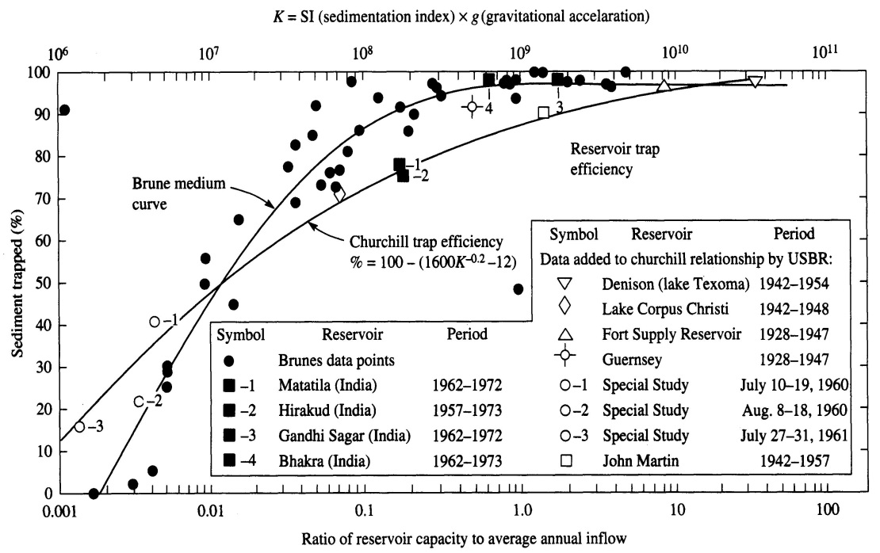
Figure 3. Empirical reservoir sediment trap efficiency curves based on Churchill (1948) and Brune (1953).

If water inflow data are not available for the reservoir, an alternative trap efficiency equation from Brown [1944] can be utilized:

C_{a,t} = 1-1 /[1+ 0.00021 * (K_{a,t-1}/W_{a})]

where C_{a,t} is trap efficiency (expressed as a decimal percent) of reservoir ‘a’ at time step ‘t’;
K_{a,t-1} is reservoir storage capacity (m³ ) ‘a’ at time step ‘t – 1,’,and W_{a} is drainage area (km² ) of reservoir ‘a.’ Minear and Kondolf (2009) additionally incorporated effects of upstream reservoirs into the Brown approach. To calculate the sediment yield from a basin with a reservoir that has a sedimentation record, Minear and Kondolf (2009) constructed a coupled worksheet model to calculate the weighted watershed area (adjusted for upstream construction of reservoirs and trapping effects) for a reservoir of interest, while taking into account trap efficiency for all reservoirs in the basin.

Reservoir Operation Effects on Sedimentation

The operation of the reservoir pool will influence the sediment trap efficiency and the spatial distribution and unit weight of sediments that settle within the reservoir. The reservoir sediment trap efficiency will be greatest if substantial portions of the inflows are stored during floods when the sediment concentrations are highest. If the reservoir is normally kept full (run of the river operation), flood flows pass through the reservoir and sediment trap efficiency is reduced. When reservoirs are frequently drawn down, a portion of the reservoir sediments (typically the delta) will be eroded and redeposited deeper in the reservoir pool. Fine sediments, that are exposed above the drawn down reservoir pool, will compact as they dry out (Strand and Pemberton, 1982). For example, fine sediment would be compacted during droughts that result in reservoir drawdown.

The design life approach for dams was typically used in the United States (and many other parts of the world). Under the design life approach, the dam and reservoir were designed to trap a certain volume of sediment over certain period of time. The elevation of the lowest dam outlet is set to be above the reservoir sediment over the sediment design life. Once the reservoir sediment has reached the lowest outlet, some undefined action will have to be taken for continued reservoir operations or projects benefits may be reduced or lost. Life-cycle design is a new alternative for dams where the reservoir sediment is managed for sustainable use. For example, Three Gorges Dam in China, includes large sediment sluice gates and an operational strategy to drawdown the reservoir during floods so the reservoir can be sustainably managed over the long term.

Once sediment has filled the reservoir to its sediment storage capacity, the entire sediment load supplied by the upstream river channel is passed through the remaining reservoir pool (Figure 12). For example, the pool behind a diversion dam is typically filled with sediment within the first few floods. In cases where the delta has reached the dam, the delta surface may partially erode resulting in a net loss in reservoir sediment storage during large floods, and then refill during moderate flows.

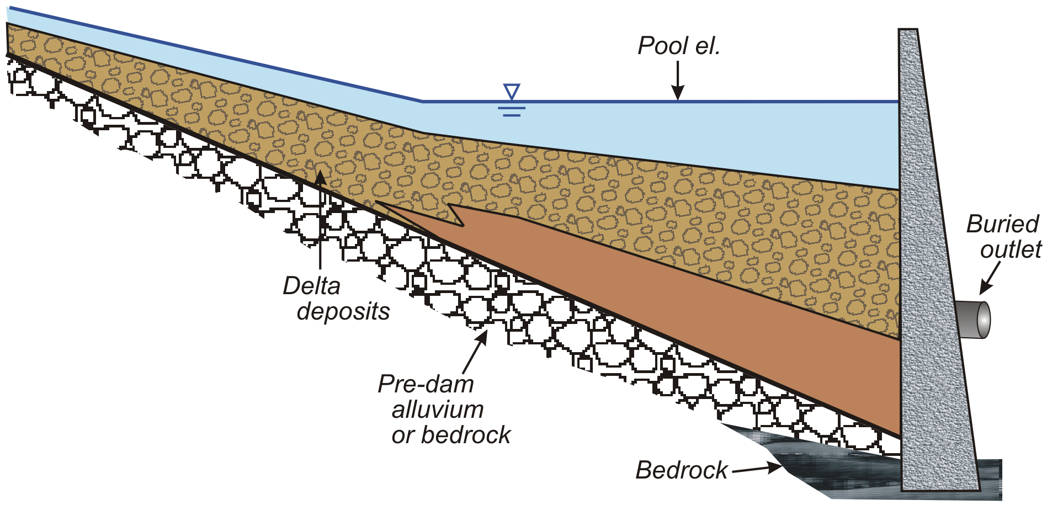
Figure 12. Reservoir sediment profile after the reservoir has filled with sediment.

SEDIMENT GUIDELINES OVERVIEW

In addition to the existing guidance and literature, the U.S. Subcommittee on Sedimentation recognized the need for technical guidelines addressing sediment analysis for dam removal investigations. Dam removal often includes a wide range of activities related to sediment data collection and analysis. Sediment management decisions related to dam removal are also varied. Stakeholders, regulating agencies, and technical staff may have varying thresholds on what constitutes significant sediment impacts, and what level of information is needed to make decisions regarding sediment management. Existing manuals do not provide a framework or guideline for determining the level of analysis needed, the significance of sedimentation issues, or certainty that can be attained with available analysis tools.

Guideline Objective
The objective of these guidelines is to provide an iterative tool for determining the level of sediment data collection, analysis, modeling, and management necessary to evaluate and plan dam removal projects.

Guideline Applicability
The guidelines are written for a technical audience with knowledge of river hydraulics and sedimentation processes, but may also serve as a reference and communication tool for scoping discussions with resource managers, permitting staff, and stakeholders. Special sections are provided to help the user in cases where there is potential for contaminants or The guideline approach may also be applicable for evaluating sediment management for sustainability or reservoir sediment response to operational drawdowns (possibly due to climate change or infrastructure maintenance activities). Dam safety programs may also find the guideline useful for evaluating sediment response and potential consequences to unplanned, rapid dam failure events.

Guideline Development
The guidelines were developed through a combination of technical workshops, individual efforts, and feedback from technical venues. Much of the development of the core guideline ideas occurred at two interdisciplinary workshops held in Portland, OR (west coast) in 2008 and in State College, PA (the east) in 2009. The various specialties represented at these workshops included engineers, modelers, biologists, ecologists, water quality specialists, and resource managers from governmental agencies (federal, tribal, state), university, non-profits, and private consultants. Workshop participants provided a range of dam removal projects for testing the guidelines that varied in sediment volume and varying landscape settings within the United States.

The guidelines were also presented at technical venues with dam removal themed sessions to get input from peers including the 2009 American Geophysical Union Conference (California), 2010 and 2015 Federal Interagency Sedimentation Conferences (Nevada), the 2011 USSD Society of Dams Conference, the 2011 National Conference on Ecosystem Restoration (Maryland), two webinars to federal scientists and resource managers in 2015, and a dam removal workshop at USSD in November 2015 (California).
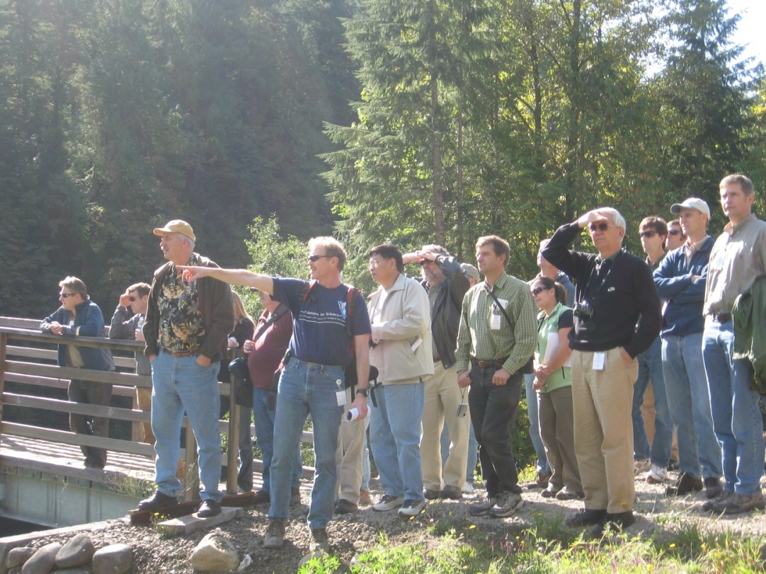
Figure 13. Workshop group discussions and field visits to assist with dam removal guideline development.

Using Risk to Guide Level of Investigation

A key theme from the 2008 workshop was relating the amount of sediment data collection, analysis, modeling, and management to the level of risk from the potential sediment impacts. The engineer or scientist may ask – “What is the predicted fate of the reservoir sediment if dam removal occurs?” However the resource manager, regulator, or stakeholder may be asking – “Will the released sediment cause any harm or increased costs and for how long?” Combining these questions to understand how the river will handle the sediment and if any resources will be impacted during its journey downstream help us determine what level of investment we need to understand sediment effects from dam removal. The level of data collection and analysis selected for a dam removal project is recommended to be a function of the level of risk associated with the sediment impacts. Identifying risk is intended to be a qualitative evaluation in collaboration with technical experts, stakeholders and resource managers.

The risk is defined as the product of the probability (e.g. likelihood) of a sediment impact and the consequence of the impact should it occur.

The greater the risk, the greater the recommended level of sediment data collection, analysis, modeling, and management.

Case Study Highlight: Savage Rapids Dam Removal, Oregon
The removal of Savage Rapids Dam in Oregon provides example to illustrate the importance of the relative reservoir sediment volume. Consider a sediment pulse released after breaching the X m high Savage Rapids Dam. Let’s say we have estimated the reservoir sediment volume as being equivalent to one to two years of the river’s annual sediment load. The sediment is composed of 95% coarse sand and gravel with no contaminants. In this situation the “probability” of coarse sediment impact is on the boundary of small to medium while probability of fine sediment impact is negligible. There is an intake located just downstream of the dam that if buried with sediment will prevent operation and be costly to stakeholders (Figure 14). The expected coarse sediment “consequence” for the intake near the dam is high, and the “risk” results in a medium to high rating for the local intake. Data collection and analysis is recommended to improve understanding of how much sediment might bury the intake and for how long. The answers can then help the project team determine if a slower, phased dam removal is needed to lessen impacts, dam removal can occur during a period when the intake is not being utilized, or mitigation can be used to simply remove the sediment allowing operations to continue. Another water intake is located 3.1 km downstream. This intake may be at risk to suspended sands during initial flushing of the reservoir sediment, but the consequence is only a temporary increase in operational costs over a short duration of hours to days with little risk of having to stop operations. As this example illustrates, the assigned risk may vary depending on the sediment grain size, how far you are from the released sediment, how much is released, and how long elevated sediment levels are expected to last. The recommended data collection and analysis helps inform management decisions that may allow reduction of risk.

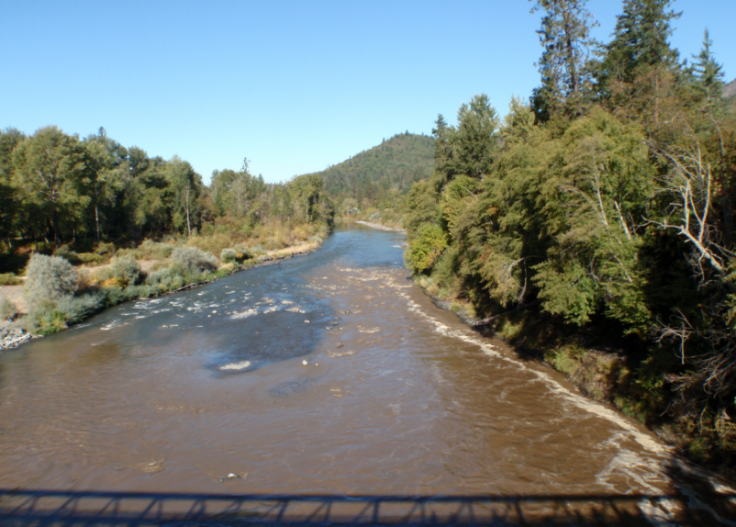 | 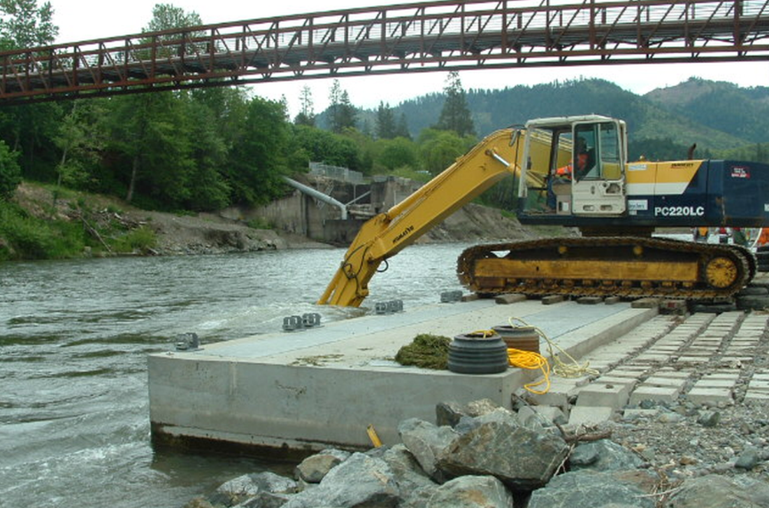
Figure 14. Downstream view of turbidity plume released from breaching of Savage Rapids Dam in Oregon (left photo), and temporary removal of sediment aggradation just downstream of dam at water intake.

Establishing the Sediment Analysis Team

A team should be established to apply the sediment analysis guidelines and evaluate sediment impacts from dam removal. The recommended expertise and complexity of the team depends on the relative reservoir sediment volume and the potential risks of sediment impacts (Table 2). As the relative reservoir sediment volume and potential risk of impacts increases, the recommended amount of expertise also increases. If there is a substantial amount of uncertainty in what relative sediment volume is or potential risks, it may be worth investing in multiple, independent estimates from different methods or people. If there is a risk that contaminated sediment may be present, specialized expertise in water quality should be included on the team. The expertise of the team may need to be tailored based on the sizes of sediment present in the reservoir (e.g. fine sediment vs coarse sediment) and based on the potential impacts (ecosystem, aggradation, water quality, etc.).

Table 2. Recommended expertise for the sediment analysis team.
Sediment Impact Risk | Recommended Expertise
Negligible | Engineers or scientists conducting the planning study should have general knowledge of river hydraulics, sediment processes, and geomorphology.
Small-medium | The analysis and planning study should be conducted by engineers or scientists who have expertise with river hydraulics, sediment transport, and geomorphology.
Large | The analysis and planning study should be conducted by engineers or scientists who have expertise and experience with river hydraulics, sediment transport, and geomorphology and ideally have experience with other dam removal projects.

GUIDELINE APPLICATION
Application of these guidelines includes nine steps for dam removal cases with small, medium, and large reservoir sediment volumes (Figure 15). A streamlined, simplified procedure is recommended for cases with little or no sediment, noted as negligible sediment (see next section of the guideline). Within the report, the steps are broken into three major discussion sections as listed below:

Data collection begins with identifying the project objectives and any concerns about the reservoir sediment in Step 1. This crucial first step will help determine the scope of the project and the range of reasonable alternatives to be considered. Step 2 is to collect data regarding the dam, reservoir sediment, and the river channel both upstream and downstream of the reservoir. Data from step 2 is used in step 3 to determine the probability of sediment impacts.

Data collection:
- Identify project objectives and sediment concerns and a communication plan
- Collect reservoir and river data and identify if contaminants are a concern
Analysis:
- Determine the relative reservoir sediment volume and probability of impact
- Refine potential sediment consequences and estimate risk
- Dam removal and sediment management alternative selection
- Conduct sediment analysis based on risk
- Assess uncertainty
Sediment Mitigation and Monitoring:
- Determine if sediment impacts are tolerable and, if needed, develop a sediment mitigation plan
- Develop monitoring and adaptive management plan

The guideline steps can be applied in an iterative approach. Initially, some assumptions may have to be made when applying the guidelines, but these assumptions can be updated as more information becomes available. First apply the guidelines with readily available information and develop the initial scope of sediment data collection and analysis (Planning Stage). Even if a dam removal or sediment management plan has already been selected, assuming full, instantaneous dam removal combined with a river erosion option will provide a valuable baseline for comparison of predicted impacts from other alternatives. Once the more detailed data and predictions become available, go back through the guidelines and re-evaluate the questions posed at each analysis step (Analysis Stage). This iterative approach to utilizing the guidelines should be employed whenever significantly new information becomes available. Once the analysis level is complete, make one additional pass through the guidelines to refine recommendations of mitigation, monitoring, and adaptive management of sediment related processes from dam removal (Implementation Stage).

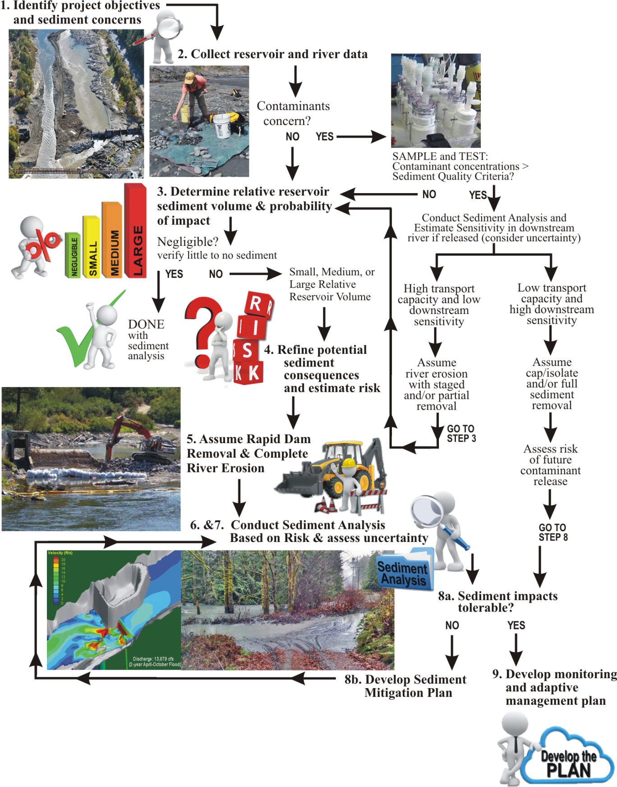
Figure 15. Sediment analysis steps for dam removal.

CASES OF NEGLIGIBLE RESERVOIR SEDIMENT

For cases where there is little or no reservoir sediment behind a dam negligible volume, there is no need for extensive sediment data collection and analysis. This section describes how to verify the sediment is “negligible” with minimal to no risk of inducing sediment impacts. If the sediment volume is verified to be negligible, the analysis can focus on structural and river hydraulic issues related to removing the dam rather than sediment impact assessment.

For the purposes of these guidelines, a negligible reservoir sediment volume is less than 0.1 (10 percent) of the mean annual sediment load entering the reservoir. This reservoir sediment volume is about the same as the volume delivered by the upstream watershed during a single month. Stream flows would be expected to easily and rapidly erode and transport such a small reservoir sediment volume. Since computation of the mean annual sediment load can require considerable effort, an alternative procedure is provided below.

Estimate if the Reservoir Has the Potential to Store Sediment

The potential for the reservoir to trap sediment can be estimated from the reservoir pool width and dam height. The reservoir pool has the potential to contain a negligible sediment volume if the following two criteria statements are true. If the criteria statements are not true, then the significance of reservoir sediment volume needs to be determined.
  - The normal reservoir width (W_{res}) is not more than 1.5 times the typical river width (W_{ch}) in an alluvial reach of stream:
$$W_{res}≤1.5 W_{ch}$$
  - The hydraulic height of the dam (H_{dam}) (reservoir water surface elevation minus the downstream river water surface elevation) is not more than the typical bankfull depth (H_{bank}) of the stream channel in an alluvial reach:
$H_{dam}≤H_{bank}$

Conduct Field Reconnaissance to Look for Reservoir Sediment

- Attempts should be made to find reservoir sediment either visually looking through shallow water, snorkeling, diving or probing, sampling, or acoustical measurements.

- If sediment is found or if the attempts to probe for sediment are inconclusive, then conduct a longitudinal profile survey through the reservoir and downstream and upstream river channels. Use a longitudinal plot of this data to detect the presence of reservoir sediment. The profile plots should include the water surface and channel bottom along the upstream and downstream river and through the reservoir pool. If little or no reservoir sediment is present, then the bottom profile slope should be consistent through the river and reservoir pool.

Evaluate if the Reservoir Sediment Volume is Negligible

If no sediment can be found by methods that should detect the presence of sediments, then the reservoir sediment volume can be considered negligible.

If reservoir sediment is found, then estimate the volume for comparisons with the downstream channel dimensions and morphology. The reservoir sediment volume (V_{sed}) may be estimated from calculation of maximum thickness (H_{max}, typically near the dam), length of the deposit (L), and average width (W) of the deposit:
$$V_{sed}=\left(\frac{H_{max}}{2}\right)L_{D} W_{D}$$

Compare the reservoir sediment volume with the downstream channel dimensions and the volume of a typical channel bar. If either of the criteria described below are met, then the reservoir sediment volume can be considered negligible. Calculate the hypothetical length of reservoir sediment volume spread evenly over the downstream active channel in a likely depositional reach assuming a uniform sediment thickness:

Coarse Reservoir Sediment
For reservoir sediments that consist primarily of gravel or cobble, assume that the reservoir sediment would be spread out in a uniform thickness over the downstream river channel as a single layer thickness equal to the D₉₀ of the reservoir sediment. Hypothetically, the longitudinal extent of deposition (L_{D}) can be computed by dividing the reservoir sediment volume (V_{sed}) by the D₉₀ of gravel or cobble and the average width of the active channel (W_{B}):
$$L_{D}=\frac{V_{sed}}{\left(D_{90} W_{B}\right)}$$

Then compute the deposition length relative to the active channel width:
$$L_{R}= \frac{L_{D}}{W_{B}}$$

If the relative deposition length (L_{R}) is less than or equal to three channel widths, then the reservoir sediment volume can be considered negligible. Also, compute how the reservoir sediment volume compares to a typical gravel bar volume. If the reservoir sediment volume is no more than the volume of a typical gravel bar, then the reservoir sediment volume can be considered negligible.

Fine Reservoir Sediment
For reservoir sediments that consist primarily of sand, silt, or clay, assume a uniform sediment deposition thickness equal to 10 percent of the bankfull channel depth (D_{B}):
$$L_{D}=\frac{V_{sed}}{\left(0.1D_{B} W_{B}\right)}$$

Then compute the deposition length relative to the bankfull channel width [L_{R} = L_{D} / W_{B}]. If the relative deposition length (L_{R}) is less than three channel widths, then the reservoir sediment volume can be considered negligible. Also, compute how the reservoir sediment volume compares to a typical alluvial bar volume. If the reservoir sediment volume is no more than the volume of an alluvial bar, then the reservoir sediment volume can be considered negligible.

Final Determination of Negligible Sediment

If the reservoir sediment is determined to be negligible, then the user may skip the remainder of the guidelines and proceed with dam removal planning. If the reservoir sediment volume is greater than negligible, then the user should apply the full guidelines starting with step 1. If the reservoir sediment volume contains contaminants beyond background levels, then special evaluation is required as denoted in step 2 and the volume cannot be considered negligible.

DATA COLLECTION STEPS

Data collection begins with identifying the project objectives and any concerns about the reservoir sediment in Step 1. This crucial first step will help determine the scope of the project and the range of reasonable alternatives to be considered. Step 2 is to collect data regarding the dam, reservoir sediment, and the river channel both upstream and downstream of the reservoir. Data from step 2 is used in step 3 to determine the risk of sediment impacts.

Step 1: Identify Project Objectives, Concerns, and Benefits

In this first step, the project objectives, communication, concerns, and benefits need to be identified to properly scope the data collection and analysis. The project objectives for dam safety can be quite different than the objectives for fish passage. Communication with stakeholders is necessary to identify concerns and benefits.

Step 1a: Identify Project Objectives
In this step, identify why the dam (or group of dams) is being considered for removal and what is hoped to be achieved after the removal. Establish how success will be measured, including any project performance expectations both during and after dam removal. For some cases, the objectives and expectations may be well documented and there may be consensus among stakeholders regarding these objectives. However, for other cases, the project objectives may not be fully or clearly defined and different stakeholders may have different objectives. In some cases, the objectives may not be fully or clearly defined because the project proponents are not aware of what can actually be achieved within available budgets. Information from engineers and scientists on what can be achieved can help the project proponents define the measureable objectives, but the objectives are ultimately a policy decision rather than a technical decision.

A list of questions to walk through, with some example answers, is provided below to help the technical team identify the dam history, dam removal objectives, and potential sediment impact concerns related to reservoir sediment management. Considerations for establishing a communication plan are also provided to help guide how to engage the technical team with important partners, regulators, and stakeholders.

- Who is the present owner and operator of the dam and associated facilities?

- How was the dam constructed and when? Has it ever been rebuilt?
  - Records on dam design and construction may be kept by the owner and also by local historical societies and described in old newspaper stories.
  - Many dams

- What were the original and present purposes of the dam and reservoir? Is there still a need for these purposes and, if so, can these purposes be achieved through other means?
  - Sometimes the purpose and function of a dam and reservoir evolve since the time of dam construction. Dam and reservoir operations will be a function of the project purpose and how well the project is maintained or upgraded. A change in operational practices (e.g. reservoir pool level and range in fluctuation) can affect the sediment trap efficiency and the sedimentation volume and spatial distribution. For example, reservoir sediment trap efficiency would be less if a dam had sluice gates that are normally used to pass sediment downstream or if the reservoir were frequently drawn to a low pool elevation. Conversely, the reservoir sediment trap efficiency would be higher if the reservoir was normally kept full and the dam did not have, or utilize, sluice gates.
  - If the dam is still providing a useful purpose, then that purpose may have to be met through some other means. For example, a water diversion dam could be replaced with a pumping plant or an infiltration gallery. If the reservoir was providing water storage, then the water may have to be stored somewhere else. New features, such as pumping plants and infiltration galleries, may have to be constructed and become operational prior to dam removal. Hydroelectric power provided by a dam can often be replaced by power from other existing powerplants that feed into the electrical grid.

- Why is the dam being considered for removal?
  - Improve fish (or other aquatic species) and boat passage
  - Eliminate dam safety hazard
  - Improve hydraulic connectivity of ecosystem features above and below the dam
  - Dam operations and repair costs are too expensive
  - Dam facilities are no longer needed or have been abandoned by owner

- How will success be measured?
  - Restoration of sediment and wood loads to the downstream river
  - Increase in aquatic species populations upstream from dam
  - Demonstration of safe boat passage
  - Dam safety hazard eliminated
  - Net decrease in operations and maintenance costs
  - Eliminate liability

Step 1b: Establish Communication Plan
A communication plan is essential to facilitate gathering of information, providing a forum to discuss key decisions, and engage people in the process of removing a dam. Frequent and open communication between the dam owner, contractors, engineers, scientists, and stakeholders is essential for successful dam removal. Communication plans identify who is involved and their role in the project, along with establishing mechanisms to share information and gather input. The following components should be included in a communication plan:

- Who are the decision makers and what role will they play?
  - Dam owners
  - Facility operators
  - Land use managers
  - Federal, Tribal, or state agencies

- Who are the stakeholders and how will information be conveyed to them and when?
  - Dam owners
  - Hydropower or water diversion users of dam facility
  - Federal, tribal, or state agencies
  - Local government (county and city)
  - Landowners in reservoir impact area and in downstream river
  - Water users
  - Private citizens
  - Recreation community
  - Local businesses
  - Non-governmental organizations (e.g., The Nature Conservancy, American Rivers, Trout Unlimited, Friends of the Earth, etc.)

- Who will comprise the technical team and how will findings be conveyed to other groups in the communication plan?
  - Physical scientist
  - Engineer
  - Botanist
  - Water quality
  - Biologists
  - Ecologists
  - Cultural resources
  - Construction specialist
  - Cost estimator

- Who will the dam removal construction contractor be and how and when will they be engaged?

  - Engaging an experienced construction contractor early in the dam removal decision making process can help inform how to remove the dam most efficiently.

- How will time sensitive, critical information be conveyed during dam removal?

  - Flow or sediment releases during dam removal
  - Emergency notifications
  - Blasting or construction activities that may have noise disturbance or unsafe conditions at the dam site or in the downstream river

- What permitting agencies will be issuing federal, state, tribal, and local permits for data collection or construction related activities? What role will these offices have in the dam removal process and who will coordinate submittal of permits?
  - Federal Energy Regulatory Commission for dams with hydroelectric power plants
  - U.S. Army Corps of Engineers for Clean Water Act Section 404 permit to discharge dredged or fill material into waters of the United States and the state agency responsible for issuing water quality certifications and permits (Sections 401 and 402)
  - Environmental Protection Action for actions affecting air quality (Clean Air Act)
  - U.S. Fish and Wildlife Service and the National Marine Fisheries Service for actions affecting threatened and endangered species (Endangered Species Act)
  - Tribal governments and the Bureau of Indian Affairs for actions affecting Native Americans
  - State water resource agency having regulatory authority over dams or ordinary high water in river corridors.
  - Federal Emergency Management A (FEMA)to address changes to floodway and floodplain
  - State fish and wildlife agency
  - Public utilities, local landowners, and other stakeholders
  - County or city governments may require a demolition permit and regulate the transportation and disposal of waste materials
  - Agencies managing any historical or cultural assessments at the site

- What information needs to be conveyed to the general public and in what forums?
  - Community forums or town halls
  - Media releases
  - Websites with pertinent information
  - Public education opportunities

- How will land access be authorized to collect reservoir and river data before, during, and after dam removal?

Step 1c: Identify Sediment Concerns for Risk Analysis

Step 1 also includes documenting any concerns about release of sediment from the reservoir during dam removal. Concerns may be related to the magnitude of sediment releases, the timing of sediment releases, or duration of impacts. The concerns may come from regulatory or water user perspectives, or may arise from concern over liability.

To identify potential sediment concerns, an initial conceptual model based on readily available information may be useful for the team to develop. Readily information at this stage may be as simple as observations of reservoir and downstream river conditions from a site visit, aerial photograph comparisons, and previously developed topographic maps. The conceptual model should describe how the reservoir landscape may respond to dam removal and an estimate of how far upstream the erosion may extend. The conceptual model should also describe the potential fate of eroded reservoir sediment into the downstream river or marine environments. In this early stage of the guideline, the conceptual model can simply assume the dam removal is rapid and instantaneous. The conceptual model will later be expanded with more detail regarding sediment erosion and transport processes in Step 6, using information gathered in Step 2. Using the conceptual model as a guide to potential locations and timing of sediment impacts, the following questions can help guideline users identify potential sediment concerns.

- What are the sediment impact concerns within the reservoir?
  - Future landscape (aesthetics) after dam removal
  - Potential for hillslope failure and bank erosion during or following reservoir drawdown that would endanger infrastructure, roads, or impact land use functions
  - Chronic reservoir sediment erosion for several years post-dam removal
  - Erosion, exposure, or burial of cultural resources
  - Reduced capacity of wells impacted by reservoir draw down
  - Temporary or permanent loss of recreation activities in the reservoir and downstream river channel
  - Knickpoint migration into upstream infrastructure such as bridge piers or property that may be at risk for undermining or bank erosion
  - Stranding of fish during reservoir drawdown
  - Erosion of spawning areas in upstream sediment delta during reservoir drawdown
  - Invasive vegetation establishing in newly exposed landscape after dam removal
  - Loss of historical landmark

- What are the sediment impact concerns in the downstream river?
  - Deteriorated water quality due to increased suspended sediment levels or contaminants that could impact drinking water, aquatic species (mussels, fish, etc).
  - Reduced capacity in wells due to sedimentation along river bed.
  - Sediment deposition at downstream water diversion structures.
  - Burial of downstream aquatic habitat for threatened or endangered species or species of concern
  - Increased flood stage in downstream river that would put land or infrastructure at risk
  - Channel widening and increased streambank erosion that would result in loss of land or infrastructure
  - Sedimentation causing reduction in storage capacity in downstream water supply or flood storage reservoirs
  - Deposition or erosion of recreational use areas including boat ramps, campgrounds, and fishing areas
  - Increased sediment loads from legacy sediments that may have deposited during periods of excessive landscape erosion due to land use impacts

- What are the sediment impact concerns in the downstream marine environment?
  - Deteriorated water quality due to increased suspended sediment levels or contaminants that could impact aquatic species (mussels, fish, etc).
  - Sediment deposition causing burial of aquatic habitat in the estuary or near-shore zones for threatened or endangered species or species of concern
  - Sediment deposition blocking aquatic species migration
  - Expansion of estuary channels leading to channel widening and increased streambank erosion that would result in loss of land or infrastructure
  - Deposition along recreational use areas including navigation channels at the river mouth and fishing or harvest areas

Step 1d: Identify Benefits from Sediment Release

While release of sediment may have temporary adverse impacts, restoration of sediment loads to downstream river reaches often initiate positive ecosystem responses. Step 1 also provides context for the potential impacts, to help frame a discussion on weighing impacts of sediment release with benefits. A few examples of potential benefits from sediment release are listed below:

- Restoration of heterogeneous grain sizes that support development of more diverse channel processes such as channel migration
- Increase in physical habitat features such as channel spawning gravels, large wood features, and side channel activation
- Facilitate growth of invertebrate communities
- Natural disturbance and sedimentation required for riparian vegetation
- Replenishment of sediment sources to beaches at the mouths of rivers
- Turbidity may benefit certain species by providing protection from predators
- Sedimentation may help reconnect floodplains where lack of sediment supply has caused incision
- Connectivity of nutrients and organics from upper watershed can be restored

Step 2: Collect Reservoir and River Data

To determine the probability of sediment impacts in Step 3, baseline data is needed to estimate the reservoir sediment volume, sediment gradation and spatial distribution, and whether contaminants are present. Several questions have been created to help guide this initial data gathering for a dam removal study. The guideline user should assemble readily available information to help answer the questions and determine if enough information exists to move forward with the guideline steps, or new data is required. Assumptions can be made during the planning stage where information is sparse, but these assumptions will have to be verified later during the analysis stage. In the analysis stage, field data are collected in more detail to fill in possible gaps with the existing data and to verify previous assumptions.

Step 2a: Determine the Dam and Reservoir Operations History

A list of questions is provided below to help engineers and scientists learn about the dam history, reservoir operations, and watershed and stream channel. The level of effort needed to answer these questions would depend on the size and complexity of the project. At a minimum, each question should be answered with a sentence or short paragraph or note that the question is not applicable for the specific project. Potential sources of historical information include: ground photographs or postcards (local museums, dam owners, and dam operators), design drawings, log books of reservoir operations for the project, aerial photographs, topographic maps, and other GIS data of the project area that document the project history. Technical reports describing the dam may be found from government agencies, consultants, universities, or dam operators and owners.

- What is the hydraulic height and crest length of the dam?
  - Dimensions of the dam can be obtained from design drawings, but can also be obtained by direct measurement in the field. The hydraulic height is the difference between the normal reservoir pool elevation and the downstream river water surface during the mean discharge. The hydraulic height is less than the structural height. The structural height of a dam includes the foundation and portions above the reservoir water surface. Dam foundations are often keyed into bedrock. Removal of the foundation below bedrock is normally not needed to restore the hydraulic function of the stream channel. However, any remaining portions of the dam foundation should not pose public safety hazard or impede fish passage.

- Has the dam been lowered or raised in the past?

- What is the type of dam to be removed (e.g., concrete, earth, rock, or masonry; gravity, arch, or buttress, etc.)?

- What is the original and current reservoir storage capacities for water?

- What are the normal operations of the reservoir pool?
  - Run-of-the river operation where reservoir outflow equals the inflow and the reservoir pool water surface is maintained at a constant elevation. Under this type of operation, sediment tends to accumulate over time, to the maximum extent possible, without erosion due to reservoir drawdown. Run-of-the river operations could apply to dams of any size.
  - Moderate to considerable drawdown and refilling for water supply. Under this type of reservoir operation, sediment that deposits at the upstream end of the reservoir is subject to erosion and transport during periods of reservoir drawdown.
  - Normally empty for flood control. Under this type of reservoir operation, any sediment would tend to accumulate near the dam.

- Does the dam have a sluiceway or low level outlet, and, if so, has it been used to evacuate sediment and how often? Repeated operation of a sluiceway would tend to reduce reservoir sediment accumulation and supply sediment to the downstream channel.

- What type of topography was the dam located on? (e.g., narrow bedrock canyon, wide river valley, natural lake, etc.)

- Was any natural ground excavated to create a reservoir pool or enlarge an existing lake?

- If a dam was constructed to enlarge a natural lake, was an outlet created to drain the lake below the natural outlet elevation?

- Was the vegetation cleared prior to reservoir filling?

Step 2b: Determine the Watershed Context
The following questions may be helpful to answer to put the reservoir in context within the watershed setting:

- Where is reservoir located within the watershed?

- Where are the major types of sediment sources and locations in the watershed relative to the dam site (e.g. tributaries, debris flows, landslides, etc.)?
  - Where are there significant sediment sources upstream from the dam?
  - Where are the closest major tributaries that enter the downstream channel?

- Are there any upstream or downstream dams and reservoirs that trap sediment?

- Does sediment get currently transported past the dam or is the reservoir still accumulating sediment?

- What are the upstream and downstream longitudinal channel slopes and active channel widths?

Step 2c: Conduct Reservoir Sediment Survey

The reservoir sediment volume may not need a lot of precision, but it does ultimately need to be accurate. For example, estimating the reservoir sediment volume from a profile survey and plan view of the reservoir can produce the correct order of magnitude (e.g., thousands or tens of thousands of cubic yards). Estimates of the reservoir sediment volume from a detailed bathymetric survey will depend on how well the predam reservoir topography is known. Accurate measurements of the reservoir sediment thickness, at many location throughout the reservoir, would produce an accurate and precise estimate of the sediment volume.

Initially, existing data and field reconnaissance should be used to get an order of magnitude estimate of the reservoir sediment volume. This estimate should then be used to determine the level of effort necessary for additional field measurements. Divers may be able to identify the location of sediment.

Reservoir sediment deltas, if they exist, typically extend upstream from the reservoir and often look like a river channel with alluvial bars. However, the longitudinal slope of the delta is typically about one-half of the natural river channel slope (Reclamation, 2006). Longitudinal profile surveys are needed of the reservoir bottom and upstream river channel. The longitudinal profile should also extend far enough upstream to capture sedimentation within riverine areas beyond the full reservoir pool. An existing longitudinal profile of the top and bottom of reservoir sediment, along with the upstream and downstream river profiles, help describe the thickness of the reservoir sediment, which can be related to the total reservoir sediment volume.

When the reservoir sediment volume may be significant, a bathymetric survey of the reservoir pool, and topographic survey of sediment exposed above the reservoir pool, is recommended. Bathymetric surveys are typically conducted from boats using depth sounders and global positioning system (GPS) survey instruments (Reclamation, 2006). The above water surveys can be conducted using GPS, photogrammetry, or LiDAR.

Reservoir Sediment Survey Data Collection Tips
  - topographic ground survey if reservoir is shallow or can be drained
  - bathymetric boat survey of existing reservoir bottom
  - make sure to look both within the normal pool and along the reservoir margins and upstream river channel
  - look for tree stumps within the normal pool that may provide an indication of the pre-dam reservoir bottom
  - look for vegetation that may provide an indication of post-dam growth on reservoir sediment deposits;

Step 2d: Measure the reservoir sediment sizes and spatial deposition patterns

Determining the quantities of coarse sediment (sand and gravel) and fine sediment (silt and clay) is important because these sediment types behave so differently. Fine sediment can resist erosion through cohesion and, when eroded, is transported as suspended load throughout the stream flow. Coarse sediment can resist erosion through the particle grain size and, when eroded, tend to be transported along the stream bed or in suspension closer to the channel bottom than the water surface.

The description of the reservoir sediment spatial distribution and size gradation should identify the quantities of coarse and fine sediment and their locations within the reservoir. In addition to the reservoir survey, collect sediment samples to quantify the reservoir sediment size gradations and spatial distribution. Sediment samples can be collected using vibracoring methods. The vibracore operates on hydraulic, pneumatic, mechanical, or electrical power from an external source.

Quantify the amount and size of woody debris that is present within the reservoir sediment based on field observations.

Describe the potential for old structures or debris buried in the reservoir sediment that could potentially limit headcut or reservoir bank erosion during dam removal. A series of questions has been crafted to help describe the depositional pattern of the reservoir sediment:

- What is the particle size gradation of the reservoir sediment?
  - Delta sediment (typically sand, gravel, and cobble sized-sediment)
  - Lake bed deposit (typically silt and clay sized sediment)
  - Upstream river deposits
  - Reservoir margin deposits

- Is there a sediment wedge evident in the longitudinal profile of the reservoir? A comparison of predam and current longitudinal profiles is an ideal way to characterize the longitudinal sediment distribution. However, predam profile data are often not available for small dams. The predam reservoir channel profile may have to be estimated from profiles downstream and upstream from the reservoir.

- Is a reservoir delta present in the longitudinal profile, from dive inspections, thickness probes or drill holes? A delta is typically composed of coarse sediment and may not be present in a stream that does not transport significant amounts of sand or gravel or in narrow reservoirs with considerable drawdown. If the presence of a delta is uncertain, document that it cannot be determined at this stage.

- What is the ratio of the reservoir delta length to the original reservoir length? If the delta deposit has not yet reached the dam, then there may be opportunities to induce lateral erosion of the exposed sediments during reservoir drawdown.

- Amount or locations of or potential for finding debris during dam removal (beaver dams, wood, manmade)

- Has large woody debris been noted to deposit in the reservoir or be transported during floods over the dam? Log jams in the reservoir sediments can locally impede the erosion of exposed sediment during reservoir drawdown. A single log may deflect flow into and erode an exposed sediment bank.

- What is the controlling geology at the dam site that could influence channel hydraulics or the extent of reservoir sediment or channel erosion following dam removal?

Reservoir Sediment Size Data Collection Tips
  - thickness probes
  - dive inspections of the reservoir sediment
  - draining or lowering of the reservoir pool to allow surficial mapping and sampling
  - core sampling of reservoir sediment using a vibracore or drill rig (large reservoirs)
  - hand cores of reservoir sediment (small to medium reservoirs with non-cohesive sediment, typically limited to depths of 5 to 10 ft)
  - laboratory testing for grain size and contaminants
  - dual frequency soundings of the reservoir sediment

Step 2e: Describe the Hydrology

Using available stream gage data or hydrology reports for the basin, identify the key hydrologic parameters for the project site that could influence dam removal methods, dam removal construction, and sediment release timing. If no stream gages are available, regional information and procedures for ungagged watersheds can be utilized (add USGS bulletin on ungagged streams and rural/urban streams bulletin).

- What is the typical annual hydrologic regime (e.g., when do floods and low flows typically occur)?
- What is the mean annual stream discharge and the peak discharge of the 2-year, 5-year, 10-year, 25-year, 50-year, and 100-year floods?
- Is flow perennial or intermittent?
- How often do high flows occur that may help flush sediment?
- Are there any major flood control reservoirs upstream that alter hydrology and reduce flood peaks or frequency?
- Has there been significant increase to runoff events due to urbanization or land use change?
- Are there any significant tributary inputs of flow and sediment within the reservoir or downstream?
- How do in-water work periods compare to the typical annual hydrologic pattern?

Step 2f: Determine the Potential for Contaminants

Step 2f.1 Watershed contaminant source investigation for “due diligence”
The level of the watershed investigation depends on the size of the reservoir and the degree of historical disturbance.
- Were there any historical land use activities (e.g. industrial, agricultural, urban, etc), in the watershed upstream from the dam, that could have potentially contributed contaminants to the reservoir? (Literature review, interviews, National Pollutant Discharge Elimination System permit reviews, hazardous waste sites, etc)?
- Are there any natural sources of contaminants within the watershed?
- Are there ongoing upstream sources of contaminants?
- What are the most likely contaminants that might be discovered?
- Over what period of time has reservoir sedimentation occurred and how old is reservoir?
- Have sediments been flushed or sluiced from the reservoir?
- Were there major floods that could have contributed contaminants to the reservoir impoundment from upstream sources?
- Were there major floods that could have flushed sediments from the reservoir?

Compile information and continue.

Step 2f.2 Determine if contaminant testing is needed

Meet with permitting agencies to determine what, if any, sediment sampling may be required.

- Use local regulations where available to determine number of samples to collect
- In lieu of local regulations, use the following guidance
  - If there is no cause for concern from the due diligence reconnaissance (step 2f.1) AND the reservoir sediments are less than 10 percent silt and clay by volume, then no contaminant testing is necessary and proceed directly to step 2g
  - If there is cause for concern that contaminants may be present or the silt and clay volume is greater than 10 percent, then continue to step 2f.3

Sand and Gravel Contaminant Examples

Contaminants are typically associated with clay and silt-sized sediment particles. However, there are examples where contaminants have been associated with sand and gravel-sized sediments. The likelihood of contaminated reservoir sediments is primarily determined from the watershed investigation (screening level sampling). The following examples illustrate highly contaminated sediments within particle sizes larger than silt:

- “Stamp sands”: A copper ore processing technique used in the late 1800s produced copper-rich sand-sized particles that were usually discharged into river valleys (500 million tons in Michigan’s Upper Peninsula alone). These stamp sands contain up to 5,000 mg/Kg total copper, well above commonly used sediment quality criteria (~ 150 mg/Kg).
- Sand-based metal casting molds: Elevated concentrations of PCBs have been found in sand-sized sediments in Michigan’s Saginaw River. These sediments are derived from discarded and weathered sand-based metal casting molds made with high temperature-resistant adhesives containing PCBs.
- Organic microfilm on gravel: Elevated concentrations (> 20 mg/Kg) of PCBs have been found in coarse sands and gravels in the Housatonic River in Massachusetts, presumably sequestered in organic microfilms on the surface of the particles. These concentrations are well above commonly used sediment quality criteria (~ 0.7 mg/Kg).

Step 2f.3 Conduct screening-level sampling

See Appendix A for guidance on determining sediment sampling locations for contaminant testing. Meet with permitting agencies to obtain concurrence on the reservoir sediment sampling plan.

- Implement a sampling plan to evaluate reservoir sediment contamination along with upstream and downstream channel sediments to assess current background conditions.
  - The laboratory analysis should test for a suite of metals (arsenic, cadmium, chromium, copper, lead, mercury, nickel, and zinc are common), PAHs, PCBs, TPH (total petroleum hydrocarbons), and total organic carbon plus any other constituents of concern identified from the historical land use assessment (e.g. pesticides); optional testing of VOCs and dissolved organic carbon where necessary.
  - If reservoir sediment is less than 10,000 cubic yards of fine-grained sediment, than collect 3 or 4 cores in the reservoir, 1 core in the downstream river channel, and consider an additional core from the upstream channel.
  - If reservoir sediment is greater than 10,000 cubic yards of fine-grained sediment, develop a customized sampling plan to meet local regulations.
If any contaminants are above background sediment levels or local sediment quality standards, proceed directly to definitive survey.
If no contaminants are above background sediment levels or local sediment regulations, then proceed to step 2g.

Step 2f.4 Conduct definitive survey

If additional information on contaminant distribution is desired, for example to delineate “hot spots”, then:
- Collect additional samples and do same chemical analysis in step 2f.3, but at new locations
  - For less than 10,000 cubic yards of fine sediment, sample according to local regulations or at least sample and evaluate 1 core per 1,000 cubic yards of fine-grained sediment.
  - For greater than 10,000 cubic yards of fine sediment, develop a customized sampling plan to meet local regulations

Compile information and continue guidelines to step 2g.

Step 2g: Determine the General Downstream River Characteristics

- Locate sediment depositional areas downstream of the dam? (coastal area, lakes, alluvial bars, pools, eddies).

- Determine if downstream river channel degradation or coastal erosion been observed or documented.

- Determine the composition of streambed materials along the upstream and downstream channels (e.g., clay, silt, sand, gravel, and cobble). Estimate the median and maximum bed material sizes (D₅₀, D₉₀).

- Measure the river profile and slope downstream from the dam.

- Where are the reaches of concern downstream of the dam?
  - Depositional zones with relatively lower transport capacity (lake, coastal zone, etc.)
  - Infrastructure built on low-level floodplains
  - Reaches with water intakes

STEP 3: DETERMINE RELATIVE RESERVOIR SEDIMENT VOLUME AND PROBABILITY OF IMPACT

The purpose of step 3 is to compute the reservoir sediment volume relative to the mean annual sediment load entering the reservoir. This information is used to evaluate the risk of sediment impact in step 4, and help the user scope the types of dam removal possible and level of analysis required. The necessary steps are computing a reservoir volume based on data collected in step 2, and breaking out the volume into fine versus coarse sediment.

Step 3a: Estimate the reservoir sediment volume and size gradation

The reservoir sediment volume is generally computed by determining the difference in elevation between the existing topography collected in step 2 and the estimated pre-dam valley bottom prior to dam construction. The size gradation should be broken into fine versus coarse sediment volumes and is computed based on field and/or lab analysis of reservoir sediment samples in step 2.

The pre-dam valley bottom topography is often the most challenging component with the greatest uncertainty in development of a reservoir sediment volume. If pre-dam topography is not available, the reservoir sediment volume should be estimated from drill holes or thickness probes that measure the minimum sediment thickness. Another method is to estimate the predam channel slope by extrapolation of the existing upstream and downstream river profile slopes into the reservoir area. Be careful to avoid extrapolating the river profile slopes that are affected by reservoir sedimentation or local scour below the dam. For example, the delta may extend upstream of the reservoir, but at about one-half of the predam channel slope (Strand and Pemberton, 1982; Randle, et al., 2006). On Lake Mills on the Elwha River, the delta extended about 1 mile upstream of the reservoir pool into a canyon creating sediment deposits several tens of feet thick above the reservoir pool stage. The predam-river profile, combined with the current reservoir sediment profile, will provide an estimate of the reservoir sediment thickness, which can be compared against probing or drill-hole data. The predam profile immediately downstream of the dam may be higher than the existing channel profile in areas affected by local scour.

Step 3b: Determine if the reservoir is still trapping sediment

All reservoirs formed by dams on natural water courses trap some sediment over time. For many small reservoir sediment volumes, the reservoir likely filled to its sediment storage capacity within the first few years of operation. Once the sediment storage capacity has been filled, sediments are transported through the reservoir to the downstream channel. The trap efficiency approaches zero for fine sediment first and eventually for coarse sediment. If the reservoir has already reached its sediment storage capacity, then the sediment volume would not change with time.

However, if the reservoir is still accumulating sediment, the sediment volume at the time of actual dam removal (in the future) should be updated and downstream impacts re-evaluated. The longitudinal profiles of the existing reservoir sediment and predam channel provide a good indication of whether the reservoir is still trapping coarse sediment. If the delta profile extends downstream to the dam, then the reservoir has likely reached its sediment storage capacity. If the depth of water and sediment size in the reservoir is similar to the upstream or downstream channel, it is also a sign that the reservoir has filled to capacity with sediment. Another tool is to compare the original storage capacity with the existing capacity. If the majority of storage capacity has been lost, the reservoir may be filled with sediment. Alternatively, if a significant portion of the storage capacity is still available, the reservoir is still trapping coarse sediment.

Step 3c: Compute Mean Annual Load
Compare the total sediment volume to the annual sediment load to determine how many years of sediment accumulation are in the reservoir. The computation should be done separately for the fine and coarse portions of the reservoir sediment volume.

- Fine sediment:
  - If the reservoir is still accumulating sediment, then mean-annual load = fine volume / reservoir age / trap efficiency
  - Estimate the number of years the reservoir would have been able to trap fine sediment
- Coarse sediment:
  - If the reservoir is still accumulating sediment, then mean-annual load = coarse volume / reservoir age
  - Computed downstream sediment transport capacity combined with hydrology

Step 3d: Compute Probability of Sediment Impact

For the purposes of this guideline, the reservoir sediment volume, relative to mean annual sediment load, is used as a surrogate for the probability of impact from releasing sediment as a result of dam removal (Figure 16). In other words, the larger the reservoir sediment volume (relative to the mean annual sediment load the river normally transports), the greater the probability of impact. For reservoirs that are much wider than the river channel, the analysis
may need to estimate the portion of sediment that would actually be eroded from the reservoir over short and long-term periods. If the reservoir sediment contains contaminants above background levels, then the probability of impact also increases. For cases of little or no sediment, the risk is assumed to be negligible and there is a special section in this guideline to address this circumstance, which may be common for the removal of very small dams. The uncertainty of the relative reservoir sediment volume is typically greatest at the beginning of the analysis. Additional data collection may be necessary to reduce this uncertainty to an acceptable level before completing the final iteration of the guideline analysis steps.

Figure 16. Probability of sediment impact based on ratio of reservoir sediment volume (Vs) to mean annual sediment load (Qs).

Coarse sediment-related effects tend to diminish with distance downstream because of tributary inflows and because coarse sediment waves attenuate with distance downstream. For example, infrastructure 1 mile below the dam would be at a higher risk for greater sediment deposition than a project 10 miles downstream of the dam. In addition, fine sediment impacts may diminish with time after dam removal because there is less risk of reservoir sediment eroding in large quantities. Therefore, the probability of sediment impact may in some cases be reduced for computing the risk of consequences for concerns far downstream from the dam or concerns that won’t interplay until long after dam removal (Table 3).

Table 3. The relationship of probability of sediment effects with time and distance downstream.
Probability Table | Probability of impact tends to decrease with time and distance downstream
Relative Reservoir Sedimentation Volume | Short-term in the reservoir and the near reach below the dam | After additional time or additional distance downstream | After additional time or additional distance downstream
Small → | Small → | Negligible
Medium → | Medium → | Small → | Negligible
Large → | Large → | Medium → | Small →

Example Calculations

For the removal of Chiloquin Dam on the Sprague River near the town of Chiloquin, OR, two independent methods were used to estimate the reservoir sediment volume (Randle and Daraio, 2003):
- A longitudinal profile and cross section method.
- A sediment thickness and area method.

A predam topographic map was not available for the reservoir area. A bathymetric survey of the reservoir was performed and a longitudinal profile was plotted along the reservoir sediment bottom (Figure 17). A straight-line slope of the predam channel bottom was estimated based on the profiles of the downstream channel and the upstream portion of the reservoir. Several cross sections of the reservoir bottom were plotted and a predam channel was estimated to coincide with the longitudinal profile of the predam channel. An example cross section is presented in Figure 18.

Figure 17. Longitudinal profiles of the reservoir behind Chiloquin Dam.

Figure 18. Example reservoir cross section plot.
The reservoir sediment volume was estimated by multiplying each sediment cross sectional area by the longitudinal distance between cross sections. The estimated reservoir sediment volume using this method was 45,000 yd³.

Reservoir sediment thickness was also estimated by divers using thickness probes. Based on these measurements, the average sediment thickness was computed for the downstream and upstream areas of the reservoir (Figure 19). The average sediment thickness was then multiplied by the respective planimetric area. The estimated reservoir sediment volume using this method was 36,000 yd³.

The two methods both produced reservoir sediment volumes that are tens of thousands of cubic yards and both methods were applied in a way to deliberately estimate the maximum sediment volume.
Figure 19. Aerial photograph of the reservoir behind Chiloquin Dam.

STEP 4: REFINE POTENTIAL SEDIMENT CONSEQUENCES AND ESTIMATE RISK

Risk could be calculated by complex numerical analysis, but the necessary data are often not available so a more qualitative approach is presented in this guideline. The risk is computed by taking the product of the probability of a sediment impact and the consequence of that impact (see qualitative risk calculator below). For example, the risk would be considered low if there were a medium probability of a sediment impact, but a low consequence if the impact were to occur. Conversely, a low probability of a sediment impact, combined with a high consequence, would produce a medium level of risk. The probabilities, consequences, and risks may be different for the release of coarse and fine sediment, so separate analyses are often necessary.

Step 4a: Identify Consequences

Consequences can occur from reservoir sediment erosion. Consequences may be higher when there are large sediment releases that cause reach-wide, longer-term effects in the downstream channel. Consequences may also be higher within close proximity to the removed dam and reservoir. Consequences may be considered low if the sediment impact is tolerable because it is short-term (hours to days).

Grain Size: Consequences may be different for fine sediment vs coarse sediment. Fine sediment tends to affect water quality while coarse sediment tends to affect the river channel width, depth, and alignment and also the substrate and associated habitats.

Spatial Extent: Consequences can be local or system-wide, and may be higher within close proximity to the dam and reservoir

Duration: Short-term consequences may be less costly or easier to mitigate than long-term consequences.

The type of sediment stored in the reservoir will play a role in the expected consequences and it may be useful to separate for fine versus coarse sediment. Reservoir sediment deposits composed largely of fine sediment are most likely to result in elevated suspended sediment concentrations and turbidity levels. However, if the fine sediment has cohesive properties, erosion may take longer, require larger flood peaks, and become more limited. Releasing coarse sediment may lead to deposition along the channel, filling of river pools, changes in channel alignment, stream bank erosion, and increased flood stage. A lot of coarse sediment deposition could bury water intakes and impair water treatment operations.

A list of potential sediment-related consequences should be generated for the project. Each potential consequence should be linked to coarse sediment, fine sediment, or both. For each consequence, the following three questions should be answered:
- Where is the potential concern located relative to the dam (distance downstream from dam)?
- When are the concerns occurring (during dam removal, seasonal, all year).
- Are they short term (during and immediately after dam removal) or long term concerns

An example list of resources and potential sediment impacts from the release of reservoir sediment is provided below for a variety of resource categories:

- Infrastructure, property, and water use
  - Burial of intakes or water diversion structures (coarse sediment effect)
  - Stream bank erosion and channel migration affecting such things as levees, bridges, and property, (coarse sediment effect)
  - River flood stage and ground water table increase affecting such things as levees, bridges, and property (coarse sediment effect)
  - Downstream reservoir sedimentation (coarse and fine sediment effect)
  - Increased suspended sediment concentration and turbidity (fine sediment effect)
  - Release of contaminants during reservoir sediment erosion (fine sediment effect)
- Species
  - Habitat substrate (fine sediment and coarse effect)
  - Increased suspended sediment concentration, turbidity, and other water quality changes (fine sediment effect)
- Reservoir lands
  - Reservoir shoreline landslides (related to rate of reservoir drawdown)
  - Reduced water level for wells and water intakes associated with the reservoir (related to extent of reservoir drawdown)
  - Vegetation growth and landscape stability (coarse and fine sediment)
- Cultural resources
  - Possible alteration of landscapes that have important cultural properties (coarse and fine sediment)

The release of an excessive coarse sediment could aggrade the river bed and increase flood stage and the potential for stream bank erosion. The release of fine sediment primarily affects water quality for the aquatic environment and downstream water users. The consequences of an impact depend on the potential effects, regulations, and the perception of stakeholders to resources of concern. Public and regulatory perception of the types and magnitude of potential sediment impacts may be greater than the actual impacts. Public education and outreach on hydraulic and sediment processes may be a useful way to help the public understand what the actual sediment effects may be and a collaborative way of determining the level of potential consequences to resources and stakeholders. For example, a medium relative reservoir sediment volume (and medium probability) would have a high level of risk if the consequence(s) were high. Conversely, a medium relative reservoir sediment volume would have a low level of risk if the consequence(s) were low.

For a given dam removal project, there may be a wide range of potential consequences of concern that could range from low to high. For determining the level of data collection, analysis, and modeling, it is recommended to take the highest risk associated with coarse and fine sediment separately. However, it is important to limit the potential consequences to what may actually occur based on the available reservoir volume and particle size gradation (fine versus coarse percentages). For example, Savage Rapids Reservoir near Grants Pass, Oregon had 98% coarse sediment stored in the reservoir with only 2% fine sediment. There was initially concern about the potential for water quality impacts and release of contaminants. However, for this example, the sediment analysis emphasis was focused on coarse sediment because no contaminants were found above background levels and the fine sediment volume was too small to cause any significant water quality impacts. The types of data collection, analysis, and modeling needed for a high level of risk from coarse reservoir sediment would be different than from fine sediment.

The potential concerns of stakeholders needs to be identified to help determine the level of consequences from the release of reservoir sediment upon dam removal. A qualitative judgment may have to be used to estimate the level of consequence. The consequence should consider the increased effects from released reservoir sediment relative to existing conditions, including periods of low and high sediment loads.

Step 4b: Group Consequences into Low, Medium, and High Categories

List and group potential resource consequences into low, medium, and high categories so that, when combined with the probability of impact, the risk can be estimated. If the consequence to any of the resources of concern is considered high, then the risk will be either medium or high, depending on the relative reservoir sediment volume.

Examples of low consequence are where there is no infrastructure or property that could be impacted by the release of reservoir sediment, such as in a canyon reach of river. In addition, there are no threatened or endangered aquatic species that are sensitive to sediment and present at the time and location of impacts. Other areas of low consequence might include natural resources that would be perceived to benefit from changes due to released sediment, such as release of spawning gravels, recovery of habitat beneath the reservoir, or reconnection of the channel with adjacent wetlands and floodplains.

Medium consequence might include cases where sediment-related impacts would be localized or temporary and such impacts may require mitigation. A medium consequence might also include cases where the consequence is not necessarily low or high.

Examples of high consequences would include streambed aggradation, leading to flooding or erosion of property or infrastructure. Increased sediment concentrations would make it very difficult or impossible for water users to obtain water for beneficial uses. Threatened or endangered species would be irreversibly harmed.

Step 4c: Compute Risk of Sediment Impact
Once the consequences have been estimated, the risk of sediment impacts can be estimated using the matrix provided in Figure 17. The level of sediment analysis and modeling is then guided by the level of risk.

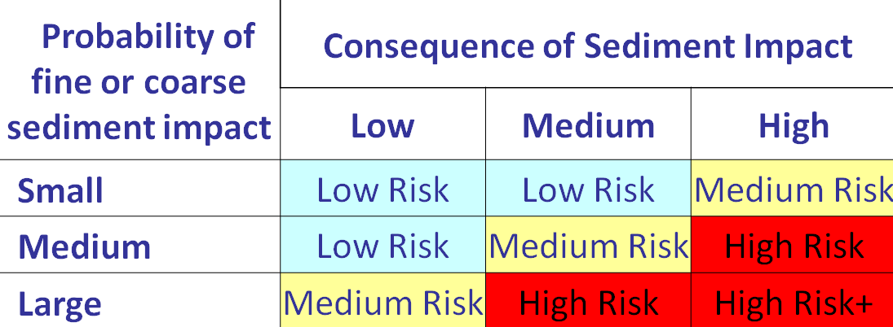
Figure 20. Matrix to estimate the risk of sediment impacts from the probability of occurrence and the consequence should the impact occur.

Low Risk Dam Removals

For the low-risk case, either the volume of reservoir sediment to be released downstream is small enough or the consequence of sediment release is low enough such that the overall risk to resources is low. This means that dam removal and reservoir sediment release is not expected to cause large (significant) consequences to infrastructure, property, and water use, aquatic species, cultural resources, and recreation.

Medium Risk Dam Removals

For the medium-risk case, the relative reservoir sediment volume could be small combined with a high consequence, medium combined with a medium consequence, or large combined with a low consequence. For the case of a relatively small reservoir sediment volume, the risk could be considered medium if the potential consequences are interpreted as high. For example, if a downstream pumping plant was present that may have problems with even a small increase in sediment load; this might be considered a medium risk. On the other hand, for the case of a large sediment volume, the risk could be considered medium rather than high if the potential consequences are low.

High Risk Dam Removals

For the high-risk case, a medium relative reservoir sediment volume could be combined with a high consequence, a medium consequence combined with a high relative reservoir sediment volume, or a large relative reservoir sediment volume combined with a high consequence. If the reservoir sedimentation volume is more than a decade of upstream sediment supply, or the potential consequences of sediment impacts are high, then the rate of dam removal may have to be slowed to reduce the magnitude of downstream effects.

STEP 5: DAM REMOVAL AND SEDIMENT MANAGEMENT ALTERNATIVE SELECTION

Once the level of risk from sediment impacts is determined in step 4, the user must assume a dam removal and sediment management plan in step 5. The dam removal and sediment management plan selection will influence how much sediment can erode from the reservoir and how fast it will be released into the downstream channel. This information can then be used to guide analysis of sediment impacts in step 6.

Step 5a: Select Dam Removal Plan

Low or medium risk cases - For reservoirs with a negligible, small, or medium sediment volume that is without contaminants, initially assume rapid and complete dam removal with reservoir sediment eroded by available stream flows and transported into the downstream channel. This initial assumption should be changed, or mitigation should be added to the sediment management plan, if subsequent analyses reveal impacts that would be unacceptable to stakeholders. The initial assumption of rapid and complete dam removal is meant to avoid unnecessary costs of dam removal and sediment management or provide adequate justification for cases for phased or partial dam removal and when more sediment management actions are needed.

High risk cases - For reservoirs with high risk of sediment impact, rapid dam removal and release of sediment may overwhelm the aquatic environment or downstream channel in alluvial reaches where the channel is not confined by bedrock canyons. Rapid and complete dam removal could be considered, but this assumption is not necessary for cases where unacceptable impacts are obvious.

Phased dam removal – If phased dam removal is necessary, initially develop a plan that would release no more coarse sediment volume than two decade’s worth of average annual coarse sediment supply to the downstream channel in a single year. For example, a dam, with a reservoir containing a coarse sediment volume equivalent to 40 years of average annual sediment supply, could be removed over a two-year period.

$$2 years= \frac{40 years of sediment volume}{20 years of sediment volume per year}$$

This rate of phased dam removal could be slowed if subsequent analyses reveal unacceptable impacts (e.g., increased flood stage or avulsion from channel aggradation or burial of critical infrastructure or habitat).

The phased release of fine sediment needs to consider the downstream concentration of suspended sediment and acceptable impacts to the aquatic environment and water users. High concentrations of suspended sediment over a shorter duration would impact fewer year classes or generations of aquatic species than lower sediment concentrations of sediment over a longer duration of time. However, water users may not be able to divert and treat water with excessively high sediment concentrations.

Step 5b. Select Sediment Management Plan

Sediment management alternatives can be grouped into four general categories (ASCE, 1997):

No action. Leave the existing reservoir sediments in place. If the reservoir-sediment storage capacity is not already full, then either allow future sedimentation to continue or reduce the sediment trap efficiency to enhance the life of the reservoir.

River erosion. Allow the river to erode sediments from the reservoir through natural processes. This option may include a pilot channel to initiate erosion processes. Some dam removals have formed a cofferdam out of reservoir sediment that is allowed to breach during a high flow and then erode by the river. Dams with gates or outlets may consider drawdown to initiate partial reservoir erosion.

Mechanical removal. Remove part or all of the reservoir sediment by hydraulic or mechanical dredging or conventional excavation (during dry conditions with drawdown) for long-term storage at an appropriate disposal site.

Stabilization. Engineer a river channel through or around the reservoir sediment and provide erosion protection to stabilize a portion or all the reservoir sediments over the long term.

The river erosion alternative appears to be the most commonly applied, especially in the western United States. This alternative potentially has the least cost, but results in the greatest amount of sediment concentration and turbidity in the downstream channel and potentially the greatest amount of uncertainty. The sediment concentration and uncertainly directly depend on the rate of reservoir drawdown, which is often associated with the rate of dam removal.

The mechanical removal alternative is typically the most expensive, but may be necessary if the sediments are contaminated beyond background levels and must be removed from the system. The reservoir stabilization alternative can be a cost effective way of preventing sediments from entering the downstream channel, so long as the stabilization measures do not catastrophically fail at some point in the future.

A sediment management plan can also consist of a combination of these categories. For example, fine sediments could be mechanically removed from the downstream portion of the reservoir to reduce the impacts on water quality. At the same time, the river could be allowed to erode coarse sediments from the reservoir delta to resupply gravel for fish spawning in the downstream river channel.

For most small reservoir sediment volumes, the dam would be completely removed and nearly all of the reservoir sediment can be expected to erode. However, there may be cases where some of the dam is left in place and this may limit the amount of reservoir sediment erosion, especially if the dam in not removed all the way down to the predam river bed. Alternatively, if portions of the dam were left in place along the left or right abutments, then some reservoir sediment near the dam may not be subjected to lateral erosion. For reservoir sediment deposits that are much wider than the river channel, the lateral extent of reservoir erosion may be limited to a few channel widths. If the reservoir sediment is cohesive or becomes quickly vegetated after dam removal, this may also reduce the extent and rate of lateral erosion.

Step 5c: Modify the Plans Based on Contaminants
If contaminants are present, consider whether the assumed sediment management plan needs to be modified to minimize release of reservoir sediment.
- Determine what happens to contaminants associated with the fine sediment when remobilized into system.
  - Determine the concentration of contaminants within the reservoir sediments and if sediment erosion would result in chronic (long-term) or acute (rapid) effects
- Determine what happens to contaminants associated with the fine sediment that are not mobilized and remain in the reservoir
- Adjust sediment management plan
  - Excavate or stabilize all sediment?
    - If yes, modify the sediment management plan and determine the future reservoir topography, then proceed with the dam removal planning.
  - Excavate or stabilize the contaminated reservoir sediments and allow the remainder of the sediments to erode or remain in place.
  - Allow contaminated sediment to erode and be transported downstream with mitigation measures as necessary.

Step 5d: Modify the Plans Based on Erosion Resistant Materials
Erosion resistant materials within the reservoir could create fish or boat passage problems after dam removal and prevent the erosion of reservoir sediments. Erosion resistant materials may also slow the rate of bank erosion and prolong potential for sediment impacts from dam removal and slow recovery of a natural landscape in the former reservoir.
- Is there non-native erosion-resistant material within the reservoir (large size particles or debris, logs, old structures) that could impede fish or boat passage?
  - If no, continue to step 5e
  - If yes
    - Would this material likely erode during a 2-year flood following dam removal? If yes, determine the flow rate required for incipient motion and when such flow is likely to occur. If no, consider the need for mechanical removal or reshaping of the erosion resistant material to achieve desired reservoir conditions.
    - Would this material likely remain within the reservoir area after dam removal over the long term? If yes and impacts cannot be tolerated, modify the dam removal plan to include the mechanical removal or reshaping of these materials to achieve desired reservoir conditions.

Step 5e: Modify the Plans Based on Threatened or Endangered species
If there are sensitive species (threatened or endangered) present downstream of the dam that cannot tolerate sediment impacts without dire consequence to the species primary production or community composition, then adjust the timing of dam removal or modify the sediment management plan. If possible, considering removing the dam and allowing reservoir sediment erosion at a time when the species are not susceptible to the impacts. If the dam must be removed when species are present, consider if excavation or stabilization of the reservoir sediment is necessary or if the species in question can be relocated to minimize impacts.

Step 5f: Consider the Case of Multiple Dam Removals
When multiple dams within a river basin are being removed, the dam removal and sediment management plans must incorporate how the sediment released from the upper dams will influence sedimentation and erosion in the downstream dams. Dams can be removed concurrently to get sediment impacts over with quickly, or in successive stages which prolong the duration of sediment impacts but may reduce the magnitude of impact. The determination of which method to pick is dependent on thresholds for consequences to aquatic species and downstream infrastructure.

STEP 6: CONDUCT SEDIMENT ANALYSIS BASED ON RISK

The most common questions about sediment in regard to dam removal include:
- What will happen to the reservoir sediment and what will the effects be on the aquatic environment, human use, infrastructure, and property?
- What will the new reservoir landscape look like after dam removal?

The answers to these questions, and their importance to stakeholders, largely depend on the level of sediment risk. For the negligible risk category (cases with little or no sediment), only simple calculations are recommended to verify that the reservoir sediment volume is very small relative to the potential sediment storage areas of the downstream channel.

The objective of the analysis and modeling step is to first determine the level of effort required (based on risk) and then predict the sediment effects related to dam removal along with the associated uncertainty. Development of a conceptual model and some simple calculations (total stream power and mass balance) are recommended for the small, medium, and large sediment risk categories (Figure 21).

Figure 21. Recommended Sediment analysis and modeling tasks for each sediment risk category.

The recommended level of more quantitative analyses and modeling progressively increases with risk and also varies with sediment grain size and the physical setting. The sediment analyses and modeling strategies (beginning with Step 6a: Develop a Conceptual Model) are described separately in subsections of Step 6.

The application of a sediment wave model is recommended for the small risk category (for coarse sediment) to estimate how the sediment deposition thickness downstream from the dam site would vary over both the longitudinal channel distance and with time. Calculations of sediment transport capacity are recommended for the medium sediment risk category to estimate the rate that reservoir sediment can be moved downstream. Numerical modeling, laboratory modeling, or field experiments are recommended for high sediment risk categories to forecast the rates and amounts of sediment erosion from the reservoir and the corresponding downstream rates and amounts of sediment transport and deposition.

In addition to risk, the sediment analyses and modeling strategies can be linked to three general impact categories:
- Stream channel aggradation (sediment deposition)
- Changes to water quality from increased sediment loads
- Changes to groundwater levels and permeability

Sediment deposition along the channel can bury aquatic food sources (e.g., macroinvertebrates), and fish eggs. Sediment deposition at water intakes can reduce the ability to withdrawal, convey, and treat water. Significant aggradation on hydraulic controls, such as riffles, can increase flood stage and, in severe cases, can lead to bank erosion, channel widening, and channel migration.

Water quality will change as suspended sediment concentration and turbidity (clay, silt, and sand) increase. This may affect fish and other aquatic species, especially as concentrations approach lethal levels. Suspended sediment can cause abrasion of fish scales. Increased turbidity can make it difficult some fish species to find food. Even at concentrations below lethal levels, increased sediment loads over prolonged periods may cause chronic problems for aquatic species. Increased sediment concentration and turbidity may pose problems for water infrastructure and water treatment. When streamflows are diverted into canals, ditches, or pipelines, high sediment concentrations can lead to deposition. Water treatment plants may have increased costs for chemical flocculants and sediment removal.

The loss of the reservoir after dam removal will reduce the groundwater level and reduce the yield for any wells that may be associated with the reservoir. Downstream deposition of fine sediment can reduce the permeability of alluvium near the surface and potentially reduce well yields. The reduction in permeability would depend on the portion of streamflow entering the groundwater. For steep channels where the stream velocity is high and the portions of flow going to groundwater are small, any effects on permeability would be small. For mild slope streams with slow velocities, the effects on permeability and well yield could be significant when the portions of stream flow going to groundwater are significant.

The applicability of the sediment analyses and modeling to the impact categories is presented in Table 4.

Table 4. Applicability of sediment analyses and modeling to impact categories.
 | Sediment Impact Categories
Sediment Analysis & Modeling | Aggradation | Water Quality | Groundwater
Conceptual Model | √ | √ | √
Reservoir Sediment Erosion Estimates | √ | √
Total Stream Power Calculations | √
Mass Balance Calculations | √
Sediment Wave Model | √
Sediment Transport Capacity Calculations | √
Geomorphic Analysis | √ | √ | √
Numerical Modeling, Laboratory Modeling, and Field Experiments | √ | √ | √

Step 6a: Develop a Conceptual Model

The conceptual model is mostly a qualitative description of what will happen to the reservoir sediment, including the effects downstream, and what will happen to the reservoir landscape after dam removal. This description should include qualitative estimates regarding the portion of reservoir sediment that is expected erode, a description of the downstream transport mechanisms, and a description of sediment depositional areas over the short and long term.

The conceptual model is developed from field inspection and measurements, literature, and professional experience. The conceptual model will describe the important physical processes that are expected to occur as a result of dam removal and guide the quantitative analyses and modeling tasks. The details of the conceptual model, and the level of effort to develop it, increases with the level of sediment risk. The conceptual model should be a dynamic document that is updated whenever new information becomes available.

A conceptual model for reservoir sedimentation was presented in earlier in this document (RESERVOIR SEDIMENTATION PROCESSES). The conceptual model that addresses the reservoir sediment erosion and downstream effects will need to address the important physical processes and the sediment-related concerns of stakeholders. A conceptual model for erosion of the reservoir sediment was developed by Doyle et al. (2003b) and later refined by Cannatelli and Curran (2012). These conceptual models were further refined for this guideline (Figure 22). The process begins with water and sediment in the reservoir (Figure 22a). Initial reservoir drawdown

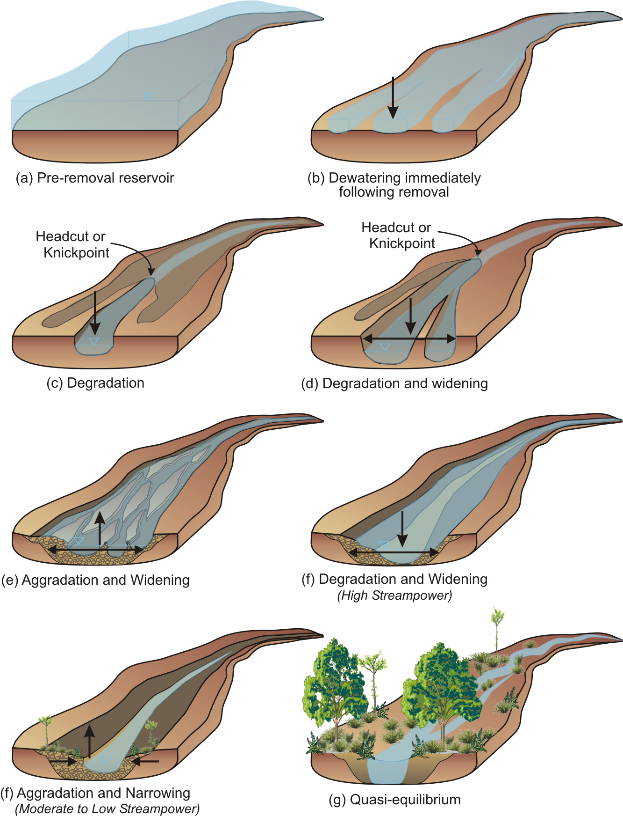
Figure 22. Conceptual model of sediment erosion from the reservoir modified from Doyle et al. (2003) and Cannatelli and Curran (2012).
exposes a network of channels flowing over the exposed sediments (Figure 22b). Continued reservoir drawdown results in channel degradation (incision) with the fastest rates occurring in the channel that conveys the most flow. Channel degradation advances upstream through the processes of headcut or knickpoint migration. Since reservoir deltas typically extend upstream from the reservoir pool, the headcut or knickpoint erosion will erode these upstream reservoir deposits (Figure 22c). However, erosion is generally not expected to occur upstream through predam sediments. Channel degradation and widening continues with reservoir drawdown until the predam surface is reached.

The extent and rate of channel widening depends on the cohesive properties of the sediment at the river level and the rate of reservoir drawdown (Figure 22d). Strongly cohesive sediment can cause headcut erosion to advance upstream at a very slow rate, especially during periods of low flow.

Initially, the erosion channel width through the reservoir sediments will be a function of the stream-flow discharge. Erosion channels will widen with each passing high stream flow of a larger magnitude. If the rate of reservoir drawdown is slow, there will be more time for lateral erosion at higher elevations of the reservoir. Conversely, if the rates of reservoir drawdown are fast, then channel degradation or incision will also be fast and there will be less time for channel widening at higher elevations of the reservoir. Mass wasting of reservoir sediment terraces can occur during rapid rates of reservoir drawdown due to slope instability.

In general, the rates of reservoir sediment erosion are expected to decay exponentially over time because the most easily eroded sediment will have already been eroded and greater, and less frequent, stream flows will be needed to initiate additional erosion. Erosion rates will be relatively fast through coarse reservoir sediments that are devoid of woody vegetation because there is typically little or no cohesion. Conversely, erosion rates will be relatively slow through fine, cohesive reservoir sediments (Figure 22d).

Coarse sediments eroding from the upstream portion of the reservoir may deposit along the lower portion of the reservoir (if that space has not already filled with sediment), depending on the rates of upstream erosion and the downstream sediment transport capacity. Channel widening occurs because of sediment deposition and also to form a new floodplain along the degraded channel (Figure 22e). Degradation and widening are most likely to occur when the sediment transport capacity, or stream power, are high. Channel widening may occur due to erosion of the sediment terrace banks (Figure 22f). Alternatively, sediment bar deposition can be expected along the channel margins when sediment transport capacity, or stream power, are low. The deposition of bars results in a narrower channel (Figure 22f). Eventually, vegetation grows on the exposed reservoir topography and remaining reservoir sediment terraces. Woody species may provide some stability to these terraces depending on density and the root depth (Figure 22g). The final channel planform through the former reservoir will depend on the upstream inputs of water and sediment, reservoir valley slope, and any geologic or human-built constraints.

The same reservoir sediment erosion processes (described above) can also be expected to occur in tributary channels that enter the reservoir. Reservoir sediments eroded from tributary channels will tend to form alluvial fans at the confluence with the main channel and locally limit the laterally position of the main channel.

The reservoir landscape that develops after dam removal will depend on the spatial thickness, size gradation, and cohesive properties of sediments that are left behind. Narrow reservoirs (less than three times the river channel width) and reservoirs with predominantly coarse sediment would be expected to have the greatest proportion of sediment erosion as a result of dam removal. A significant volume of sediment may be left behind in reservoirs that are much wider than the river channel, especially when the sediments have cohesive properties or have deposited on terrace surfaces within the former reservoir. Cohesive properties of the sediment may exist when more than 20% is composed of clay, when woody material is abundant in the sediments, or a combination of both. The greater the amount of sediment cohesion, the slower the rate of reservoir sediment erosion and the greater the sediment volume that will be left behind within the former reservoir.

For narrow reservoirs (less than three times the active channel width), all sediment can be assumed to erode from the reservoir at nearly the rate the reservoir is drawn down in conjunction with dam removal, provided that stream flows are high enough to initiate sediment erosion. A portion of the sediment may remain over the long term in reservoirs that are much wider than the river channel. The portion of reservoir sediment that remains, depends on the degree of cohesion, magnitude and frequency of stream flows, woody vegetation growth, and any geologic or human-built constraints.

Old structures or debris may be buried in the reservoir sediment that could potentially slow or limit stream channel erosion during reservoir drawdown. Therefore, the final extent of reservoir sediment erosion may depend on the ability to implement adaptive management plans to address such contingencies.

The presence of woody material and litterfall in reservoir sediment deposits can affect the rate and extent of reservoir sediment erosion along with an increased supply of wood and litterfall to the downstream channel. During reservoir drawdown, exposed log jams or large pieces of wood can deflect the flow and alter lateral erosion processes. In many cases, old timber crib dams or debris may exist that could limit the extent of headcut migration or lateral erosion and may need to be removed if the predam channel is to be restored. For example, a large timber crib dam was found just upstream of Gold Ray Dam on the Rogue River in Oregon and had to be removed in conjunction with removal of the main dam. The supply of wood to the downstream channel may increase as a result of dam removal. Large wood released may help restore fluvial processes and form log jams, surfaces for vegetation to grow on, and improve aquatic habitat. Small woody material, and any accompanying litterfall, could also pose challenges to operate and maintain water diversions and treatment facilities.

Reservoirs may have trapped coarse sediment, fine sediment, or a combination of both depending on the upstream sediment supply and the reservoir sediment trap efficiency. The risk of downstream sediment impacts can be very different for coarse and fine sediment because both their proportions in the reservoir, and their downstream fate, can be so different. The reservoir trap efficiency for fine sediment can be much less than the high trap efficiency for coarse sediment. For example, the sediments trapped behind a small diversion dam may be predominantly coarse will little or no fine sediment. A medium sized reservoir may trap a significant volume of fine sediment, but this volume may be less than the coarse sediment volume if the travel time of water through the reservoir is short (e.g., hours). A large reservoir would likely trap the entire sediment load of coarse and fine sediment and the volume of fine sediment may dominate.

If contaminants or heavy metals have deposited with a reservoir, they will most likely be associated with the finest sediment particles, but not exclusively. The deposition of contaminants or heavy metals within the reservoir may improve the water quality of the downstream river, but the water quality in the reservoir may degrade over time as the concentrations accumulate.

The risk of downstream sediment impacts depends on the amount and rate of reservoir sediment erosion. The erosion rate depends on the rate of reservoir drawdown associated with dam removal and on the stream-flow hydrograph, especially the frequency and duration of high flows (Randle et al., 2015). The rate of channel incision through the reservoir sediment will tend to follow the rate of dam removal and reservoir drawdown, so long as the streamflow rate is high enough to transport sediment. Reservoir sediment erosion can stall when stream flows become too low. The rate of channel widening and lateral migration will tend to increase or decrease with the rate of stream flow.

Coarse sediments eroded from a reservoir may be transported downstream as bed load or suspended load, depending on the local stream velocity, shear stress, and turbulence. The downstream transport rates for coarse sediment will be limited by the hydraulic capacity of the stream flows and at least some deposition can be expected in low velocity areas of the stream channel. The stream channel will adjust over time to increase the sediment transport capacity by achieving a straighter and steeper slope with less roughness. The hydraulic capacity to transport fine sediments, or wash load, is typically very large so fine sediments can be expected to keep moving downstream until depositing in a downstream reservoir, lake, estuary, or coastal area or if water were lost from the stream channel. However, some fine sediments can be expected to deposit in the interstitial spaces of the coarse sediments. These fine sediment may be subsequently washed away during future floods (following dam removal), but the fine sediment deposition could affect aquatic organisms, the permeability of coarse sediments, ground water flow, and wells.

A bullet list of questions that the conceptual model should try to address are listed below along with some example answers as sub-bullets:
- How much sediment will be eroded from the reservoir and over what time frame?
  - erosion of 50%, 60%, 70%, 80%, 90%, or 100%
  - erosion period of days, weeks, months, or years
- What will the reservoir landscape eventually look like?
  - predam topography without reservoir sediment or
  - sediment terraces along the margins of the reservoir valley
- What species of vegetation will grow back and how long will that take?
  - native vegetation on the exposed landscape within three years after dam removal or
  - exotic vegetation on the exposed landscape within one year after dam removal
- Will the dam be removed during a period of low, medium, or high stream flows?
  - dam removal during low stream flows resulting in the slowest rates of reservoir sediment erosion or
  - dam removal during high stream flows resulting in the fastest rates of reservoir sediment erosion
- What will happen to coarse sediment that are eroded from the reservoir?
  - transport downstream to a reservoir, lake, or estuary;
  - deposition along the channel banks in eddies or as bars;
  - deposition along the channel bottom, especially in river pools;
  - deposition of finer sediments on top of a coarser streambed with possible effects to the aquatic environment, ground water flow, and well yields;
  - deposition at water diversion and pumping plant intakes resulting in the less water diversions and increased diversion of sediment;
  - floodplain deposition during flows greater than the bankfull channel capacity;
  - aggradation of riffles or other hydraulic controls resulting in more frequent inundation of the floodplain;
  - significant deposition that results in streambank erosion, channel widening, and effects on property and infrastructure
- What will happen to fine sediment eroded from the reservoir?
  - increase in turbidity and suspended sediment concentration during the period of reservoir drawdown, and channel incision and widening within the exposed reservoir;
  - downstream deposition of fine sediment along floodplains, in reservoirs and in estuaries;
  - the increase in turbidity may affect aquatic species, which may help native species that evolved under high sediment conditions;
  - the increase in turbidity may affect downstream water users because of increased diversion of sediment, which may require additional water treatment;
- What will happen to woody material eroded from the reservoir?
  - woody material of large and fine sizes will deposit along the downstream channel in slow velocity areas and add to other wood jams already in the channel;
  - woody material of large and fine sizes will accumulate on trash racks and screens of any water intakes
- What effect will upstream sediment and wood loads have on the downstream channel after dam removal?
  - the reservoir had already filled to its sediment storage capacity so the upstream sediment and wood loads were already being transported downstream, however, these loads will increase as the reservoir sediment erodes with dam removal; or
  - upstream sediment and wood loads are still being trapped in the reservoir, so downstream sediment and wood loads will increase because of dam removal and restoration of the loads upstream from the reservoir
- How will the supply of water and sediment from downstream tributaries affect the transport of sediment?
  - downstream tributaries will supply relatively little water or sediment;
  - downstream tributaries will supply large volumes of water, some sediment, and significantly increase the sediment transport capacity; or
  - downstream tributaries will supply some water and significant sediment loads that will add to the loads from the upstream reservoir sediment

Step 6b: Estimate the Proportion of Reservoir Sediment Erosion

Not all of the sediment may be eroded from a reservoir following dam removal, especially within the first year and especially for wide reservoirs. Sawaske and Freyberg (2012) evaluated 12 predominantly low-head dam removals (6 to 45 feet high) and found that the sediment volume eroded from the reservoir during the first year ranged from 8 to 65 percent with an average of 28 percent. They also found that the erosion volume was less where the sediment deposits were predominantly fine and consolidated or cohesive. Major et al. (2016) evaluated 16 dam removal cases, including some of those assessed by Sawaske and Freyberg (2012) along with some more recent large dam removals. For reservoirs with coarse sediment (sand and gravel), Major et al. (2016) found that the sediment volume eroded from the reservoir ranged from 1 to 77 percent (with an average of 43 percent) within the first year of dam removal (Table 4). For reservoirs with more than 30 percent fine sediment (silt and clay), Major et al. (2016) found that the sediment volume eroded from the reservoir ranged from 8 to 72 percent (with an average of 25 percent) within the first year of dam removal. Where data were available, the percentage of reservoir sediment erosion increased over the period of 1.5 to 3.7 years after dam removal, but the rates of erosion generally decreased with time.

Table 5. Portion of sediment volume eroded from the reservoir after dam removal for case studies reported by Major et al. (2016).
Dam and State | Sediment Type | Short Term |  | Long Term
Dam and State | Sediment Type | Time after dam removal (years) | Sediment Erosion Volume | Time after dam removal (years) | Sediment Erosion Volume
Condit, WA | > 30% Fine | 0.7 | 72%
Glines, WA | > 30% Fine | 1 | 37% | 2 | 55%
Elwha, WA | > 30% Fine | 1 | 20% | 3 | 28%
Rockdale, WI | > 30% Fine | 0.8 | 17%
Ivex, OH | > 30% Fine | 0.2 | 13%
La Valle,WI | > 30% Fine | 1 | 8%
Brewster, IL | > 30% Fine | 1 | 8% | 3.7 | 13%
Milltown, MT | Coarse | 0.4 | 77%
Simkins, MD | Coarse | 1 | 73% | 3.6 | 94%
Merrimack Village, NH | Coarse | 1 | 63% | 1.5 | 79%
Marmot, OR | Coarse | 1 | 53% | 1.8 | 58%
Savage Rapids, OR | Coarse | 0.4 | 50%
Lost Man, CA | Coarse | 0.6 | 30%
Brownville, OR | Coarse | 1 | 30% | 1.9 | 38%
Secor, OH | Coarse | 0.4 | 10%
Stronach, MI | Coarse | 1 | 1% | 2.8 | 3%

Major et al. (2016) also found that rapid and large amounts of reservoir lowering lead to mass wasting and an increased volume of reservoir sediment erosion. Tullos et al. (2016) documented that the erosional processes are initially dominated by the rate and amount of reservoir lowering rather than hydrology (Randle et al., 2015; Major et al., 2016) in the absence of floods. The hydrology after dam removal is primarily responsible in achieving the final equilibrium extent of lateral reservoir sediment erosion. The hydrology can affect the progression of both vertical and lateral erosion of sediment deposits (Tullos et al., 2016).

The portion of sediment that erodes from a reservoir is generally believed to less for wide reservoirs than for narrow reservoirs (Wildman and MacBroom, 2010 and Randle et al., 2015). Sawaske and Freyberg, 2012 found this to be true when the ratio of the average width of the reservoir sedimentation to channel width was greater than 2.5. This is because the eroding channel, and developing floodplain, may not need to be as wide as the reservoir valley width and some reservoir sediment terraces may be perched on natural terraces that the river is not as likely to erode. However, erosion widths can be quite wide through coarse reservoir sediments that lack the cohesion provided clay or the roots of woody vegetation (Randle et al., 2015). This was the case for erosion of the upper layer of delta in Lake Mills behind Glines Canyon Dam (Figure 23).

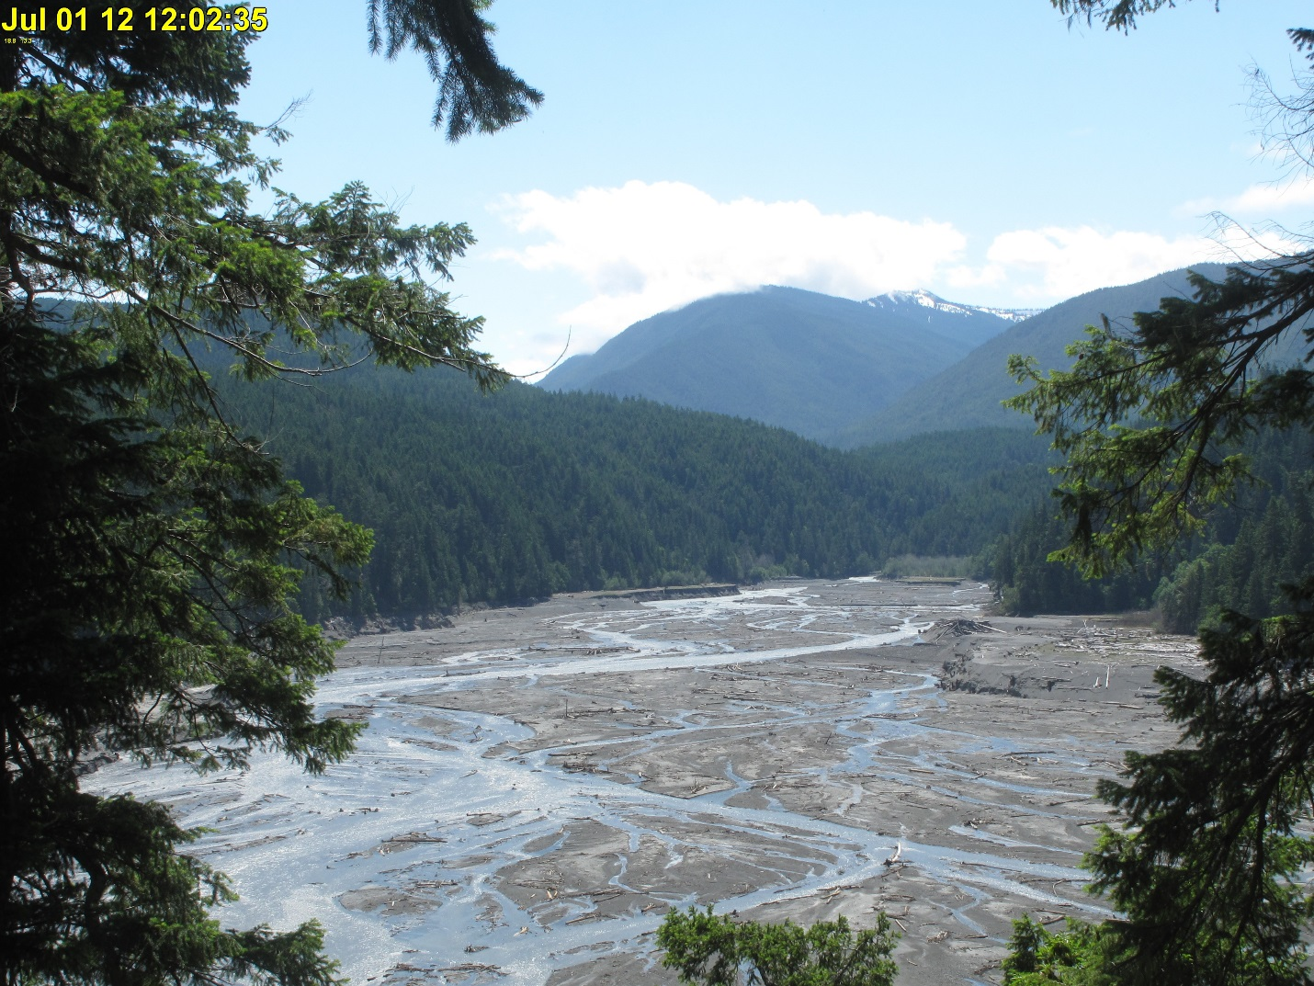
Figure 23. Looking upstream at extensive lateral erosion of Lake Mills delta (upper coarse layer) near Port Angeles, WA.

The initial alignment of erosion channels through the reservoir sediment can affect the total amount of erosion. This is because the eroding channels have a tendency to incise along their initial alignment and then widen (Randle, et al., 2015). In the case of multiple channels, the channel conveying the most flow will tend to incise at the fastest rate and capture flow from the other channels. Erosion rates can be expected to accelerate as flow is captured from other channels. If the erosion channel alignment is along the reservoir margin, there is less room for the channel to widen and a chance that the vertical erosion may be limited by bedrock, or a highly erosion resistant surface, along the valley margin. If the initial channel alignment through the reservoir does not coincide with the predam channel alignment, the river could end up cutting into a predam terrace and be stuck between tree stumps. Erosion through the Lake Aldwell delta (behind Elwha Dam) was initially along the valley wall and into a formerly forested area of the predam surface (Figure 24). Tree stumps may slow or prevent the new channel from occupying the predam channel alignment. Excavation of a pilot channel would help ensure that the initial alignment of the channel eroding through the reservoir sediment coincides with the predam channel alignment.

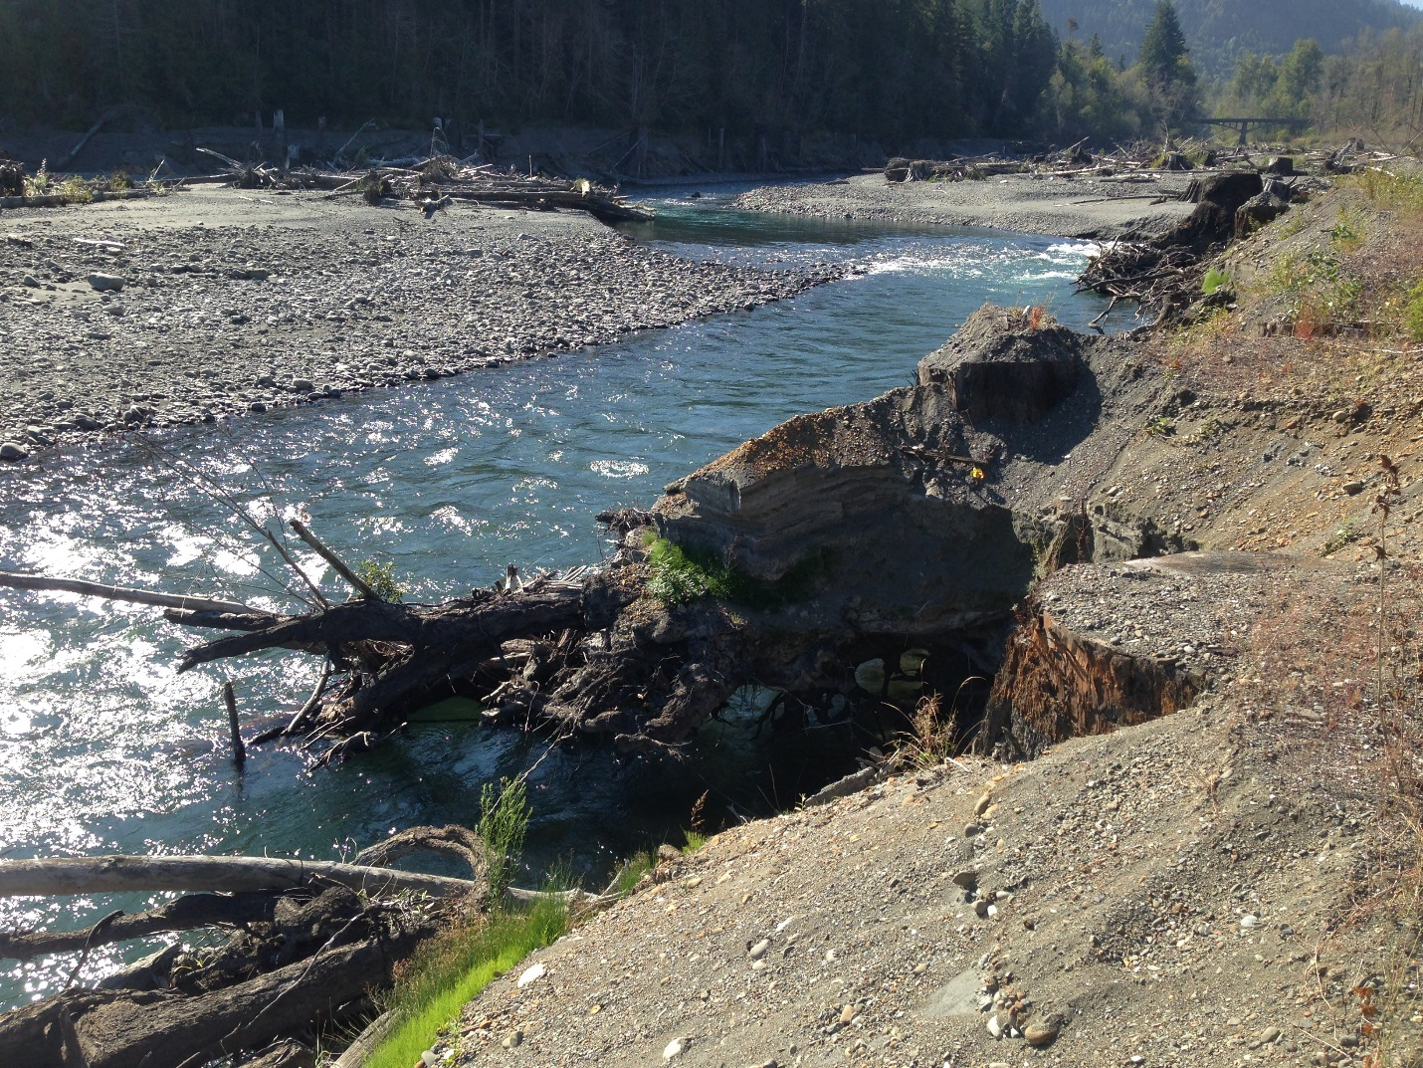
Figure 24. The Elwha River initially incised through the Lake Aldwell delta over a cleared forested area that did not coincide with the predam channel alignment.

Predicting the Volume of Reservoir Sediment Erosion

Accurately estimating the volume of sediment that is expected to erode from a reservoir is difficult because the processes of channel widening and lateral migration are quite complex. Numerical models can predict the vertical erosion of a channel through the reservoir sediment, but numerical models aren’t generally available to predict the lateral channel erosion, which is a problem when the reservoirs are much wider than the river channel. In addition, the proportions of sediment eroded from reservoirs vary widely among the reported case studies. The data reported by Major et al. (2016) are summarized for the first year of dam removal in Table 5. For half of these case studies, the sediment-erosion volume percentages were available for periods ranging from 1.5 to 3.7 years after dam removal (Table 4). Where possible, the trend lines of the data reported by Major et al. (2016) were extrapolated to estimate the portion of reservoir sediment that was expected to erode over the long term (Table 5).

Table 6. Summary of sediment volume eroded from the reservoir over the short term and long term based on data reported by Major et al., 2016).
Reservoir Sediment Type | Portion of Reservoir Sediment Volume Erosion
Reservoir Sediment Type | Within 1 year after dam removal | Long-term Estimate
Coarse | 1% to 77%, Average = 43% | 4% to 100%, Average = 67%
> 30% Fine | 8% to 72%, Average = 25% | 10% to 90%, Average = 40%

The data presented in Table 5 may be used to help guide estimates of the sediment volume that may erode from a reservoir. In general, reservoir sediment will continue to erode following dam removal until a new equilibrium is reached, but the rates of erosion typically decrease over time. The average sediment erosion volumes are significantly less for reservoir sediments that are composed of more than 30 percent silt and clay.

If a flood were to occur within the first year after dam removal, then more of the sediment would be expected to erode from the reservoir during the first year.

If the relative reservoir width (ratio of reservoir sediment width to river channel width) is greater than 2.5, then the portion of sediment eroded from the reservoir would typically be less. The relative reservoir width should be computed using the active channel width of the stream in a wide alluvial reach that has essentially the same discharge as that flowing through the reservoir reach.

If the relative reservoir width is greater than five times the active channel width, then the amount of sediment erosion may be limited to the volume contained within five active channel widths. The estimated erosion width should be centered along the expected erosion channel alignment, which may be the present alignment of the flow path through the reservoir.

If there is a reason to expect that a significant portion of the reservoir sediment volume will not erode, the relative reservoir sediment volume should be reevaluated and step 5 should be revisited.

The rate of reservoir sediment erosion can be simulated using a sediment transport model that computes how the transport capacity changes over time in response to changing stream flows and changing sediment conditions over time. There are many sediment transport equations available for sand and gravel (Garcia, 2007) (Sediment Transport Capacity Calculations), but relatively few for fine sediment. Cui et al. (2016) applied a transport capacity formula for fine sediment to the proposed removal of Matilija Dam near Ventura, CA.

$$C=\left\{\begin{aligned}{50\left(\frac{V^{3}}{gHν_{s}}\right)}^{1.55}, \frac{V^{3}}{gHν_{s}}≤10 \\ \\ 135{\left[ln\left(\frac{V^{3}}{gHν_{s}}\right)\right]}^{3.1} , 10 <\frac{V^{3}}{gHν_{s}}≤100 \\ \\ {620\left(\frac{V^{3}}{gHν_{s}}\right)}^{0.7} , 100 <\frac{V^{3}}{gHν_{s}} \end{aligned}\right\}$$

Where C is the suspended sediment concentration in mg/L. V is the average flow velocity, g is the acceleration due to gravity, H is the average water depth, and ν_{s} is the settling velocity of the median sediment size. The sediment transport capacity is a function of the dimensionless ratio V ³/(g H ν_{s}).

Assessing Reservoir Sediment Stability

Additional guidance on assessing the stability of sediments remaining in the reservoir are provided below:

- For most reservoirs, assume that predam topographic surface, if exposed, will be relatively stable over the long term. However, an erosion channel may incise through a predam terrace if the eroding channel alignment is directly over the predam terrace.

- If the thickness of the reservoir sediment is thin (less than a typical bankfull channel depth), then the reservoir topography likely will be consistent with the predam landscape and the remaining reservoir sediment will be relatively stable. Even though the remaining reservoir sediment terraces may erode locally, the low terrace height will be less susceptible to slope stability erosion than high sediment terraces.

- If the reservoir sediment deposit is thick (greater than a typical bankfull channel depth), then the reservoir topography won’t be as consistent with the natural landscape and the high sediment terrace banks would be more susceptible to local stream channel erosion and slope stability erosion than low terrace heights.

- If an incised river channel encounters erosion resistant material (e.g., old dam or structure, bedrock, large rocks, clay), then either a large portion of the reservoir sediment may be left behind or a prolonged period of reservoir sediment erosion may occur.

- In many cases, the remaining reservoir sediment can become stabilized by vegetation.
  - If the root depth of vegetation is deeper than the sediment thickness, and the vegetation can survive for at least three years, then the vegetation is likely to stabilize the reservoir sediment. Although, local erosion from channel meander bends may still occur.
  - If the reservoir sediment thickness is greater than the root depth of vegetation, then vegetation may only help to control surface erosion from rainfall runoff, but not bank erosion. However, floodplain vegetation along the toe of a sediment terrace may act to help stabilize the sediment terrace bank.

Step 6c: Predict Downstream Sediment Effects

After developing the conceptual model for the reservoir sediment erosion, the following steps are suggested to help evaluate the downstream effects:

- Determine if the reservoir pool behind the dam to be removed had a significant effect on hydrology (stream flows). If the reservoir pool volume is small compared with the mean annual stream flow volume (< 1%), then dam removal would not be expected to have much effect on the downstream hydrology. If the reservoir stores water during high flows and releases stored water during low flows, then the effects on downstream hydrology should be considered. As of 2016, very few, if any, dams have been removed where the primary purpose was water supply or flood control, so the effects of dam removal on hydrology have been small.

- Describe the geomorphology of the downstream channel and floodplain.
  - Estimate the proportions of the existing bed-material particle sizes along the downstream channel (e.g., percentages of cobble, gravel, sand, silt, and clay).
  - Identify significant downstream tributaries and their relative contribution of water and sediment.
  - Compute and plot the total stream power (Total Stream Power Calculations), versus downstream river length (e.g., river mile). Assume a mean-annual discharge (or some consistent flow frequency) for the channel below the dam and all downstream tributaries. The total stream power will provide an estimate of how the relative sediment transport capacity changes with distance downstream.
  - Characterize distinct reaches of the downstream channel. The reaches should be distinguished by such things as longitudinal slope, channel or valley width, channel planform, geology, or land use.
  - Describe the potential depositional environments for sediment (e.g. pools, bars, side channels, floodplains, downstream lake, reservoir, or estuary).

- Estimate portion of eroded reservoir sediment that is expected to be transported along the stream bed (bed load or bed-material load) versus suspended in the water column (suspended load or wash load).

- Describe what may happen to the released bed-material load (Mass Balance Calculations), including potential effects to resources.
  - Identify potential areas of deposition of coarse reservoir sediment (e.g., eddies, pools, slow-velocity channel reaches, floodplains, downstream lake or estuary).
  - Identify potential effects of coarse sediment deposition.
  - Estimate how long coarse sediment deposits along the downstream channel are expected to persist. If the reservoir had been trapping coarse sediment for decades, then some of the depositional bars after dam removal may persist over the long term because the upstream sediment supply has been restored.

- Describe what may happen to the released fine sediment (wash load) (Mass Balance Calculations), including potential effects to resources.
  - Identify potential areas of deposition of fine reservoir sediment (e.g., very slow-velocity channel reaches, floodplains, downstream lake or estuary).
  - Identify potential effects of increased turbidity, wash load, and suspended sediment concentration.
  - Estimate the additional effects of suspended sand loads along with the suspended loads of silt and clay.

- Identify and describe the ultimate downstream depositional environments (e.g. slow-velocity channel reaches, reservoir, lake, or estuary)

Total Stream Power Calculations

The total stream power analysis will help determine the downstream channel reaches where sediment released from the reservoir is likely to be transported or deposited. The greater the total stream power, the greater the sediment transport capacity and less potential for reservoir sediment deposition. The total stream power (P) can be computed as the product of discharge (Q), longitudinal channel slope (S), and the unit weight of water (γ):
$$P=Υ Q S$$

A mean annual discharge (or a discharge of some consistent flow frequency) can be assumed for the channel below the dam and all downstream tributaries. Stream gage records will be the best source of data for mean-annual discharge. Stream-discharge estimates may have to be extrapolated from other gaged locations based on drainage area. For most streams, the discharge tends to increase with distance downstream where tributaries are encountered. However, stream flow can be taken from the channel at surface water diversions and pumped from wells. Some reaches can also loose or gain stream flow to and from the groundwater.

For most streams, the longitudinal river slope tends to decrease with distance downstream. However, some rivers encounter steep reaches through bed rock canyons. The longitudinal channel slope through various reaches can be determined from topographic maps, digital terrane models, or field surveys.

Total stream power increases downstream at tributary confluences that provide more discharge, but may decrease as the channel slope becomes less steep or where stream flow reduces. Reaches with highest total stream power can be expected to transport sediment without much deposition while the reaches with the lowest stream power are more likely to experience sediment deposition.

Mass Balance Calculations

Simple mass balance computations are recommended to relate the reservoir sediment volume to downstream channel features such as sand or gravel bars or the average thickness of sediment deposition on the channel bed.

There are several ways to put the reservoir sediment volume into perspective. Calculate the average thickness of reservoir sediment if the entire volume were to deposit evenly over a length of the downstream channel that had relatively low total stream power. For this computation, assume that the sediments deposited evenly across the width of the active channel (bankfull channel width). If the computed sediment deposition thickness is less than 10 percent of the average channel depth at bankfull discharge, then compute the ratio of the reservoir sediment volume to the volume of a typical sand or gravel bar along the downstream channel. If the potential reservoir sediment deposition is less than a few sand or gravel bars, then the effects on the physical channel likely would be small and no other calculations or modeling are necessary. However, if the computed deposition thickness is significant, then more evaluation is necessary.

Separate analyses for coarse and fine sediment will be useful. Repeat the above calculation for only the coarse sediment. If the computed deposition thickness of coarse sediment is less than 10 percent of the average channel depth, then compute the average length of deposition assuming a thickness:
- For gravel and cobble-bed streams, assume a deposition thickness equal to one or two times the coarsest particle size (d₉₀) of the existing downstream bed material.
- For sand-bed streams, assume the sediment deposition thickness is equal to one or two times the typical dune height of the existing downstream channel or assume 10 percent of the average channel depth at the bankfull discharge.

The computed deposition length can then be divided by the average active channel width to help provide some context. For example, the computed result may indicate that the coarse reservoir sediment may deposit evening over a longitudinal distance equivalent to five channel widths with an average thickness equal to the largest cobbles of the existing streambed.

An equation was previously presented to predict the concentration of fine sediment erosion (Step 6b: Estimate the Proportion of Reservoir Sediment Erosion). For comparison, an alternative method is provided below:

For the fine reservoir sediment, initially assume that it will erode as quickly as the reservoir is drawn down and be transported downstream. Then compute the average sediment concentration as the ratio of the fine reservoir sediment mass and the mass of stream water discharged during the reservoir drawdown period. The fine sediment mass can be computed by multiplying the fine sediment volume by the unit weight. The unit weight can be measured from reservoir sediment cores or estimated (e.g., 35 to 70 lbs/ft³) based on the portions of clay and silt and years of compaction.

The peak sediment concentration will be greater than the average concentration, but the computed average concentration will be overestimated using the assumption that all the fine reservoir sediments erode during the reservoir drawdown period. If the calculated average sediment concentration is large, then the rate that fine sediment will actually erode from the reservoir should be evaluated. The greater the cohesive properties of the fine sediment, the slower the rates of erosion. Highly cohesive sediment may take a few years to erode from a reservoir, especially during drought periods. The period of erosion may have to be estimated.

Based on the total stream power calculations and knowledge of downstream reaches, predict the most likely locations for fine sediment deposition (e.g. downstream slow velocity reach, reservoir, lake, estuary, or ocean).

Sediment Wave Model

The sediment wave model is fairly simple to use and provides estimates of coarse sediment deposition thickness that tend to decrease with time and with distance downstream from the dam. Data requirements for this model include the initial reservoir sediment thickness, sediment porosity, longitudinal slope of the downstream river channel, and the transport rates of the reservoir sediment and downstream channel bed material. This model utilizes the average longitudinal river slope rather than detailed cross sections.

An analytical sediment wave model can be found in Greimann, et al. (2006) or in the ASCE Monograph on Sediment Dynamics upon Dam Removal, Chapter 9: Movement of Sediment Accumulations (Greimann, 2009). This sediment wave model was used to estimate coarse sediment (sand and gravel) deposition for the removal of Hemlock Dam on Trout Creek within the Wind River watershed of southwest Washington State. Prior to dam removal, reservoir sediment thickness values ranged from 2.3 to 8.8 feet with an average thickness of 5.9 feet over a longitudinal distance of 940 feet (0.18 mile). Longitudinal profiles of sediment deposition thickness are plotted for the initial conditions in the reservoir and along the downstream channel at various times after dam removal ranging from 0.5 to 32 days (Figure 25). The model predicts the maximum sediment deposition would be immediately downstream from the removed dam (2.1 feet after 0.5 day). At 0.5 mile downstream from the dam site, the model predicts a maximum deposition thickness of 0.5 feet, which occurs after 32 days.

Figure 25. Example sediment wave model results for the removal of Hemlock Dam on Trout Creek in southwest Washington State.

Sediment Transport Capacity Calculations

The hydraulic capacity of the stream to transport coarse sediments can be computed using a variety of equations. Sediment transport capacity can be computed at various downstream locations of interest for a range of stream flows or discharges. The required input data for the sediment transport equations include channel hydraulics and the sediment grain size. For each stream discharge of interest, the average cross-section hydraulics (depth, width, velocity, and energy slope) will have to be measured or computed using a hydraulic model or computed assuming normal depth.

In order to compute the hydraulic capacity of the stream to transport reservoir sediment, use the grain size distribution representing the coarse reservoir sediments rather than the stream bed-material below the dam. Assume that the fine sediments, eroded from the reservoir, will be transported in suspension as wash load.

There are many computer programs available to computer sediment transport capacity. The Bureau of Reclamation provides one such program (Huang and Bountry, 2009), which can be downloaded for free at:
http://www.usbr.gov/tsc/techreferences/computer%20software/models/srhcapacity/index.html

This program can compute sediment transport capacity using the equations listed in Table 6.

Table 7. Sediment transport equations available in the SRH-Capacity program.
Sediment Transport Equation | Sand | Gravel | Sand & Gravel Mixture
Engelund and Hansen (1972) | √
Ackers and White (1973) | √
Yang (1973) | √
Yang (1979) | √
Wilcock and Crowe (2003) |  | √ | √
Parker (1990) |  | √ | √
Meyer-Peter and Müller (1948) |  | √
Yang (1984) |  | √
Wu (2004) |  |  | √

The U.S. Army Corps of Engineers HEC-RAS (Bruner, 2016a and 2016b) can be used to compute the channel hydraulics parameters for various stream discharges of interest:
http://www.hec.usace.army.mil/software/hec-ras/downloads.aspx

The data required for the hydraulic model include the cross section coordinates of the stream channel and floodplains, estimates of channel roughness, and the downstream boundary water surface elevations associated with the stream discharges of interest.

The HEC-RAS model can also compute sediment transport capacity using the following equations:
- Ackers and White
- Engelund and Hansen
- Larsen
- Meyer-Peter and Müller

Geomorphic Analysis

For medium and high risk dam removals, a geomorphic analysis is recommended, by an experienced geomorphologist. Initially, the geomorphic analysis would utilize historic aerial photographs, geologic maps, soil maps, topographic maps, historical ground photographs and accounts, and field reconnaissance. Additional analysis may require collection and interpretation of sediment and soil samples. The geomorphic analysis will describe the physical setting of the dam, reservoir, and river channel, a description of geologic controls, significant water and sediment sources, and characterization of the river and reservoir sediment. The geomorphic analysis also will identify historic channel trends and allow for estimates of future channel evolution trends following dam removal.

For dam removals with a significant reservoir drawdown and steep reservoir shoreline slopes, the potential for landslides during reservoir drawdown should be investigated.

There are numerous references for geomorphic analysis of stream channels. The ASCE Sedimentation Engineering Manual provides two chapters:
- Fundamental of Fluvial Geomorphology (Biedenharn et al., 2008)
- Engineering Geomorphology (Schumm and Harvey, 2008)

The ASCE Sediment Dynamics upon Dam Removal also provides a chapter on the geomorphic effects of dam removal (Skalak et al., 2011).

Numerical Modeling, Laboratory Modeling, and Field Experiments

Numerical models, laboratory models, and field experiments can be used to help understand and simulate reservoir sediment erosion and the downstream transport and deposition. If potential consequences are important, consider applying numerical and physical models and field experiments. Experiments always work best when hypotheses or predictions are made in advance to guide the measurements and interpret the results. Laboratory or physical models can provide useful qualitative predictions of complex processes such as knickpoint erosion, armoring, channel widening, braiding, some meandering, downstream transport, and deposition. There are sediment scaling issues with laboratory models that make quantitative predictions difficult. For example, the specific gravity, particle fall velocity, and the grain sizes of clay, silt, sand, and gravel cannot be scaled in the same way. Therefore, the exact physical properties of coarse and fine sediment (including cohesion) are not easily replicated in the laboratory. Bromley et al. (2011) constructed a physical model to simulate the sediment erosion in Lake Mills behind Glines Canyon Dam in Washington (Figure 26). This physical model was used to evaluate the portion of reservoir delta erosion in response to the rate of dam removal and the initial alignment of the erosion channel.

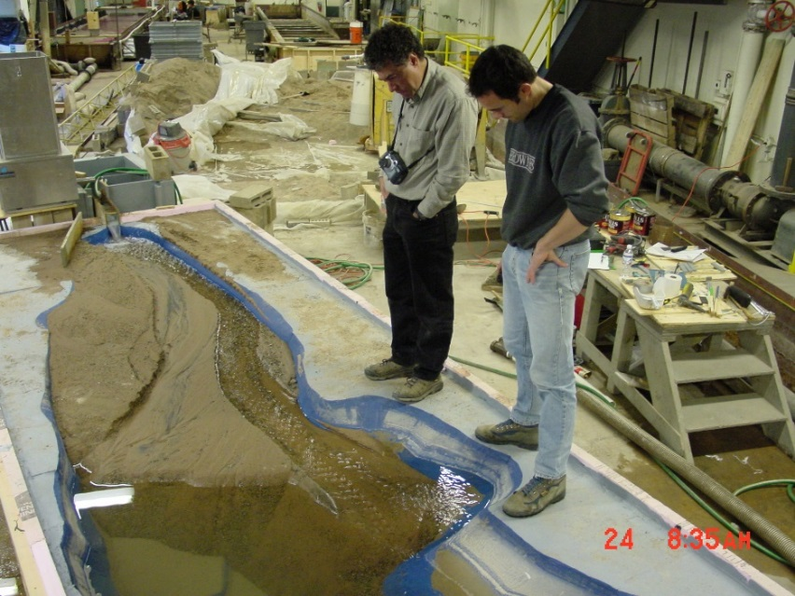
Figure 26. Gordon Grant (left) inspects the physical model constructed by Chris Bromley (right) at the Saint Anthony Falls Laboratory, MN of Lake Mills behind Glines Canyon Dam to investigation reservoir sediment erosion processes.

Field experiments can be quite useful and there are no scaling issues. A field experiment would require the ability to lower the reservoir pool, or open a sluice gate, and a monitoring program to test hypotheses or predictions. The reservoir drawdown or sluice gate opening needs to be enough to create a measurable response, but not so much that environmental effects create significant problems for resources of concern. Support from stakeholders and permitting agencies is also quite helpful and may be necessary.

A reservoir drawdown experiment was conducted at Lake Mills in April 1994 (Figure 27) to investigate delta erosion processes (Childers et al., 2000).

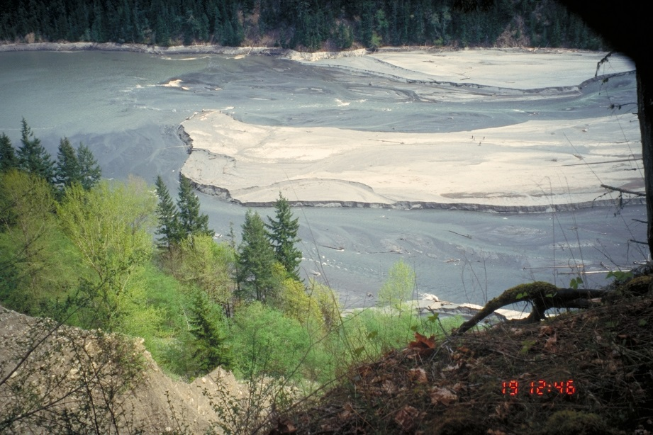
Figure 27. Time lapse photograph of the lower Lake Mills delta during the reservoir drawdown experiment on April 19, 1994.

Numerical models can simulate channel degradation of the exposed reservoir sediments during dam removal and simulate the downstream transport and deposition over time and with distance downstream. Numerical models do not have scaling issues, they do not create environmental impacts, and they can simulate a wide range of scenarios. Numerical models are good at estimating the relative effects of different dam removal and sediment management alternatives, different hydrologic scenarios, and sensitivity analysis. However, numerical models cannot simulate all the complex processes found in nature. Some of the most difficult processes to simulate are channel widening, meander-bend formation, lateral-channel migration, and erosion processes with log jams and scattered wood.

The domain of a numerical models may include the entire reservoir area, the delta extending upstream from the reservoir pool, and the channel downstream from the reservoir. The model should include the entire downstream reach of concern. An appropriate downstream model boundary may include a lake, estuary, major tributary, entrance to a bedrock canyon, or a grade control structure. The numerical model can be used to simulate and track both the bed-material load and the wash load (fine sediment).

Numerical models to simulate sediment transport, erosion, and deposition are often one dimensional, which means that hydraulic and sediment transport variables represent average conditions for each stream cross section and time step. One-dimensional models are powerful tools because they are able to simulate many tens of river miles, over decades of time, and for many alternatives and scenarios. One-dimensional models cannot simulate eddies and most do not attempt to predict the velocity distribution across the channel and, therefore, cannot simulate the distribution of sediment erosion and deposition across the channel for a given time step. The entire wetted cross section is assumed to have either erosion or deposition over a given time step. The models adjust each cross section over time in the vertical direction and some models have the ability to adjust the cross section width. However, most one-dimensional models maintain their initial channel alignment with no ability to simulate meander bend formation or lateral channel migration.

There are some two dimensional hydraulic and sediment transport models that assume depth averaged conditions for each cell of the model mesh. These models do simulate variations in hydraulics and sediment transport both along and across the stream channel and floodplains. Eddies can be simulated as well as erosion in some parts of the channel and deposition in other parts of the channel. Because two-dimensional models are more computationally intensive than one-dimensional models they are typically applied to just miles of river and simulate months of time. The number of alternatives or scenarios may have to be limited.

Some three-dimensional sediment transport models exist, but mostly for research. These models are even more computationally intensive than two-dimensional models and are often applied to less than a mile of river and simulate less than a week of time. The historic trends of increased computational hydraulics capability and computer speed mean that the use of two and three dimensional sediment transport models will be more common in the future.

Many numerical sediment transport models are available. The list of models is too numerous and dynamic to present in this guideline. The choice of the modeler is more important than the choice of the model. The ASCE Sedimentation Engineering manual (Garcia, 2008) provides some important chapters on sediment modeling:
- Chapter 14: “Computational Modeling of Sedimentation Processes” (Thomas and Chang, 2008).
- Chapter 15: “Two- and Three-Dimensional Numerical Simulation of Mobile-Bed Hydrodynamic and Sedimentation” (Spasojevic and Holly, 2008).
- Chapter 23: “Development and Application of Numerical Models of Sediment Transport Associated with Dam Removal” (Cui and Wilcox, 2008).

The ASCE monograph: Sediment Dynamics upon Dam Removal (Papanicolaou and Barkdoll, 2011) also provides chapters specific to modeling sediment:
- Chapter 8: “Modeling and Measuring Bed Adjustments for River Restoration and Dam Removal: A Step toward Habitat Modeling” (Granata et al., 2011).
- Chapter 10: “Guidelines for Numerical Modeling of Dam Removals” (Randle and Bountry, 2011).
- Chapter 11: “Sedimentation Studies for Dam Removal Using HEC-6T” (Thomas, 2011).

Some tips are summarized below for numerical sediment modeling of dam removal:

- For most reservoirs, the predam channel and valley topography are more resistant to erosion than the overlying reservoir sediments. The presence of the reservoir pool and sediments over decades of time would provide additional compaction to the predam alluvial materials. Therefore, specify that the numerical model may only simulate the erosion of reservoir sediments and not the predam topography. This can be accomplished by assuming a non-erodible surface beneath the reservoir sediments. For cases where a new river channel alignment may form over a high predam floodplain or terrace surface, the channel may indeed incise the predam surface to achieve the predam channel slope, but the incision would not be significantly deeper than the predam river channel.

- For one-dimensional model simulations of reservoir sediment erosion, the cross sections must be spaced closely enough to account for the steep channel slopes created by knickpoint or headcut erosion. If measured reservoir cross sections are too widely spaced (more than length equal to one half of a typical river channel width), then interpolate cross sections between the measured cross sections. If a two-dimensional model is used, the model mesh size is typically fine enough to simulate the steeper slopes caused by knickpoint or headcut erosion.

- Sand and gravel that is eroded from the reservoir may deposit along the downstream channel, but these depositing sediments will not generally mix with a much coarser sediments that comprise the streambed downstream from the dam. Numerical sediment transport models will typically assume that depositing sediments do mix with the underlying streambed. However, the numerical mixing of much coarser grain sizes from the stream bed with finer deposits from the reservoir can often result in a mixed grain size that is too coarse for subsequent transport. For example, the numerical mixing of medium sand (0.5 mm diameter) with cobbles (130 mm diameter) will result in a mixed grain size that is much coarser than the depositing sand, under predict the transport capacity, and over predict downstream sediment deposition.

Therefore, do not allow the model to mix depositing reservoir sediment with a much coarser material of the streambed. This can be accomplished by specifying the initial bed material for the downstream channel as a thin layer (0.1 foot or 2 cm) with the same grain size as the reservoir sediment of the sand and gravel size. Do not specify the grain size of the coarse or armored stream bed. The model may simulate deposition on top of the initially thin sediment layer (representing the streambed surface), but specify that the model is not allowed to simulate erosion beyond this thin layer. In reality, the streambed material below the dam may experience some erosion, but for the stream channel downstream from a dam removal, simulation of sediment deposition and subsequent transport is of primary importance. Simulating the erosion of the existing streambed is usually not important.

If the dam removal could result in a rapid reservoir drawdown and potentially case a small flood wave to be released downstream, then a level-pool routing model should be used to predict the rate of reservoir drawdown and the resulting discharge hydrograph. The model can also be used to help design the dimensions for the dam removal or gate openings. The data requirements for a level-pool routing model include a table of reservoir surface area versus elevation, the geometric properties of the dam opening, and the reservoir inflow discharge hydrograph. The reservoir inflow assumption may be a constant or steady value for dam removal during low-flow conditions or a flood hydrograph for dam removal during high-flow conditions. Controlled increments of dam removal were used to drain Lake Aldwell behind Elwha Dam during periods of low flow (Figure 28). A level-pool routing model was used to help design the size of notch openings in the dam.

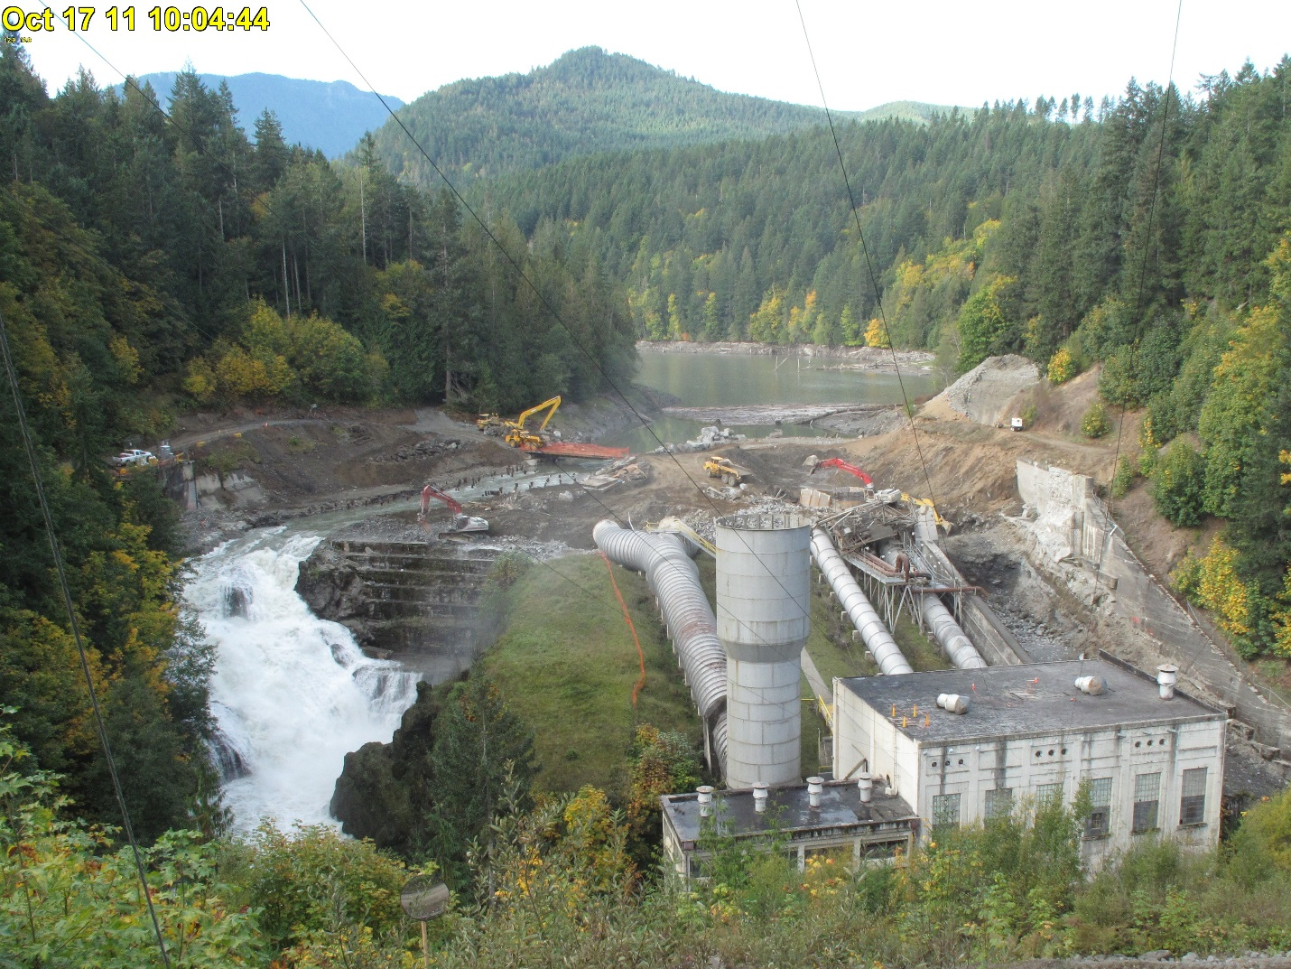
Figure 28. Photograph of Lake Aldwell spilling through an excavated breach in Elwha Dam near Port Angeles, WA on October 17, 2011.

UNCERTAINTY, MONITORING, AND ADAPTIVE MANAGEMENT STEPS

The uncertainty in predicting the sediment effects of dam removal can be significant. The predam reservoir topography, and corresponding sediment volume, may not be well known. Structures (including an older dam) may be buried by the reservoir sediments. The hydrology of reservoir inflows can only be estimated and the actual progress of the dam removal contractor may be different than the planned schedule. However, monitoring of the actual sediment effects can be used to verify predictions. If the sediment effects may begin to create unexpected problems, then adaptive management actions may be taken to reduce those problems.

Step 7: Assess Uncertainty

Estimate the confidence of each data category to assess if the data are adequate for decision making or if additional data collection or analyses are needed to reduce significant data gaps or uncertainty. The data categories where uncertainty may be most significant are listed below:

Reservoir Sediment Volume Uncertainty

The reservoir sediment volume should be known with enough certainty to determine the relative reservoir sediment size (e.g., small, medium, or large). This determination is based on the reservoir sediment volume relative to the average annual sediment load. For example, if the relative sediment volume (V_{R}) were 0.4 ± 0.2, the sediment size will be considered small (0.1 < V_{R} < 1), even with a 50% uncertainty. However, if the relative sediment volume (V_{R}) were 8 ± 4 (50% uncertainty), the sediment size could be considered either medium (1 < V_{R} < 10) or large (10 < V_{R}) and more data may be needed to reduce the uncertainty.

For many small dams, the predam reservoir topography was never measured, so the sediment volume has to be estimated from sediment thickness measurements or assumed predam topography. The uncertainty of the sediment thickness measurements generally increases with the sediment thickness. If a legacy channel still exists through the reservoir sediments, then the sediment is likely not thick and there would be greater confidence in the sediment volume estimate.

Data from thickness probes should be considered to represent the minimum sediment thickness. Vibracoring and drilling can penetrate deeper into the sediment than thickness probes. Attempts should be made to construct the predam reservoir topography from the present reservoir topography and estimates of sediment thickness. The development of the predam topography is a good way to test the reasonableness of the sediment thickness estimates. Estimation of the predam, longitudinal-channel profile through the reservoir, based on the upstream and downstream channel profiles, is useful for comparison with the constructed predam reservoir topography. If the constructed predam topography appears to be reasonable and is consistent with the estimated profile through the reservoir, then there would be some confidence with the sediment volume estimate.

For reservoirs where the predam topography was measured, then the uncertainty of the reservoir sediment volume primarily depends on how well the datums are known for the predam and present surveys. Widely spaced contours of a predam map will lead to more uncertainty than more tightly spaced contours.

Sediment Grain Size Distribution Uncertainty

The sediment grain size distribution should be known with enough certainty to estimate the portions of fine and coarse reservoir sediment, estimate the medium grain size of the coarse sediment, and the availability of armor size sediments. In addition, knowing the proportion of clay in the fine sediment will be needed to help characterize the cohesive properties of the fine sediment. The uncertainty of the grain size distribution tends to decrease with the collection of more sediment samples, both spatially and with depth.

Contaminant Uncertainty

The absence or presence of contaminants, in harmful concentrations, needs to be known with enough certainty to determine if reservoir sediments need to be removed or stabilized in place, or to predict their effects if released downstream. The uncertainty of contaminants tends to decrease with the collection of more sediment samples (spatially throughout the reservoir area and with depth) and with the number of constituents being tested from each sample.

Stream Flow Hydrograph Uncertainty

The evaluation of the sediment effects, associated with dam removal, will need to consider a range of stream flows to understand sensitivity and reduce uncertainty. The hydrology of streams with long-term measurement records (stream gage) will be much better understood than streams without gage records. Stream gage records near the dam will provide more certainty than gages farther away.

The uncertainty related to stream flows will increase with flow variability. Streams with flash floods will have more hydrologic uncertainty and streams dominated by groundwater or snowmelt. Stream flow regulated by upstream dams will have more certainty and wild rivers without regulation.

Sediment Transport and Deposition Uncertainty

Sediment transport rates and deposition thickness are most sensitive to the longitudinal channel slope, sediment grain size, and the stream flow hydrographs. Estimates of sediment transport and deposition need to have enough certainty to estimate where sediment deposition is most likely to occur and if the sediment deposition will be significant for a given dam removal scenario. Significant sediment deposition could lead to stream bank erosion, channel widening, lateral migration, and increased flood stage. Uncertainty can be reduced by employing and comparing numerical modeling, physical modeling, and field experiments.

Step 8: Determine If Sediment Impacts are Tolerable

Compile the predicted sediment effects from step 6 and assess the impacts to resources of concern including aquatic organisms and habitat, property, water quality, infrastructure, diversion water needs, etc. If sediment impacts could be tolerated, then proceed with dam removal planning. If the predicted sediment impacts could not be tolerated, then develop alternative dam removal or sediment management plans, or mitigation options to reduce impacts to tolerable levels, or leave all or a portion of the dam in place. Some management alternatives are listed below:
- Determine if more data collection or analysis are needed to increase the certainty of predictions or evaluate new alternatives.
- Slow the rate of dam removal to slow the erosion and downstream release of reservoir sediment.
- Construct new water treatment plants, improve existing water treatment plant capabilities, construct or improve levees and dikes, and prepare for stream bank stabilization to mitigate sediment effects.
- Reduce the amount of reservoir sediment that is allowed to erode from the reservoir by use of the following methods:
  - Sediment removal prior to dam removal
  - Sediment stabilization within the reservoir prior to dam removal
  - Leave a portion of the dam in place

Step 9: Develop Monitoring and Adaptive Management Plan

Additional information on developing a monitoring plan is provided in Appendix D.

- Establish predictions of sediment erosion and transport rates and volumes
- Develop a monitoring plan to determine if predictions are correct. If not, determine how the monitoring results differ from prediction effects in terms of location, timing, duration, and magnitude.
- Consider a tiered monitoring plan (e.g., monitoring of reservoir sediment erosion can be used to trigger downstream monitoring)
- Monitoring results can be used to approve increments of removal
- Monitoring results can be used to anticipate water quality effects from subsequent increments of dam removal
- Monitoring results can be used to anticipate bank erosion or flooding problems
- Monitoring results need to be real-time to provide feedback for adaptive management decisions.

Potential data collection:
  - Time-lapse photography
  - Stage recorders to evaluate stage-discharge relationships to detect signs of aggradation
  - Repeat reservoir surveys
  - Repeat river channel surveys
  - Repeat sediment bed-material size gradation measurements
  - Suspended sediment and bedload measurements
  - Turbidity measurements
  - Repeat aerial photography
  - Bank erosion monitoring
  - Sediment wave tracking (location and speed)
  - Bulk density

SUMMARY

While the great majority of dams still provide a vital function to society, some of these dams may need to be removed for various reasons such as economics, dam safety and security, legal and financial liability, ecosystem restoration (including fish passage improvement), site restoration, and recreation use.

The sediment effects related to dam removal may be significant if any of the following conditions apply:

- The reservoir storage, below the normal operating pool, is at least 1 percent of the average annual inflow.
- The reservoir sediment volume is equivalent to a multi-year sediment supply from the upstream river channel, or several years would be required to transport the reservoir sediment volume through the downstream river channel.

- The reservoir sediments are contaminated at concentrations significantly above background levels.

Portions of the dam can be left in place for historic preservation, to reduce dam removal costs, and to help stabilize reservoir sediments. The rate of reservoir sediment erosion and release to the downstream river channel is primarily controlled by the rate of dam removal and reservoir drawdown and by the upstream hydrology. Although headcuts may erode the reservoir sediments during periods of low flow, sufficient flow is necessary to provide transport capacity of reservoir sediments. The rate of reservoir drawdown needs to be slow enough to avoid a flood wave of reservoir water spilling into the downstream river channel. Also, the rate needs to be slow enough to avoid inducing any potential landslides along the reservoir margins or a slide failure of any earthen dams. The ability to draw down the reservoir pool depends on how flows can be released through, over, or around the dam. If the dam has a low-level, high-capacity outlet works or diversion tunnel, then the reservoir could be emptied at a prescribed rate and the dam could be removed under dry conditions. Otherwise, a diversion channel may have to be constructed around the dam or an outlet may have to be constructed through the dam.

The basic types of sediment management alternatives associated with dam removal include no action, river erosion, mechanical removal, and stabilization. River erosion is typically the least expensive and most commonly employed alternative. However, mechanical removal or stabilization may be required if the reservoir sediments are contaminated. If the reservoir is many times wider than the upstream river channel, then a significant portion of the reservoir sediments will remain stable in the reservoir over the long term, even without stabilization techniques.

The rate and extent of reservoir sediment erosion, and the possible redistribution and storage within the reservoir, need to be predicted before sediment transport can be predicted through the downstream river channel. The primary predictive tools include both numerical and physical modes. Physical models can provide accurate predictions if the model scales are properly selected and they can be used to calibrate numerical models. The numerical models tend to be more easily adaptable to simulate multiple management or hydrology scenarios. Most numerical sediment transport models are one dimensional and can simulate river conditions over many miles and over a time period of many decades. Two-dimensional models are also available, but their focus is normally limited to relatively short river lengths over periods of days or maybe weeks. A thorough understanding of the numerical model equations and limitations is necessary for proper application of the model to a dam removal problem. In addition, thorough understanding of the geomorphic, hydraulic, and sediment transport processes of the river is necessary for proper model application and interpretation of the results.

REFERENCES

American Rivers. 2015. Electronic information accessed at AmericanRivers.org, September 2015.

American Society of Civil Engineers (1997). “Guidelines for Retirement of Dams and Hydroelectric Facilities,” New York, 222 p.

Aspen Institute (2002). Dam Removal, A New Option for a New Century, Aspen Institute Program on Energy, the Environment, and the Economy, Queenstown, Maryland, 66 p.
Aspen Institute. 2002. Dam Removal: A New Option for a New Century. 81 pp.

ASCE/EWRI Task Committee on Sediment Dynamics Post Dam Removal (2011). Monograph on Sediment Dynamics upon Dam Removal, edited by Thanos Papanicolaou and Brian D. Barkdoll, 175 p.

Babbit, B. 2002. What Goes Up, May Come Down. Bio-Science 52:656–658.

Bellmore J. Ryan, Duda Jeffrey J., Craig Laura S., Greene Samantha L., Torgersen Christian E., Collins Mathias J., Vittum Katherine. Status and trends of dam removal research in the United States. WIREs Water 2016. doi: 10.1002/wat2.1164.

Bernhardt, E.S, E.B. Sudduth, M.A. Palmer, J.D. Allan, J.L. Meyer, G. Alexander, J. Follastad-Shah, B. Hassett, R. Jenkinson, R. Lave, J. Rumps, L. Pagano (2007), Restoring rivers one reach at a time: results from a survey of U.S. river restoration practitioners. Restoration Ecology 15(3): 482–493.

Biedenharn, D.S., Watson, C.C., and Thorne, C.R. (2008). “Fundamentals of Fluvial Geomorphology,” in ASCE Manuals and Reports on Engineering Practice No. 110, Sedimentation Engineering, Processes, measurements, Modeling, and Practice, García, M.H. editor, American Society of Civil Engineers, Reston, VA, Chapter 6, pp 355 to 386.

Billington, D.P., Jackson, D.C., and M.V. Melosi (2005). The History of Large Federal Dams: Planning, Design, and Construction, prepared by U.S. Bureau of Reclamation, US Army Corps of Engineers, and the U.S. National Park Service.

Bromley, C., Randle, T.J., Grant, G., Thorne C. (2011). “Physical Modeling of the Removal of Glines Canyon Dam and Lake Mills from the Elwha River, Washington,” in Sediment Dynamics upon Dam Removal. American Society of Civil Engineers, Task Committee on Sediment Dynamics Post-Dam Removal of the Environmental and Water Resources Institute, Edited by Athanasios (Thanos) N. Papanicolaou and Brian D. Barkdoll, Chapter 7, pp. 97-114.

Brunner, G.W. (2016a). HEC-RAS River Analysis System Hydraulic Reference Manual, Version 5.0, US Army Corps of Engineers, Institute for Water Resources, Hydrologic Engineering Center (HEC), Davis, CA.

Brunner, G.W. (2016b). HEC-RAS River Analysis System Hydraulic User’s Manual, Version 5.0, US Army Corps of Engineers, Institute for Water Resources, Hydrologic Engineering Center (HEC), Davis, CA.

Bureau of Reclamation (Reclamation), 2006. Erosion and Sedimentation Manual.

Burroughs, B.A., D.B. Hayes, K.D. Klomp, J.H. Hansen, and J. Mistak, (2009), Effects of Stronach Dam removal on fluvial geomorphology in the Pine River, Michigan, United States. Geomorphology 110:96-107, doi: 10.1016/j.geomorph.2009.03.019.

Cannatelli, K. M., and J. C. Curran. 2012. Importance of hydrology on channel evolution following dam removal: case study and conceptual model. Journal of Hydraulic Engineering 138:377–390.

Cheng, F. and T. Granata, (2007), Sediment transport and channel adjustments associated with dam removal: field observations. Water Resources Research 43:W03444.

Childers, D., Kresch, D.L., Gustafson, S.A., Randle, T.J., Melena, J.T., Cluer, B. (2000). Hydrologic Data Collected During the 1994 Lake Mills Drawdown Experiment, Elwha River, Washington. USGS Water-Resources Investigations Report: 99-4215.

City of Loveland. 2010. Descriptions of FERC Project No. 2829, Idylwilde Hydroelectric Project, City of Loveland, CO, Licensee.

Collins, M., K. Lucey, B. Lambert, J. Kachmar, J. Turek, E. Hutchins, T. Purinton, and D. Neils. 2007. Stream Barrier Removal Monitoring Guide. Gulf of Maine Council on the Marine Environment,www.gulfofmaine.org/streambarrierremoval.

Conyngham, J., 2009. Data needs and case study assessment for dam fate determination and removal projects. EMRRP Technical Notes Collection. ERDC TN-EMRRP-SR-66. Vicksburg, MS: U.S. Army Engineer Research and Development Center, http://el.erdc.usace.army.mil/emrrp/techtran.html
Conyngham, J., and C. Wallen. (2009). "DAM_Explorer: A modeling framework for assessing the physical response of streams to dam removal," EMRRP-SR-65, U.S. Army Engineer Research and Development Center, Vicksburg, MS, http://el.erdc.usace.army.mil/emrrp/techtran.html.
Conyngham, J., Fischenich, J.C. and K.D. White. (2006). "Ecological and engineering aspects of dam removal - An overview.," EMRRP-SR-80, U.S. Army Engineer Research and Development Center, Vicksburg, MS.
Cui, Y. and Wilcox, A. (2008). “Development and Application of Numerical Models of Sediment Transport Associated with Dam Removal,” in ASCE Manuals and Reports on Engineering Practice No. 110, Sedimentation Engineering, Processes, measurements, Modeling, and Practice, García, M.H. editor, American Society of Civil Engineers, Reston, VA, Chapter 23, pp 995 to 1020.

Cui, Y., Booth, D.B., Monschke, J., Gentzler,S., Roadifer, J., Greimann, B., and Cluer, B. (2016): Analyses of the erosion of fine sediment deposit for a large dam-removal project: an empirical approach, International Journal of River Basin Management, DOI: 10.1080/15715124.2016.1247362

De Graff, J.V. and J.E. Evans. 2013. The Challenges of Dam Removal and River Restoration, The Geological Society of America, Reviews in Engineering Geology Volume XXI.

Downs, P.W., Y. Cui, J.K.Wooster, S.R. Dusterhoff, D.B. Booth, W.E. Dietrich, and L.S. Sklar (2009), Managing reservoir sediment release in dam removal projects: An approach informed by physical and numerical modelling of non-cohesive sediment, Intl. J. River Basin Management, 7(4), 433–452, doi: 10.1080/15715124.2009.9635401

Doyle, M.W., E. Stanley, and J. Harbor. 2002. Geomorphic Analogies for Assessing Probable Channel Response to Dam Removal. J. American Water Resources Association 38:1567-1579. Plus the discussion letter and rebuttal, in 39:1309-1312 (2003).

Doyle, M.W., E.H. Stanley, J.M. Harbor, and G.S. Grant (2003a), Dam removal in the United States: Emerging needs for science and policy, Eos Trans. AGU, 84(4), 29–36, doi:10.1029/2003EO040001.

Doyle, M.W., E.H. Stanley, and J.M. Harbor (2003b), Channel adjustments following two dam removals in Wisconsin, Water Resour. Res., 39(1), 1011, doi:10.1029/2002WR001714.

Garcia, M.H. (2007). Sedimentation Engineering, Processes, Measurements, Modeling, and Practice, ASCE Manuals and Reports on Engineering Practice No. 110, American Society of Civil Engineers, pages 24-29.

Granata, T., Cheng, F., Zika, U., Gillenwater, D., and Tomsic, C. (2011). “Modeling and Measuring Bed Adjustments for River Restoration and Dam Removal: A Step toward Habitat Modeling,” in Sediment Dynamics upon Dam Removal. American Society of Civil Engineers, Task Committee on Sediment Dynamics Post-Dam Removal of the Environmental and Water Resources Institute, Edited by Athanasios (Thanos) N. Papanicolaou and Brian D. Barkdoll, Chapter 8, 115-131.

Greimann, B., Randle, T. and Huang, J. (2006). "Movement of Finite Amplitude Sediment Accumulations," J. Hydraulic Engineering, ASCE, Vol. 132, No. 7, 731-736.

Greimann, B. (2011). “Movement of Sediment Accumulations,” in Sediment Dynamics upon Dam Removal. American Society of Civil Engineers, Task Committee on Sediment Dynamics Post-Dam Removal of the Environmental and Water Resources Institute, Edited by Athanasios (Thanos) N. Papanicolaou and Brian D. Barkdoll, Chapter 9, 133-140.

Harrelson, C., C. Rawlins, and J. Potyondy. 1994. Stream Channel Reference Sites: An Illustrated Guide to Field Technique. Gen. Tech. Rep. RM-245. Fort Collins, CO: U.S. Department of Agriculture, Forest Service, Rocky Mountain Forest and Range Experiment Station. 61 p. ww.stream.fs.fed.us/publications/PDFs/RM245E.PDF

Hart, D.D., T.E. Johnson, K.L. Bushaw-Newton, R.J. Horwitz, D.F. Bednarek, D.A. Kreeger, and D.J. Velinsky (2002), Dam removal: Challenges and opportunities for ecological research and river restoration, BioScience, 52(8), 669–681, doi:10.1641/0006-3568(2002)052[0669:DRCAOF]2.0.CO;2.

Hay, D.H. 2008. Small Dam Removal in Oregon – A guide for Project Managers, Oregon Watershed Enhancement Board.

Huang, J.V. and Bountry, J. (2009). SRH-Capacity User Manual, Version 1.37. Bureau of Reclamation, Technical Service Center, Sedimentation and River Hydraulics Group, Denver, CO.

H. John Heinz III Center for Science, Economics, and the Environment. 2002. Dam Removal Science and Decision Making, Washington D.C., 221 pages.

H. John Heinz III Center for Science, Economics, and the Environment. 2003. Dam Removal Research Status and Prospects.

Kibler, K.M., D.D. Tullos, and G.M. Kondolf, (2010), Learning from dam removal monitoring: challenges to selecting experimental design and establishing significance of outcomes, River Research and Applications, doi: 10.1002/rra.1415.

Kibler, K., D. Tullos, and M. Kondolf, (2011), Evolving expectations of dam removal outcomes: downstream geomorphic effects following removal of a small, gravel-filled dam. Journal of the American Water Resources Association (JAWRA) 1-16. DOI: 10.1111/j.1752-1688.2011.00523.x

Kondolf, G.M., and H. Piégay, eds. (2003), Tools in fluvial geomorphology. John Wiley & Sons, Chichester.

Lorang, M., and G. Aggett. 2005. Potential Sedimentation Impacts Related to Dam Removal: Icicle Creek, Washington, U.S.A. Geomorphology 71:182-201.

Major, J.J., J.E. O’Connor, G.E. Grant, K.R. Spicer, H.M. Bragg, A. Rhode, D.Q. Tanner, C.W. Anderson, and J.R. Wallick (2008), Initial fluvial response to removal of Oregon’s Marmot Dam, Eos Trans. AGU,89(27), 241–242, doi:10.1029/2008EO270001.

Major, J.J., J.E. O’Connor, C.J. Podolak, K. Keith, K.R. Spicer, J.R. Wallick, H.M. Bragg, S. Pittman, P.R. Wilcock, A. Rhode, and G.E. Grant (2010). “Evolving fluvial response of the Sandy River, Oregon, following removal of Marmot Dam,” 2nd Joint Federal Interagency Conference, Las Vegas, NV.

Major, J.J., A.E. East, J.E. O’Connor, G.E. Grant, A.C. Wilcox, C.S. Magirl, M.A. Collins, and D.D. Tullos, 2016. Geomorphic Responses to U.S. Dam Removal—A Two-Decade Perspective. In: D. Tsutsumi and J. Laronne (Editors). Gravel-Bed Rivers and Disasters, Wiley and Sons, pp.

Massachusetts Department of Environmental Protection. December 2007. Dam Removal and the Wetland Regulations.

Michigan Department of Natural Resources, April 2004, Dam Removal Guidelines for Owners, Michigan Department of Environmental Quality.

Morris, G.L. and J. Fan (1997). Reservoir Sedimentation Handbook, Design and Management of Dams, Reservoirs, and Watersheds for Sustainable Use, McGraw-Hill, New York.

National Oceanic and Atmospheric Administration (NOAA, 2010), Patapsco River Restoration Adaptive Management Plan.

New Hampshire Department of Environmental Services. Revised 2007. Guidelines to the Regulatory Requirements for Dam Removal Projects in New Hampshire. Water Division - Dam Bureau River Restoration Program.

Pearson, A.J., N.P. Snyder, and M.J. Collins (2011), Rates and processes of channel response to dam removal with a sand-filled impoundment, Water Resour. Res., 47, W08504, doi:10.1029/2010WR009733.

Randle, T.J. and Dario, J. (2003). Sediment and Geomorphic Assessment for the Potential Removal of Chiloquin Dam, U.S. Department of the Interior Bureau of Reclamation, Technical Service Center, Denver, Colorado.

Randle, T. and Bountry, J. (2011). “Guidelines for Numerical Modeling of Dam Removals,” in Sediment Dynamics upon Dam Removal. American Society of Civil Engineers, Task Committee on Sediment Dynamics Post-Dam Removal of the Environmental and Water Resources Institute, Edited by Athanasios (Thanos) N. Papanicolaou and Brian D. Barkdoll, Chapter 10, pp. 141-155.

Randle, T.J., Bountry, J.A., Ritchie, A., and Wille, K. (2015). Large-scale dam removal on the Elwha River, Washington, USA: Erosion of reservoir sediment, Geomorphology, http://dx.doi.org/10.1016/j.geomorph.2014.12.045

Roni, P., M.C. Liermann, C. Jordan, E.A. Steel (2005), Steps for designing a monitoring and evaluation program for aquatic restoration. In Monitoring Stream and Watershed Restoration, Roni P (ed.). American Fisheries Society: Bethesda.

Sawaske, S.R. and D.L. Freyberg, 2012. A Comparison of Past Small Dam Removals in Highly Sediment-Impacted Systems in the U.S. Geomorphology 151:50-58.

Schumm, S.A. and Harvey, M.D. (2008). “Engineering Geomorphology,” in ASCE Manuals and Reports on Engineering Practice No. 110, Sedimentation Engineering, Processes, measurements, Modeling, and Practice, García, M.H. editor, American Society of Civil Engineers, Reston, VA, Chapter 18, pp 859 to 884.

Skalak, K., Pizzuto, J., Egan, J., Allmendinger, N. (2011). “The Geomorphic Effects of Existing Dams and Historic Dam Removals in the U.S. Mid-Altantic Region,” in Sediment Dynamics upon Dam Removal. American Society of Civil Engineers, Task Committee on Sediment Dynamics Post-Dam Removal of the Environmental and Water Resources Institute, Edited by Athanasios (Thanos) N. Papanicolaou and Brian D. Barkdoll, Chapter 6, pp. 83-96.

Spasojevic, M. and Holly, F.M. (2008). “Two- and Three-Dimensional Numerical Simulation of Mobile-Bed Hydrodynamic and Sedimentation,” in ASCE Manuals and Reports on Engineering Practice No. 110, Sedimentation Engineering, Processes, measurements, Modeling, and Practice, García, M.H. editor, American Society of Civil Engineers, Reston, VA, Chapter 15, pp 683 to 762.

Texas Commission on Environmental Quality September 2006, Dam Removal Guidelines, Dam Safety Program, Document GI-358.

Thomas, W.A. and Chang, H. (2008). “Computational Modeling of Sedimentation Processes,” in ASCE Manuals and Reports on Engineering Practice No. 110, Sedimentation Engineering, Processes, measurements, Modeling, and Practice, García, M.H. editor, American Society of Civil Engineers, Reston, VA, Chapter 14, pp 649 to 682.

Thomas, W. (2011). “Sedimentation Studies for Dam Removal Using HEC-6T,” in Sediment Dynamics upon Dam Removal. American Society of Civil Engineers, Task Committee on Sediment Dynamics Post-Dam Removal of the Environmental and Water Resources Institute, Edited by Athanasios (Thanos) N. Papanicolaou and Brian D. Barkdoll, Chapter 11, 157-171.

Tuckerman, S, and B. Zawiski. 2007. Case Studies of Dam Removal and TMDLs: Process and Results. J. Great Lakes Research 33(Special Issue 2):103-116.

Tullos, D., Collins, M., Bellmore, J., Bountry, J., Connolly, P., Shafroth, P., and Wilcox, A. 2016, Common management concerns associated with dam removal, Journal of the American Water Resources Association, September 2016.

Tullos, Desiree D., Mathias J. Collins, J. Ryan Bellmore, Jennifer A. Bountry, Patrick J. Connolly, Patrick B. Shafroth, and Andrew C. Wilcox (2016). Synthesis of Common Management Concerns Associated with Dam Removal. Journal of the American Water Resources Association (JAWRA) 1-28. DOI: 10.1111/1752-1688.12450

U.S. Society on Dams. July 2015. Guidelines for Dam Decommissioning Projects, Prepared by the USSD Committee on Dam Decommissioning, available at http://ussdams.org/reports.html#whitepapers

Warrick, J.A.; Bountry, J.; East, A.E.; Magirl, C.S.; Randle, T.J.; Gelfenbaum, G.; Ritchie, A.C.; Pess, G.R.; Leung, V.; Duda, J.J. 2015. Large-scale dam removal on the Elwha River, Washington, USA: Source-to-sink sediment budget and synthesis, Journal of Geomorphology, Volume 246, 1 October 2015, Pages 729-750.

Wildman, L. and MacBroom, J. (2010). “A Broad Level Classification System for Dam Removals,” 2nd Joint Federal Interagency Conference, Las Vegas, NV, June 27 - July 1, 2010.

Williams, B. K., R. C. Szaro, and C. D. Shapiro. (2007). “Adaptive Management: The U.S. Department of the Interior Technical Guide,” Adaptive Management Working Group, U.S. Department of the Interior, Washington, DC.

Wohl, E., and D. Cenderelli. 2000. Sediment Deposition and Transport Patterns Following a Reservoir Sediment Release. Water Resources Research 36:319-333

Appendix A: Tips on Collecting a Representative Set of Sediment Samples for Potential Contaminant Analysis

Characterizing the composition and possible contamination of reservoir sediments can be a great challenge. Reservoir sediments are generally not visible (unless the reservoir is first dewatered) and so they must be assessed and sampled remotely. Particle sizes and contaminant distributions can be fairly heterogeneous. The history of land use, contaminant discharges, and dam operation all influence the magnitude and extent of sediment contamination, but are not always known. Steps to improve the representativeness; that is, how well the collected samples represent the true magnitude and extent of contaminant distribution; of a sediment quality survey are described below.

It is strongly recommended that a qualitative “probing” reconnaissance survey be conducted prior to designing a quantitative survey and collecting sediment samples. If water levels are shallow enough to wade or work from a small boat, a long piece of rebar, a soil auger, or a chimney sweep rod can be used to both measure the depth of the unconsolidated sediments and qualitatively assess their grain size (clay, silt, sand, and gravel/cobble “feel” differently when probed). If the reservoir is deeper (> 10 feet), a grab sampler or coring device can be used to collect samples for visual assessment. Simultaneous collection of geographic coordinates allows the creation of a map of sediment type.

To design a more quantitative sediment sampling survey that is representative of in situ conditions, the following three factors must be considered:

- How samples will be collected
- How many samples will be collected
- Where samples will be collected

MacDonald and Ingersoll (2002) provide a good introduction to these topics, and a brief summary of these three factors is provided below.

The two principal types of sediment samplers are grab samplers and core samplers. The local regulatory agency may require one or the other, or both, depending on site conditions such as the depth of unconsolidated sediments behind the dam. Core samplers are most commonly employed in reservoirs. Both samplers work best (i.e. penetrate deepest) in silty sediment, usually work well in unconsolidated sand, and do not efficiently sample dense clay or gravel/cobble. Grab samplers (e.g., Ponar or Ekman samplers) collect the surficial 6-8 inches (maximum) of unconsolidated sediment. Core samplers collect 2 to 4 inch diameter cores up to 15 feet long, depending on the coring device used and the compaction of the sediments. There are several types of sediment core samplers, and those most commonly used in reservoirs are hand cores, gravity cores, and vibrocores. Maximum core lengths collected by these three samplers are typically four feet, four feet, and 15 feet, respectively.

The number of samples to collect is often prescribed by the local regulatory agency. This document recommends:

- Performing a screening level survey of 3 or 4 cores if the reservoir sediment is less than 10,000 cubic yards (Step 2.f.3), unless local regulations require a different number.
- Performing a definitive survey of 1 core per 1,000 cubic yards if the reservoir sediment is less than 10,000 cubic yards (Step 2.f.4), unless local regulations say otherwise.

In many instances, best professional judgment (BPJ) also plays a role in deciding how many samples to collect. Factors to consider when exercising BPJ include expected sediment deposition patterns (which will be known if a probing survey has been performed), expected contaminant spatial heterogeneity (considering location of contaminant sources, location of fine-grained sediment deposits, prior sediment removals or reservoir flushing, the physiochemical properties of the contaminant(s) of interest, etc.), and the possible fate of the sediment (left in-place, removed, or allowed to transport downstream).

A more quantitative approach to deciding how many cores to collect is to use geostatistical calculations to estimate the number of samples needed to detect a contaminant ‘hot spot’ of a certain size with a known certainty. A useful, and free, geostatistical program is Elipgrid, which is included in the U.S. Department of Energy’s Visual Sampling Plan software package, available at:

http://vsp.pnl.gov/

An example of the results of the Elipgrid calculations is given in the box below. As expected, detecting small contaminant hot spots with high confidence can require a very large number of samples; hence, the popularity of BPJ.

Scenario  - Canals on Lake St. Clair, MI  - Surface area = 21,700 m²  (~ 6 football fields)  - Assume a square grid, and desire 95% confidence of detecting a circular hot spot  - Calculate how many samples for different hot spot sizes | Hot Spot Radius (m)  1  5  10  15  20 | Required # of Samples  7,787  312  78  35  20

The results of the probing survey will greatly assist in deciding where to collect sediment samples; generally preference is given to fine-grained, highly organic silty sediments. The four most commonly used sampling strategies in sediment quality studies are:

- Simple random sampling
- Systematic grid sampling
- Subjective sampling (where known or suspected contaminant sources influence the selection of sampling points)
- Stratified random sampling

Gilbert (1987) gives an excellent discussion of these and other sample collection strategies.

While all four strategies can be useful in sediment quality studies (box, below), stratified random sampling is often recommended because sediments in reservoirs often exhibit distinct “strata”; e.g., fine-grained organic sediments near the dam and along the edges of the reservoir, and coarser sediment in the upstream end of the reservoir.

Known or Suspected Contaminant Distribution | Recommended Strategy
Random and uniform | Random sampling
Known strata | Stratified random sampling
Known hot spots | Subjective sampling
Linear trends, or mapping of data important to project | Systematic grid sampling

In addition to sampling sediments within the reservoir, it is often desirable (and sometimes required) to also collect a few samples from upstream and/or downstream of the reservoir. These samples provide a “local background” against which to compare the reservoir samples, with the rationale that contaminated reservoir sediment may be less of a concern if adjacent stream reaches are similarly contaminated

References

Gilbert, R.O. 1987. Statistical Methods for Environmental Pollution Monitoring. Van Nostrand Reinhold, New York, NY. 320 pp.

MacDonald D.D., and C.G. Ingersoll. 2002. A Guidance Manual to Support the Assessment of Contaminated Sediments in Freshwater Ecosystems. Volume II: Design and Implementation of Sediment Quality Investigations, (PDF) EPA-905-B02-001-B, USEPA Great Lakes National Program Office, Chicago, IL. 136 pp.

Appendix B: Sediment Transport Capacity Computations
Tim Randle and Blair Greimann

Note what step this supports

Sediment transport capacity needs to be computed to determine the significance of the coarse sediment mass contained within the reservoir. In these guidelines, the significance of the coarse reservoir sediment mass is defined as negligible, small, medium, or large and the classification is based on the sediment transport capacity at discharges of a certain frequency.

Sediment transport capacity needs to be computed for the downstream channel to evaluate the potential to move the coarse reservoir sediment downstream from the reservoir. The following data are required for the sediment transport computations:

- Streamflow discharge
- Channel hydraulic data
- Coarse reservoir sediment unit weight and particle size gradation
- Selection of a predictive sediment transport equation

Streamflow discharge

If available, streamflow data from a stream gage in the downstream channel reach is the best source of discharge data. If streamflow gage data are not available, then discharge for the downstream channel reach will have to be estimated from a stream gage in the watershed or from a gage in a nearby watershed with similar characteristics.
Where,
Q_{d} = discharge at dam site,
Q_{g} = discharge at stream gage,
A_{d} = drainage area above dam site,
A_{d} = drainage area above stream gage, and
p = exponent power, typically 0.5

Another option is to estimate discharge from a regional regressions. Regional regressionsfor the United States can be found at the following USGS website: http://water.usgs.gov/osw/programs/nss/summary.html

The regional regressions also may provide guidance on the appropriate exponent (p) to use for extrapolating discharge from a nearby stream gage. The regional regressions also include effects of elevation and average annual precipitation.

Channel hydraulic data

Channel hydraulic data are needed to represent the hydraulic capacity of the downstream channel to transport sediment. The required hydraulic data are listed below:
- Cross-sectional channel shape from which to compute the following variables as a function of the water depth, y:
  - Cross-sectional area (A),
  - Wetted channel width (T),
  - Wetted perimeter (P), and
  - Hydraulic radius (R = A/P)
- Channel roughness (Manning’s n coefficient)
- Longitudinal energy slope (S_{e}) for the cross section of interest

The best source of hydraulic data are from a one-dimensional hydraulic model that is based on measured channel cross sections and calibrated to measured water surface elevations. At least one cross section must be chosen from the hydraulic model to represent the downstream channel. Selection of a typical river cross section that represents average friction slope and transport capacity is recommended. Selection of a riffle cross section is not recommended in pool-riffle river systems because it is likely to over-estimate the typical sediment transport capacity. Conversely, the same recommendation is true for a section with backwater or eddies present or locations with localized influences near bridges or other man-made in-stream structures.

If a one-dimensional model is not available, then Manning’s equation can be used to compute normal depth at a measured cross section. As a minimum, the channel width and maximum depth should be measured and channel geometry assumed (e.g. rectangular, trapezoidal, and triangular).

where
c = 1.486 for English units and 1.0 for S.I. units and
S_{o} = average longitudinal bottom slope of the channel.

For normal depth, the average bottom slope is assumed to be equal to average friction slope, S_{f}. By iteration, Manning’s equation can be used to compute the cross-section flow depth for a given discharge, longitudinal slope, and channel roughness.

Coarse reservoir sediment unit weight and particle size gradation

The coarse sediment mass is computed by multiplying the sediment volume by the unit weight (dry weight or mass per unit volume). The best source for obtaining the unit weight of reservoir sediment is by direct field measurement (ASTM D4823 - 95(2008) Standard Guide for Core Sampling Submerged, Unconsolidated Sediments, http://www.astm.org/Standards/D4823.htm). As an alternative, the unit weight can be assumed. Morris and Fan (1998) reported unit weights for various sizes of reservoir sediments for cases where the sediment is always submerged and the sediment exposed above the water (Table 4).

Table 7. Reservoir sediment unit weights reported by Morris and Fan (1988).
Dominant grain size | Always submerged | Exposed above water
Clay | 40 to 60 lbs/ft³ | 60 to 80 lbs/ft³
Silt | 55 to 75 lbs/ft³ | 75 to 85 lbs/ft³
Clay-silt mixture | 40 to 65 lbs/ft³ | 65 to 85 lbs/ft³
Sand-silt mixture | 75 to 95 lbs/ft³ | 95 to 110 lbs/ft³
Clay-silt-sand mixture | 50 to 80 lbs/ft³ | 80 to 100 lbs/ft³
Sand | 85 to 100 lbs/ft³ | 85 to 100 lbs/ft³
Gravel | 85 to 125 lbs/ft³ | 85 to 125 lbs/ft³
Sand-gravel mixture | 95 to 130 lbs/ft³ | 95 to 130 lbs/ft³

Laura and Pemberton (1982) and Bureau of Reclamation (2006) reported initial unit weights for clay, silt, and sand-sized reservoir sediment under different reservoir conditions (Table 5). The unit weights of clay and silt would be expected to increase over time as the sediments compact. Clay would be expected to compact the most. For older reservoirs, the unit weights for river conditions can be assumed.

Table 8. Initial unit weights of reservoir sediment reported by Lara and Pemberton (1982).
Reservoir Condition | Clay | Silt | Sand
Reservoir always full | 26 lbs/ft³ | 70 lbs/ft³ | 97 lbs/ft³
Reservoir periodically drawn down | 35 lbs/ft³ | 71 lbs/ft³ | 97 lbs/ft³
Reservoir normally empty | 40 lbs/ft³ | 72 lbs/ft³ | 97 lbs/ft³
River conditions | 60 lbs/ft³ | 73 lbs/ft³ | 97 lbs/ft³

The bed-material size gradation of the downstream channel is often coarser than the coarse reservoir sediment. When a thin layer of reservoir sediment is assumed to cover the downstream channel, the capacity to transport the reservoir sediment through the downstream channel can be computed. The transport capacity to move the existing bed-material sizes of the downstream river channel may be much less than the reservoir sediment and, therefore, is not a good indicator for the reservoir sediment mass.

Most sediment transport equations predict transport capacity for each grain size. Therefore, the coarse reservoir sediment mass should also be computed for each grain size.

Selection of a predictive sediment transport equation

Many sediment transport functions are available, each one specified for a certain range of sediment size and flow conditions. Computed results based on different transport equations can differ significantly from each other and from actual measurements. No universal equation exists which can be applied with accuracy to all sediment and flow conditions. Many predictive sediment transport equations have been programmed to facilitate their use. Many federal agencies and universities have developed computer programs to compute sediment transport. For example, the U.S. Bureau of Reclamation and the U.S. Army Corps of Engineers have developed computer programs to compute sediment transport.

The choice of a predictive sediment transport equation depends primarily on the sediment particle grain size and on the experience of the user. Some predictive sediment transport equations that are often used for sand-sized sediment are listed below:

- Engelund and Hansen (1972),
- Ackers and White (1973),
- Yang (1973),
- Yang (1979),

Some predictive sediment transport equations that are often used for gravel-sized sediment are listed below:
- Wilcock and Crowe (2003),
- Parker (1990),
- Meyer-Peter and Müller (1948)
- Yang (1984)

Some predictive sediment transport equations that are often used for rivers with both sand and gravel-sized sediment are listed below:
- Parker (1990)
- Wilcock and Crowe (2003)
- Wu (2004)

Sediment Transport Capacity Computation Steps
The sediment transport capacity of the downstream channel will be computed for certain discharge frequencies to classify the significance of the coarse reservoir sediment mass:
- Median discharge at time of dam removal (upper limit for negligible mass),
- 2-year flood hydrograph (upper limit for small mass),
- 10-year flood hydrograph (upper limit for medium mass), and
- 50-year flood hydrograph (upper limit for large mass and lower limit for very large mass).

The sediment transport capacity does not have to be computed for all of the above discharge frequencies, only the frequencies that bracket the coarse reservoir sediment mass. The first step is to estimate (using best judgment) the significance of the coarse reservoir sediment mass: Negligible, small, medium, large, or very large. Don’t worry if the initial guess is wrong, because the following procedure will eventually determine the appropriate significance classification.

Negligible coarse sediment mass:
- Estimate the most likely season or month of dam removal.
- From the available streamflow data, compute the median discharge during the estimated time of dam removal.
- Determine the hydraulic properties for the median discharge at the cross section representing the downstream channel.
- Calculate the sediment transport capacity rate (for each grain size) at the median discharge. Multiply this transport capacity rate by one day to compute the sediment transport capacity mass.
- Compare the transport capacity mass with the coarse reservoir sediment mass for each grain size.
  - If the reservoir sediment mass is less than or equal to the transport capacity mass for each grain size, then the significance is negligible and no other transport capacity calculations are required. If the transport capacity mass is less than the reservoir mass in just a few of the coarsest grain sizes and if the reservoir mass that cannot be transported is less than 10 percent of the total reservoir mass, then the significance can still be considered negligible.
  - If the reservoir sediment mass is greater than the transport capacity mass, then the significance is at least small. The transport capacity of the 2-year flood needs to be computed to determine if the significance is small or large.

Small coarse sediment mass:
- From the available streamflow data or regional curve, determine the 2-year flood peak.
- Sort the available flood peak data and find the date where a flood peak occurred that is close in magnitude to the 2-year flood peak. Continue with the following steps:
  - Compute the ratio of the 2-year flood peak to the actual flood peak.
  - Find the measured hydrograph data (e.g., daily, hourly, 15 minute) associated with an actual flood, which is close to the 2-year flood peak. The hydrograph data should include the discharge values greater than the base flow just prior to and just after the 2-year flood. Do not use the instantaneous flood peak discharge because the duration may be too short and the transport capacity rate at this discharge may overestimate the transport capacity of the entire hydrograph. It is recommended to use hourly or 15-minute hydrograph data, if available, to provide an estimate of sediment transport.
  - Multiply the measured discharge hydrograph values by the ratio of the 2-year flood peak to the actual flood peak.
- Determine the hydraulic properties for each discharge of the 2-year flood hydrograph at the cross section representing the downstream channel.
- Using a suitable predictive equation, calculate the sediment transport capacity rate for each discharge of the 2-year flood hydrograph and multiply these transport capacity rates by the hydrograph time step. Sum the transport capacity mass for each discharge of the hydrograph to compute the transport capacity mass for the entire hydrograph.
- Compare the 2-year flood transport capacity mass with the coarse reservoir sediment mass for each grain size.
  - If the reservoir sediment mass is less than or equal to the 2-year flood transport capacity mass for each grain size, then the significance is small. The coarse sediment transport capacity for the median discharge may need to be computed to determine if the coarse sediment mass is negligible.
  - If the reservoir sediment mass is greater than the 2-year flood transport capacity mass, then the significance is at least medium. The transport capacity of the 10-year flood needs to be computed to determine if the significance is large or very large.

Medium coarse sediment mass:
- From the available streamflow data or regional curve, determine the 10-year flood peak.
- If streamflow data are available, sort the flood peak data and find the date where a flood peak occurred that is close in magnitude to the 10-year flood peak. Continue with the following steps:
  - Compute the ratio of the 10-year flood peak to the actual flood peak.
  - Find the measured hydrograph data (e.g., daily, hourly, 15 minute) associated with the actual flood, which is close to the 10-year flood peak. The hydrograph data should include the discharge values greater than the base flow prior to and after the 10-year flood. Do not use the instantaneous flood peak discharge because the duration may be too short and the transport capacity rate at this discharge may overestimate the transport capacity of the entire hydrograph. The use hourly or 15-minute hydrograph data, if available, will provide the most accurate estimate.
  - Multiply the measured discharge hydrograph values by the ratio of flood peaks.
- Determine the hydraulic properties for each discharge of the 10-year flood hydrograph at the cross section representing the downstream channel.
- Using a suitable predictive equation, calculate the sediment transport capacity rate for each discharge of the 10-year flood hydrograph and multiply these transport capacity rates by the hydrograph time step. Sum the transport capacity mass for each discharge of the hydrograph to compute the transport capacity mass for the entire hydrograph.
- Compare the 10-year flood transport capacity mass with the coarse reservoir sediment mass for each grain size.
  - If the reservoir sediment mass is less than or equal to the 10-year flood transport capacity mass for each grain size, then the significance is medium. The coarse sediment transport capacity for the 2-year flood hydrograph may need to be computed to determine if the coarse sediment mass is small.
  - If the reservoir sediment mass is greater than the 10-year flood transport capacity mass, then the significance is at least large. The transport capacity of the 50-year flood needs to be computed to determine if the significance is very large.

Large coarse sediment mass:
- From the available streamflow data or regional curve, determine the 50-year flood peak.
- If streamflow data are available, sort the flood peak data and find the date where a flood peak occurred that is close in magnitude to the 50-year flood peak. Continue with the following steps:
  - Compute the ratio of the 50-year flood peak to the actual flood peak.
  - Find the measured hydrograph data (e.g., daily, hourly, 15 minute) associated with the actual flood, which is close to the 50-year flood peak. The hydrograph data should include the discharge values greater than the base flow prior to and after the 50-year flood. Do not use the instantaneous flood peak discharge because the duration may be too short and the transport capacity rate at this discharge may overestimate the transport capacity of the entire hydrograph. The use hourly or 15-minute hydrograph data, if available, will provide the most accurate estimate.
  - Multiply the measured discharge hydrograph values by the ratio of flood peaks.
- Determine the hydraulic properties for each discharge of the 50-year flood hydrograph at the cross section representing the downstream channel.
- Using a suitable predictive equation, calculate the sediment transport capacity rate for each discharge of the 50-year flood hydrograph and multiply these transport capacity rates by the hydrograph time step. Sum the transport capacity mass for each discharge of the hydrograph to compute the transport capacity mass for the entire hydrograph.
- Compare the 50-year flood transport capacity mass with the coarse reservoir sediment mass for each grain size.
  - If the reservoir sediment mass is less than or equal to the 50-year flood transport capacity mass for each grain size, then the significance is large. The coarse sediment transport capacity for the 10-year flood hydrograph may need to be computed to determine if the coarse sediment mass is medium.
  - If the reservoir sediment mass is greater than the 50-year flood transport capacity mass, then the significance is very large and no other transport calculations are needed for classification.

Appendix C: Flow Charts to Assist With Impact Evaluation of Contaminated Sediments
The purpose of this appendix is to provide sample decision trees that may assist with determining what sediment management plan is acceptable when contaminated sediment is present in the reservoir.

Step C1: If dam removal and sediment management activities leave contaminated sediment in the reservoir, evaluate reservoir soil decision tree, if not continue to Step C2.

Reservoir Soil Decision Tree
Evaluate Sediment Deposit Remaining after Dam Removal
Sediment Left > Human Health Criteria for Soil
YES
NO
Acceptable to Leave Reservoir Sediment in Place; Proceed with Analysis
Leaving and mitigating is acceptable
Perform appropriate soil management BMPs, depending on future land use (varies by state; examples below)

NO
YES
Remove and Dispose Prior to or After Dam Removal
Industrial
Commercial
Residential
Step C2: If contaminated sediment or an unacceptably large volume of clean sediment will be released into the downstream river channel, evaluate the potential impact on aquatic biota (endangered, threatened, or other sensitive species). If impacts are tolerable and contaminated sediment will still be released, continue to Step C3.

Aquatic biota decision tree – example for freshwater mussels
“Due diligence” = mussels likely present? (1)
No
Yes, downstream in zone of potential sedimentation
Conduct survey (2)
Density > 1/m²?
and/or
Juveniles present?
and/or
Federal or State-listed species present

Collect and relocate to appropriate site; monitor survival; possibly return to worksite in future if feasible
Proceed with analysis
Yes
No
Note that mussel populations stranded in the reservoir may also be of ecological, regulatory and/or public relations concern, unrelated to contaminated sediments. Consultation on survey and relocation plans with appropriate State and/or Federal agencies is required for these populations.

Step C3: If contaminated sediment is planned to be released into the downstream river channel, evaluate potential impact to drinking water.

Drinking Water (DW) Decision Tree (chemical, not biological)
Test Sediment in Reservoir
Contaminant Concentration > Criteria (varies by state)
YES
NO
Continue with analysis

Evaluate Dam Removal, Sediment Management, and Mitigation Options
Examples Include:
- Adjust dam removal plan to minimize impacts by adjusting timing of sediment release
- Dewater reservoir to minimize sediment transport
- Remove contaminated sediment deposit
- Install silt curtain around drinking water intake during dam removal activities
- Change water treatment methods to reduce contaminants (e.g. coagulation, settling,activated carbon)

Step C4: If contaminated sediment is planned to be released into the downstream river channel, evaluate potential impact to fish consumption by humans.

Fish Consumption Example Decision Tree
Evaluate Potential for Sediment Transport Quantity and Timing
Sediment Mobilized > Sediment Quality Criteria for Bioconcentratable Chemicals of Concern
YES
NO, low risk
Continue with Analysis
>TEC but
<PEC
Medium risk
Equilibrium Partitioning Model or Test Resident Biota
NO
YES
Lab Test or Resident Biota¹ or Caged Biota
Model or Biota > Criteria (FCA)?
Partial or Full Dredge
NO
>PEC
High risk
Lab Test Accumulation Factor > Local Value, or Resident Biota or Caged Biota > FCA
Evaluate Mitigation Options
Staged Dam Removal
Cap or Isolate
YES
Phase 1
Phase 2
¹Adult or young of the year of appropriate species

FCA = fish consumption advisory
TEC = threshold effects concentration
PEC = probable effects concentration

Appendix D: Tips for Monitoring
Contributed by Matt Collins, NOAA

I. BACKGROUND

A decade ago, as dam removal became an increasingly appealing option for dam owners and resource managers, there were numerous calls for increased monitoring of dam removal projects to better understand ecological effectiveness, reduce uncertainties about short and long-term impacts, increase the predictive capabilities of project planners and designers, and enable adaptive management (Aspen Institute, 2002; Babbitt, 2002; Doyle et al., 2003a; Hart et al., 2002). It was recognized that robust project monitoring is necessary to improve the practice of dam removal.

While many still note the relative paucity of quantitative effectiveness monitoring for dam removals, especially small dams (Bernhardt et al., 2007; Burroughs et al., 2009; Downs et al., 2009; Kibler et al., 2011), there has been progress in recent years particularly with respect to sediment monitoring (Burroughs et al., 2009; Cheng and Granata, 2007; Doyle et al., 2003b; Kibler et al., 2011; Major et al., 2008, 2010; Pearson et al., 2011). Despite these advances, the geomorphic responses of the upstream and downstream channels vary considerably by impoundment grain size distribution, reach gradients, valley morphology, regional physiography, surficial geology (e.g., glaciated versus non-glaciated), and climate. Thus it is necessary to monitor more sites to adequately represent the range of fluvial habitat variability across the nation so that practitioners can have useful analogs for planning and prediction.

Monitoring may also be warranted to support adaptive management at any given site. The fundamental motivation for using adaptive management is to reduce uncertainty. This occurs by promoting flexible decision making that can be adjusted as outcomes from previous management actions and other events become better understood (Williams et al, 2007). Monitoring data are a necessary component to measure river responses and whether management actions are working and meeting objectives. If objectives are not being met, then the focus would shift on determining why not and how existing actions should be modified or new actions implemented to achieve those objectives. For the Elwha River Restoration Project near Port Angles, Washington, monitoring tasks were designed to be conducted in a “real-time” operational mode for rapid decision making during the dam-removal process.

II. MONITORING PURPOSES AND SCOPES

The type of sediment monitoring, as well as the spatial and temporal scale over which it is conducted, will vary depending on the purpose for the monitoring and the questions guiding it. Monitoring is usually done to support permit compliance, specific adaptive management actions, verify implementation quality, and/or understand ecological effectiveness. Generally speaking, permit compliance and ecological effectiveness sediment monitoring are end-members on the spectrums of spatial and temporal monitoring scales. Permit compliance and implementation monitoring is typically conducted over small spatial scales and short durations. Ecological effectiveness monitoring, on the other hand, usually requires larger spatial coverage and considerably longer durations. The spatial and temporal scales over which monitoring is done for adaptive management purposes will vary according to the needs identified in the applicable adaptive management plan.

Permit compliance sediment monitoring is usually concerned with documenting suspended sediment concentrations during project construction. The purpose of the monitoring is to assure that suspended sediment concentrations remain within a range specified in a permit governing work at the site, typically a state Section 401 (of the federal Clean Water Act) water quality certification. Turbidity is frequently the parameter monitored and it is often done continuously throughout the construction period at sites a relatively short distance downstream and upstream from the dam removal.

Implementation monitoring simply evaluates whether a project is carried out as designed and meets basic structural goals. It is also short-term. At dam removal sites, implementation monitoring is often achieved by the comparison of an as-built survey with the design plans.

Ecological effectiveness monitoring, in contrast, is concerned with functional success and documents the physical, biological, and geochemical response of the river to the removal. Understanding effectiveness very frequently requires monitoring over larger spatial scales, including control sites or control reaches, and the monitoring durations are usually considerably longer than compliance and implementation monitoring. Effectiveness monitoring is usually focused on parameters that will document whether the project was successful at achieving specific project objectives, for example passage of target fish species. However, some effectiveness monitoring evaluates a range of parameters to understand broad-scale ecological response. Effectiveness monitoring also enables impact analyses of specific dam removal techniques (e.g., sediment release) and better equips practitioners to improve construction methods and prediction tools. Thus, effectiveness monitoring advances the scientific basis for the practice of dam removal.

Monitoring to support adaptive management will vary in spatial and temporal scope according to the project’s management objectives and priorities. These will ideally be described in an adaptive management plan. For example, for a small dam removal on the Patapsco River in Maryland, specific locations as much as 4 river miles downstream are being monitored for as long as two years to observe whether conditions over that time exceed pre-determined erosion or aggradation thresholds (NOAA, 2010). Monitoring can be applied to adaptively manage specific implementation actions such as approve increments of removal or anticipate the sediment-related effects of subsequent dam removal increments.

III. MONITORING DESIGN CONSIDERATIONS

A. Monitoring Design

The monitoring design should be guided by the questions of interest for the site. These questions should be well defined and agreed upon by all of the interested parties before the monitoring program is planned. As noted above, the questions of interest will usually be associated with permit compliance, adaptive management, implementation quality, and project effectiveness. Simple questions may only require short-term monitoring of simple parameters at one or a few locations proximal to the dam. More complex questions may require long-term monitoring of parameters that require more sophisticated methods employed over larger spatial scales.

From a practical perspective, monitoring designs are also driven by available project monitoring budgets which are frequently small or non-existent. Indeed, the relative lack of dam removal monitoring over the last decade or so, and the difficulty with getting a greater level of monitoring at a larger number of dam removal sites, is directly related to the challenge of securing funding for monitoring activities. For the purposes of this document, the recommended level of monitoring should correspond to the level of risk. Adaptive management will require some level of monitoring to implement the project.

After identifying clear guiding questions, the project team should identify the extent of the monitoring reach. It is important to establish this early in the planning process because the spatial scale that must be evaluated may dictate the parameters and methods that should be employed. For example, is the project team interested in the magnitude of aggradation within a comparatively short distance downstream or over a much longer reach?

With the exception of narrowly focused permit compliance monitoring and implementation monitoring, there is usually an interest to have sediment monitoring at dam removal sites reveal whether there are changes to the system brought about by the removal. A simple before and after monitoring design will accomplish this by sampling the parameters of interest before the impact (e.g., removal) and again after the impact. While the intention of a before and after monitoring design is to evaluate changes brought about by the impact, sometimes it is impossible to distinguish between changes caused by the impact and those brought about by other environmental conditions (Kibler et al., 2010). For that reason investigators usually prefer a monitoring design that not only compares before and after monitoring, but also monitoring of a control reach. Monitoring of a control reach will help distinguish between changes caused by the dam removal and those that may be caused by external factors (natural or otherwise) (Collins et al., 2007). Roni et al. (2005) and Kibler et al. (2010) provide reviews of both monitoring designs and a number of variants that can improve monitoring design rigor.

B. Parameters, Methods, and Reporting Standards

Project proponents, stakeholders, regulators, and researchers have a wide range of concerns about how sediment storage and release at dam removal sites will affect upstream and downstream channels and floodplains—and related effects on stream and floodplain biota as well as human uses. Most sediment concerns are related to a handful of physical processes: reservoir sediment erosion, downstream sediment transport, channel bed and floodplain aggradation and degradation, bank erosion, and channel morphology. The spatial extent and duration of these processes can be investigated through repeat monitoring activities:
- Reservoir surveys
- Channel cross-section surveys
- Channel longitudinal profile surveys
- Channel and floodplain digital elevation models
- Water stage recorders to detect bed aggradation or incision
- Photography stations including web cameras
- Orthophotography
- Bed material grain size distribution measurements
- Stratigraphic observations and measurements of sediment deposits
- Suspended sediment and bedload measurements
- Turbidity

Collins et al. (2007) describe traditional survey techniques for accomplishing channel cross-section and longitudinal profile surveys; repeat photograph stations; and bed material grain size distribution measurements on wadeable streams at dam removal sites. Harrelson et al. (1994) also provide detailed methods for stream channel surveys. Methodologies for some of the other parameters listed are reviewed generally in Kondolf and Piegay (2003).

